Lab3: DSAP 075BCT092

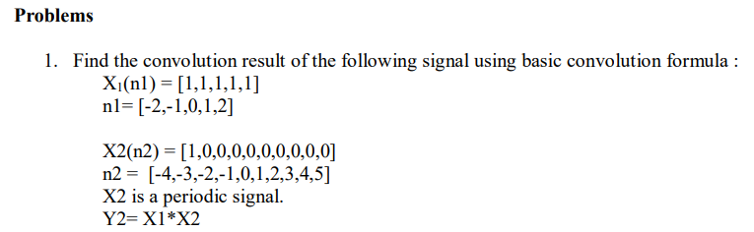

Ans: n1 = [-2,-1,0,1,2];

x1 = [1,1,1,1,1];

n2 = [-4,-3,-2,-1,0,1,2,3,4,5];

x2 = [1,0,0,0,0,0,0,0,0,0];

i= -6:7;

s = zeros(1,length(i));

[y2_fold,n_fold] = sigfold(x1,n1);

temp = 1;

for j = i

[y_shift,n_shift] = sigshift_m(y2_fold,n_fold,j);

[y_multiply,n_multiply] = sigmulti(y_shift,n_shift,x2,n2);

for k = 1:length(n_multiply)

s(temp) = s(temp) + y_multiply(k);

end

temp = temp+1;

end

stem(i,s);

title('y[n] = x_1[n_1] * x_2[n_2] 075bct092');

xlabel('n');

ylabel('y[n]');

function [y,n] = sigshift_m(x,m,n0)

n = m + n0;

y = x;

end

function [y,n] = sigfold(x,n)

y = fliplr(x);

n = -fliplr(n);

stem(n,y)

end

function[y,n] = sigmulti(x1,n1,x2,n2)

n = min(min(n1),min(n2)):max(max(n1),max(n2));

y1=zeros(1,length(n));

y2 = y1;

y1((n>=min(n1))&(n<=max(n1))==1)=x1;

y2((n>=min(n2))&(n<=max(n2))==1)=x2;

y = y1.*y2;

end

OUTPUT:

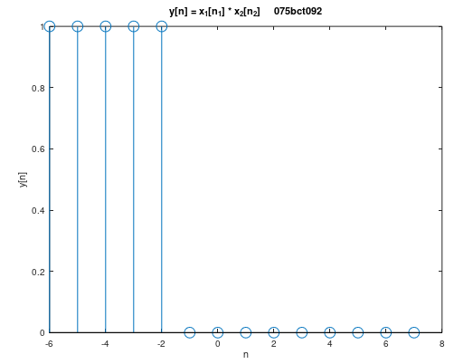

1. Find the convolution using conv function

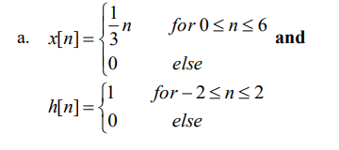

Ans: n1= [0,1,2,3,4,5,6];

x1=[0,1/3,2/3,1,4/3,5/3,2];

n2=[-2,-1,0,1,2];

x2=[1,1,1,1,1];

y=conv(x1,x2);

n=-2:8;

stem(n,y);

title('y[n]=x[n]*h[n] 075bct092');

xlabel('n');

ylabel('y[n]');

OUTPUT:

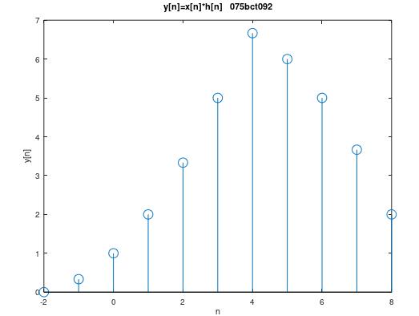

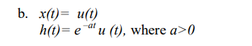

Ans: t= -10:0.0005:10;

ut = (t>=0);

xt = double(ut);

a= 0.25;

ht=exp(-a*t).*ut;

subplot(1,3,1);

plot(t,xt);

title('x(t) = u(t)');

subplot(1,3,2);

plot(t,ht);

title('h(t)=exp(-at) * u(t)');

subplot(1,3,3);

r = -(length(t)-1):length(t)-1;

y=conv(xt,ht);

plot(r,y)

title('y(t) = x(t) * h(t) 075bct092');

xlabel('t');

ylabel('y(t)');

OUTPUT:

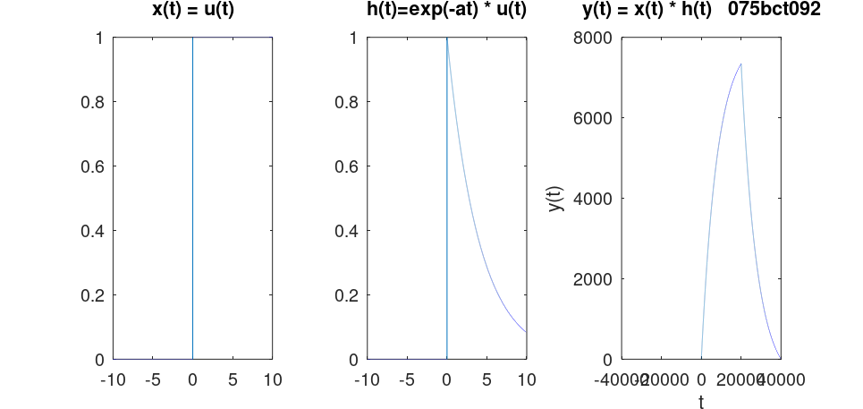

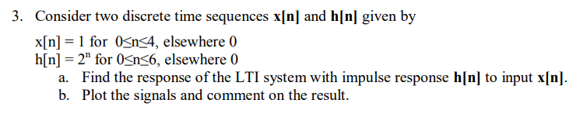

Ans: n1 = [0,1,2,3,4];

x1 = [1,1,1,1,1];

n2 = [0,1,2,3,4,5,6];

h2 = [2^0,2^1,2^2,2^3,2^4,2^5,2^6];

y = conv(x1,h2);

n = 0:10;

subplot(2,2,1);

stem(n1,x1);

title('x[n] = 1, 0<=n<=4');

subplot(2,2,2);

stem(n2,h2);

title('h[n] = 2^n, 0<=n<=6');

subplot(2,2,3);

stem(n,y);

title('y[n] = x[n] * h[n] 075bct092');

xlabel('n');

ylabel('y[n]');

OUTPUT:

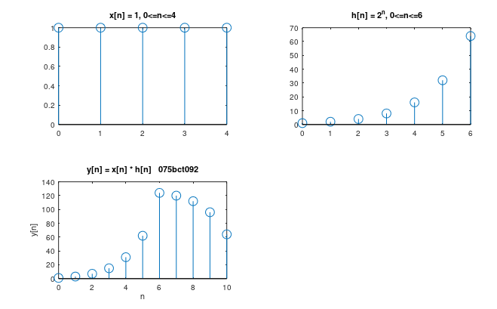

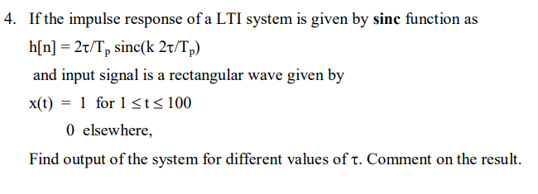

Ans: t = -10:0.005:10;

Tp = 4;

ht = 2*t/Tp.*sinc(2*t/Tp);

xt = double(and(t>=1,t<=100));

subplot(2,2,1);

plot(t,xt);

title('x(t) = 1, 1<=t<=100');

subplot(2,2,2);

plot(t,ht);

title('h(t) = 2t/Tp*sinc(2t/Tp)');

subplot(2,2,3);

r = -(length(t)-1):length(t)-1;

y = conv(xt,ht);

plot(r,y)

title('y(t) = x(t) * h(t) 075bct092');

xlabel('t');

ylabel('y(t)');

OUTPUT:

