DSAP LAB4

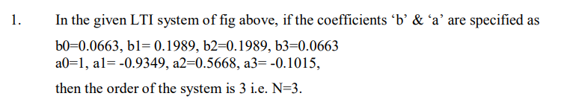



Code:

b= [0.0663, 0.1989, 0.1989, 0.0663];

a= [1, -0.9349, 0.5668, -0.1015];

freqz(b,a);

Output:

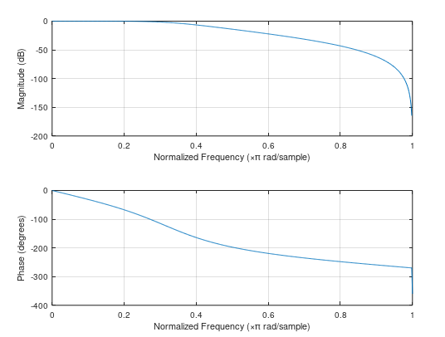



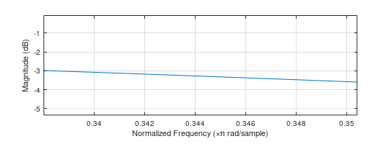

From the magnitude response, it can be observed that the cutoff frequenct corresponding to magnitude of -3dB is 0.338 pi rad/sample.



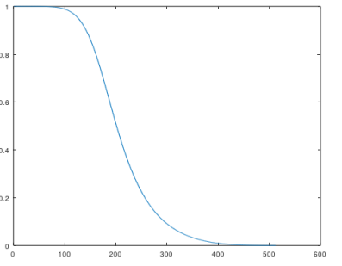

Analyzing the frequency response, it is clear that it is similar to that of a low pass filter, as it passes only lower frequency components (f<=fc).

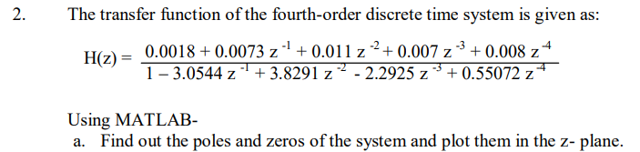

Code:

pkg load signal

b = [0.0018, 0.0073, 0.011, 0.007, 0.008];

a = [1, -3.0544, 3.8291, -2.2925, 0.55072];

%a

[zeros, poles, gain] = tf2zp(b,a);

zeros

poles

gain

zplane(b,a);

Output:

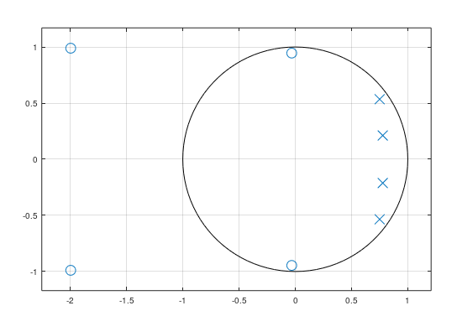

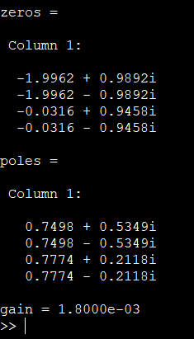



Code:

pkg load signal

b = [0.0018, 0.0073, 0.011, 0.007, 0.008];

a = [1, -3.0544, 3.8291, -2.2925, 0.55072];

%b

[zeros, poles, gain] = tf2zp(b,a);

[sos, g] = zp2sos(zeros, poles, gain);

sos

g

Output:

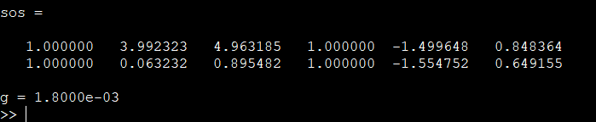

first row(section1) and second row(section2) with b’s coefficients being the first three and a’s coefficients being the final three respectively.



Code:

pkg load signal

b = [0.0018, 0.0073, 0.011, 0.007, 0.008];

a = [1, -3.0544, 3.8291, -2.2925, 0.55072];

%c

freqz(b,a);

Output:

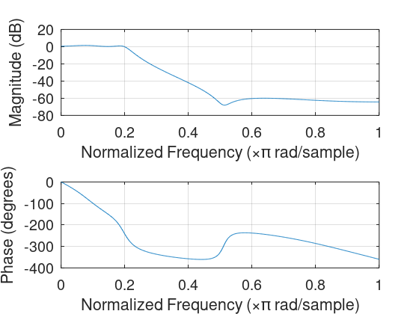



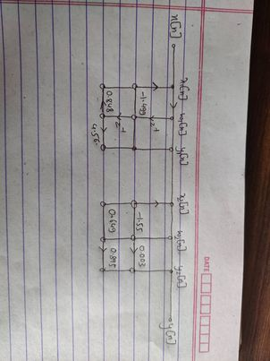

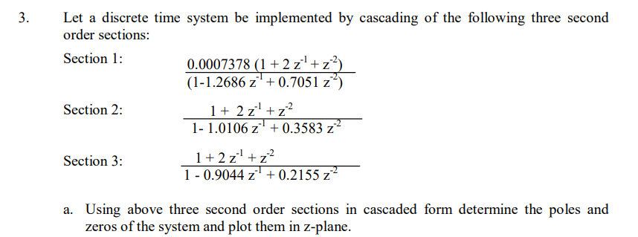

Code:

b1 = [1,2,1];

a1 = [1, -1.2686,0.7051];

a2 = [1, -1.0106, 0.3583];

a3 = [1, -0.9044, 0.2155];

a = conv(a1, conv(a2,a3));

b = conv(0.0007378\*b1, conv(b1,b1));

figure, zplane(b,a);

[zeros, poles, k] = sos2zp([[0.0007278\*b1,a1];[b1,a2];[b1,a3]]);

zeros

poles

K

Output:

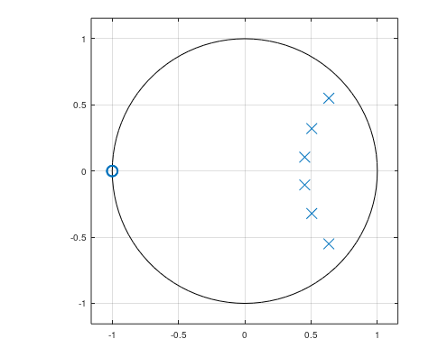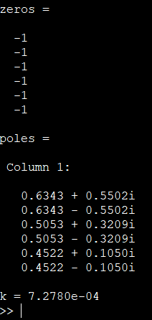



Code:

sos = [0.007378, 2\* 0.0007378, 0.0007378, 1 , -1.2686, 0.7051;

1,2,1,1,-1.0106,0.3583;

1,2,1,1,-0.9044,0.2155];

[b,a] = sos2tf(sos);

b

a

[z,p,k] = tf2zp(b,a);

z

p

k

zplane(b,a);

Output:

