DSAP LAB5 075bct092

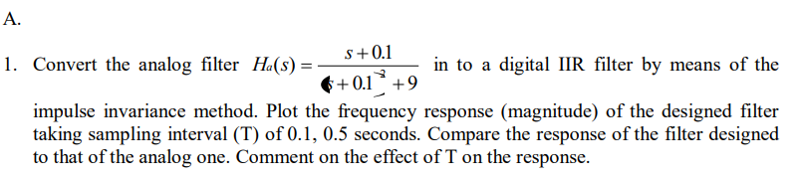

**Code:**

pkg load signal

b = [1 0.1];

a = [1 0.2 9.01];

Ts = 0.1;

fs = 1/Ts ;

Wa = linspace (0,8,64) ;

Ha = freqs (b,a,Wa);

% Converting the analog filter to discrete one

[bz,az] = impinvar (b,a,fs);

[ Hz , Wz ] = freqz (bz,az,512);

Ts1 = 0.5;

fs1 = 1/Ts1;

[ bz1, az1 ] = impinvar (b,a,fs1) ;

[ Hz1, Wz1 ] = freqz (bz1, az1, 512) ;

% Frequency Response Comparison

plot (Wa/(2* pi) ,20*log10(abs(Ha)),'b-',Wz ,20*log10(abs(Hz)),'r--',

Wz1/(2* pi) ,20*log10(abs(Hz1)),'k:','LineWidth',2);

axis ([0 1 -50 20]) ;

xlabel ('Frequency(Hz)') , ylabel ('Magnitude(dB)') ;

title ('Magnitude Response Comparison') ;

legend('Analog Filter','Digital Filter with T = 0.1 s','Digital Filter with T= 0.5s','Location','NorthEastOutside');

**Output:**

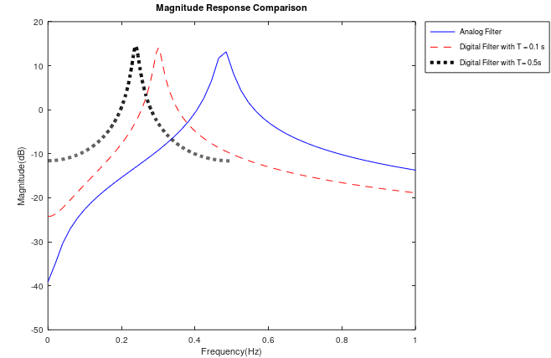



**Code:**

pkg load signal

b =[1 0.1];

a =[1 0.2 9.01];

Ts = 0.1;

fs = 1/ Ts ;

[bz,az] = impinvar(b,a,fs) ;

Ts1 = 0.5;

fs1 = 1/ Ts1 ;

[bz1,az1] = impinvar(b,a,fs1) ;

impulse(b,a); hold on ;

dimpulse(bz,az); hold on;

dimpulse(bz1,az1) ;

legend ('Analog Filter','Digital IIR Filter with T = 0.1 s','Digital IIR Filter with T = 0.5 s');

**Output:**

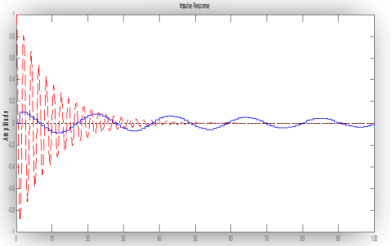



**Code:**

b = [1 0.1]; a = [1 0.2 9.01];

Ts = 0.5; fs = 1/ Ts ;

Wa = linspace (0 , 8 , 64) ;

Ha = freqs (b ,a , Wa);

plot ( Wa /pi ,20*log10(abs(Ha)),'LineWidth',2); hold on;

[bz,az]=bilinear(b,a,fs);

[Hz,Wz]=freqz(bz,az,512);

plot(Wz,20*log10(abs(Hz)) ,'r--') ;

xlabel('Frequency(Hz)'), ylabel('Magnitude(dB)');

title('Magnitude Response Comparison');

legend('Analog Filter','Digital Filter');

**Output:**

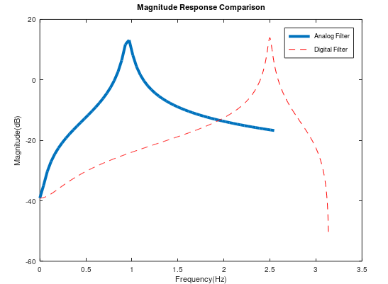

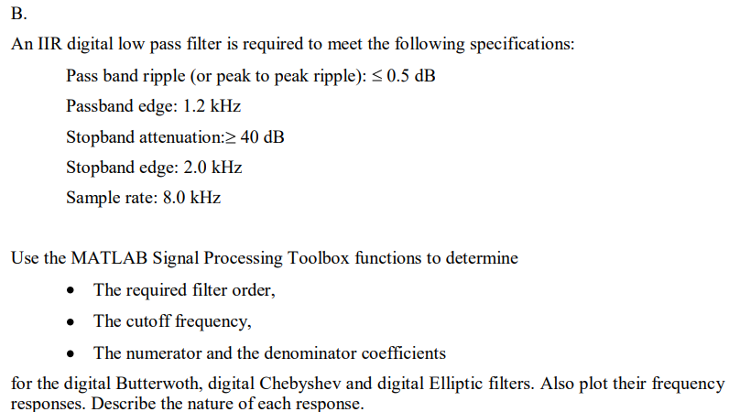

**Code:**

function [N, num1, den1]= b(fil_choice)

fs=8000; pb=1200;

sb=2000;Rp=0.5;

Rs=40;

fn=fs/2;

wp=pb/fn;

ws=sb/fn;

switch (fil_choice)

case 'butter'

[N,wc]=buttord(wp,ws,Rp,Rs);

[num1,den1]=butter(N,wc);

case 'cheby'

[N,wc]=cheb1ord(wp,ws,Rp,Rs);

[num1,den1]=cheby1(N,Rp,wc);

case 'ellip'

[N,wc]=ellipord(wp,ws,Rp,Rs);

[num1,den1]=ellip(N,Rp, Rs, wc);

end

[Hd,wd]=freqz(num1,den1);

magd=abs(Hd);

phase=angle(Hd)*180/pi;

subplot(2,1,1);

plot(wd/pi,magd);title('Magnitude Plot')

subplot(2,1,2);

plot(wd/pi,phase);title('Phase Plot')

end

**Output:**

1. **Butterworth**

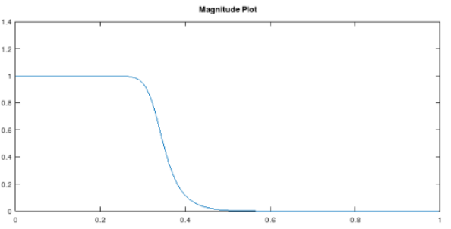

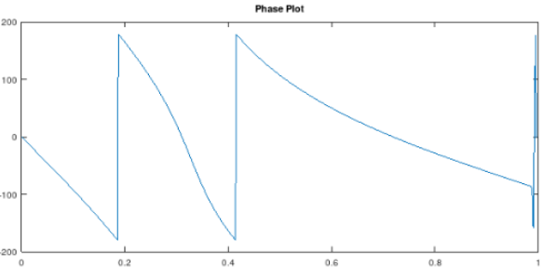

1. **Chebyshev**

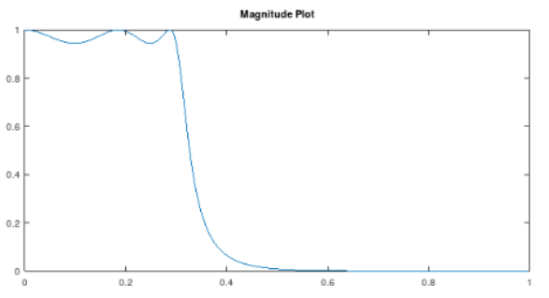

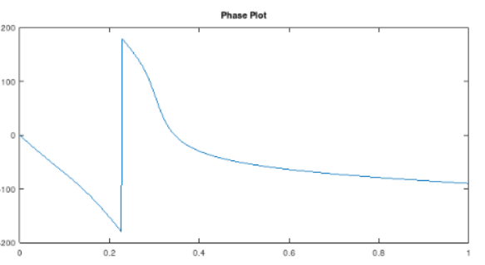

1. **Elliptic**

