DSAP LAB6 075BCT092

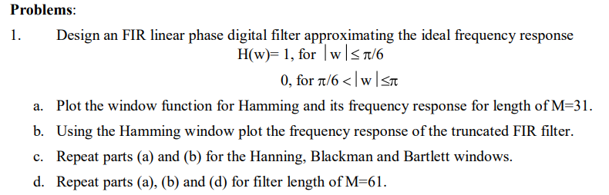

**Code :**

%a

f = [0 pi/6 pi/6 pi];

H = [1 1 0 0];

M = 31;

w = 0:pi/30:pi;

subplot(2,2,1);

h = hamming(M);

plot(w/pi,h,'linewidth', 2);

grid on;

title('31-point symmetric Hamming window');

subplot(2,2,2);

[H1,w] = freqz(h,1,1024);

plot(w/pi,abs(H1),'linewidth', 2);

grid on;

title('Frequency Response for Hamming window function');

subplot(2,2,3);

B = fir1(M-1,1/6,h); %It uses Hamming window of length M+1 by default

if not specified

[H2,w] = freqz(B,1,1024);

plot(w/pi,abs(H2),'linewidth', 2);

grid on;

ylabel('Amplitude');

xlabel('Radian Frequency');

title('Frequency Response of FIR filter using Hamming window');

gk = 20*log(abs(H2));

subplot(2,2,4);

plot(w/pi,gk,'linewidth', 2);

grid on;

ylabel('dB');

xlabel('Radian Frequency');

%b

w = 0:pi/30:pi;

figure(2);

h = hanning(M);

subplot(2,2,1);

plot(w/pi,h,'linewidth', 2);

title('31-point symmetric Hanning window');

grid on;

subplot(2,2,2);

[H1,w] = freqz(h,1,1024);

plot(w/pi,abs(H1),'linewidth', 2);

title('Frequency Response for Hanning window function');

grid on;

subplot(2,2,3);

B = fir1(M-1,1/6,h); %It uses Hamming window of length M+1 by default

[H2,w] = freqz(B,1,1024);

plot(w/pi,abs(H2),'linewidth', 2);

grid on;

ylabel('Amplitude');

xlabel('Radian Frequency');

title('Frequency Response of FIR filter using Hanning window');

gk = 20*log(abs(H2));

subplot(2,2,4);

plot(w/pi,gk,'linewidth', 2);

grid on;

ylabel('dB');

xlabel('Radian Frequency');

%c

w = 0:pi/30:pi;

figure(3);

subplot(2,2,1);

h = blackman(M);

plot(w/pi,h,'linewidth', 2);

grid on;

title('31-point symmetric Blackman window');

subplot(2,2,2);

[H1,w] = freqz(h,1,1024);

plot(w/pi,abs(H1),'linewidth', 2);

grid on;

title('Frequency Response for Blackman window function');

subplot(2,2,3);

B = fir1(M-1,1/6,h); %It uses Hamming window of length M+1 by default

[H2,w] = freqz(B,1,1024);

plot(w/pi,abs(H2),'linewidth', 2);

grid on;

ylabel('Amplitude');

xlabel('Radian Frequency');

title('Frequency Response of FIR filter using Blackman window');

gk = 20*log(abs(H2));

subplot(2,2,4);

plot(w/pi,gk,'linewidth', 2);

grid on;

ylabel('dB');

xlabel('Radian Frequency');

w = 0:pi/30:pi;

figure(4);

subplot(2,2,1);

h = bartlett(M);

plot(w/pi,h,'linewidth', 2);

grid on;

title('31-point Bartlett window');

subplot(2,2,2);

[H1,w] = freqz(h,1,1024);

plot(w/pi,abs(H1),'linewidth', 2);

grid on;

title('Frequency Response for Bartlett window function');

subplot(2,2,3);

B = fir1(M-1,1/6,h); %It uses Hamming window of length M+1 by default

[H2,w] = freqz(B,1,1024);

plot(w/pi,abs(H2),'linewidth', 2);

grid on;

ylabel('Amplitude');

xlabel('Radian Frequency');

title('Frequency Response of FIR filter using Bartlett window');

gk = 20*log(abs(H2));

subplot(2,2,4);

plot(w/pi,gk,'linewidth', 2);

grid on;

ylabel('dB');

xlabel('Radian Frequency');

%d

figure(5);

M = 61;

w = 0:pi/60:pi;

subplot(2,2,1);

h = hamming(M);

plot(w/pi,h,'linewidth', 2);

grid on;

title('61-point symmetric Hamming window');

subplot(2,2,2);

[H1,w] = freqz(h,1,1024);

plot(w/pi,abs(H1),'linewidth', 2);

grid on;

title('Frequency Response for Hamming window function');

subplot(2,2,3);

B = fir1(M-1,1/6,h);%It uses Hamming window of length M+1 by default

[H2,w] = freqz(B,1,1024);

plot(w/pi,abs(H2),'linewidth', 2);

grid on;

ylabel('Amplitude');

xlabel('Radian Frequency');

title('Frequency Response of FIR filter using Hamming window');

gk = 20*log(abs(H2));

subplot(2,2,4);

plot(w/pi,gk,'linewidth', 2);

grid on;

ylabel('dB');

xlabel('Radian Frequency');

end

**Output:**

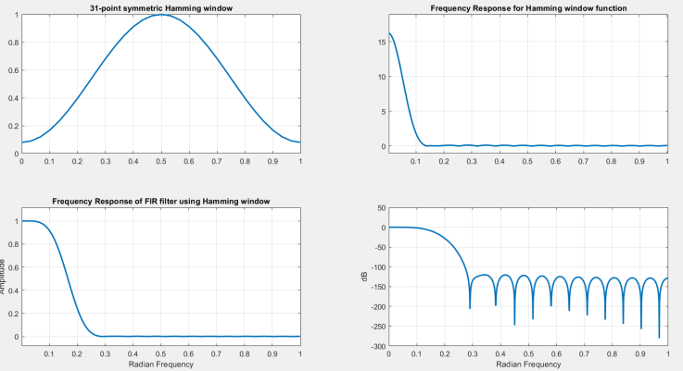

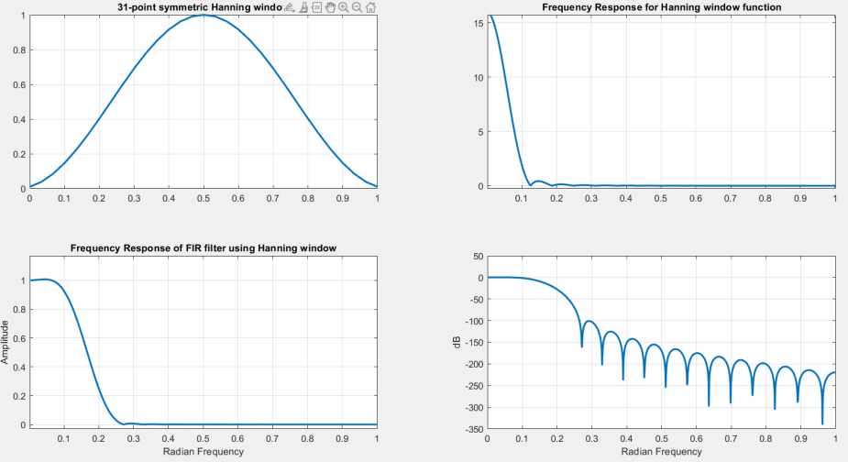

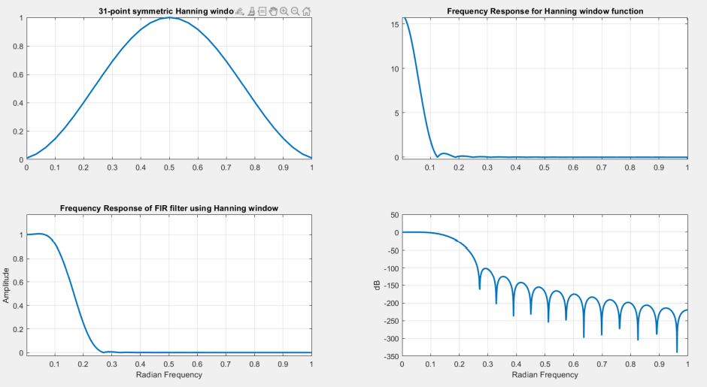

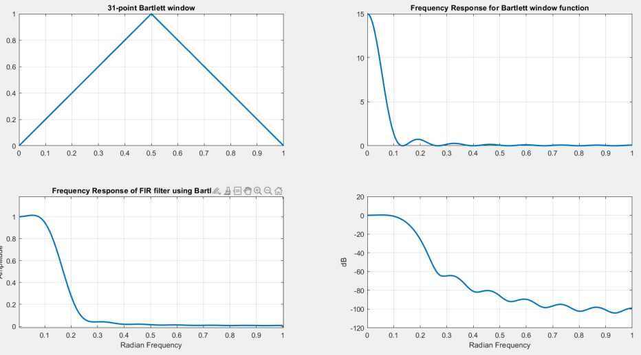

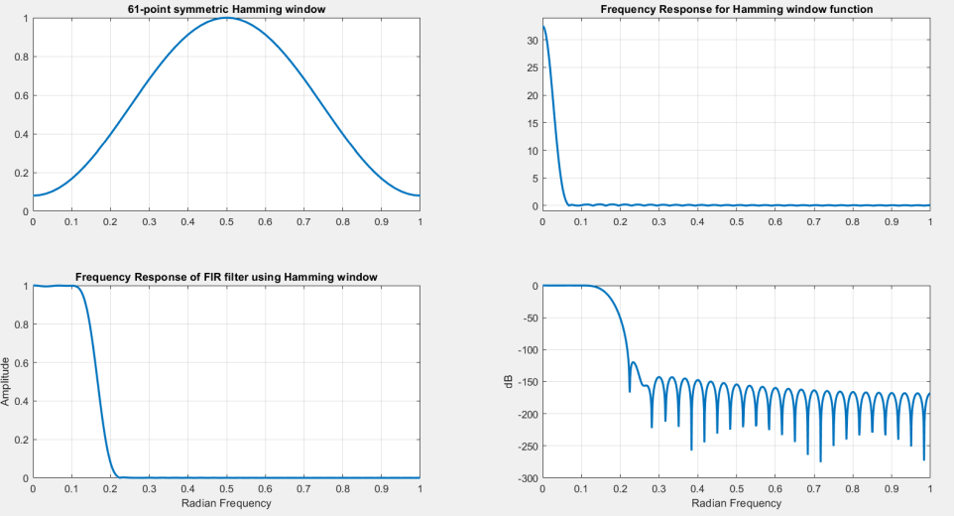

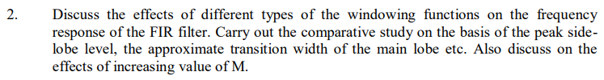

**Ans:**  In 4th figure above the frequency response of every FIR filter using different window function is shown in the log magnitude form. The fourier transforms is concentrated around w = 0. In consideration of Hamming, Hanning , Bartlett and Blackman windows, the frequency response using the Blackman window has the largest main lobe width about 12 * pie/31 and has the largest transition width for a given length. When tapering the window to zero , as with Hamming, Bartlett and Hanning and Blackman , the side lobes are greatly reduced in amplitude, however the price paid is a much wider main lobe. By increasing M, the area under each lobe remains constant and thus results in non-uniform convergence known as the GIbbs phenomenon.

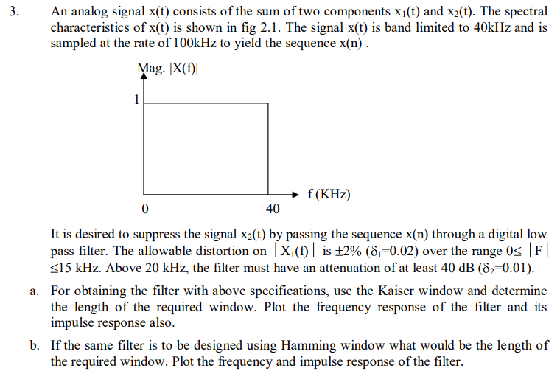

**Code:**

wsample = 100;

wp = 15;

ws = 20;

wpn = 2*wp/wsample;

wsn = 2*ws/wsample;

wn = (wpn + wsn)/2;

Rs = 40;

beta = 0.5842.*(Rs-21)^0.4+0.07886.*(Rs-21);

dw = (wsn - wpn)/2;

M = ((Rs-7.95)./(14.36*dw)) + 1;

N = round(M);

Kaiser_window_length = N

wk = kaiser(N,beta);

bk = fir1(N-1,wn,wk);

[H,w] = freqz(bk,1,512);

subplot(2,1,1);

plot(w/pi,abs(H), 'linewidth', 2);

title('Frequency Response of FIR filter using Kaiser Window');

grid on;

subplot(2,1,2);

plot(w/pi,20*log10(abs(H)), 'linewidth', 2);

xlabel('radian frequency');

ylabel('dB');

grid on;

figure('Name','impulse response');

nk = 0:N-1;

dimpulse(nk,bk);

title('Impulse Response of the FIR filter');

grid on;

**Output:**



