DOUBLY LINKED LIST Suyog Dhakal 075BCT092

theory:
Doubly linked list is a type of linked list in which each node apart from storing its data has two links. The first link points to the previous node in the list and the second link points to the next node in the list. The first node of the list has its previous link pointing to NULL similarly the last node of the list has its next node pointing to NULL.

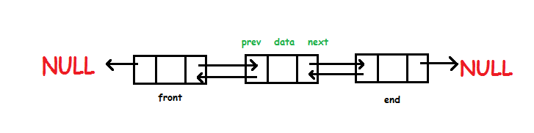

The two links help us to traverse the list in both backward and forward direction. But storing an extra link requires some extra space.

Insertion at beginning
1.start
2. *head = *tail = NULL;
3.temp→data = data;
temp→next = NULL;
temp→previous = NULL;
if(head == NULL){
head = temp;
tail = temp;
}else{
temp->next = head;
head->previous = temp;
head = temp;
}
4.end
insertion at end
1.start
2.temp->data = data;
temp->next = NULL;
temp->previous = NULL;
if(head == NULL){
head = temp;
tail = temp;
}else{
tail->next = temp;
temp->previous = tail;
tail = temp;
}
3.end

insertion after specific node(data, nodeNum)
1.start
2. temp->data = data;
temp->next = NULL;
temp->previous = NULL;
Node *ptr = head;
for(int i=1;i<nodeNum;i++){
ptr = ptr->next;
}
temp->next = ptr->next;
temp->previous = ptr;
ptr->next->previous = temp;
ptr->next = temp;
3.end

insertion before specific node (data, nodeNum)
1.start
2.temp->data = data;
temp->previous = NULL;
temp->next = NULL;

Node *ptr = head;
if(nodeNum == 1){
addBeginning(data);
}else{
insertAfter(data, nodeNum-1);
}
3.end

deletion at beginning
1.start
2.if head = null print empty list
Node *temp = head;
head = head->next;
head->previous = NULL;
delete temp;
3.end

deletion at end
1.start
2.if head = null print empty list
Node *temp = tail;
tail = tail->previous;
tail->next = NULL;
delete temp;
3.end

deletion after specific node
1.start
2.Node *ptr = head
3.for(int i=1;i<nodeNum;i++){
ptr = ptr->next;
}
4. Node *temp = ptr->next;
ptr->next = temp->next;
temp->next->previous = ptr;
delete temp;
5.end
deletion before specific node
1.start
2.if(nodeNum == 1){
cout<<"error"<<endl;
}else if(nodeNum == 2){
deleteBeginning();
}else{
deleteAfter(nodeNum -2);
}
with the help of above function we run deletionbeforespecific node function
3.end

