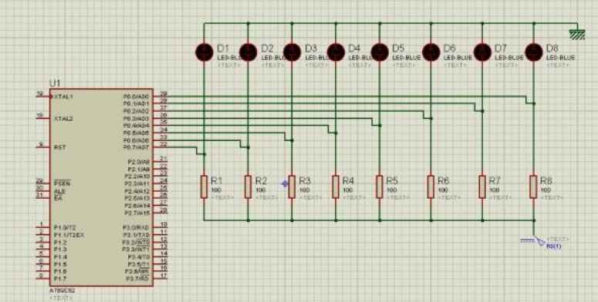

1. Write code to add the numbers 897F9AH and 34BC48H and save the result in internal RAM starting at 40H. The result should be displayed continuously on the LEDs of the development board starting from least significant byte with an appropriate timing interval between each byte. Use port zero (P0) of the micro-controller to interface with LEDs.

Assembly code C code

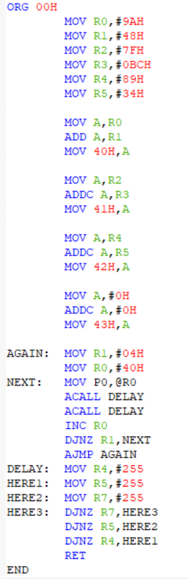 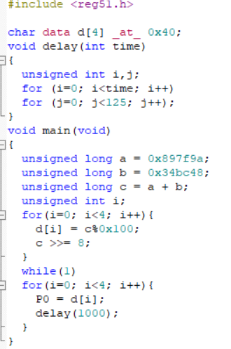

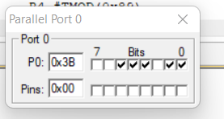 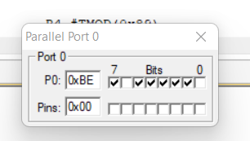

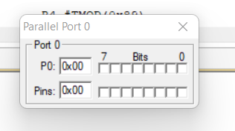 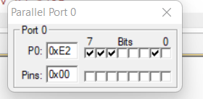

1. Implement a subroutine that replaces the SWAP instruction using rotate right instructions. Test your program on the contents of the accumulator when it contains the number 6BH.

Assembly code C code

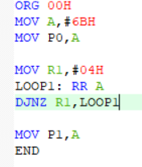 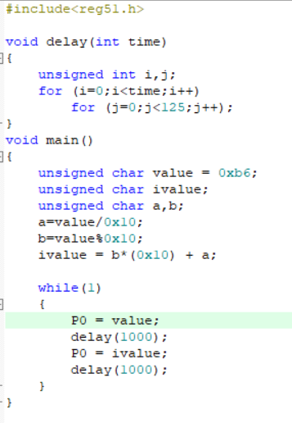

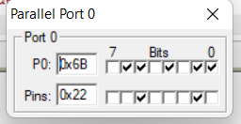 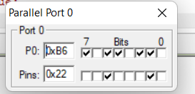

1. Multiply, by using looping and successive addition technique, the data in RAM location 22H by the data in RAM location 15H and put the result in RAM locations 19H (low byte) and 1AH (high byte). Data in 22H should be FFH and data in 15H should be DEH.

Assembly Code C code

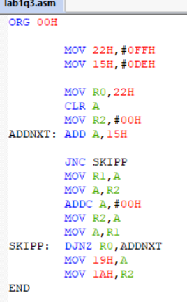 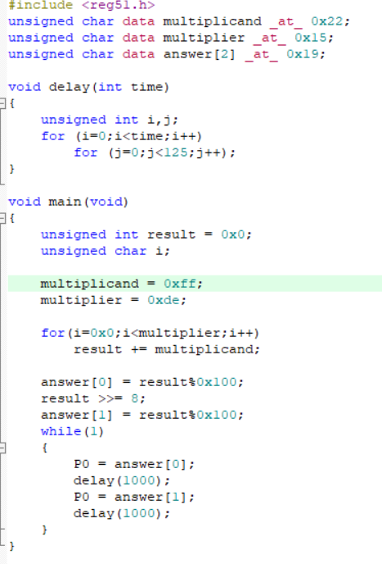

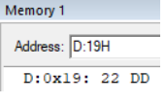

Product of FFH and DEH is DD22H. 19H has lower byte(22H) and 0AH has higher byte(DDH).

1. Divide, by using looping and successive subtraction technique, the data in RAM location 3EH by the number 12H; put the quotient in R4 and remainder in R5. Data in 3EH should be AFH.

Assembly Code C code

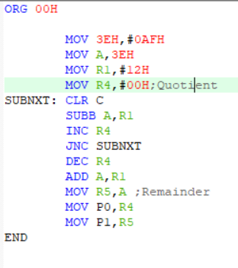 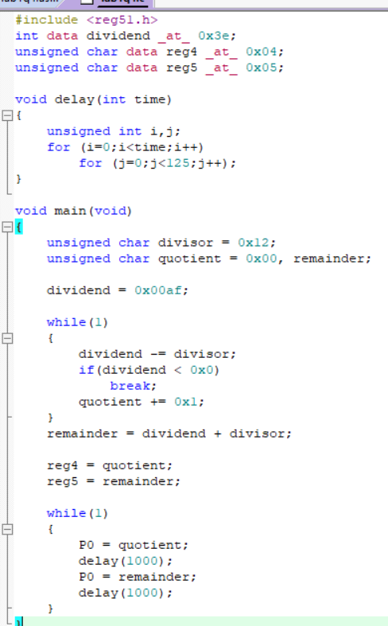

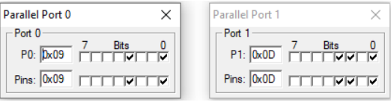

When AFH divided by 12H, the Quotient 09H is and the remainder is 0DH.

5. Store ten hexadecimal numbers in internal RAM starting from memory location 50H. The list of numbers to be used is: D6H, F2H, E4H, A8H, CEH, B9H, FAH, AEH, BAH, CCH. Implement a subroutine that extracts both the smallest and largest numbers from the stored numbers.

Assembly Code C code

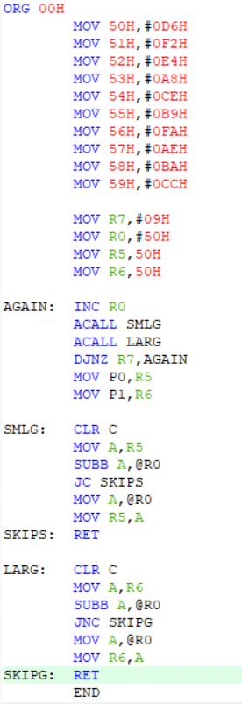 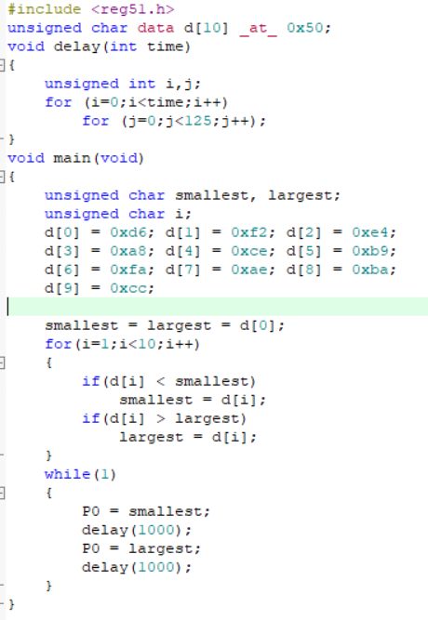

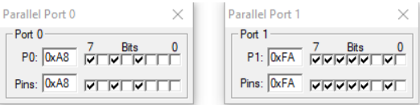

The smallest number is A8H(Port 0) and the largest number is FAH(Port 1).

6.Store ten hexadecimal numbers in internal RAM starting from memory location 60H. The list of numbers to be used is: A5H, FDH, 67H, 42H, DFH, 9AH, 84H, 1BH, C7H, 31H. Implement a subroutine that orders the numbers in ascending order using bubble or any other sort algorithm and implement s subroutine that order the numbers in descending order using selection sort algorithm.

Assembly code

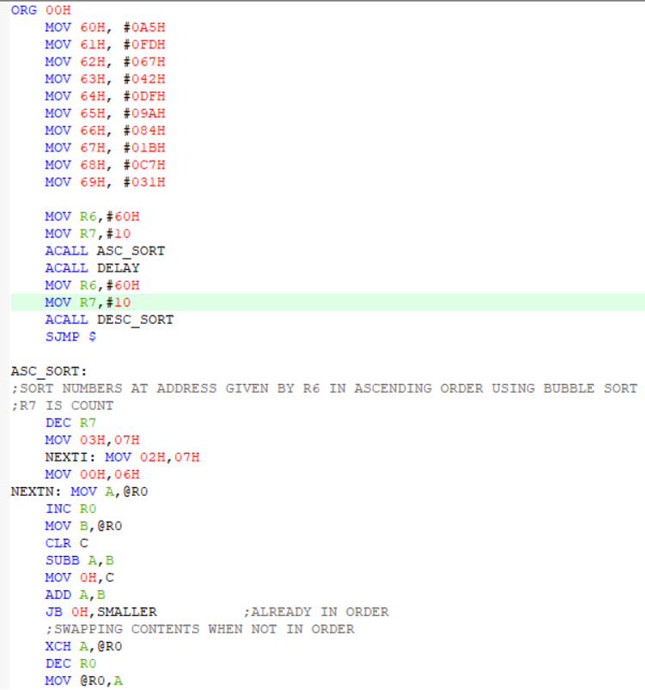

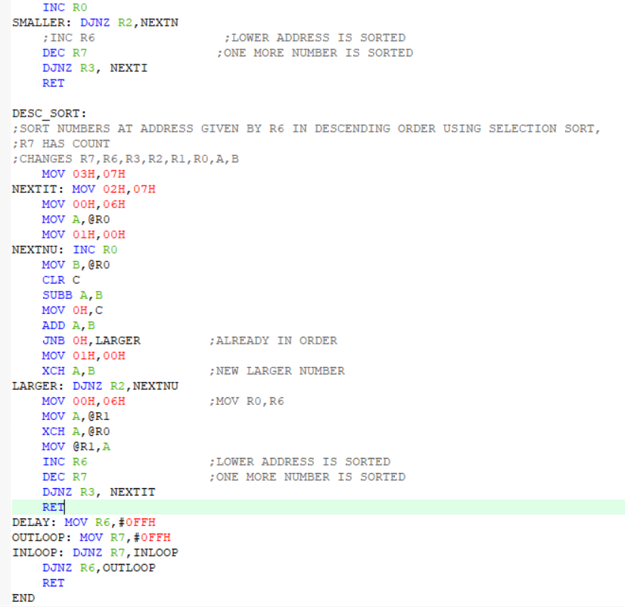

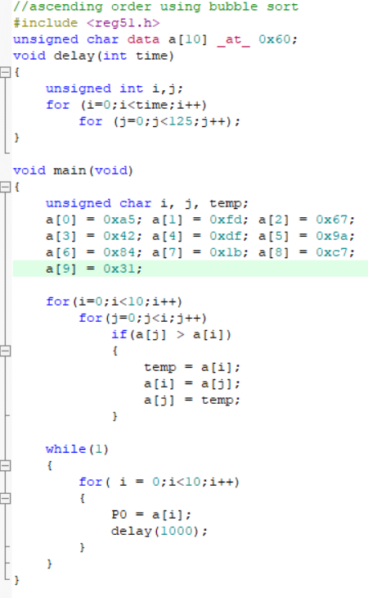

Output

Ascending Order:

aoutput

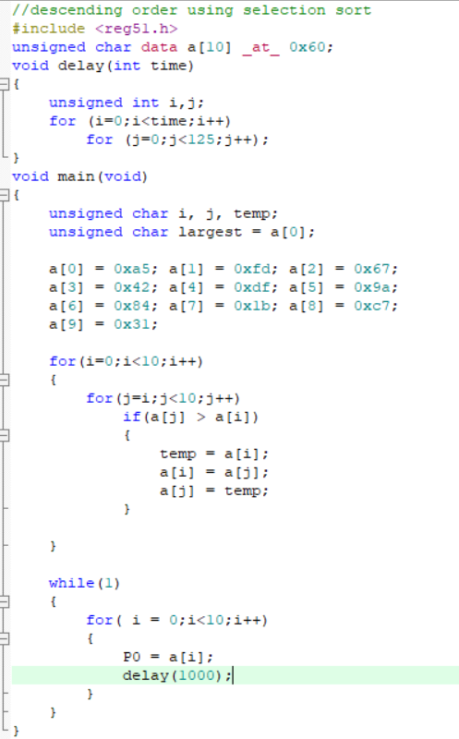

Output

Descending Order:

doutput

7.Store numbers from 00H to 20H in internal RAM starting from memory location 40H. Implement a subroutine that extracts only the prime numbers.

Assembly code

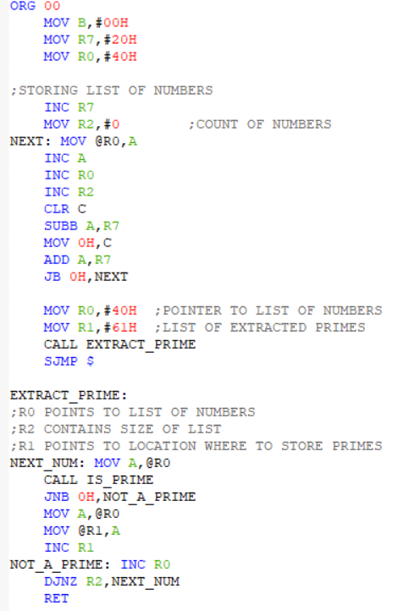

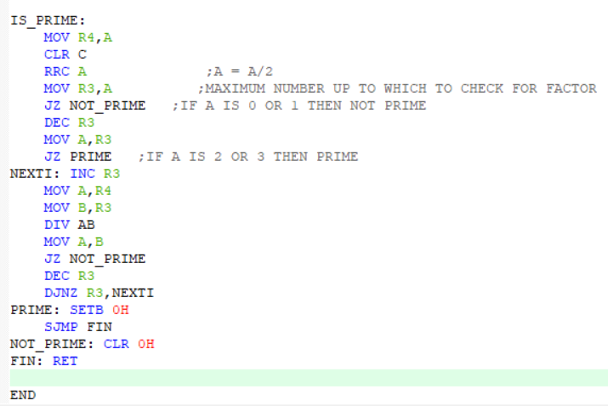

C code

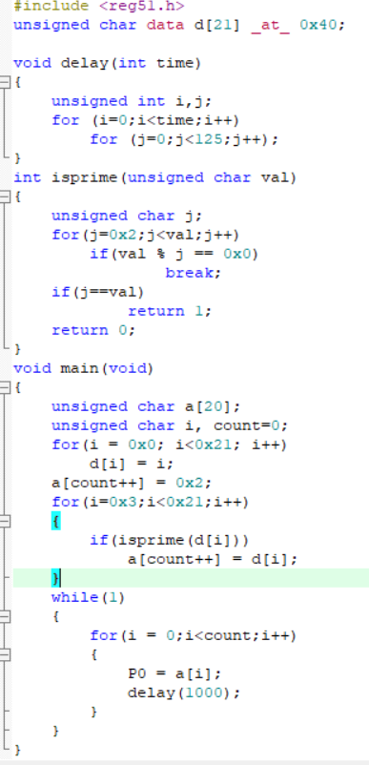

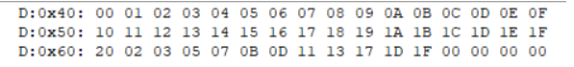

The Prime numbers are stored in location 60H and onwards.

1. Find the factorial of a number stored in R3. The value in R3 could be any number in the range from 00H to 05H. Implement a subroutine that calculates the factorial. The factorial needs to be represented in both hexadecimal and decimal formats.

Assembly Code

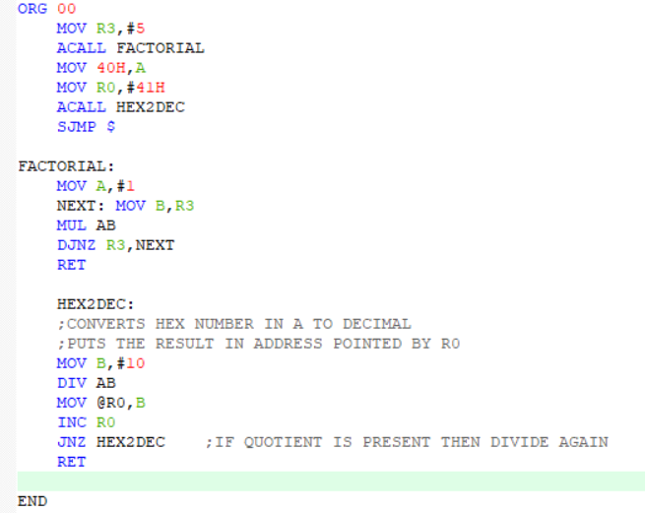

C code

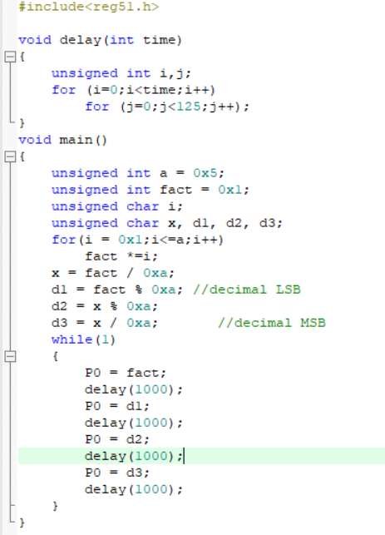

Output

Screenshot 2021-12-18 193910

The factorial of 05H is 78H.