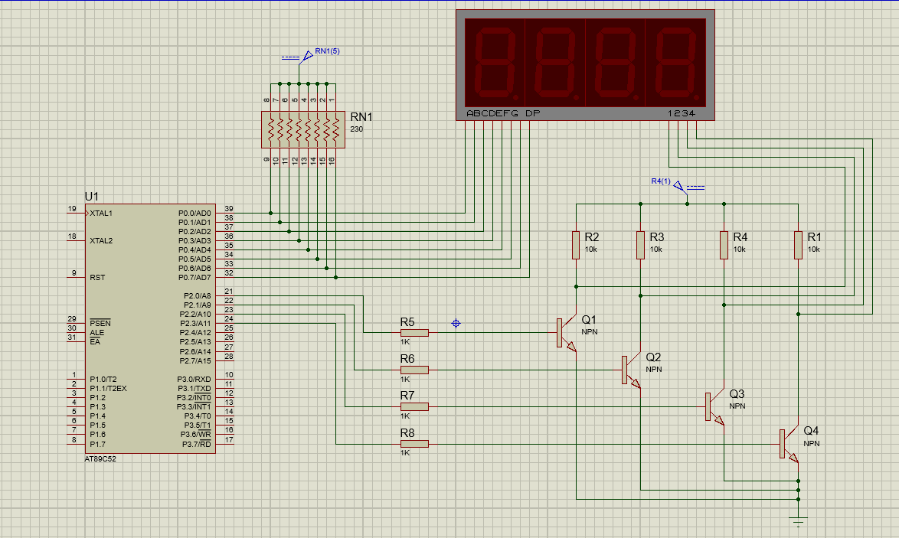

Fig: Circuit Diagram Interfacing 7 Segment Display with AT89C52 Micro-controller

1. Write a code to design a single digit decimal counter that counts up from 0 to 9 and back to 0. This process should repeat indefinitely.

**Program Code:**

ORG 00H

MOV 40H, #3FH

MOV 41H, #06H

MOV 42H, #5BH

MOV 43H, #4FH

MOV 44H, #66H

MOV 45H, #6DH

MOV 46H, #7DH

MOV 47H, #07H

MOV 48H, #7FH

MOV 49H, #6FH

MOV P2, #01H

REPEAT:

MOV R0, #40H

MOV R7, #0AH

INCREASE:

MOV P0, @R0

INC R0

ACALL DELAY

DJNZ R7, INCREASE

MOV R7, #08H

DEC R0

DECREASE:

DEC R0

MOV P0, @R0

ACALL DELAY

DJNZ R7, DECREASE

AJMP REPEAT

DELAY:

MOV R3, #7

LOOP3:

MOV R4, #255

LOOP2:

MOV R5, #255

LOOP1:

DJNZ R5, LOOP1

DJNZ R4, LOOP2

DJNZ R3, LOOP3

RET

END

**C Program Code:**

#include <reg51.h>

unsigned char led_pattern[10] = {

0x3f, 0x06, 0x5b, 0x4f, 0x66, 0x6d,

0x7d, 0x07, 0x7f, 0x6f};

void delay(int time)

{

unsigned int i,j;

for (i=0;i<time;i++)

for (j=0;j<125;j++);

}

void display(int i)

{

P0 = led_pattern[i];

delay(1000);

}

void main(void)

{

unsigned int i;

P2 = 0x01;

while(1)

{

for(i=0; i<10; i++)

display(i);

for(i=8; i>0; i--)

display(i);

}

}

**Results:**

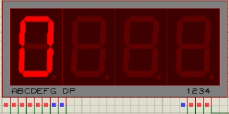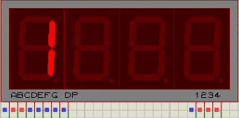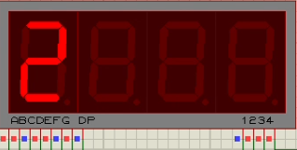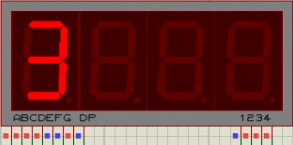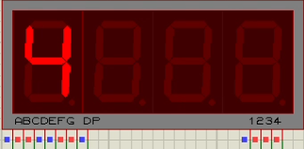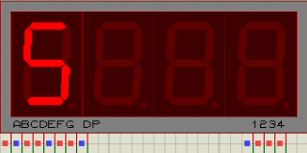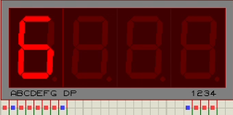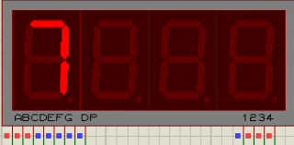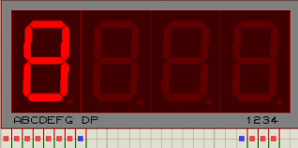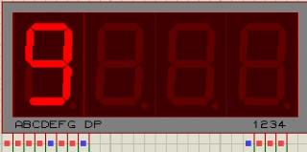

1. Write a code to design a double digit decimal counter that counts up from 00 to 20 and back to 00 indefinitely.

**Program Code**:

ORG 00H

MOV 40H, #3FH

MOV 41H, #06H

MOV 42H, #5BH

MOV 43H, #4FH

MOV 44H, #66H

MOV 45H, #6DH

MOV 46H, #7DH

MOV 47H, #07H

MOV 48H, #7FH

MOV 49H, #6FH

MOV 4AH, #3FH

MOV 50H, 40H

MOV 51H, 41H

MOV 52H, 42H

AGAIN: MOV R1, #50H

MOV R6, #02H

LOOP2: MOV R0, #40H

MOV R5, #0AH

LOOP1: MOV R7, #255

MAIN: MOV A,@R1

MOV P2, #01H

MOV P0, A

ACALL DELAY

MOV A, @R0

MOV P2, #02H

MOV P0, A

ACALL DELAY

DJNZ R7, MAIN

INC R0

DJNZ R5, LOOP1

INC R1

DJNZ R6, LOOP2

MOV R7, #255

LOP: MOV A, @R1

MOV P2, #01H

MOV P0, A

ACALL DELAY

MOV A, @R0

MOV P2, #02H

MOV P0, A

ACALL DELAY

DJNZ R7, LOP

DEC R1

MOV R6, #02H

LOOP22: MOV R0, #49H

MOV R5, #0AH

LOOP11: MOV R7, #255

MAIN_D: MOV A, @R1

MOV P2, #01H

MOV P0, A

ACALL DELAY

MOV A, @R0

MOV P2, #02H

MOV P0, A

ACALL DELAY

DJNZ R7, MAIN_D

DEC R0

DJNZ R5, LOOP11

DEC R1

DJNZ R6, LOOP22

AJMP AGAIN

DELAY:

MOV R3, #02H

DEL1: MOV R2, #0FAH

DEL2: DJNZ R2, DEL2

DJNZ R3, DEL1

RET

END

**C Program Code:**

#include <reg51.h>

unsigned char led_pattern[10] = {

0x3f, 0x06, 0x5b, 0x4f, 0x66, 0x6d,

0x7d, 0x07, 0x7f, 0x6f};

void delay(int time)

{

unsigned int i,j;

for (i=0;i<time;i++)

for (j=0;j<125;j++);

}

void display(unsigned int i)

{

unsigned int j, led1, led2;

led1 = i / 10;

led2 = i % 10;

for(j=0; j<10; j++)

{

P2 = 0x1;

P0 = led_pattern[led1];

delay(40);

P2 = 0x2;

P0 = led_pattern[led2];

delay(40);

}

}

void main(void)

{

unsigned int i;

while(1)

{

for(i=0; i<20; i++)

display(i);

for(i=20; i>0; i--)

display(i);

}

}

**Results:**

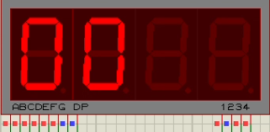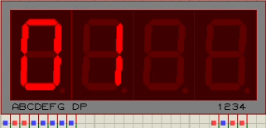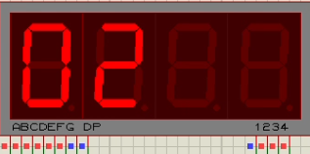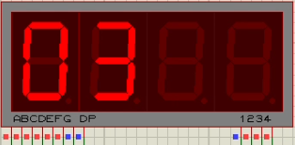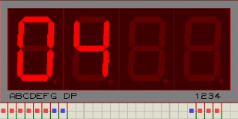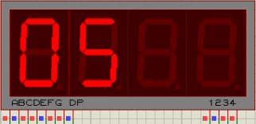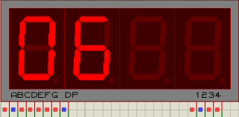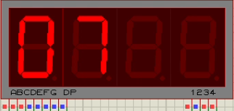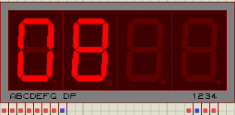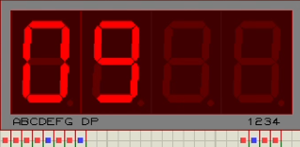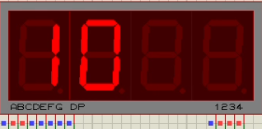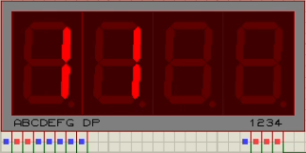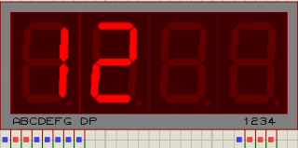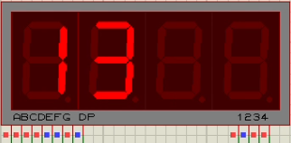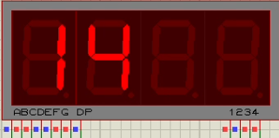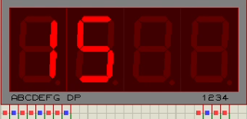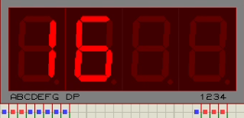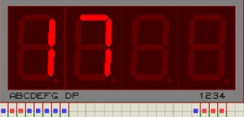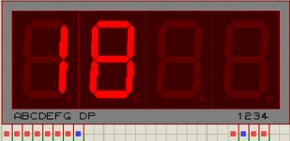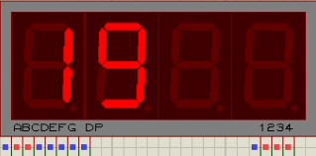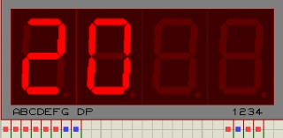

3.Write a code to display the first (N) numbers of the Fibonacci sequence, where the number (N) must be stored in a memory location and can be any integer from 1 to 10. The sequence should repeat indefinitely.

**Program Code:**

ORG 00H

MOV P2, #00H

MOV DPTR, #LABEL1

MOV R0, #50H

MOV R7, #8

MOV A, R7

MOV R6, A

; FIRST TWO TERMS OF FIBONACCI SEQUENCE

MOV R1, #00H

MOV R2, #01H

MOV A, R1

MOV @R0, A

INC R0

DEC R6

MOV A, R2

MOV @R0, A

INC R0

DEC R6

; CALCULATION OF FIBONACCI TERMS

AGAIN: MOV A, R1

ADD A, R2

MOV @R0, A

INC R0

MOV B, R2

MOV R1, B

MOV R2, A

DJNZ R6, AGAIN

; HEX TO DEC CONVERTER

MOV R0, #50H

MOV A, R7

MOV R6, A

AGN2: MOV A, @R0

MOV R4, #00H

MOV B, #0AH

DIV AB

MOV R2, A

SUBB A, #0AH

JC SKIP

MOV A, R2

MOV R3, B

MOV B, #0AH

DIV AB

MOV R4, A

MOV A, B

MOV B, R3

SKIP: MOV A, R2

SWAP A

ADD A, B

MOV B, R4

MOV @R0, A

INC R0

DJNZ R6, AGN2

; DISPLAY

REPEAT: MOV R0, #50H

MOV A, R7

MOV R4, A

LOOP1: MOV R6, #255

MAIN: MOV A, @R0

MOV B, A

ANL A, #0FH

MOV P2, #02H

ACALL DISPLAY

MOV P0, A

ACALL DELAY

MOV A, B

ANL A, #0F0H

SWAP A

MOV P2, #01H

ACALL DISPLAY

MOV P0, A

ACALL DELAY

DJNZ R6, MAIN

INC R0

DJNZ R4, LOOP1

AJMP REPEAT

DELAY: MOV R3, #02H

DEL1: MOV R2, #0FAH

DEL2: DJNZ R2, DEL2

DJNZ R3, DEL1

RET

; CHOOSE REQUIRED PATTERN

DISPLAY: MOVC A, @A + DPTR

RET

; LED PATTERNS FOR NUMBERS 0-9

LABEL1: DB 3FH

DB 06H

DB 5BH

DB 4FH

DB 66H

DB 6DH

DB 7DH

DB 07H

DB 7FH

DB 6FH

END

**C Program Code:**

#include <reg51.h>

#define N 10

unsigned char led_pattern[10] = {

0x3f, 0x06, 0x5b, 0x4f, 0x66, 0x6d,

0x7d, 0x07, 0x7f, 0x6f};

void delay(int time)

{

unsigned int i,j;

for (i=0;i<time;i++)

for (j=0;j<125;j++);

}

void display(unsigned int i)

{

unsigned int j, led1, led2;

led1 = i / 10;

led2 = i % 10;

for(j=0; j<10; j++)

{

P2 = 0x1;

P0 = led_pattern[led1];

delay(40);

P2 = 0x2;

P0 = led_pattern[led2];

delay(40);

}

}

void main(void)

{

unsigned int i, fibo_seq[N]={0, 1};

for(i=2; i<N; i++)

fibo_seq[i] = fibo_seq[i-1] +

fibo_seq[i-2];

while(1)

for(i=0; i<N; i++)

display(fibo_seq[i]);

}

**Results:**

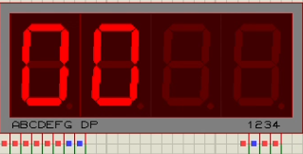 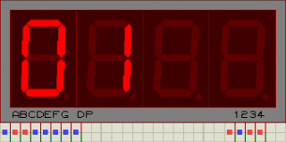 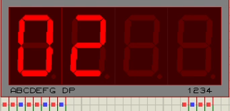 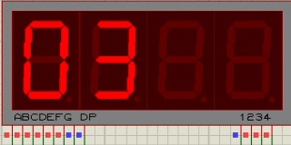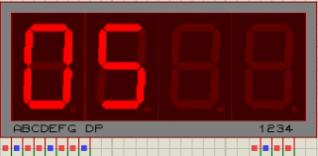 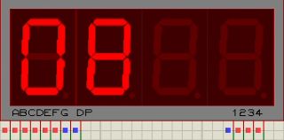 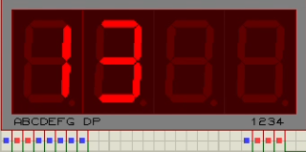

4.Write a code to generate the multiplication table of a number (N) stored in a memory location which can be any integer from 1 to 10. Repeat the sequence indefinitely.

**Program Code:**

ORG 00H

MOV R7, #8

MOV P2, #00H

MOV DPTR, #LABEL1

MOV B, R7

MOV R0, #5AH

MOV R6, #10

AGN: MOV B, R6

MOV A, R7

MUL AB

MOV @R0, A

DEC R0

DJNZ R6, AGN

; HEX TO DEC CONVERTER

MOV R0, #51H

MOV R6, #10

AGN2: MOV A, @R0

MOV R4, #00H

MOV B, #0AH

DIV AB

MOV R2, A

SUBB A, #0AH

JC SKIP

MOV A, R2

MOV R3, B

MOV B, #0AH

DIV AB

MOV R4, A

MOV A, B

MOV B, R3

MOV R2, A

SKIP: MOV A, R2

SWAP A

ADD A, B

MOV B, R4

MOV @R0, A

INC R0

DJNZ R6, AGN2

; DISPLAY

REPEAT: MOV R0, #51H

MOV R4, #10

LOOP1: MOV R7, #255

MAIN: MOV A, @R0

MOV B, A

ANL A, #0FH

MOV P2, #02H

ACALL DISPLAY

MOV P0, A

ACALL DELAY

MOV A, B

ANL A, #0F0H

SWAP A

MOV P2, #01H

ACALL DISPLAY

MOV P0, A

ACALL DELAY

DJNZ R7, MAIN

INC R0

DJNZ R4, LOOP1

AJMP REPEAT

DELAY: MOV R3, #02H

DEL1: MOV R2, #0FAH

DEL2: DJNZ R2, DEL2

DJNZ R3, DEL1

RET

; CHOOSE REQUIRED PATTERN

DISPLAY: MOVC A,@A+DPTR

RET

; LED PATTERNS FOR NUMBERS 0-9

LABEL1: DB 3FH

DB 06H

DB 5BH

DB 4FH

DB 66H

DB 6DH

DB 7DH

DB 07H

DB 7FH

DB 6FH

END

**C Program Code:**

#include <reg51.h>

#define N 6

unsigned char led_pattern[10] = {

0x3f, 0x06, 0x5b, 0x4f, 0x66, 0x6d,

0x7d, 0x07, 0x7f, 0x6f};

void delay(int time)

{

unsigned int i,j;

for (i=0;i<time;i++)

for (j=0;j<125;j++);

}

void display(unsigned int i)

{

unsigned int j;

for(j=0; j<15; j++)

{

P2 = 0x1;

P0 = led_pattern[i / 10];

delay(40);

P2 = 0x2;

P0 = led_pattern[i % 10];

delay(40);

}

}

void main(void)

{

unsigned int i;

while(1)

for(i=1; i<=10; i++)

display(N*i);

}

**Results:**

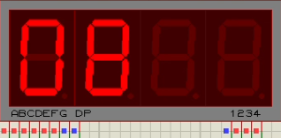 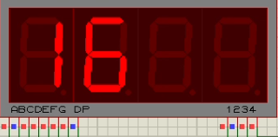 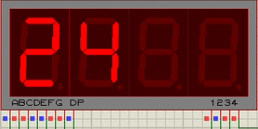 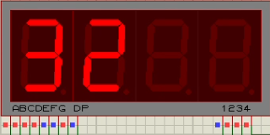 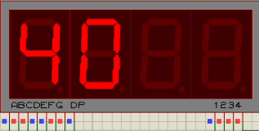 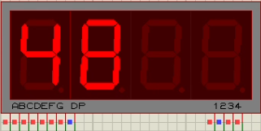 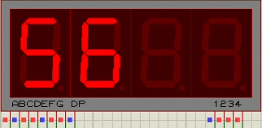 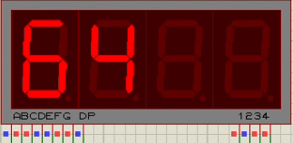 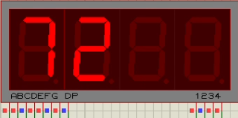 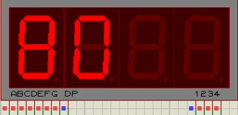

5.Write a code to display the roll numbers of your lab group members one by one in static format. Each student roll number should be of four characters. Display of student roll numbers should repeat indefinitely.

**Program Code:**

ORG 00H

; C090

MOV 40H, #39H

MOV 41H, #3FH

MOV 42H, #6FH

MOV 43H, #3FH

; C091

MOV 44H, #39H

MOV 45H, #3FH

MOV 46H, #6FH

MOV 47H, #06H

; C092

MOV 48H, #39H

MOV 49H, #3FH

MOV 4AH, #6FH

MOV 4BH, #5BH

; C093

MOV 4CH, #39H

MOV 4DH, #3FH

MOV 4EH, #6FH

MOV 4FH, #4FH

; DISPLAY

REPEAT: MOV R0, #40H

MOV R4, #4

LOOP1: MOV R7, #255

MAIN: MOV A, @R0

SETB P2.0

MOV P0, A

ACALL DELAY

CLR P2.0

INC R0

MOV A, @R0

SETB P2.1

MOV P0, A

ACALL DELAY

CLR P2.1

INC R0

MOV A, @R0

SETB P2.2

MOV P0, A

ACALL DELAY

CLR P2.2

INC R0

MOV A, @R0

SETB P2.3

MOV P0, A

ACALL DELAY

CLR P2.3

DEC R0

DEC R0

DEC R0

DJNZ R7, MAIN

INC R0

INC R0

INC R0

INC R0

DJNZ R4, LOOP1

AJMP REPEAT

DELAY: MOV R3, #02H

DEL1: MOV R2, #0FAH

DEL2: DJNZ R2, DEL2

DJNZ R3, DEL1

RET

END

**C Program Code:**

#include <reg51.h>

unsigned char led_pattern[10] = {

0x3f, 0x06, 0x5b, 0x4f, 0x66, 0x6d,

0x7d, 0x07, 0x7f, 0x6f};

unsigned char dept_init = 0x39;

void delay(int time)

{

unsigned int i,j;

for (i=0; i<time; i++)

for (j=0; j<125; j++);

}

void display(unsigned int i)

{

unsigned int j, led2, led3, led4;

led2 = i / 100;

led3 = (i - led2 * 100) / 10;

led4 = i - led2 * 100 - led3 * 10;

for(j=0; j<20; j++)

{

P2 = 0x1;

P0 = dept_init;

delay(10);

P2 = 0x2;

P0 = led_pattern[led2];

delay(10);

P2 = 0x4;

P0 = led_pattern[led3];

delay(10);

P2 = 0x8;

P0 = led_pattern[led4];

delay(10);

}

}

void main(void)

{

unsigned int i;

unsigned int roll_no[4] = {090,

091, 092, 093};

while(1)

for(i=0; i<4; i++)

display(roll_no[i]);

}

**Results:**

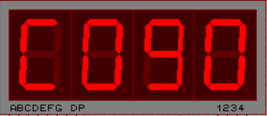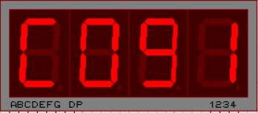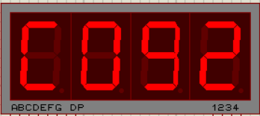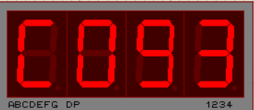

6.Write a code to display the roll numbers of your lab group members in scrolling format, separated by using decimal point. Roll numbers should be scrolled towards the left and is repeated indefinitely.

**Program Code:**

ORG 00H

; C090

MOV 40H, #39H

MOV 41H, #3FH

MOV 42H, #6FH

MOV 43H, #0BFH

; C091

MOV 44H, #39H

MOV 45H, #3FH

MOV 46H, #6FH

MOV 47H, #86H

; C092

MOV 48H, #39H

MOV 49H, #3FH

MOV 4AH, #6FH

MOV 4BH, #0DBH

; C093

MOV 4CH, #39H

MOV 4DH, #3FH

MOV 4EH, #6FH

MOV 4FH, #0CFH

; C09

MOV 50H, #39H

MOV 51H, #3FH

MOV 52H, #6FH

; DISPLAY

REPEAT: MOV R0, #40H

MOV R4, #10H

LOOP1: MOV R7, #255

MAIN: MOV A, @R0

SETB P2.0

MOV P0, A

ACALL DELAY

CLR P2.0

INC R0

MOV A, @R0

SETB P2.1

MOV P0, A

ACALL DELAY

CLR P2.1

INC R0

MOV A, @R0

SETB P2.2

MOV P0, A

ACALL DELAY

CLR P2.2

INC R0

MOV A, @R0

SETB P2.3

MOV P0, A

ACALL DELAY

CLR P2.3

DEC R0

DEC R0

DEC R0

DJNZ R7, MAIN

INC R0

DJNZ R4, LOOP1

AJMP REPEAT

DELAY: MOV R3, #02H

DEL1: MOV R2, #0FAH

DEL2: DJNZ R2, DEL2

DJNZ R3, DEL1

RET

END

**C Program Code:**

#include <reg51.h>

unsigned char scroll_pattern[] = {

0x39, 0x3f, 0x6f, 0xbf, 0x39, 0x3f,

0x6f, 0x86, 0x39, 0x3f, 0x6f, 0xdb,

0x39, 0x3f, 0x6f, 0xcf, 0x39, 0x3f,

0x6f};

void delay(int time)

{

unsigned int i,j;

for (i=0; i<time; i++)

for (j=0; j<125; j++);

}

void display(unsigned int i)

{

unsigned int j;

for(j=0; j<20; j++)

{

P2 = 0x1;

P0 = scroll_pattern[i-4];

delay(10);

P2 = 0x2;

P0 = scroll_pattern[i-3];

delay(10);

P2 = 0x4;

P0 = scroll_pattern[i-2];

delay(10);

P2 = 0x8;

P0 = scroll_pattern[i-1];

delay(10);}

}

void main(void)

{unsigned int i;

while(1)

for(i=4; i<20; i++)

display(i);

}