Email Deduplication Tool
  - Technical guide and interview preparation
Prepared for Suyog Kulkarni | 6 October 2026
This guide explains how the Java and Spring Boot tool accepts an Excel workbook, validates and normalizes email addresses, separates first occurrences from repeated occurrences, and makes two Excel files available through a simple browser interface.
The central design is a single synchronous processing pipeline. A HashSet detects previously seen addresses, ArrayLists preserve source order, and Apache POI reads and writes the Excel workbooks. MySQL is not required because the application does not keep a database of uploads or results.

What you will learn
- How to set up and run the project in IntelliJ and use its REST endpoint.
- What each class does and how control passes between the browser, controller and services.
- How normalization, validation and duplicate classification work with concrete examples.
- Which data structures and design principles are used, and how to explain their complexity.
- How to test the tool, troubleshoot failures and describe its limitations honestly in interviews.

Guide map
Pages | Topic
2–3 | Requirements, package layout and local setup
4–5 | Architecture, request flow and REST contract
6–9 | Models, validation, deduplication and output generation
10–11 | Frontend behavior and exception handling
12–13 | Data structures, design principles and complexity
14–16 | Tests, troubleshooting, interview preparation and references

Verification status: the implementation and four test cases have been supplied during development. A successful build or end-to-end test result for this email tool has not yet been recorded. The earlier payment sandbox results do not establish this project’s test status.

Requirements and counting rules
The user chooses one .xlsx file, clicks Check, then downloads either unique-emails.xlsx or duplicate-emails.xlsx. The page shows processed, unique and duplicate counts. It has one file picker and three application buttons; Check uploads and processes the selected file.
Rule | Behavior
Workbook | Only .xlsx; read the first worksheet. Other worksheets are not processed for emails.
Header | The first row must contain one Email header, matched after trimming and ignoring case.
Input limits | 5 MiB file; 6 MB multipart request; 10,000 data row positions; at most 50 columns in checked rows.
Blank cells | Skip absent rows, missing cells and strings empty after stripping whitespace.
Cell types | Accept text email cells. Reject formula, numeric, boolean and error cells.
Output | Keep normalized Email and original Source Row. Other input columns are not copied.
Invalid data | Reject the entire request. No partial results are returned.

Unique means one representative per address
Every first occurrence goes to the unique file, even if the address appears again later. Every occurrence after the first goes to the duplicate file. Therefore processed = unique + duplicates. Processed counts accepted, nonblank email rows; it excludes the header and skipped blanks.
Excel row | Input text | Classification
2 | Asha@Example.com | Unique: asha@example.com
3 | ben@example.com | Unique: ben@example.com
4 | asha@example.com | Duplicate: asha@example.com
5 | ASHA@example.com | Duplicate: asha@example.com
6 | blank | Skipped

This example produces 4 processed, 2 unique and 2 duplicate occurrences. There is only 1 distinct address that repeats. The tool does not currently calculate that fourth metric, nor does it put the first occurrence into the duplicate file.

Project structure and local setup
Install JDK 21 and use IntelliJ with Maven support. Apache POI and Spring dependencies are downloaded by Maven. No Docker, Kafka, Keycloak or database is needed for this tool. Those belong to the separate payment sandbox.
Use src/main/java as the source root. The Java base package is emailtool, not src.main.java.emailtool. All component classes belong beneath that base package so Spring can discover them.
src/main/java/emailtool/
EmailToolApplication.java
api/EmailController.java
api/ApiExceptionHandler.java
exception/InvalidExcelException.java
model/EmailEntry.java
model/DeduplicationResult.java
service/ExcelEmailReader.java
service/EmailDeduplicator.java
service/ExcelArchiveWriter.java
service/EmailProcessingService.java
src/main/resources/application.yml
src/main/resources/static/index.html
src/test/java/emailtool/service/
EmailDeduplicatorTest.java
EmailProcessingServiceTest.java
Maven coordinates: group dev.suyog, artifact email-deduplication-tool, version 0.1.0-SNAPSHOT. The supplied build uses Spring Boot 4.1.1, Java 21 and Apache POI 5.5.1. Dependencies are spring-boot-starter-webmvc, spring-boot-starter-validation, poi-ooxml and spring-boot-starter-test in test scope; packaging uses spring-boot-maven-plugin.
spring:
application:
name: email-deduplication-tool
servlet:
multipart:
max-file-size: 5MB
max-request-size: 6MB
server:
address: 127.0.0.1
port: 8082
In IntelliJ set the project SDK and Maven runner JRE to Java 21, reload Maven, and run EmailToolApplication.main(). Open http://localhost:8082/. Binding to 127.0.0.1 restricts access to the same computer.
From the directory containing pom.xml, run .\mvnw.cmd clean verify when the wrapper exists. If missing, run mvn wrapper:wrapper through IntelliJ’s Maven tooling or an installed Maven. Verify creates no proof of tests unless the output actually lists executed tests.

Architecture and startup
The application separates HTTP details, workflow coordination, email rules and file formats. This makes the classification algorithm testable without starting Spring or opening an HTTP connection.
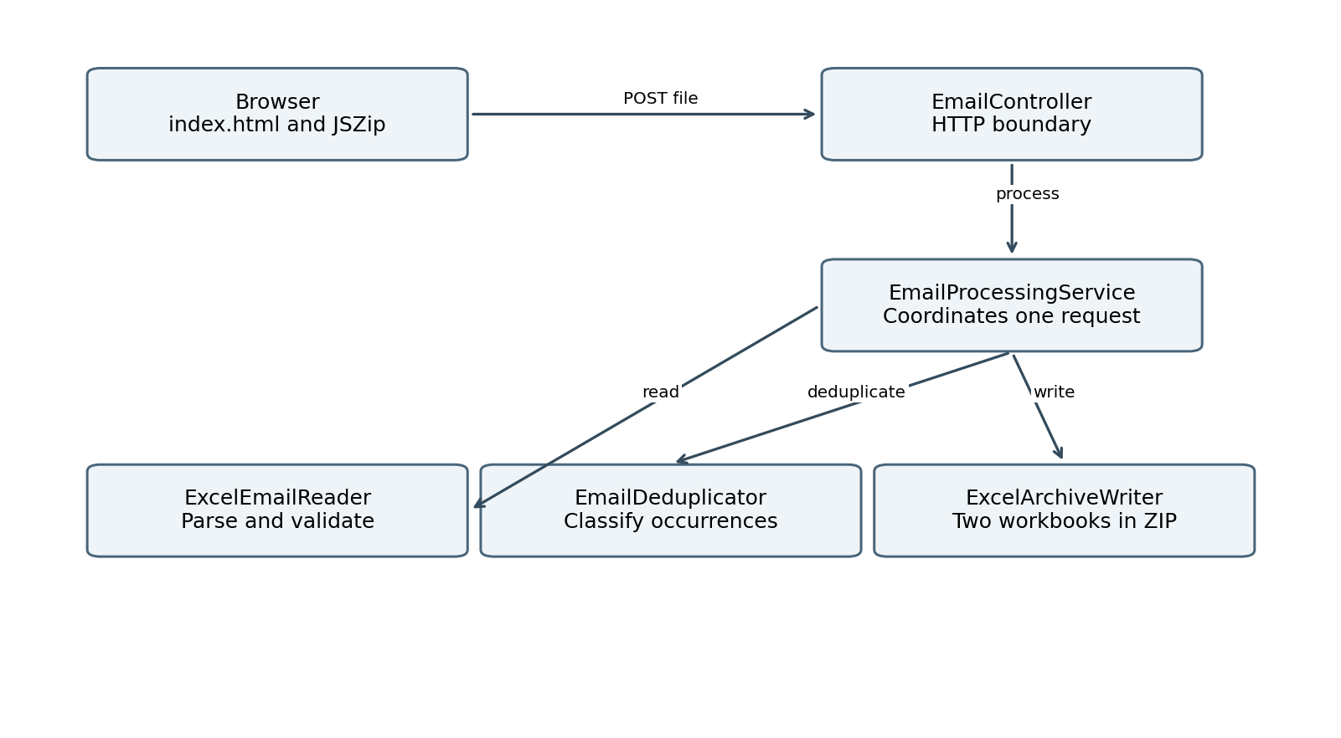
Figure 1 Component relationships within one processing request

How Spring starts the application
EmailToolApplication.main() calls SpringApplication.run(). @SpringBootApplication enables configuration, auto-configuration and component scanning under emailtool. Spring creates the controller, service and component beans, supplies the Jakarta Validator, and injects dependencies through constructors. The embedded servlet server listens on port 8082.
When the browser asks for /, Spring’s static resource support serves src/main/resources/static/index.html when that file is packaged correctly. JavaScript later submits the workbook to the API. The HTML does not belong under src/main/java.

Dependency direction
EmailController depends on EmailProcessingService. The service depends on ExcelEmailReader, EmailDeduplicator and ExcelArchiveWriter. The model records carry data between them. ApiExceptionHandler translates failures into HTTP error responses; it is not a step called manually by the service.
Spring normally creates one instance of each component bean. The collections and workbooks used for processing are local variables, so concurrent requests do not share a “seen emails” set. This avoids cross-upload contamination, although concurrent large uploads can still exhaust memory.

Request flow and REST contract
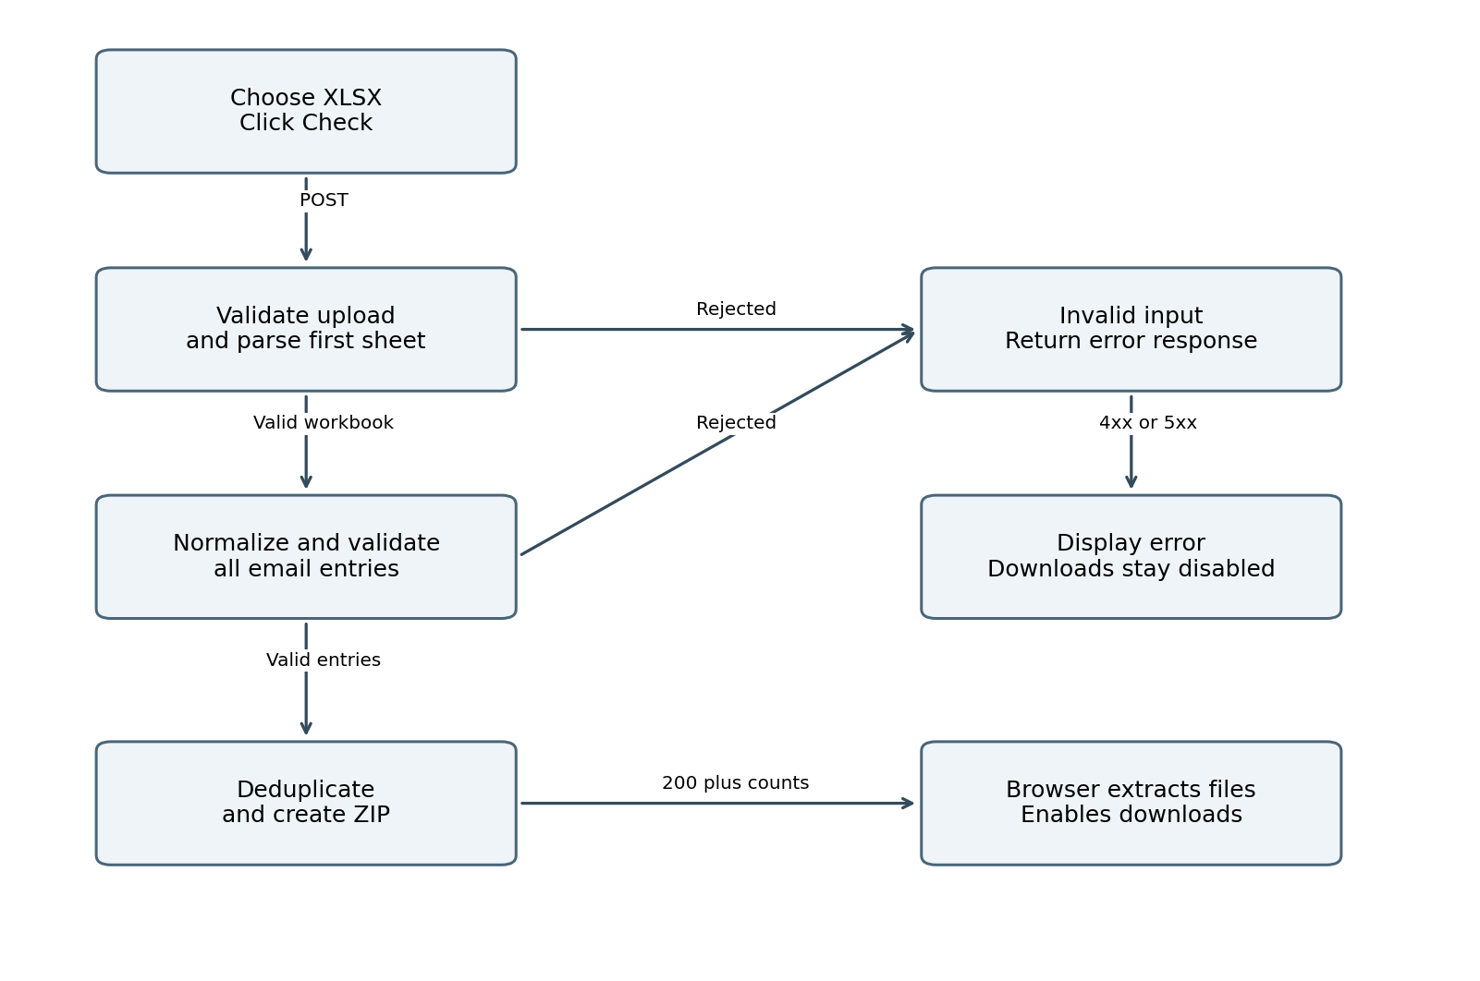
Figure 2 Success and failure paths for one upload
Contract item | Value
Method and route | POST /api/emails/deduplicate
Request | multipart/form-data with a file part named file
Success | 200 OK; Content-Type: application/zip
Attachment | email-deduplication-results.zip
Count headers | X-Total-Emails, X-Unique-Emails, X-Duplicate-Emails
Cache policy | Cache-Control: no-store
ZIP entries | unique-emails.xlsx and duplicate-emails.xlsx

EmailController is annotated @RestController and maps the route using @RequestMapping and @PostMapping. @RequestParam("file") binds the uploaded part to MultipartFile. It calls process(file), builds download and count headers, and returns ResponseEntity<byte[]> containing the ZIP bytes.
The controller does not parse Excel or decide which address is a duplicate. Keeping those rules outside the HTTP layer lets unit tests call the same logic directly. One request produces both files; clicking either download button later does not submit another request.

Model classes and domain errors

EmailEntry
public record EmailEntry(
int sourceRow,
@NotBlank @Email @Size(max = 254) String email
) {}
This record represents one accepted row. sourceRow is the original 1-based Excel row number, so users can trace an output back to the input. email stores the stripped, lowercase address. Generated accessors are sourceRow() and email(); records also provide equals(), hashCode() and toString().
The annotations declare validation constraints. They do not validate automatically just because a record is constructed. ExcelEmailReader explicitly calls validator.validate(entry). @Email checks syntax according to the validator; it does not contact the mail server or prove that a mailbox exists.

DeduplicationResult
This record holds List<EmailEntry> uniqueEmails and duplicateEmails. Its compact constructor replaces both lists with List.copyOf(...), preventing callers from adding, removing or reordering entries through the result. totalEmails() returns the sum of the list sizes.
The copies duplicate list references, not each EmailEntry object. This is suitable here because EmailEntry contains an int and an immutable String. Defensive copying costs O(n) time and O(n) references across both lists; it does not make the whole pipeline constant-space.

InvalidExcelException
This custom unchecked exception extends RuntimeException and provides constructors for a message and for a message with a cause. The reader throws it for expected input problems such as a missing header, invalid email or unreadable workbook. The exception handler maps it to HTTP 400 with an understandable message.

ProcessingDownload
EmailProcessingService declares a nested record containing byte[] archive and the three integer counts. It gives the controller one return value with everything needed for the HTTP response. A record makes fields final, but the byte array is still mutable; an accessor can expose its contents. Do not describe this record as deeply immutable.
No entity, repository or database table is present. These records are in-memory data carriers, not JPA entities. MySQL becomes useful only if later requirements introduce accounts, persistent jobs, audit metadata or retained results.

ExcelEmailReader in depth
ExcelEmailReader is a @Component responsible for the complete input boundary. Its constructor receives a Jakarta Validator. read(MultipartFile) returns a validated list of EmailEntry records or throws InvalidExcelException.

Validation order
- Check for a null or empty upload, enforce 5 MiB, and require an original filename ending in .xlsx after case-insensitive comparison. The extension check alone does not prove file content; POI must parse it.
- Open the input stream and XSSFWorkbook with try-with-resources. Reject a workbook with no worksheets and select worksheet zero.
- Reject a first-sheet last-row index above 10,000. Excel row one is index zero, so this allows at most 10,000 data row positions. Formatting far below the data can affect the last-row index.
- Find exactly one string header equal to Email after stripping whitespace and ignoring case. Reject a missing header, repeated matching header or more than 50 header columns.
- Traverse row indexes from one to the last row. Skip absent rows. Reject checked rows with more than 50 columns, and obtain the email cell with RETURN_BLANK_AS_NULL.
- Skip missing email cells; reject non-string cell types. Strip the text, skip empty strings, lowercase with Locale.ROOT, construct the entry and validate it.
- Reject a workbook with no accepted emails. Otherwise return List.copyOf(entries).

Why normalization comes before comparison
" Asha@Example.com " and "asha@example.com" become the same key. Locale.ROOT makes case conversion independent of the machine’s locale. Lowercasing the entire address is a deliberate business policy: email local parts can theoretically be case-sensitive. The tool does not remove dots or plus tags and does not implement provider-specific identity rules.

Resource and error boundaries
Try-with-resources closes the stream and workbook on success and failure. InvalidExcelException is rethrown; IO and other runtime failures during reading are wrapped as an invalid or unreadable workbook. That broad RuntimeException catch can also disguise a programming defect as a bad file and should be narrowed if troubleshooting requires more precise classification.
The workbook is loaded before the row and column checks. Consequently, those limits protect processing rules but are not a hard bound on POI heap use. Unused worksheets and workbook metadata can still contribute to parsing cost and memory. File size is compressed size, not expanded workbook size.

EmailDeduplicator and algorithm trace
EmailDeduplicator is a @Component with a pure processing method: deduplicate(List<EmailEntry>). It assumes its input is already normalized and validated by the reader. It neither opens files nor calls the database or network.
Set<String> seenEmails = new HashSet<>();
List<EmailEntry> uniqueEmails = new ArrayList<>();
List<EmailEntry> duplicateEmails = new ArrayList<>();
for (EmailEntry entry : entries) {
if (seenEmails.add(entry.email())) {
uniqueEmails.add(entry);
} else {
duplicateEmails.add(entry);
}
}
return new DeduplicationResult(uniqueEmails, duplicateEmails);
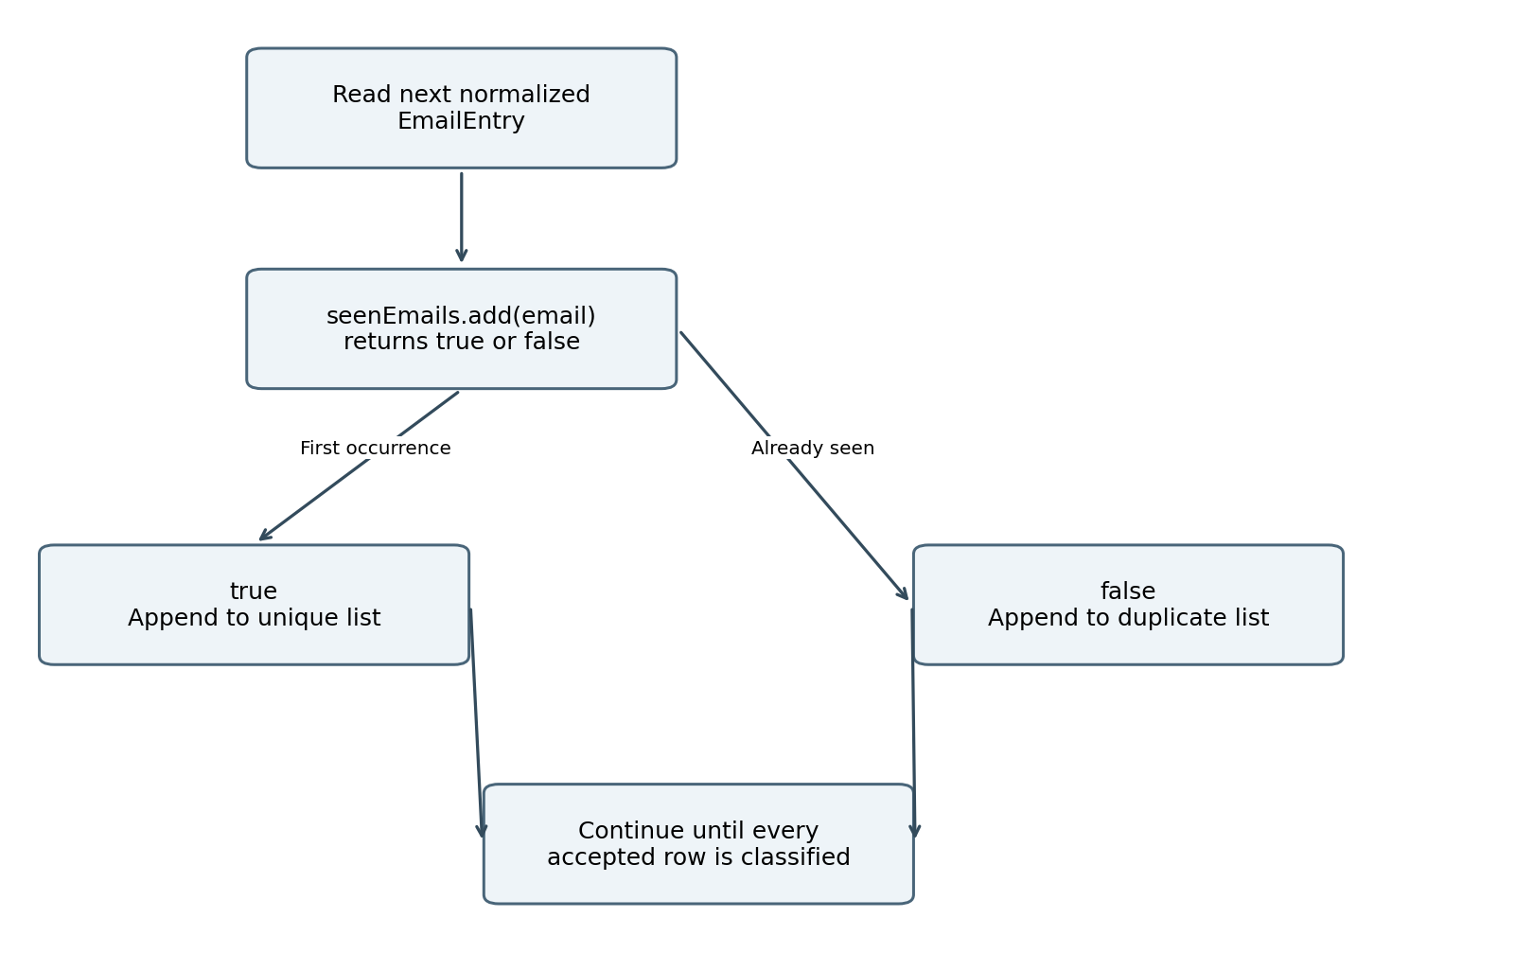
Figure 3 One set insertion both checks and records membership
HashSet.add returns true when it inserts a new address and false when the set already contains it. Each accepted entry goes to exactly one output list. The set is not used for output iteration; the ArrayLists preserve the original encounter order within each category.
For input [a, b, a, a], the set evolves as {a}, {a,b}, {a,b}, {a,b}. The unique list becomes [a,b] and the duplicate list becomes [a,a]. Comparing by entry.email() is essential: comparing whole EmailEntry records would include sourceRow and could treat identical addresses on different rows as different entries.

Service orchestration and Excel output

EmailProcessingService
The @Service constructor receives the reader, deduplicator and writer. process(file) calls read(file), passes the returned entries into deduplicate(entries), and passes the result into writeArchive(result). It then returns a ProcessingDownload containing the ZIP and result counts. If any step throws, subsequent steps do not run.
This is a synchronous application service: the HTTP request waits for parsing, validation, classification and file creation. There is no background queue, job identifier, polling endpoint or transaction manager. The all-or-nothing behavior comes from returning only after every step succeeds; it is not a database transaction.

ExcelArchiveWriter
writeArchive(result) creates a ByteArrayOutputStream and a ZipOutputStream. It calls addWorkbook for the unique list and then for the duplicate list. Each call creates a separate .xlsx workbook, opens a named ZIP entry, writes its bytes and closes that entry. The ZIP stream must finish before the final byte array is returned so the archive directory is complete.
createWorkbook builds an XSSFWorkbook containing one sheet, named Unique Emails or Duplicate Emails. Row one has Source Row and Email headers in bold. Each entry contributes its numeric source row and normalized email string. The first row is frozen and the two columns use fixed widths of 14 and 60 characters.
An empty duplicate list still produces a valid workbook containing its header. The email is written as a string cell with setCellValue, not as a formula. The source row retains traceability without copying unrelated spreadsheet columns.

Why ZIP and byte arrays were chosen
One HTTP response can return both workbooks as one attachment. Byte arrays keep the first implementation straightforward and allow the browser to split the response into two download buttons. The tradeoff is memory: workbook objects, serialized workbook buffers, archive buffers and toByteArray copies can coexist.
XLSX files already use ZIP compression internally. Wrapping them in another ZIP is convenient for packaging but may add CPU work without much size reduction. This is not a streaming implementation. Try-with-resources closes workbooks and streams, but releasing references does not force immediate garbage collection.
IOException during output creation is wrapped in IllegalStateException. The general exception handler returns a safe server error rather than a partially generated archive. There is no permanent application result store; servlet multipart handling may nevertheless use temporary disk files.

Frontend behavior and browser flow
The entire interface is in src/main/resources/static/index.html. It uses HTML, CSS, native fetch and JSZip 3.10.1 loaded from a CDN. The page contains one file picker, Check, Download unique and Download duplicates, plus three counters and a status message.
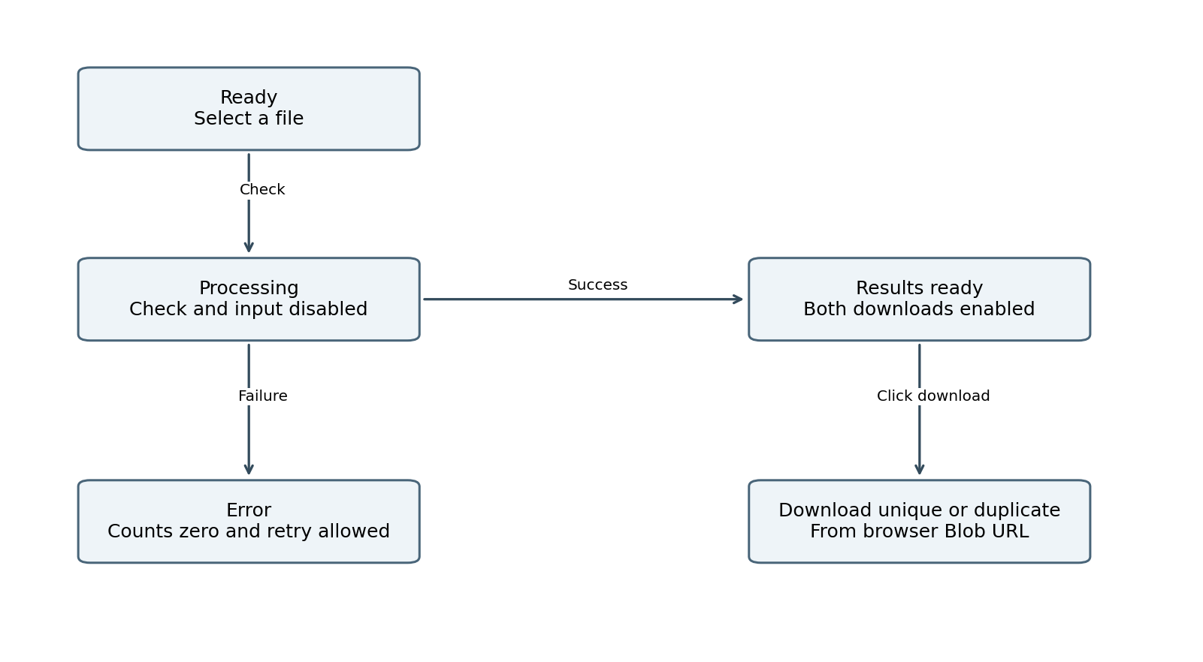
Figure 4 Browser states during one processing cycle
Submitting the form prevents normal navigation. JavaScript clears old results, checks that a nonempty .xlsx file is selected, enforces the client size limit and confirms JSZip loaded. It disables Check and the file picker while sending FormData with a part named file. It lets the browser set the multipart Content-Type and boundary.
For a successful response, readCount parses the count headers as nonnegative safe integers. JSZip loads the response ArrayBuffer, locates both expected filenames and extracts their Blob contents. Object URLs are created, counters are updated and both download buttons are enabled. The current code does not independently verify that total equals unique plus duplicates.
A download click creates a temporary anchor with a Blob URL and a fixed download filename. It uses bytes already in browser memory. Changing the selected file resets counters and disables old downloads; clearResults revokes old URLs. pagehide also clears results, so returning through browser history may require checking again.
Errors are displayed using textContent. A finally block re-enables the picker and Check. There is no explicit request timeout or cancellation control. CDN failure prevents ZIP extraction; self-hosting JSZip would remove that runtime internet dependency. Browser memory includes the ZIP data and both extracted workbooks.

Errors and troubleshooting
ApiExceptionHandler is a @RestControllerAdvice. Spring invokes its @ExceptionHandler methods when request handling fails. The API returns ProblemDetail-style bodies with a status and readable detail rather than leaking a stack trace to the browser.
Failure | Intended response
InvalidExcelException | 400 with the validation message
Missing file part | 400 indicating that the file field is required
Unreadable multipart request | 400
Upload size exceeded | 413 with file and request limits
Missing static resource | 404 after adding the NoResourceFoundException handler
ErrorResponseException | Use its provided error body and status
Unexpected exception | 500 with a generic processing failure message

The supplied general handler logs the exception’s simple class name, without raw email data. This reduces accidental exposure but provides little debugging context. A later improvement is structured diagnostics with a correlation ID and carefully controlled stack traces, avoiding workbook contents and addresses in logs.

The NoResourceFoundException seen during development
A missing page or static asset can raise NoResourceFoundException. With only a broad generic handler, it was logged as an unexpected processing failure. The added specific handler returns 404. A missing favicon is possible, but the logged exception name alone does not identify which URL failed.
- Ensure index.html is inside src/main/resources/static, not the Java package.
- Stop the app, run a clean package, and check that target/classes/static/index.html exists.
- Restart and try http://localhost:8082/index.html and then http://localhost:8082/.
- Use browser Network tools to identify a failed URL and its response. Check the actual request before changing Java logic.
The error mapping is not yet comprehensive for every Spring MVC exception. For example, unsupported methods or media types need explicit verification; a broad handler may turn some framework errors into 500. Extending ResponseEntityExceptionHandler is a possible improvement. Do not claim all HTTP edge cases are tested.

Collections and design decisions
Structure | Role | Why it fits
HashSet<String> | Previously seen normalized addresses | Expected constant-time membership and insertion; no frequency data needed.
ArrayList<EmailEntry> | Input and ordered output groups | Sequential iteration and amortized constant-time append.
Immutable List copies | Reader and result boundaries | Prevent structural modification by callers.
byte[] and byte streams | Excel and ZIP response buffers | Simple in-memory transport with explicit memory cost.
HashMap in a test | Named ZIP entry lookup | Test helper only; not the production deduplication algorithm.

Principles that are actually present
Layered architecture separates HTTP, orchestration and file-processing responsibilities. Constructor dependency injection makes collaborators explicit and permits tests to construct the service directly. Single responsibility keeps Excel parsing, classification and output formatting in separate classes. Model records act as data transfer objects, and centralized exception translation keeps HTTP errors out of the algorithm.
EmailProcessingService provides a small facade over the three processing components: callers ask it to process an upload rather than coordinating the individual steps. That is a useful facade-like role, but it is not evidence of every GoF pattern. The current project has no Strategy interface, Repository, Observer, event bus or database Unit of Work. Spring’s default singleton bean scope is also different from writing a GoF Singleton class.

Alternatives and tradeoffs
A LinkedHashSet could preserve distinct-key order, but this tool already needs full EmailEntry lists and separate repeated occurrences. A HashMap<String,Integer> would be appropriate for frequency counts. A two-pass map approach would be needed if the duplicate report must contain every member of a repeated group, including its first occurrence.
A naive nested scan or repeated List.contains can require quadratic comparisons. Sorting can group equal values in O(n log n) comparisons but changes order unless extra work preserves it. Hash-based classification gives a direct pass and preserves output encounter order using lists.
MySQL would add deployment and data-retention concerns without benefiting this one-upload computation. A database becomes appropriate for durable job status, user history, audit records or cross-file deduplication with defined retention rules.

Time and space complexity
Let n be accepted nonblank email entries, u distinct normalized addresses, d repeated occurrences, and L maximum processed address length. Then n = u + d. Let R be traversed first-sheet row positions, W the loaded workbook footprint, X generated workbook memory and B the archive and serialization buffers. Skipped rows mean R can exceed n.
Stage | Time model | Additional memory
Normalize and validate | O(R + nL) for row work under bounded column checks; validator details vary | O(nL) for accepted strings and records, plus loaded workbook W
HashSet classification | Expected O(nL); O(n) when email lengths are treated as bounded | O(u) set references plus O(n) output references
List.copyOf boundaries | O(n) total element references copied | O(n) additional references
Workbook read | Depends on expanded workbook structure, cells, styles and ZIP/XML parsing | W; not bounded by n alone
Workbook and ZIP write | O(n) logical output rows plus serialization and compression work | X + B plus retained model lists
Browser extraction | Depends on archive bytes and decompressed workbook sizes | ZIP data and extracted Blobs

Why expected linear is the right algorithm claim
HashSet insertion is expected constant time when hashes are well distributed, excluding variable-length string processing. Hashing or comparing a fresh email can inspect O(L) characters. Thus expected O(nL) is the precise working model, commonly shortened to O(n) for bounded email lengths. ArrayList resizing is amortized across appends, not constant time on every individual append.
Hash collisions mean O(1) is not an unconditional worst-case guarantee. Java’s implementation can treeify sufficiently large collision buckets, but an interview answer should state the expected-case assumption rather than promise universal constant-time behavior. A simple collision-chain model can degrade to O(n²L); that is not a precise bound for every JDK implementation path.

Whole application memory and performance
A useful upper accounting model is O(W + nL + X + B), with browser memory considered separately. List copies share entry objects, but byte-array copies duplicate bytes. Some allocations occur in different phases; the formula is an accounting model, not a measured simultaneous peak. Concurrent requests multiply retained per-request data.
The 254-character rule applies after normalization; oversized input strings still have to be read and normalized before rejection. The full request cannot be described solely as O(n) independent of workbook size: extra sheets, styles and compression affect cost. No latency, heap benchmark or production throughput measurement has been recorded.

Testing and expected results

Four supplied automated tests
Test class | Scenario and assertion
EmailDeduplicatorTest | Four entries containing three occurrences of one address: unique 2, duplicates 2, total 4; assert output order and source rows.
EmailDeduplicatorTest | Two distinct entries: unique 2 and duplicates empty.
EmailProcessingServiceTest | In-memory workbook with case and whitespace variants: process through real reader, deduplicator and writer; total 3, unique 2, duplicates 1. Inspect both ZIP entries and workbook contents.
EmailProcessingServiceTest | Invalid email text: reader throws InvalidExcelException and identifies row 2.

The service test constructs components directly with a ValidatorFactory and MockMultipartFile. It exercises integration between Java components and POI, but it does not test HTTP routing, the browser, multipart configuration or a running Spring application. The supplied tests have not yet been confirmed as executed successfully for this project.

The 5000 email sample
email_test_5000.xlsx contains 5,000 email data rows, excluding the Email header. Its expected output is 4,000 unique addresses and 1,000 duplicate occurrences. Exactly 1,000 identities appear twice and 3,000 appear once. Some repeated rows contain uppercase text and surrounding whitespace to exercise normalization. All addresses use example.com.
After processing, the unique workbook should have 4,001 rows including its header and the duplicate workbook 1,001 rows including its header. Their Source Row values must point back to the input; counts alone are not sufficient to prove correctness.

Next meaningful test coverage
- Reader boundaries: missing or duplicate header, header-only sheet, blank rows, numeric/formula cells, oversized input, extra columns and row limits.
- Counting semantics: one address repeated many times, all unique, and mixed-case duplicates with original source order.
- HTTP contract: multipart file binding, ZIP content type, count headers, missing part, 413 and 404 behavior.
- Browser behavior: failed requests clear stale downloads, changing file resets results, offline JSZip failure and zero duplicates.
- Resource behavior: large or highly compressed workbooks and concurrent requests, using measurements rather than assumptions.

Running and diagnosing the tool

A complete local verification sequence
- Open the project folder containing pom.xml in IntelliJ. Select Java 21 for the SDK and Maven runtime; reload dependencies.
- Run the Maven test/verify lifecycle and inspect the executed-test summary. Fix failures before relying on the UI.
- Run EmailToolApplication and confirm the server starts on 127.0.0.1:8082.
- Open http://localhost:8082/. Select email_test_5000.xlsx and click Check.
- Confirm 5000 processed, 4000 unique and 1000 duplicates. Download both files and inspect headers, counts and sample Source Row values.
- Try a workbook with one invalid email. Confirm a readable error and disabled download buttons; correct the workbook and retry.

Testing the API without the page
In Postman use POST http://localhost:8082/api/emails/deduplicate. Choose Body → form-data; set key file to type File and choose the workbook. Let Postman generate the multipart boundary. Save a successful response as a ZIP and inspect its two entries.
curl.exe --fail-with-body -D response-headers.txt `
-F "file=@C:\Users\Administrator\Downloads\emails.xlsx" `
-o email-results.zip `
http://localhost:8082/api/emails/deduplicate
The backticks above are PowerShell line continuations. Inspect the status and headers before extracting email-results.zip: an error body may be JSON even though the chosen output filename ends in .zip.

Common failures
Symptom | What to check
Port already in use | Stop the other process or change server.port and the browser URL.
404 for the page | Static resource path, packaged index.html and requested URL.
400 on upload | File part name, Email header, cell types and validation detail.
413 | 5 MiB file and 6 MB total multipart request limits.
Counts differ from expectation | Blank rows are skipped; duplicates exclude the first occurrence; matching uses normalized text.
Check succeeds but extraction fails | JSZip availability, response type and exact ZIP entry filenames.

Interview explanation and future work

A concise project explanation
“I built a Java 21 and Spring Boot tool that accepts an Excel file through a REST endpoint and a small upload page. It validates the Email column, normalizes addresses and uses a HashSet to identify repeated occurrences in one expected-linear pass. I preserve source order and row numbers with ArrayLists and records. Apache POI generates unique and duplicate Excel reports, returned together as a ZIP and exposed through two download buttons. I separated parsing, business logic and output generation so the components can be tested independently.”

Questions worth practicing
Why a set? I need a membership answer rather than a frequency. add both checks and records the key. Why two lists? They preserve the original row order in each report. Why normalize? It implements the agreed case-insensitive matching policy. Why validate on the server? Client checks can be bypassed. Why no database? The current requirement has no durable state.
What is the complexity? Expected O(n) classification for bounded address length, O(nL) when character work is explicit; set memory O(u) and retained lists O(n), plus workbook and byte-buffer memory. What does duplicate mean? Every occurrence after the first. What is unproven? End-to-end correctness, throughput and memory usage still need executed tests and measurements.

Improvements in a sensible order
- Complete and execute boundary, HTTP and frontend tests. Record verified results and commands in the README.
- Improve framework error mapping and safe diagnostics; self-host the frontend dependency and add timeout/cancellation behavior.
- For larger workbooks, investigate POI’s event-based reader and SXSSF writer. Streaming reduces workbook memory, but the membership set still grows with distinct emails. Temporary files require cleanup.
- For slow workloads, introduce background jobs with a status API, bounded workers, expiring downloads and documented retention. Add MySQL only when durable metadata is actually required.
- Before public deployment, add authentication, authorization, HTTPS, upload and concurrency controls, dependency review and privacy-aware retention. The current loopback-only utility is not a production multiuser service.

Technical references
Java HashSet API and expected constant-time assumptions: https://docs.oracle.com/en/java/javase/21/docs/api/java.base/java/util/HashSet.html
Apache POI spreadsheet models and streaming options: https://poi.apache.org/components/spreadsheet/ and https://poi.apache.org/components/spreadsheet/limitations.html
Spring static web content guide: https://spring.io/guides/gs/serving-web-content
JSZip documentation: https://stuk.github.io/jszip/documentation/

