ReconBridge project requirements and architecture
  - Settlement reconciliation and exception management
Prepared for Suyog Kulkarni | 20 October 2026 | Version 1.0
We will build a Java backend that compares internal payment records, processor settlement reports and bank credits, then explains or escalates differences. This document defines the proposed scope, data model, control flows, Kafka reliability design and development milestones. It is a design baseline; no ReconBridge features or performance results are claimed as implemented.

Problem statement
Finance and operations teams cannot establish that expected settlement money arrived by looking only at successful payment requests. The three sources use different formats and identifiers, arrive at different times, and may report individual payments or aggregated credits. Fees, duplicates and missing records create discrepancies that manual spreadsheet comparisons can overlook. Teams need repeatable matching, traceable evidence and controlled resolution without changing the original records.

How we will solve it
Import and normalize the three source types into tenant scoped, immutable financial records.
Match payments to settlement lines, then reconcile settlement batch totals against bank credits.
Create evidence backed cases for missing, ambiguous or mismatched records and require independent approval for manual resolution.
Publish committed outcomes through an outbox to Kafka so notifications and reporting can retry independently.

What this project demonstrates
Java collections and money modelling; SQL and indexes; Spring Batch restartability; Spring Security and Keycloak; Kafka producers and consumers; transaction boundaries; idempotency; testable matching strategies; operational recovery.

Reading map
Pages 2–5 explain scope and processing. Pages 6–7 define the ER model. Pages 8–10 cover messaging, approvals and code boundaries. Pages 11–14 define API contracts, verification, Kubernetes deployment and the build sequence.

Business example and delivery scope
Assume the processor settles two INR payments as one bank credit. Amounts below are shown in rupees for readability; storage uses integer minor units.
Payment | Gross INR | Fee INR | Net INR
P101 | 1,000 | 20 | 980
P102 | 2,000 | 40 | 1,960
Batch B01 | 3,000 | 60 | 2,940

A bank credit of INR 2,940 with batch reference B01 is consistent with the processor net total. A credit of INR 2,900 leaves a discrepancy of INR 40. An absent credit before its expected date is pending; it becomes overdue only after the configured grace period. Payment success and bank settlement are separate facts.

First usable release
Support one tenant at a time per run, INR, three documented CSV schemas, exact payment references, explicit settlement batch references, exact gross and fee arithmetic, and one bank credit per settlement batch. Import data, persist results, investigate cases and generate a reconciliation summary through REST APIs and Postman.

Boundaries
ReconBridge detects and explains discrepancies. It does not move money, authorize payments, correct bank balances or silently repair LedgerFlow records. It can consume synthetic LedgerFlow exports but must run independently using bundled fixtures.
Included next | Deferred until the core is reliable
Kafka outcome events and an idempotent consumer | Automatic live bank or processor connections
Maker checker resolution and audit history | Refund, chargeback and reserve accounting
Restartable imports and reconciliation runs | FX conversion and multi currency netting
File and row deduplication | Partial settlements and arbitrary subset matching

Definition of a useful demo
An interviewer imports three fixture files, runs reconciliation, sees an exact match and a planted discrepancy, rejects self approval, and observes an event consumer recover from duplicate delivery. The demo includes the expected answer and reproducible commands.

System architecture and deployment boundaries
Start with one Spring Boot codebase organized into modules. The API and worker may run in one process initially; the diagram shows logical responsibilities, not a requirement for separate microservices.
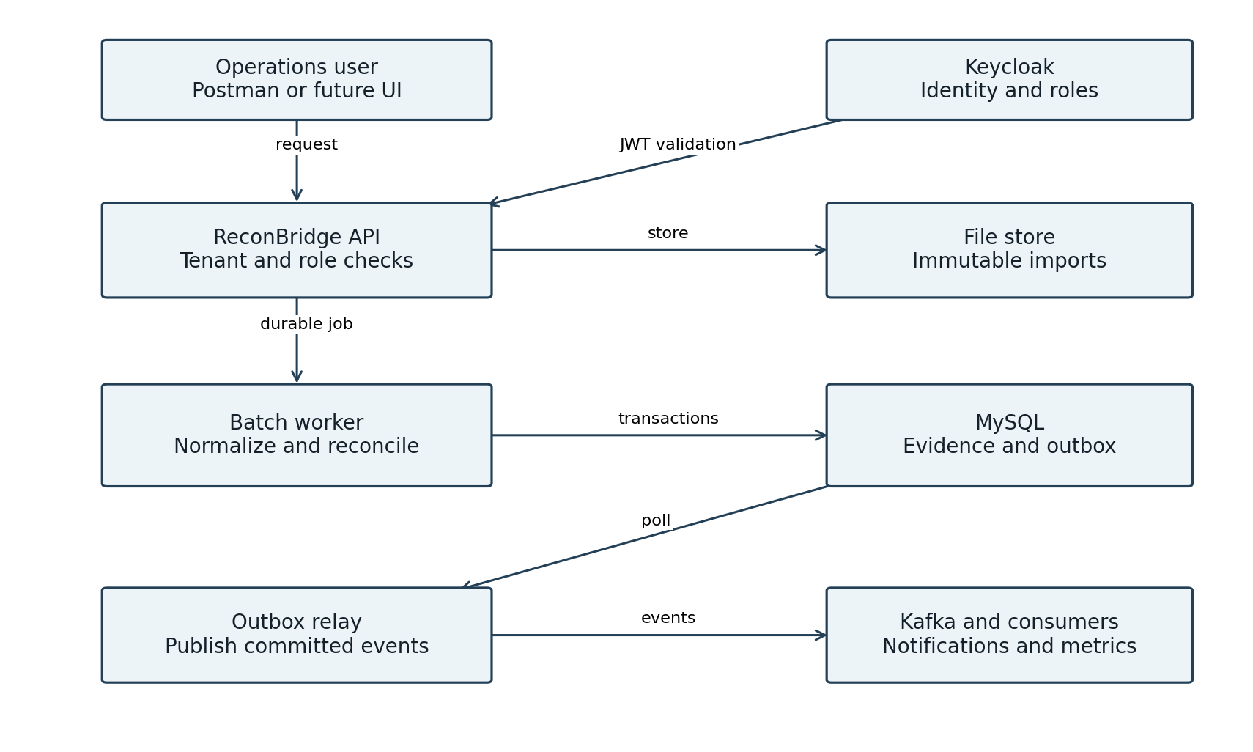
Figure 1 Logical architecture with durable data and event boundaries
MySQL is the authoritative store for imports, match allocations, cases and outbox events. File bytes live in a persistent local directory for development; a future object store can replace it through a storage interface. Kafka carries small outcome events, not uploaded CSV files.

Local deployment
Use the existing JDK 21 and local MySQL/Keycloak installation. Introduce a local Kafka broker when the event milestone starts; Docker Compose is the preferred reproducible lab option. API port 8083 is proposed to avoid existing applications. Use reconbridge and reconbridge_test schemas and separate least privilege accounts. Pin compatible framework and broker versions when creating the POM and Compose files.

Import flow and restart behaviour
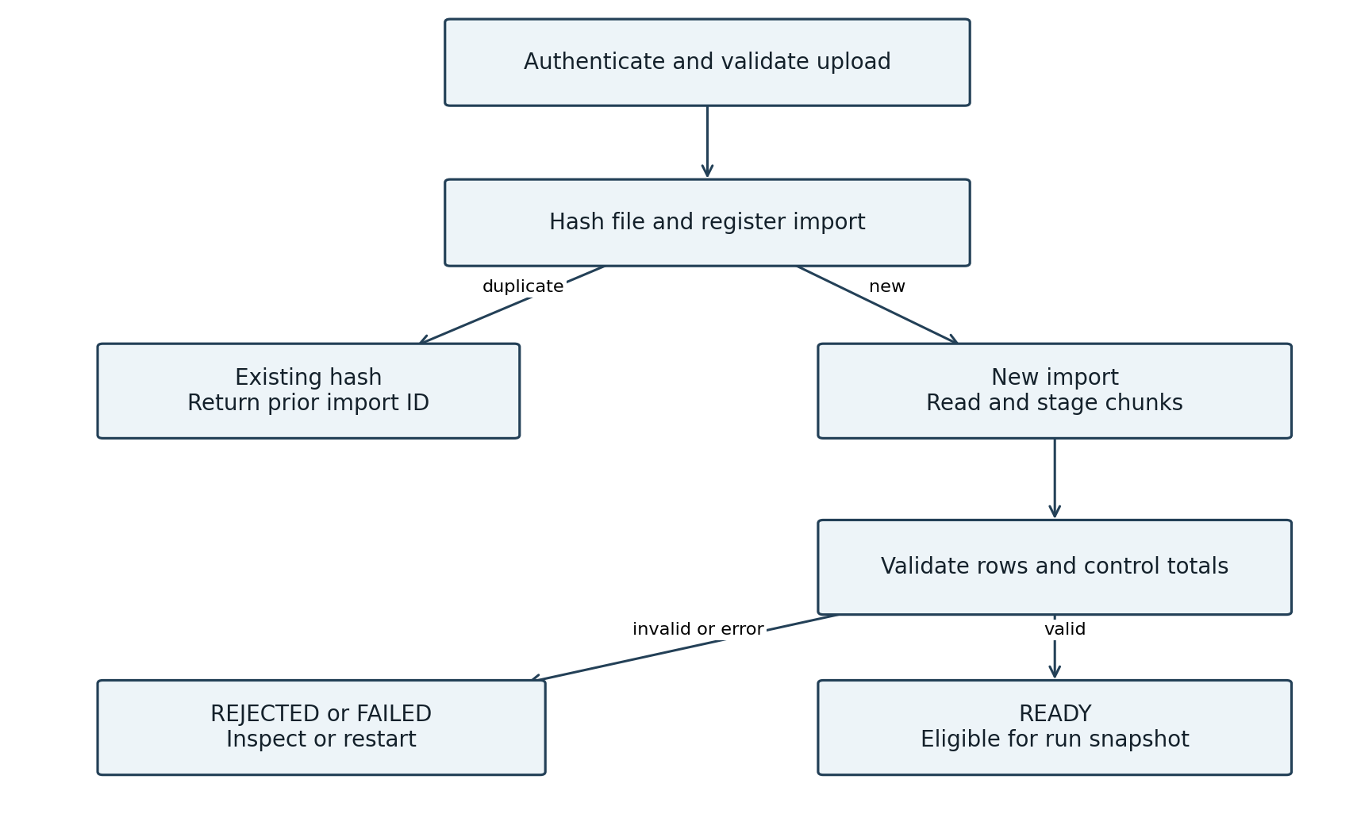
Figure 2 Duplicate aware import flow with a readiness gate
Upload returns 202 with an import ID after durable acceptance. A streaming SHA 256 digest identifies repeated file content within a tenant and source type. Retain original bytes, adapter version and line numbers. A unique source record ID catches duplicates across different files; identical repeats are recorded as duplicates, while conflicting content creates an import error.
Spring Batch reads, normalizes and writes bounded chunks within transactions. Persist batch metadata and restart checkpoints; reuse the same import/job identity on recovery. An import becomes READY only when all rows and configured control totals pass validation. Failed or rejected staging rows cannot participate in reconciliation. [1]

Failure rules
Malformed rows produce a rejection report rather than silent skips. Transient I/O or database errors are retryable within limits. File storage precedes import registration; an interrupted upload can leave an unreferenced file, which a cleanup job removes. A published READY marker and its outbox event are committed together. Never delete evidence to make a retry pass.

Matching flow and practical algorithms
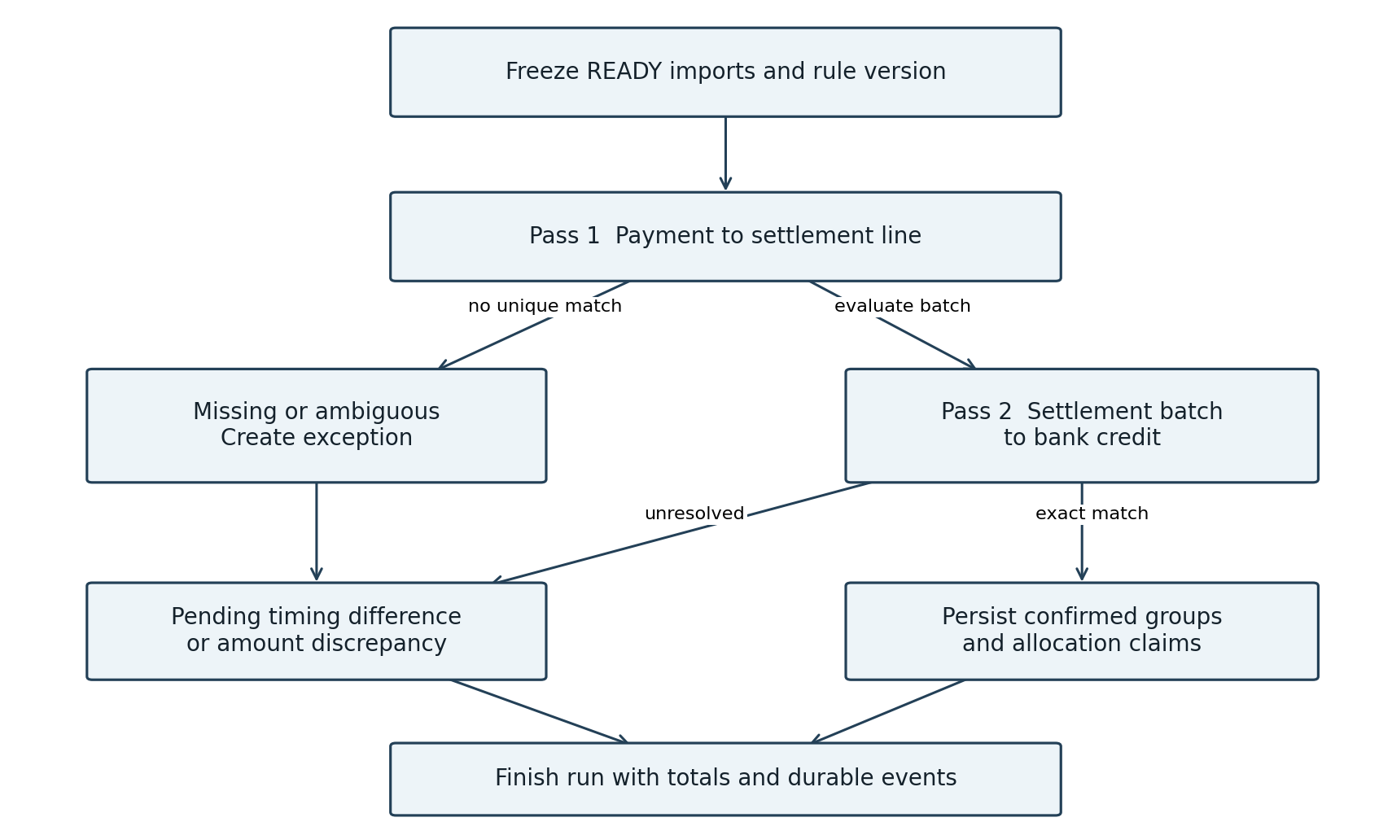
Figure 3 Two matching passes and explicit unresolved outcomes
Pass 1 uses tenant, provider and payment reference to select settlement lines, then checks currency and gross amount. More than one plausible candidate is ambiguous. Pass 2 sums processor net amounts by batch and compares the declared batch total and bank credit. A batch can match the bank while still containing an unresolved payment line; report each pass separately.
Technique | Use and limit
HashMap of key to candidate list | Expected O(n + m) for bounded in memory inputs; preserve duplicates.
Indexed SQL and chunked reads | Default for large datasets; avoid holding the entire file in memory.
Sort and merge | O(n log n + m log m) including sorting; streaming merge for ordered input.
Priority queue | Optional case ordering in a worker; SQL remains the durable case store.

Use long minor units with checked arithmetic, explicit currency and UTC timestamps plus business dates. Initial tolerance is zero. Never force a match using amount alone, a greedy subset sum or a floating point comparison.

Entity relationships for source evidence
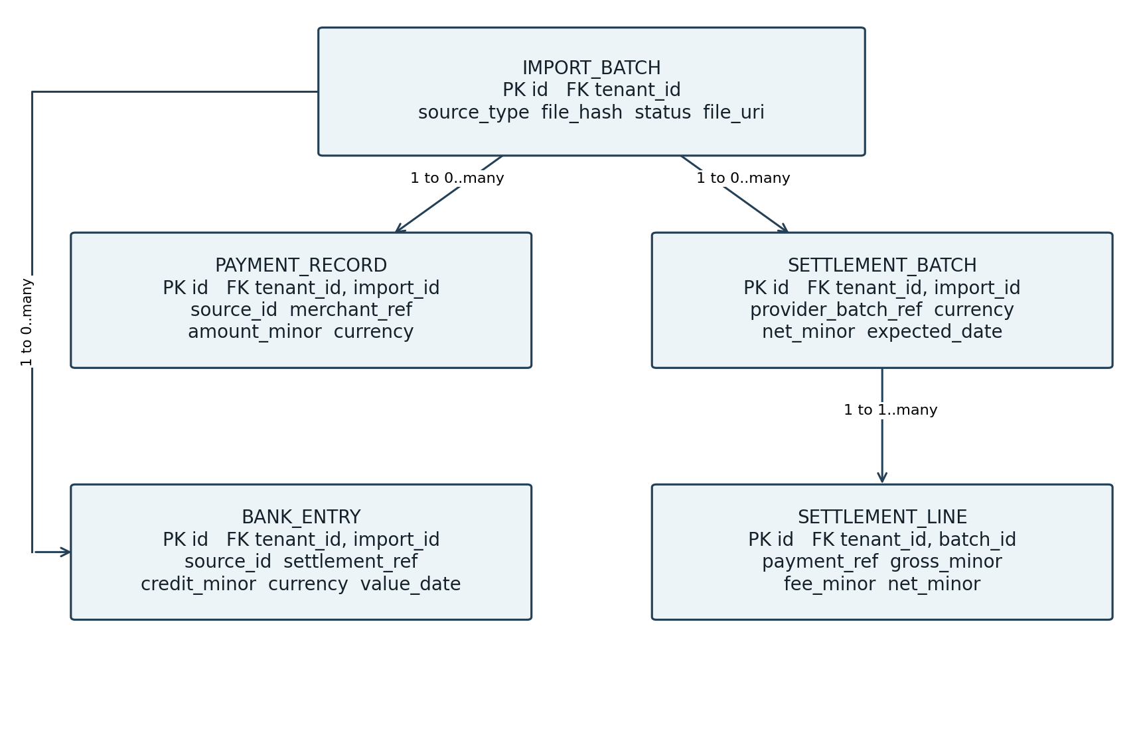
Figure 4 Source evidence ER diagram showing parent to child cardinalities
Each entity belongs to exactly one TENANT; tenant links are omitted from the drawing to keep it readable. IMPORT_BATCH has many child records of its declared source type. IMPORT_ROW stores raw row payload, row number, validation state and error details and links accepted rows to normalized records; it is omitted from this focused view.

Keys and financial fields
Every table uses an immutable ID and tenant_id. Composite foreign keys include tenant_id to prevent cross tenant parent links. Unique keys cover tenant/source/file_hash, tenant/source/source_id, tenant/provider/provider_batch_ref, and tenant/import/row_number. External references are namespaced by provider or bank account where appropriate.
SETTLEMENT_LINE.net_minor equals gross_minor minus fee_minor for the first release. BANK_ENTRY stores account reference, value date, signed amount and direction; only eligible credits enter settlement matching. Retain original source identifiers and payloads. New evidence creates new records rather than overwriting financial history.

Entity relationships for results and control
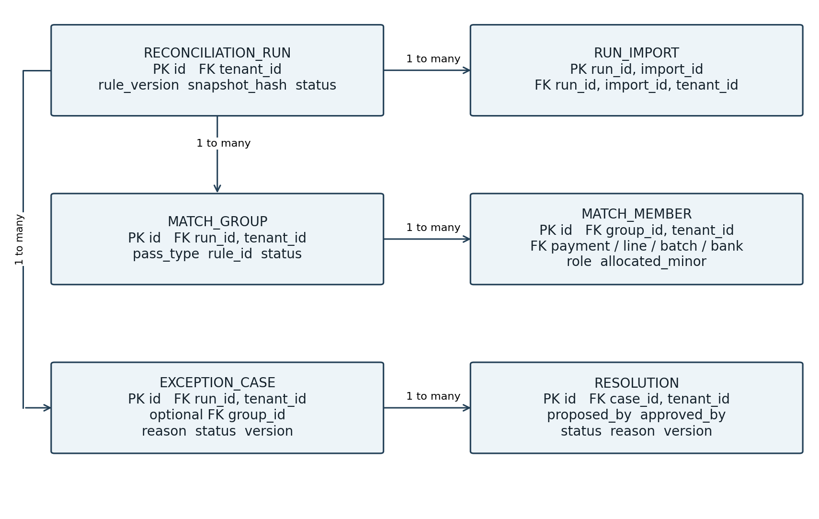
Figure 5 Reconciliation results and review ER diagram
RUN_IMPORT freezes the READY import set. Each MATCH_MEMBER references exactly one typed source via nullable foreign keys plus a database check; its role records payment, settlement line, settlement batch or bank credit. Use real foreign keys rather than an unchecked generic record ID.
ALLOCATION_CLAIM records confirmed ownership of a source per matching pass, with a unique tenant/pass/source identity. This permits a settlement line to participate in payment matching while its parent batch participates in bank matching. Create claims atomically; a concurrent run losing a claim reports a conflict instead of allocating the same item twice.

Supporting tables
TENANT stores tenancy identity; RULE_SET stores immutable rule versions; IMPORT_ROW retains ingestion evidence; CASE_EVIDENCE links cases to typed records. AUDIT_EVENT records actor and transitions. OUTBOX_EVENT stores event ID, aggregate ID, payload version, payload and publish status. CONSUMED_EVENT uses a unique consumer-name/event-ID key. Spring Batch metadata tracks job and step execution. These supporting tables are part of the planned schema, omitted from the two focused ER views.

Kafka delivery and transaction sequence
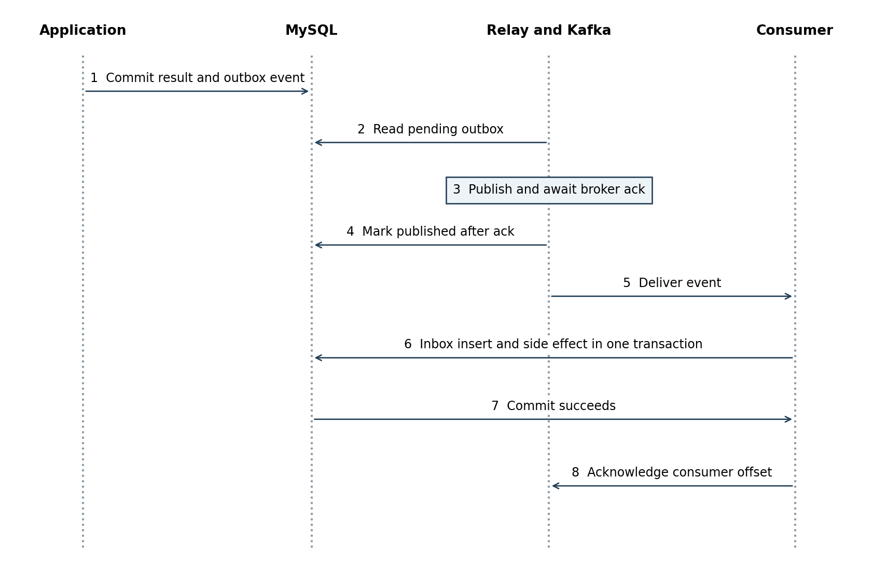
Figure 6 Outbox publication and duplicate safe consumer processing
The application commits the result and OUTBOX_EVENT in the same MySQL transaction. A polling relay publishes it, waits for acknowledgement, then marks it published. A crash between those last two steps causes a duplicate, not an assumed exactly once delivery. Each consumer inserts CONSUMED_EVENT and its database effect in one transaction, then acknowledges its Kafka offset. [2]

Topics and event contract
Start with reconbridge.run-events.v1 and reconbridge.case-events.v1. Key messages by tenant ID plus aggregate ID. Include eventId, eventType, schemaVersion, tenantId, aggregateId, aggregateVersion, occurredAt and correlationId. Consumers such as reporting and notification planning use separate groups; instances within a group share work. Partition ordering does not imply ordering across topics or aggregates.
Use bounded retry with backoff and a dead letter topic after exhaustion. Replay requires operator authorization and preserves the original event ID. Version checks reject stale updates; projections reload authoritative state when a version gap matters. External email requires its own durable delivery queue and deduplication because a MySQL transaction cannot atomically commit a remote email.
Begin with a polling relay. Debezium CDC is a later replacement, not a second simultaneous publisher. Its outbox router exposes unique event IDs that can support duplicate removal. [3]

Exception workflow and security controls
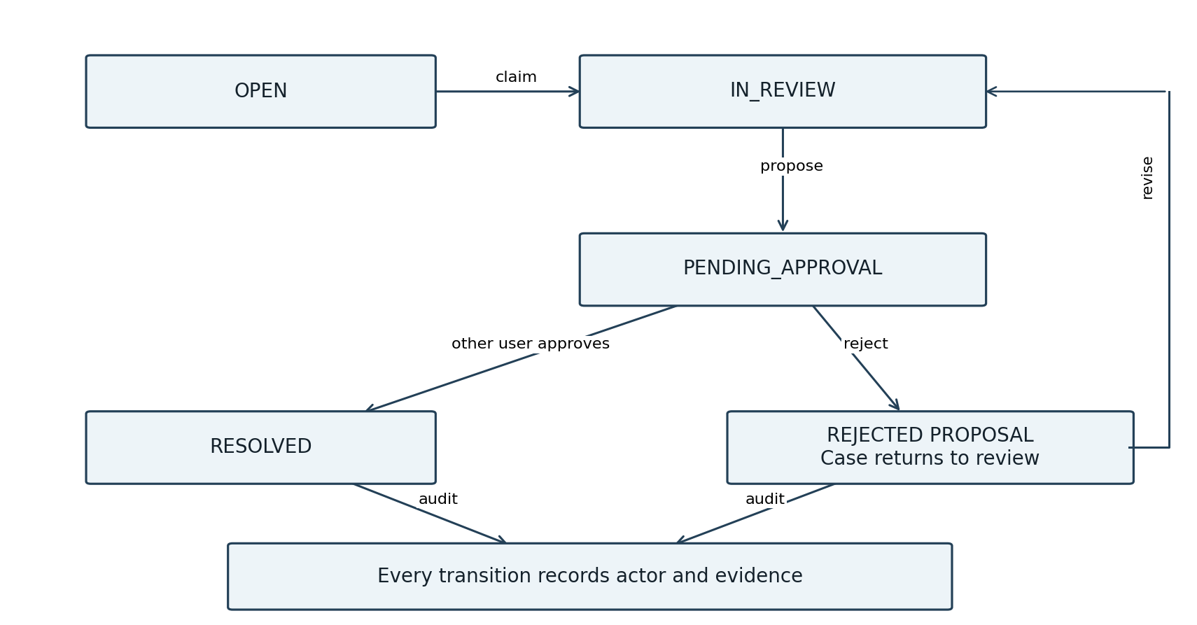
Figure 7 Case workflow with independent approval and audit
Role | Allowed action
Importer | Upload and inspect imports within its tenant.
Analyst | Claim cases, attach evidence and propose a resolution.
Approver | Approve or reject another person’s proposal.
Auditor | Read records, decisions and audit history.

Spring Security validates issuer, signature, expiry, API audience and administrator controlled tenant_id. Resolve tenancy from the verified token, never from a request body override. Compare authenticated subject IDs to block self approval even if one person holds both roles. Enforce transitions in the service layer, not only at the endpoint.
Use optimistic version checks for case updates. Approval records the proposed version and atomically commits the resolution, audit event and outbox event. It explains or closes the case; it does not fabricate a bank credit. A future financial adjustment requires a separate explicit business operation.

Code boundaries and design patterns
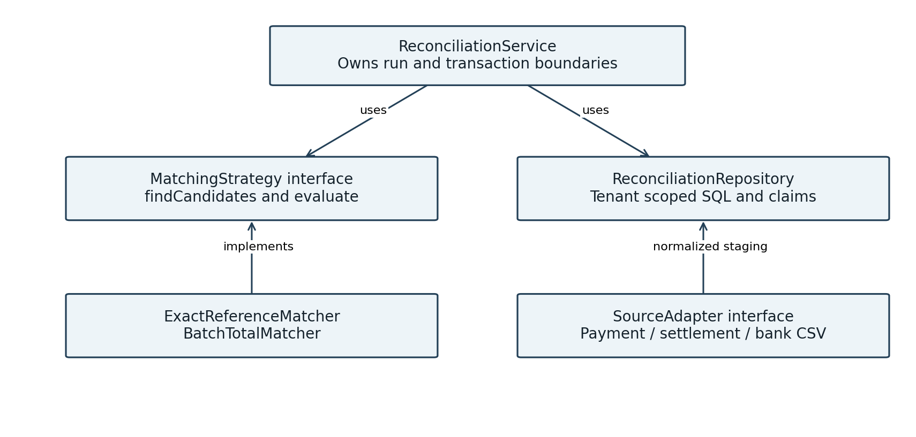
Figure 8 Main code abstractions and dependency direction
Use packages com.suyog.reconbridge.ingestion, reconciliation, exceptions, security and messaging. Each feature separates API DTOs, application services, domain rules and persistence adapters. Domain matching code should be executable without starting Spring or Kafka.
Pattern or Java feature | Concrete responsibility
Strategy | Exact reference and batch total matchers with immutable rule configuration.
Adapter | Parse payment, processor and bank formats into normalized records.
Repository | Tenant scoped SQL, evidence lookup and allocation constraints.
State machine | Validate import, run and case lifecycle transitions explicitly.
Records and collections | Immutable Money, MatchKey and CandidateResult values; maps and sets.
Managed executors | Bound concurrent jobs; avoid shared mutable matching state.

Do not wrap the whole reconciliation run in one transaction. Persist bounded work units and restart checkpoints. Use a run identity derived from tenant, frozen input set and rule version; repeated requests return the existing run. A revised input set creates a new run, while confirmed allocation claims prevent duplicate effects.

API contracts and acceptance scenarios
Endpoint | Contract
POST /api/imports | Multipart file and declared source type; 202 with import ID.
GET /api/imports/{id} | State, row totals and validation error summary.
POST /api/reconciliation-runs | READY import IDs and rule version; 202 with run ID.
GET /api/reconciliation-runs/{id} | Per pass match counts, totals and unresolved items.
GET /api/exceptions | Tenant scoped filtered and paginated case list.
POST /api/exceptions/{id}/proposals | Evidence references, reason and expected case version.
POST /api/proposals/{id}/approve | Independent actor and expected proposal version.
POST /api/proposals/{id}/reject | Reason required; return case to review.

Use 400 for invalid input, 401 for invalid or absent credentials, 403 for insufficient permission or self approval, 404 for missing or foreign tenant IDs, and 409 for state/version or idempotency conflicts. Error responses include a safe code and correlation ID; credentials and raw files do not appear in logs.

Acceptance checks
- Two payments settle as one credit: both payment lines and the batch reconcile, with recorded evidence.
- A bank shortfall produces the exact minor unit difference, with no automatic ledger correction.
- Duplicate file and source row imports do not duplicate normalized data or financial allocations.
- Ambiguous references remain unresolved; missing late data stays pending until the grace deadline.
- Cross tenant access and self approval are rejected; every approved resolution preserves its original evidence.

Initial input contracts
Payment CSV: source_id, provider, payment_ref, merchant_ref, amount_minor, currency, paid_at. Settlement CSV: source_id, provider, batch_ref, payment_ref, gross_minor, fee_minor, net_minor, currency, expected_date. Bank CSV: source_id, account_ref, settlement_ref, credit_minor, currency, value_date. Define UTF 8 encoding, header names, date formats and duplicate rules before coding adapters.

Verification and operational learning
Test layer | What must be demonstrated
Domain unit tests | Money overflow, matching ambiguity, fee arithmetic, currency checks and state rules.
Database integration | Flyway schema, tenant foreign keys, uniqueness, rollback and concurrent allocation.
Batch restart tests | Crash after a committed chunk; restart without missing or duplicated records.
Kafka integration | Duplicate delivery; database commit before offset acknowledgement; unavailable broker.
Security tests | Invalid audience/tenant, role restrictions, self approval and foreign record lookup.
System demonstration | Three fixture files, expected reconciliation answer and scripted failure recovery.

Use Testcontainers for isolated MySQL and Kafka tests once a supported container runtime is available. Existing local services can support manual testing, but automated tests must not connect to the application database. Inject Clock for due dates and use deterministic barriers for concurrent tests instead of arbitrary sleeps.

Observability
Record import throughput, rejected rows, match rates per pass, pending case age, job duration, outbox backlog age, publish failures and consumer lag. Propagate correlation IDs. Avoid tenant or payment IDs as unbounded metric labels; keep such identifiers in authorized logs or traces.

Performance experiment
Generate 10,000 deterministic synthetic payments first, then expand to 100,000 with seeded discrepancies. Record dataset shape, JVM heap, hardware, chunk size, SQL plans, peak memory and run duration. Measure before publishing throughput claims. Demonstrate that larger files do not require loading all rows at once.

Recovery exercise
Stop Kafka after a result commits: the outbox must remain pending. Restart it and observe publication. Replay an event and verify one consumer database effect. Stop a batch worker after a checkpoint and verify a resumed import reaches the same READY totals as an uninterrupted run.

Kubernetes deployment and learning milestone
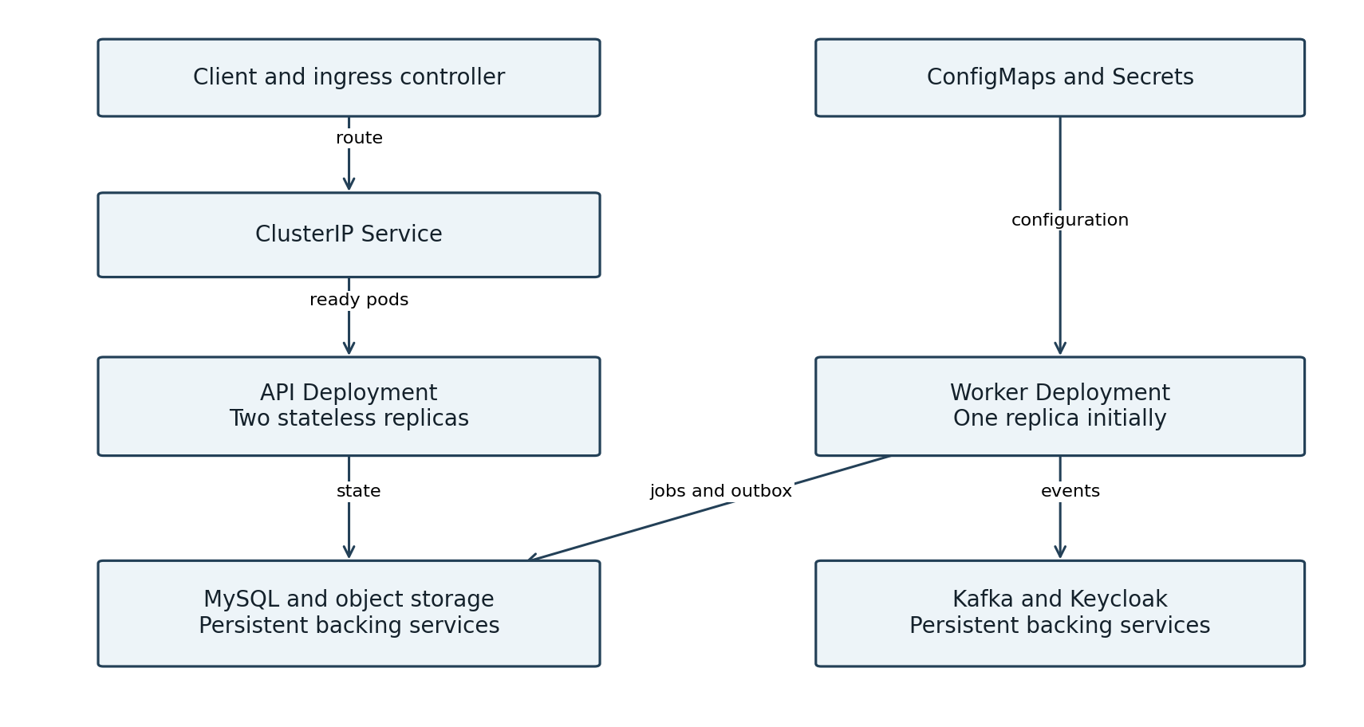
Figure 9 Target Kubernetes application topology with external backing services
Use a local kind or minikube cluster after the Docker Compose demo works. Deploy the same application image with API and worker profiles. API pods accept requests; the worker owns batch dispatch and outbox publication. Disable automatic batch execution in API replicas. All pods must use reachable service addresses; localhost inside a pod refers to that pod.
Keep database, Kafka, Keycloak and file storage outside the application pods. For a local lab they can use separate persistent installations; a later in cluster exercise needs dedicated stateful workloads and volumes. Use shared object storage before multiple API replicas so uploaded files survive rescheduling. Keep the token issuer consistent between browser login and pod validation.
Configure startup, readiness and liveness probes, resource requests and limits, graceful shutdown and rolling updates. Readiness controls traffic eligibility; liveness should not restart healthy pods merely because a shared database or Kafka is unavailable. Secrets are sensitive configuration, not automatic encryption; keep values out of Git and restrict access. [4]
Begin with one worker. Before scaling, implement database job leases with expiry, fencing or guarded updates, and concurrency tests for claim ownership. An HPA needs metrics and resource settings; extra consumers are useful only up to available partitions. Kubernetes does not supply business idempotency or repair lost in memory work.

Technology roadmap and first implementation step
Technology | Why we will learn it | Phase
Spring Batch | Chunk transactions, checkpoints and restartable jobs. | 2
Apache Kafka and Spring Kafka | Partitions, groups, offsets, retries and event delivery. | 5
Outbox and consumer inbox | Coordinate database state and messages with duplicate tolerance. | 5
Docker Compose and Testcontainers | Reproducible infrastructure and isolated integration tests. | 2–5
Micrometer and Prometheus | Expose operational metrics; add Grafana dashboards later. | 6
Kubernetes | Deployments, Services, probes, resources and rolling updates. | 7
Debezium CDC | Optional evolution from polling to change capture. | Later

Kafka is the selected messaging learning goal. RabbitMQ would also suit task dispatch, but Kafka offers event retention and independent replay useful for this portfolio. We will not add both. Kubernetes is included as a dedicated deployment milestone after the local Kafka flow works. Redis remains deferred until a measured need appears.

Build sequence
1. Domain foundation: Money, SourceType, MatchKey, matching outcomes and pure Java tests.
2. Persistence and imports: migrations, file contracts, chunk processing and readiness gate.
3. Reconciliation: exact matching, batch aggregation, frozen runs and allocation claims.
4. Security and cases: tenant enforcement, proposals, independent approval and audit.
5. Messaging: transactional outbox, Kafka consumer, duplicate tests and dead letter recovery.
6. Portfolio release: metrics, container setup, CI, Postman collection and measured demo.
7. Kubernetes lab: deploy the app, verify recovery, rolling updates and safe scaling.
Begin with project name reconbridge, package com.suyog.reconbridge and JDK 21. Before exposing import or reconciliation endpoints, complete tenant validation. The first coding milestone is the domain model and tests for the INR 2,940 example; no Kafka broker is needed for that milestone. Choose a compatible supported Spring Boot release and let its dependency management align Spring Batch and Spring Kafka when scaffolding.

Primary technical references
[1] Spring Batch — Chunk oriented processing
https://docs.spring.io/spring-batch/reference/step/chunk-oriented-processing.html
[2] Apache Kafka — Message delivery semantics
https://kafka.apache.org/documentation/#semantics
[3] Debezium — Outbox Event Router
https://debezium.io/documentation/reference/stable/transformations/outbox-event-router.html
[4] Kubernetes — Configure liveness readiness and startup probes
https://kubernetes.io/docs/tasks/configure-pod-container/configure-liveness-readiness-startup-probes/
References reviewed on 20 October 2026. Component choices are proposed architecture, not assertions about any bank’s internal implementation.

