A Project Report on
CYBER LAW AND DIGITAL FORENSICS
PS Code:
Domain: Cyber Law and Digital Forensics
Complexity: Intermediate
Submitted in partial fulfilment of the requirements of the course
SEMINAR (24UCYPC201) Laboratory
S.Y. B.Tech Cyber Security, Semester III
Submitted by
Suyog Bandopant Jadhav
PRN: 2125UCSM1010 Roll No.: 10
Under the guidance of
Mr. Madhu Bandari
Assistant Professor, Department of Cyber Security.

Department of Cyber Security
School of Engineering and Technology
Sanjivani University, Kopargaon
Academic Year 2026-2027
CERTIFICATE
This is to certify that the Seminar report entitled “CYBER LAW AND DIGITAL FORENSICS” (PS Code: ) submitted by Suyog Bandopant Jadhav
(PRN: 2125UCSM1010) is a bonafide record of the laboratory project work carried out by him/her under my guidance, in partial fulfilment of the requirements of the course SEMINAR (24UCYPC201) Laboratory, S.Y. B.Tech Cyber Security, during the Academic Year 2026-2027 at the Department of Cyber Security, School of Engineering and Technology, Sanjivani University, Kopargaon. The similarity index of this report is %.

(Signature)  Mr MADHU BANDARI  Subject Teacher | (Signature)  Dr. Chetan D. Bawankar  Head, Department of Cyber Security
Place: Kopargaon
Date: / / 2026
CYBER LAW AND DIGITAL FORENSICS
Student: Suyog Jadhav PRN: 2125UCSM1010 PS Code:

Abstract
Digital technology is now central to both crime and its investigation, but evidence taken from computers, phones and networks is useful only if it is collected lawfully and can be proved authentic in court. This seminar report studies how cyber law and digital forensics work together. It reviews the Indian legal framework, namely the Information Technology Act 2000, the Bharatiya Nyaya Sanhita, the Bharatiya Nagarik Suraksha Sanhita, the Bharatiya Sakshya Adhiniyam 2023 and the Digital Personal Data Protection Act 2023, and maps it to the forensic process of ISO/IEC 27037 and NIST SP 800-86. A small Python tool demonstrates SHA-256 evidence verification and a hash-chained custody log. In testing, an identical copy was verified, a one-bit change was detected, and a tampered custody record was located. The study concludes that lawful authority, hashing and documentation form the base of admissible evidence.
Keywords: cyber law, digital forensics, electronic evidence, chain of custody, SHA-256, Information Technology Act.

1. Introduction and Problem Statement
Online banking, mobile payments, social media and cloud services have moved much of daily life into digital form, and crime has followed. Phishing, ransomware, identity theft, online fraud and data breaches are now routine, and even an ordinary offence usually involves a phone, a laptop or an online account. Two disciplines deal with this situation. Cyber law defines offences, the powers of investigators and the rules for admitting electronic records in court. Digital forensics is the scientific process of identifying, preserving, analysing and presenting digital evidence [1], [2].
Problem statement. Many cases fail not because the crime is unproven but because the evidence is challenged: it was seized without authority, the device was altered during examination, or the original cannot be shown to be unchanged. The problem for this seminar is to study how cyber law and digital forensics together make digital evidence reliable and admissible, and to show with a working demonstration how the integrity of evidence can be proved. A weak link in either discipline can invalidate the whole investigation.
Existing work and gap. Standards such as ISO/IEC 27037 [3], NIST SP 800-86 [1] and RFC 3227 [4] describe how evidence should be handled. Carrier [5] and Casey [6] explain file system analysis and the use of digital evidence, and Garfinkel [2] discusses open research challenges. Tools such as Autopsy, FTK Imager and Volatility automate acquisition and analysis. On the legal side, the IT Act 2000 [7] and the Bharatiya Sakshya Adhiniyam 2023 [8] set the Indian rules, and the Supreme Court has recently upheld the hash-value certificate under Section 63(4) [9]. Most of these sources treat law and technique separately. This report brings them into a single flow (Figure 1.1) and shows how each legal requirement maps to a technical control.
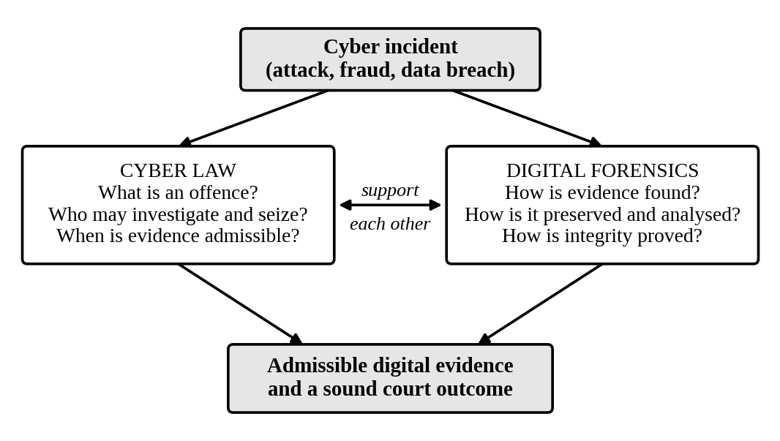
Figure 1.1: Relationship between cyber law and digital forensics

2. Objectives
- To explain the main Indian cyber law provisions relevant to investigation and evidence (IT Act 2000, BNSS 2023, BSA 2023 and DPDP Act 2023).
- To describe the digital forensic process and standards (ISO/IEC 27037, NIST SP 800-86 and RFC 3227) and link each stage to a legal requirement.
- To implement and test a small tool that verifies evidence integrity with SHA-256 and keeps a tamper-evident chain of custody.
- To analyse the main threats to digital evidence and show how the proposed controls reduce them.

3. Methodology and System Design

3.1 System Architecture
The framework used in this seminar has four layers (Figure 3.1). The legal layer decides what may be done and what must be proved. The process layer divides the work into ordered stages. The technical layer lists the tools that carry out each stage, and the output layer produces the report and certificate that a court needs. Each layer depends on the one below it: a perfect technical analysis is of little value if legal authority is missing.
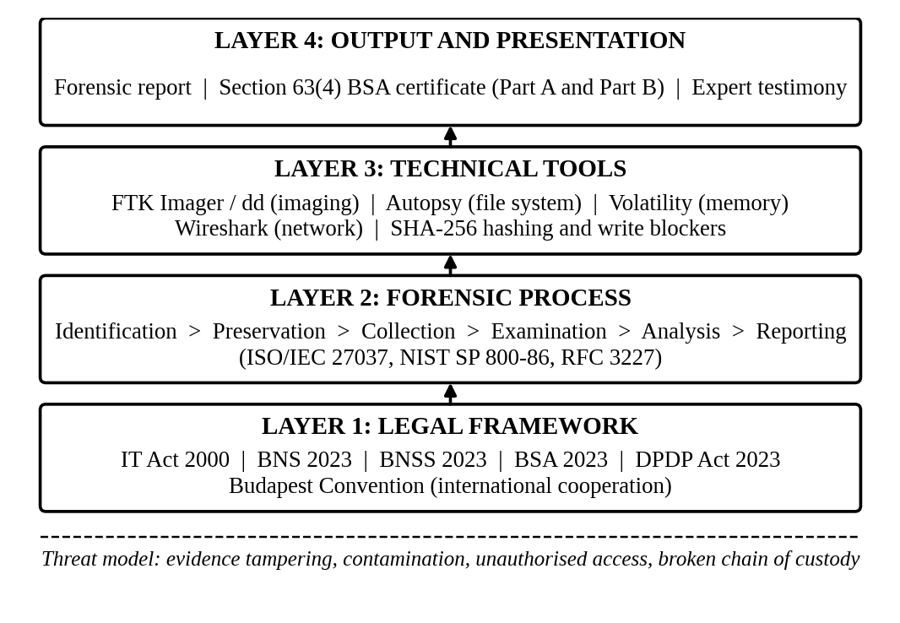
Figure 3.1: Layered framework linking law, process, tools and output

3.2 Legal Framework
Table 3.1 lists the IT Act provisions most often used in investigations [7]. Since 1 July 2024 the Bharatiya Nyaya Sanhita (BNS), the Bharatiya Nagarik Suraksha Sanhita (BNSS) and the Bharatiya Sakshya Adhiniyam (BSA), all of 2023, have replaced the Indian Penal Code, the Code of Criminal Procedure and the Indian Evidence Act respectively [8].
Table 3.1: Key IT Act 2000 provisions and their forensic relevance
Section | Provision | Forensic relevance
43 | Unauthorised access, damage or data theft (civil compensation) | System logs and file timestamps
65 | Tampering with computer source documents | Source code and version history
66 | Computer-related offences (dishonest or fraudulent act under s. 43) | Server, network and access logs
66C, 66D | Identity theft; cheating by personation using a computer resource | Account, IP and payment trails
66E, 67 | Violation of privacy; publishing obscene material electronically | File recovery and image metadata
69 | Power to intercept, monitor or decrypt information | Lawful interception under government order
79A | Examiner of Electronic Evidence | Government-notified expert opinion

Two points matter most for forensics. First, Section 63 of the BSA allows an electronic record to be produced as evidence only with a certificate in the prescribed Schedule. Part A is completed by the person producing the record and states its hash value, and Part B is signed by an expert [8]. The Supreme Court has upheld this requirement and held that persons with proven skills in computer science and cyber forensics can sign Part B, not only examiners notified under Section 79A of the IT Act [9]. Second, the BNSS provides for audio-video recording of search and seizure (Section 105) and for forensic experts to visit the scene in serious offences (Section 176(3)). The DPDP Act 2023 [10], whose Rules were notified in November 2025 with phased commencement [11], also matters to organisations that investigate their own breaches, because personal data seen during analysis must be protected.

3.3 Forensic Process
Figure 3.2 shows the process followed. Before anything is touched, the investigator confirms legal authority such as a warrant, consent or a court order. The scene is secured and devices are photographed and labelled. Volatile data such as memory and network connections are captured first because they are lost at power-off [4]. A bit-for-bit image of the storage is made through a write blocker, and its SHA-256 hash is compared with that of the source; if they differ, the image is made again. All examination is done on the verified copy only. Findings, tools, hash values and limitations are then written in a report, and the Section 63(4) certificate is prepared.
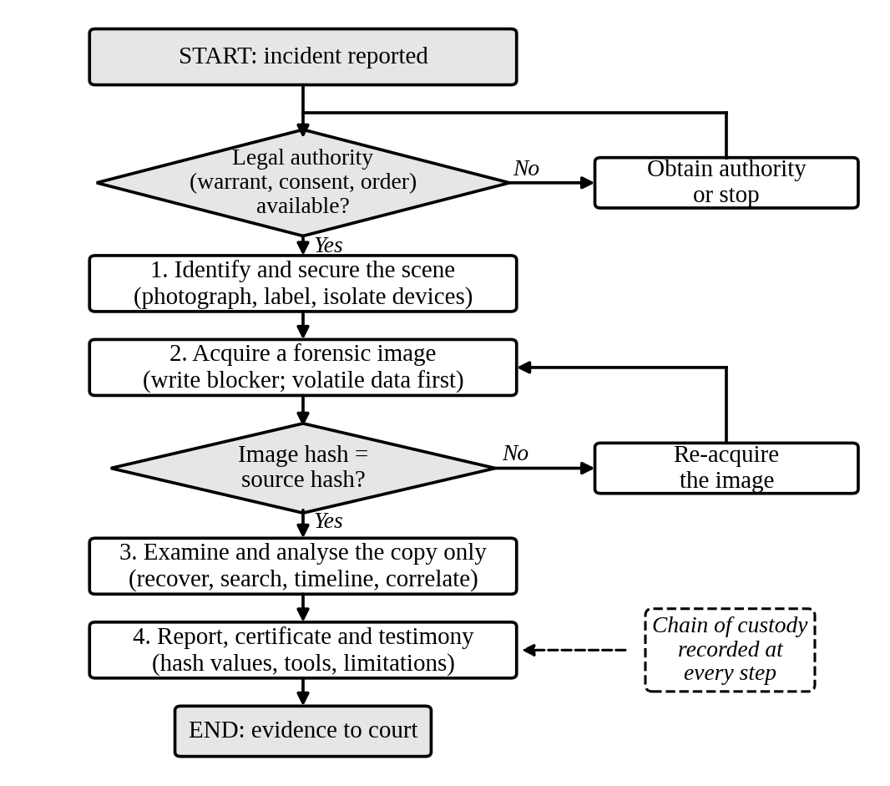
Figure 3.2: Digital forensic process flowchart with legal and integrity checkpoints

3.4 Integrity and Chain of Custody
Integrity is proved with a cryptographic hash. SHA-256 [12] gives a 256-bit digest (64 hexadecimal digits), and a change of even one bit in the input changes the digest completely. It was chosen instead of MD5 or SHA-1 because collisions have been shown for those two, which an opponent could use to challenge or forge evidence. To prove who handled the evidence, each custody event is stored as a record holding the actor, action, evidence hash and the hash of the previous record (Figure 3.3). The records form a chain, so editing an earlier record breaks the link and is detected.
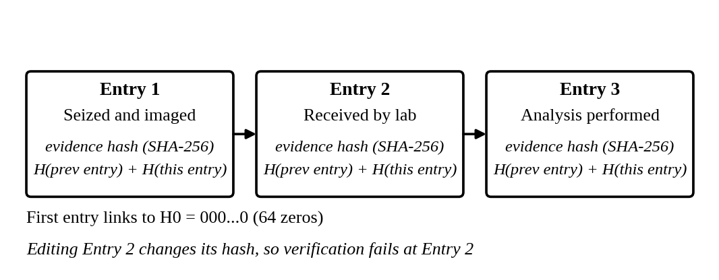
Figure 3.3: Hash-chained chain-of-custody log

3.5 Threat Model
The assets protected are the evidence image, the custody log and the report. The attacks considered are (a) modification of evidence, deliberate or accidental, (b) substitution of one image for another, (c) alteration of the custody log to hide a person or action, and (d) loss of authenticity through unlawful seizure. Hashing addresses (a) and (b), the hash chain addresses (c), and the legal checkpoint in the process addresses (d).

4. Implementation
The tool was written in Python 3.12.3 using only the standard library (hashlib, json, shutil, time), so it runs on any system without extra packages. It was tested on Ubuntu 24 with a 50 MB file, generated with a fixed random seed, as a stand-in for a disk image. Table 4.1 shows which tools were only reviewed and which were used.
Table 4.1: Tools covered in the study
Tool | Purpose | Status in this study
FTK Imager / dd | Forensic disk imaging | Reviewed
Autopsy | File system and timeline analysis | Reviewed
Volatility | Memory (RAM) analysis | Reviewed
Wireshark | Network capture analysis | Reviewed
Python 3.12 (hashlib) | SHA-256 hashing, custody log | Implemented and tested

Three functions form the core. sha256_file() reads the file in 1 MB blocks so that large images do not fill memory. add_entry() builds a custody record that includes the hash of the previous record. verify_log() recomputes every hash and reports the first record that fails (Listing 4.1).
def sha256_file(path, chunk=1 << 20):
h = hashlib.sha256()
with open(path, "rb") as f:
while block := f.read(chunk):
h.update(block)
return h.hexdigest()

def add_entry(log, actor, action, evidence_hash):
prev = log[-1]["entry_hash"] if log else "0" * 64
entry = {"seq": len(log) + 1, "actor": actor, "action": action,
"evidence_hash": evidence_hash, "prev_hash": prev}
body = json.dumps(entry, sort_keys=True).encode()
entry["entry_hash"] = hashlib.sha256(body).hexdigest()
log.append(entry)

def verify_log(log):
prev = "0" * 64
for e in log:
body = {k: v for k, v in e.items() if k != "entry_hash"}
payload = json.dumps(body, sort_keys=True).encode()
calc = hashlib.sha256(payload).hexdigest()
if e["prev_hash"] != prev or calc != e["entry_hash"]:
return False, e["seq"]
prev = e["entry_hash"]
return True, None
Listing 4.1: Core functions of evidence_tool.py

5. Results and Security Analysis
Four test cases were run on the 50 MB test file (Table 5.1), and the program output is shown in Figure 5.1. Hash values are shortened in the table; full values are in the figure.
Table 5.1: Test Cases
Test ID | Input / Action | Expected Output | Actual Output | Status
TC01 | Copy the file; hash source and copy | Hashes identical | Both 83986a60220398e9...; MATCH | Pass
TC02 | Flip one bit in the copy; hash again | Hash differs | b069c58dabd27077...; 61 of 64 digits changed | Pass
TC03 | Verify the untouched 3-entry custody log | Verification passes | (True, None) | Pass
TC04 | Change actor in Entry 2; verify log | Verification fails at Entry 2 | (False, 2) | Pass

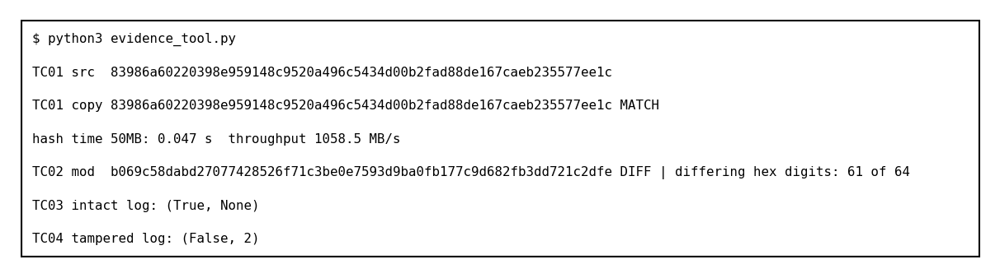
Figure 5.1: Program output for test cases TC01 to TC04
Performance. Hashing the 50 MB file took 0.047 s, about 1,058 MB/s. This was measured with the file in the operating system cache, so real imaging will be limited by the speed of the storage device.
Security analysis. Against attack (a), TC02 shows that even a single changed bit alters 61 of the 64 digits, so modification cannot go unnoticed. Against attack (b), TC01 shows that a substituted image would not match the recorded hash. Against attack (c), TC04 shows that an edited custody record is detected and its position is located. Attack (d) is handled by the legal checkpoint of Figure 3.2, which is a procedure and not code. Hashing proves that data is unchanged but not who made a record, so it must be combined with legal authority.

6. Conclusion and Future Scope
The report explained the main Indian provisions on cyber offences, search and seizure, and electronic evidence (Objective 1), described the forensic process and tied each stage to a legal step (Objective 2), implemented and tested an integrity and custody tool with four passing tests (Objective 3), and analysed four threats to evidence and the controls against them (Objective 4).
Limitations. The tests used a synthetic file and not a real seized device. The custody log is not digitally signed, and the legal summary is limited to India and to the position in October 2026; laws and rules change (the DPDP Rules, for example, commence in phases), so current texts must be checked before use.
Future scope. The tool can be extended with digital signatures and trusted time stamps for custody records, and with automatic generation of the hash details needed in Part A of the Section 63(4) certificate.
GitHub Repository Link:

References
[1] K. Kent, S. Chevalier, T. Grance and H. Dang, “Guide to Integrating Forensic Techniques into Incident Response,” NIST Special Publication 800-86, Aug. 2006.
[2] S. L. Garfinkel, “Digital forensics research: The next 10 years,” Digital Investigation, vol. 7, pp. S64–S73, Aug. 2010.
[3] Information Technology – Security Techniques – Guidelines for Identification, Collection, Acquisition and Preservation of Digital Evidence, ISO/IEC 27037:2012, 2012.
[4] D. Brezinski and T. Killalea, “Guidelines for Evidence Collection and Archiving,” IETF RFC 3227, Feb. 2002.
[5] B. Carrier, File System Forensic Analysis. Boston, MA, USA: Addison-Wesley, 2005.
[6] E. Casey, Digital Evidence and Computer Crime: Forensic Science, Computers and the Internet, 3rd ed. Waltham, MA, USA: Academic Press, 2011.
[7] Government of India, The Information Technology Act, 2000 (Act 21 of 2000), as amended by the Information Technology (Amendment) Act, 2008.
[8] Government of India, The Bharatiya Sakshya Adhiniyam, 2023 (Act 47 of 2023), Section 63 and the Schedule.
[9] JSA, “Supreme Court clarifies scope of expert certification under Section 63(4) of the Bharatiya Sakshya Adhiniyam, 2023,” JSA Prism, Jun. 2026 (Pune Bar Association v. Union of India).
[10] Government of India, The Digital Personal Data Protection Act, 2023 (Act 22 of 2023).
[11] Ministry of Electronics and Information Technology, Digital Personal Data Protection Rules, 2025, Nov. 2025.
[12] National Institute of Standards and Technology, “Secure Hash Standard (SHS),” FIPS PUB 180-4, Aug. 2015.

