A SYSTEMATIC IMPLEMENTATION OF AI ENHANCE CENTRAL LIBRARY SYSTEM WITH CHATBOT
Submitted in partial fulfilment of the requirements of
the degree of
Bachelor of Engineering
By
Mr. Rohan Desale ARMIET/AI21/DR007
Mr. Shlok Thete ARMIET/AI21/TS021
Miss. Sakshi Lone ARMIET/AI21/LS003
Miss. Snehal Gojare ARMIET/AI21/GS002
Under the Guidance of
PROF. PRIYANKA DESHMANE

ALAMURI RATNAMALA INSTITUTE OF ENGINEERING AND TECHNOLOGY
AFFILIATED TO
UNIVERSITY OF MUMBAI

Department of Computer Science
Engineering
Academic Year – 2023-2024

CERTIFICATE

This Mini Project report entitled “A SYSTEMATIC IMPLEMENTATION OF AI ENHANCE CENTRAL LIBRARY SYSTEM WITH CHATBOT” by, Mr. Rohan Desale, Mr. Shlok Thete, Miss. Sakshi Lone, Miss. Snehal Gojare is approved for the degree of Bachelor of Engineering in TE CSE (AIML) for academic year 2023 - 2024

Examiners
- ____________________________

- __________________________

Supervisor

1. ____________________________

__________________________________ _______________________________
Head of the Department Principal

Date:
Place:

DECLARATION
I declare that this written submission represents my ideas in my own words and where others' ideas or words have been included, I have adequately cited and referenced the original sources. I also declare that I have adhered to all principles of academic honesty and integrity and have not misrepresented or fabricated or falsified any idea/data/fact/source in my submission. I understand that any violation of the above will be cause for disciplinary action by the Institute and can also evoke penal action from the sources which have thus not been properly cited or from whom proper permission has not been taken when needed.

_________________ _________________ | _________________ | _________________
Mr. Rohan Desale Mr. Shlok Thete | Miss. Sakshi Lone | Miss. Snehal Gojare
ARMIET/AI21/DR007 ARMIET/AI21/TS021 | ARMIET/AI21/LS003 | ARMIET/AI21/GS002

Date:
Place:

ACKNOWLEDGEMENT

A Mini Project is something that could not have been materialized without cooperation of many people. This project shall be incomplete if do not convey my heartfelt gratitude to those people from whom I have got considerable support and encouragement. It is a matter of great pleasure for us to have a respected Prof. Priyanka Deshmaneas my project guide. We are thankful to her for being constant source of inspiration. We would also like to give our sincere thanks to Prof. Vivek Pandey, Head of Department, for their kind support. Last but not the least I would also like to thank all the staffs of ARMIET college of Engineering (CSE (AIML) Department) for their valuable guidance with their interest and valuable suggestions brightened us.

CONTENTS

CH. No | Topic Name | Page No
 | LIST OF FIGURES | I
 | LIST OF TABLES | II
 | LIST OF ABBREVATION | III
 | ABSTRACT | IV
1 | INTRODUCTION | 1
 | - Motivation  - Problem Statement  - Objective  - Scop | 1-
2 | LITERATURE REVIEW  2.1 Literature Review  2.2 Literature Review Table
3 | RESEARCH GAP
4 | RESEARCH OBJECTIVE
5 | PROPOSED SYSTEM  5.1 System Architecture
6 | SYSTEM REQUIREMENTS  6.1 Software Requirements  6.2 Hardware Requirements  6.3 Technologies Use
7 | SYSTEM DESIGN
8 | IMPLEMENTATION AND RESULT  5.1 Implementation
 | CONCLUSION
 | REFRENCE
 | ACKNOWLEDGEMENT

LIST OF FIGURES

Sr. No. |  | Figure Name | Page No.
1. | Flow Chart |  | 9
2. | Use Case Diagram |  | 10
3. | System Architecture |  | 12
4. | Block Diagram |  | 13

LIST OF TABLES

Sr. No. | Figure Name | Page No.
1. | Literature Review | 6

LIST OF ABBREVATIONS

Sr. No | Abbreviations | Definition
1 | HTML | Hyper Text Markup Language
2 | CSS | Cascading Style Sheet
3 | SQL | Structure Query Language
4 | JS | JavaScript
5 | PHP | Hypertext Pre-Processor

ABSTRACT

Library Management System is a project which aims in developing a computerized system to maintain all the daily work of library. This project has many features which are generally not available in normal library management systems like facility of user login and a facility of admin login. It also has a facility of admin login through which the admin can monitor the whole system. It has also a facility where student after logging in their accounts can see list of books issued and its issue date and return date. Traditional Libraries can be turned into digital libraries using the Library Management System (LMS). LMS allows a user to maintain a library efficiently and keep records of the books and customers accurately. The biggest advantage of LMS is it saves time and money and needs less human interaction. The purpose of the thesis is to develop a LMS system, which can perform basic tasks of a library. Overall, this project of ours is being developed to help the students as well as staff of library to maintain the library in the best way possible and also reduce the human efforts.

CHAPTER 1.
INTRODUCTION

  - MOTIVATION: -
Creating a Library Management System with a chatbot can be a rewarding project for several reasons:
Practical Application It addresses a real-world problem by improving the efficiency of library operations and enhancing the user experience. Learning Opportunity You’ll gain valuable skills in software development, database management, and natural language processing (for the chatbot). Innovation Integrating a chatbot adds a modern twist to a traditional system, making it more engaging and user-friendly. Problem Solving You’ll encounter various challenges, from designing a user-friendly interface to implementing search algorithms. Solving these problems can be intellectually stimulating. Community Impact Libraries play a crucial role in education and knowledge dissemination. Library Management System using PHP and MySQL is a web-based application. Library Management System is a project which aims in developing a computerized system to maintain all the daily work of library. This project has many features which are generally not available in normal library management systems like facility of user login and a facility of admin login. It also has a facility of admin login through which the admin can monitor the whole system. It has also a facility where student after logging in their accounts can see list of books issued and its issue date and return date. The main purpose of the project is to is to build an online LMS system by using different software methodologies. The author designed the LMS with the basic and necessary features like the admin/librarian can add/delete book, can add/delete author, can issue books, can manage books and users, and users/students can search and borrow books. For Frontend part of the project the author used HTML, CSS, JavaScript and Bootstrap framework and for the Backend part the author used PHP and MySQL database.
The main purpose of the project is to is to build an online LMS system by using different software methodologies. The author designed the LMS with the basic and necessary features like the admin/librarian can add/delete book, can add/delete author, can issue books, can manage books and users, and users/students can search and borrow books. For Frontend part of the project the author used HTML, CSS, JavaScript and Bootstrap framework and for the Backend part the author used PHP and MySQL database. For Unified modelling language (UML) design the author used Lucid chart. The author divided the thesis into three sections. In first section the author planed the project through UML methodologies. In the second section the author designed the graphical user interface of the project. And in the third section the author presented some of the code snippet of the project and tests the outcome.

  - Problem Statement:
Improvement in control and performance the system is developed to cope up with the current issues and problems of library. The system can add user, validate user and is also bug free.
Save cost After computerized system is implemented less human force will be required to maintain the library thus reducing the overall cost. Save time Librarian is able to search record by using few clicks of mouse and few search keywords thus saving his valuable time. Traditional library management systems often lack efficient and effective user support, accessibility, and personalization features. This leads to user dissatisfaction, limited accessibility to library resources and services, and increased staffing costs. Therefore, there is a need for an innovative solution that integrates chatbot technology into library management systems to address these challenges and provide improved user support, 24/7 availability, cost-effectiveness, personalization, and data collection and analysis capabilities. The objective of this project is to design and develop a library management system with an integrated chatbot that meets these requirements and enhances the overall user experience.
  - Purpose:
The purpose of this library management system project, which includes a chatbot, is to improve user support, accessibility, and personalization in traditional library management systems. By integrating chatbot technology, the project aims to provide 24/7 availability, cost-effectiveness, and data collection and analysis capabilities. The ultimate goal is to enhance the overall user experience and address the challenges faced by traditional library management systems. Efficiency Streamline library operations by automating tasks such as book check-in/check-out, cataloguing, and managing due dates. This reduces manual work and human errors.
Enhanced User Experience Improve the experience for library patrons by offering a modern and user-friendly interface. The chatbot can assist users in finding books, accessing information, and resolving inquiries in a more interactive way. Accessibility Increase access to library resources by enabling users to search, reserve, or renew books from anywhere with an internet connection. Data Management Efficiently manage and organize the library's collection, including cataloguing, tracking inventory, and generating reports for informed decision-making. Notifications and Reminders The system can send automated reminders for due dates, hold requests, and other important library-related notifications.

  - Scope:
User Support The chatbot will provide instant responses to user queries and support in a conversational manner, improving user satisfaction and reducing the need for human intervention.
Accessibility: The chatbot will be accessible to users anytime and anywhere, allowing them to access library services and resources without any time or location constraints. Personalization: The chatbot will be capable of understanding user preferences and providing personalized recommendations, enhancing the user experience and making library services more tailored to individual needs.24/7 Availability: The chatbot will be available round the clock, ensuring that users can access library services and get assistance at any time, even outside of regular library hours. Cost-effectiveness: By automating certain tasks and providing self-service options, the chatbot will help reduce operational costs and improve efficiency in library management. Data Collection and Analysis: The chatbot will collect user data and interactions, allowing for analysis and insights into user behaviour and preferences. This data can be used to improve services, make data-driven decisions, and enhance the overall library experience.7. Addressing Challenges: The project aims to address challenges faced by traditional library management systems, such as limited support availability, long response times, and lack of personalized services. By integrating a chatbot, these challenges can be overcome, leading to an improved library management system.

CHAPTER 2.
REVIEW OF LITERATURE

2.1Literature Review:
Ass. Pro. Adhana Mengsteab (2020), There have been several studies and research papers conducted on library management systems that incorporate chatbot technology. These studies have explored various aspects of such systems, including their implementation, functionality, benefits, and user satisfaction. The study highlighted the importance of integrating chatbot technology to enhance user experience and improve library services. The authors discussed the design and development process of the chatbot, as well as its functionalities such as providing information about library resources, answering frequently asked questions, and assisting users in searching for books. The impact of a chatbot-based library management system on user satisfaction. The researchers implemented a chatbot in a university library and conducted a survey to gather feedback from users. The study found that the majority of users were satisfied with the chatbot's performance and found it helpful in accessing library resources and services. The use of natural language processing (NLP) techniques in a library management system chatbot.
Meenal Katole (2022), The researchers developed a chatbot that could understand user queries and provide appropriate responses. The study demonstrated the effectiveness of NLP in improving the accuracy and efficiency of the chatbot in understanding user queries related to library resources. Previous studies on library management systems: This would involve reviewing literature on traditional library management systems and identifying their limitations and challenges. Understanding the current landscape of library management systems will provide a context for the need and potential benefits of integrating a chatbot. Chatbots in libraries: Researching existing studies and articles on the use of chatbots in libraries will help identify the different ways in which chatbots have been implemented and their impact on library services.
T. Karan (2021), This could include case studies of libraries that have successfully integrated chatbots, as well as any challenges or issues that have been identified. User experience and satisfaction: Exploring studies that have evaluated the impact of chatbots on user experience and satisfaction in library settings will provide insights into the potential benefits of integrating a chatbot. This could involve examining user feedback, surveys, or usability testing conducted in libraries with chatbot systems. Personalization and recommendation systems: Investigating literature on personalization and recommendation systems in libraries will provide an understanding of the techniques and approaches that can be used to enhance the user experience through personalized recommendations. This information can help inform the design and functionality of the chatbot in the library management system project. Data collection and analysis: Researching studies on data collection and analysis in library settings can provide insights into best practices for collecting and analysing user data and interactions.
R. N., Raqueño (2023), Understanding how libraries have used data to improve services and make data-driven decisions will be valuable for designing the data collection and analysis capabilities of the chatbot. Library Management Systems (LMS)Review the evolution of LMS, from traditional card catalogues to modern, integrated digital systems. Discuss the features and functionalities of contemporary Misidentify the challenges faced by libraries in managing their collections and operations. Chatbots and Natural Language Processing (NLP)Examine the application of chatbots in various domains, including customer service, e-commerce, and education. Explore the principles of NLP and its role in enabling chatbots to understand and respond to user queries. Integration of Chatbots in LMS Analyse studies and projects where chatbots have been integrated into library systems to enhance user services. Evaluate the impact of chatbots on user engagement, satisfaction, and efficiency in libraries. User Experience in Libraries Investigate the importance of user-centric design in library systems. Explore studies that focus on user preferences and expectations in library services. Automation in Libraries Assess the benefits and challenges of automation, including RFID technology, for managing library collections and operations. Accessibility and Inclusivity Discuss the role of LMS and chatbots in making library resources more accessible to diverse user groups, including people with disabilities. Library Trends and Innovations Investigate how libraries are adapting to the digital age, embracing technology, and innovating in response to changing user needs. Case Studies and Best Practices Analyse specific library cases or projects that have successfully implemented LMS with chatbots. Identify best practices and lessons learned from these cases. Challenges and Concerns Consider the potential challenges and ethical concerns associated with the implementation of chatbots in library services, such as data privacy and security. Future Directions and Research Gaps Identify areas for future research in the domain of library management systems and chatbots. Discuss how emerging technologies, like artificial intelligence, might further transform library services.

Sr.no | Author Name | Topic Name | Year of  Publication | Paper Outcome | Limitation
1 | Ass. Pro. Adhana Mengsteab | Blockchain Technology for Securing Forensics Evidence | 2020 | To improve integrity, transparency and security | Complexity, scalability and data size
2 | Nieto et al., Frankle et al. | Privacy in Digital Forensics | 2022 | To improve integrity, transparency and security | Multiple judges and no court trial.

Table No. 2.1 Literature Review

CHAPTER 3.
RESEARCH GAP

- Usability and User Experience (UX):
Research is needed to improve the user experience of library systems, ensuring they are user-friendly and accessible, especially for diverse user groups, including people with disabilities.
- Interoperability and Integration:
Investigate methods for improving interoperability between different library systems, as well as integration with external databases and resources to streamline library operations and provide a more comprehensive service to users.
- Security and Privacy:
Explore ways to enhance the security of library systems, especially in the context of patron data and digital resources. Research on privacy concerns and compliance with data protection regulations is essential.
- AI and Machine Learning:
Examine the applications of artificial intelligence (AI) and machine learning in library systems, including recommendation systems, content analysis, and metadata enhancement.
- Digital Preservation:
Investigate strategies for long-term digital preservation of library collections, especially in the context of digital materials, ensuring they remain accessible and authentic over time.
- User-Centered Services:
Research how library services can be better aligned with the evolving needs and expectations of library users, especially in the digital age.
- Library Analytics:
Study the use of data analytics to gain insights into library operations, including resource utilization, collection development, and user behavior.
- Open Source vs. Proprietary Systems:
Examine the pros and cons of open-source and proprietary LMS solutions, and how they impact library operations, costs, and customization.
- Mobile and Remote Access:
Investigate ways to improve mobile access to library resources and services, especially in the context of remote and distance education.
- Rural and Underserved Libraries:
Research the unique challenges and solutions for library systems in rural and underserved communities, where access to technology and internet connectivity can be limited.
- Collaborative Systems:
Explore how library systems can support collaborative work and resource sharing among libraries and institutions, including resource sharing networks and consortiums.
- Community Engagement:
Research the role of libraries in community engagement, including strategies to build stronger relationships with local communities and deliver services that meet their specific needs.
- Emerging Technologies:
Investigate the impact of emerging technologies like blockchain, Internet of Things (IoT), and virtual reality on library systems and services.
- Multilingual Support:
Examine how library systems can better support multilingual resources and user interfaces to serve diverse user populations.
- Sustainability:
Research ways to make library systems and operations more environmentally sustainable, considering energy consumption, paper usage, and other aspects.
- Library Systems in Crisis or Disaster:
Investigate how library systems can better prepare for and respond to crises and natural disasters, ensuring that valuable collections are protected.
Research on best practices for collecting and analysing user interactions with the chatbot can inform the design of data-driven decision-making processes in libraries. In conclusion, the existing literature lacks comprehensive research on the integration of chatbots in library management systems. This research gap presents an opportunity to explore the potential benefits, challenges, and impact of chatbots on user experience and library services. By addressing this gap, future studies can contribute to the development of more efficient and user-friendly library management systems with chatbot capabilities

Entity Relationship Diagram

CHAPTER 4
RESEARCH OBJECTIVE

When developing a Library Management System (LMS) with integrated chatbot functionality, the research objectives should focus on enhancing the library's services, user experience, and operational efficiency. Below are research objectives for such a system:
- Improving User Engagement and Support:
To enhance user engagement by implementing a chatbot feature that provides instant assistance to patrons with inquiries regarding library resources, policies, and services.
- Enhancing Accessibility:
To investigate how chatbots can improve the accessibility of library resources and services for users with disabilities by offering voice recognition and text-to-speech capabilities.
- Optimizing Search and Discovery:
To assess the impact of chatbots on improving search and discovery of library materials, including how chatbots can assist users in finding relevant resources quickly.
- User Satisfaction and Experience:
To measure user satisfaction and experience with a chatbot-integrated LMS and identify areas for improvement based on user feedback.
- Efficiency in Resource Retrieval:
To study how chatbots can streamline the process of checking out, renewing, or reserving library materials, reducing wait times and increasing operational efficiency.
- Automation of Routine Tasks:
To evaluate the effectiveness of chatbots in automating routine library tasks, such as sending overdue reminders, gathering user feedback, and providing administrative support.
- User Training and Guidance:
To explore the use of chatbots in delivering training and guidance to library patrons, particularly in teaching research skills, citing sources, and using library databases effectively.
- Language Support and Multilingual Capabilities:
To assess the chatbot's ability to provide support in multiple languages and offer a user-friendly experience for diverse language-speaking library patrons.
- Data Privacy and Security:
To investigate the implementation of data privacy and security measures in chatbot interactions, ensuring that user data is protected and that chatbot interactions comply with privacy regulations.
- Integration with Library Systems:
To evaluate the integration of the chatbot with existing library management systems, including how it handles user accounts, library databases, and collection management.
- Content Recommendation:
To study the chatbot's effectiveness in offering personalized content recommendations to library users based on their preferences and search history.
- Chatbot Customization and Learning:
To explore the customization options and the chatbot's ability to learn and adapt to user preferences and changing library resources.
- Scalability and Performance:
To assess the chatbot's scalability and performance as library patron numbers grow, ensuring it can handle a high volume of inquiries without degradation in service quality.
- Staff Training and Support:
To investigate the effectiveness of chatbots in providing support to library staff, such as answering frequently asked questions and assisting with administrative tasks.
- Cost-Benefit Analysis:
To conduct a cost-benefit analysis of implementing a chatbot within the LMS, considering factors like development costs, maintenance, and the benefits in terms of improved user satisfaction and operational efficiency.
The objective is to establish effective mechanisms for gathering and acting upon user suggestions and concerns to enhance the chatbot's performance and usability. Data Security and Privacy Investigate the security and privacy implications of using a chatbot in a library setting. Assess how sensitive user data is handled, stored, and protected, and propose measures to ensure compliance with data protection regulations and maintain user trust. Personalization and Customization Explore the extent to which the chatbot can be customized to cater to the unique needs and preferences of different libraries and their diverse user bases, with a focus on tailoring the chatbot's responses to specific library resources and services.

CHAPTER 5

PROPOSED SYSTEM

5. PROPOSED SYSTEM
- User Interface:
The system should have a user-friendly and responsive web-based interface for both library staff and patrons. It should include features for searching the catalog, accessing user accounts, and interacting with the chatbot.
- Chatbot Integration:
The chatbot should be integrated into the LMS interface, providing instant assistance and information retrieval. It should be accessible through a chat window, and users should be able to initiate conversations with it.
- Authentication and User Management:
The system should include user authentication and management functionalities. Library patrons should be able to create accounts, access their profiles, and manage their borrowing history.
- Catalog Management:
Library staff should be able to add, edit, and delete records for library materials. This includes books, journals, e-books, multimedia, and digital resources.
- Circulation Management:
The system should facilitate the management of the circulation process, including checking out, checking in, renewals, and fine calculations. It should also manage patron accounts and notifications.
- Online Public Access Catalog (OPAC):
A user-friendly OPAC should allow patrons to search the library's collection, view availability, place holds, and access additional information about materials.
- Resource Management:
The LMS should handle a wide range of materials, including print and digital resources, with support for metadata management.
- Chatbot for User Assistance:
The chatbot should provide instant help to patrons by answering questions, offering library information, assisting with research, and navigating the catalog.
- Interlibrary Loan (ILL):
The system should support interlibrary loan requests, allowing users to request materials from external libraries if they're not available in the local collection.
- Reporting and Analytics:
Generate reports on library statistics, including circulation data, user behavior, and collection usage to help make data-driven decisions.
- Digital Asset Management:
Manage digital collections, preserving metadata and content in various formats, including e-books, e-journals, and digital archives.
- AI and Machine Learning Capabilities:
Implement AI and machine learning to enhance user recommendations, automate routine tasks, and provide advanced natural language processing for the chatbot.
- Integration with External Systems:
Integrate the LMS with external systems, such as RFID technology, self-checkout kiosks, and academic databases, to streamline operations and improve the user experience.
- Privacy and Security:
Implement robust security measures to protect patron data and comply with privacy regulations.
- Multilingual Support:
Include support for multiple languages to cater to diverse user populations.
- Customization and Scalability:
Allow libraries to customize the system to their specific needs, and ensure it can scale as library collections and user bases grow.
- Content Recommendation Engine:
Use machine learning algorithms to suggest relevant resources to users based on their interests and previous borrowing history.
- Administrator Tools:
User Management and Permissions:
Give administrators control over user accounts and access levels to ensure data security.
- Backup and Data Recovery:
Implement regular data backup and recovery processes to prevent data loss.

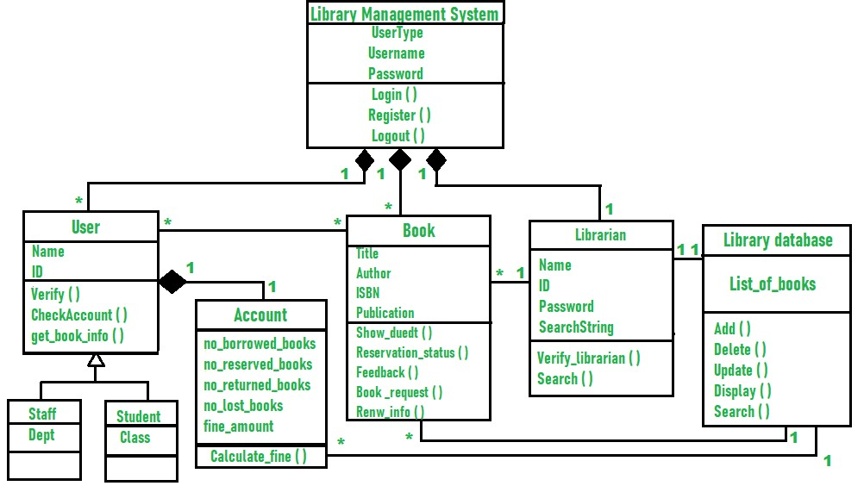
5.1 System Architecture

CHAPTER 6
SYSTEM REQUIREMENT

6.1 Software requirements:
- Operating System
- Database Management System
- Web server software
- Programming languages
- Natural Language Processing libraries
- Machine learning frameworks
- APIs for integrating external systems and services
6.2 Hardware requirements:
The minimum hardware requirements to execute the system are as follows:
- Processor intel core processor for better performance.
- Operating system windows vista, windows7, ubuntu.
- Memory 1gb ram or more.
- Hard disk space minimum 3 Gb for database usage.
6.3 Technology Use:
The technology used for the library management system with a chatbot may include:
- Natural Language Processing (NLP): NLP technology is used to enable the chatbot to understand and respond to user queries in a conversational manner.
- Machine Learning: Machine learning algorithms can be utilized to train the chatbot to improve its understanding and response accuracy over time. It can also be used for personalized recommendations based on user preferences
- Database Management System: A database management system is used to store and manage the library's book cat logs, user information, reservation data, and other relevant information.
- Web Development Technologies: Web development technologies like HTML, CSS, and JavaScript are used to create the user interface for the system, allowing users to interact with the chatbot and access library services through a web browser.
- These technologies work together to create an intelligent virtual assistant that can effectively manage library operations and provide personalized assistance to users.

CHAPTER 7
SYSTEM DESIGN

7.1 UML Diagram:
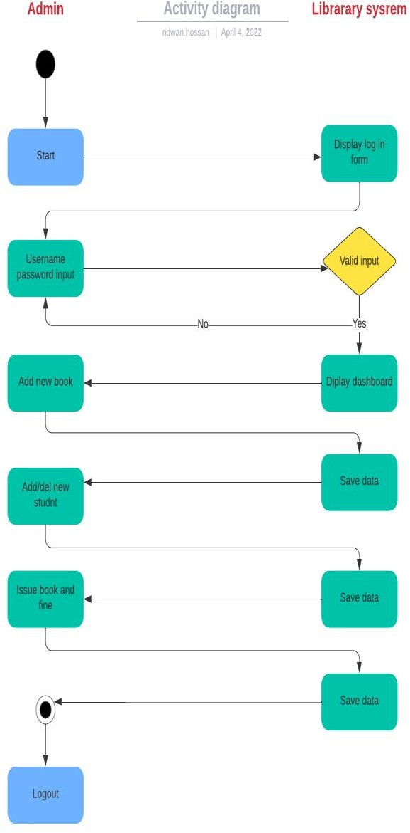
7.1 Admin activity diagram

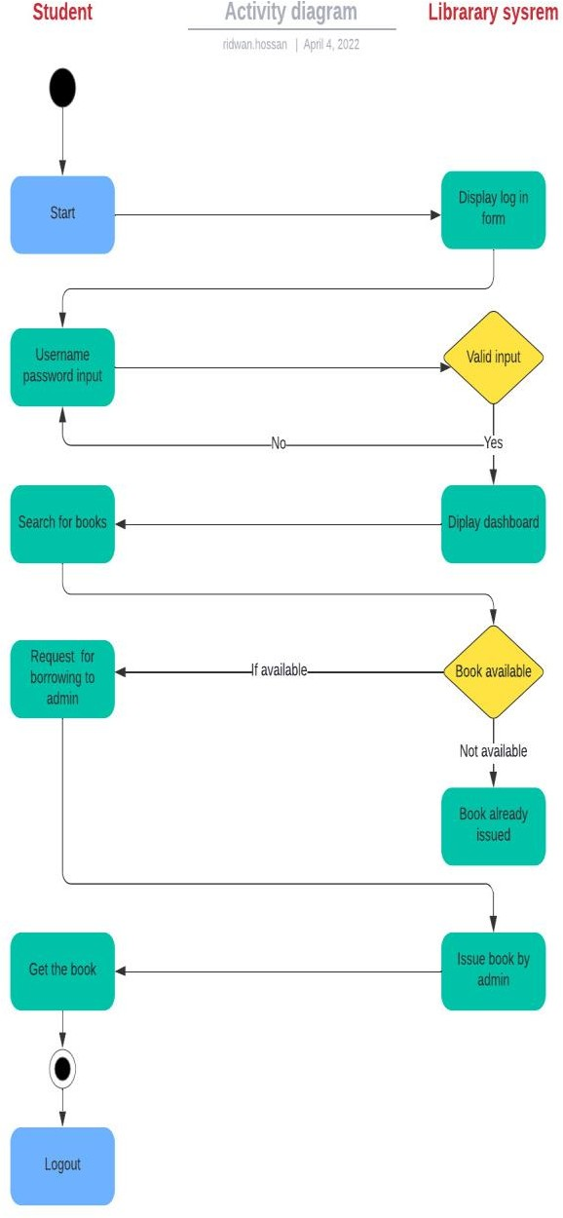

7.2 User Activity Diagram

CHAPTER 8
PROJECT IMPLEMENTATION

CHAPTER 9
USE CASES

9.1 UNIT TEST CASE
- User Registration:
Test that users can successfully register for a library account.
Verify that the system handles different password requirements (length, special characters, etc.).
Check for proper validation of user information.
- User Login:
Confirm that registered users can log in using their credentials.
Verify that incorrect login credentials result in appropriate error messages.
Check for successful account locking after a specified number of failed login attempts.
- Search and Resource Retrieval:
Test various search queries (e.g., title, author, ISBN) to ensure accurate search results.
Verify that search filters (e.g., by author, genre) work correctly.
Confirm that users can view resource details, availability, and location.
- Check-Out and Check-In:
Test the check-out process for library materials, including checking item availability and user eligibility.
Verify that due dates are calculated correctly based on user type and loan policies.
Test the check-in process, including late return notifications and fine calculation.
- Renewal of Materials:
Confirm that users can renew materials online, subject to renewal limits.
Check that users receive renewal confirmation and new due dates.
- Hold Requests:
Test the process of placing hold requests on checked-out items.
Verify that users are notified when their requested items become available.
Check that holds are released after a specified period.
- Chatbot Interaction:
Test the chatbot's ability to understand and respond to common user inquiries, such as opening hours, fines, and available resources.
Verify that the chatbot provides accurate information and links to relevant resources.
- Chatbot Error Handling:
Test the chatbot's behavior when it encounters invalid or unclear user queries.
Ensure the chatbot provides meaningful error messages or suggestions for improving the query.
User Account Management:Test user account updates, such as changing contact information, password resets, and profile modifications.
Verify that changes are saved correctly and that users receive confirmation messages.
- Interlibrary Loan (ILL):
Test the ILL process, including requesting materials from other libraries.
Confirm that users are informed about the status of their ILL requests.
- Privacy and Security:
Verify that sensitive user data, such as personal information and borrowing history, is appropriately secured and protected from unauthorized access.
- Data Backups and Recovery:
Test the system's data backup and recovery procedures to ensure data integrity in case of unexpected issues.
- Integration with External Systems:
Confirm that the LMS properly integrates with external systems, such as RFID scanners and academic databases.
Verify that data exchange and communication with these systems work as expected.
- Multilingual Support:
Test the system's ability to provide support in multiple languages.
Verify that content, interfaces, and chatbot responses adapt to the selected language.
- Customization and Scalability:
Verify that libraries can customize the system to meet their specific needs and that the system can handle growing collections and user bases without performance degradation.
- Content Recommendation Engine:
Test the recommendation engine by ensuring that it provides relevant resource suggestions to users based on their preferences and borrowing history.
- Administrator Tools:
Confirm that administrators can manage user accounts, permissions, and configure system settings effectively.

CONCLUSION

CONCLUSION

The Online Library Management System represents a significant leap forward in the management and accessibility of library resources. In a world where digitalization and convenience are paramount, this system has emerged as a vital tool for libraries to adapt and thrive in the digital age.

One of the most notable advantages of this system is its ability to streamline library operations. It simplifies tasks like cataloguing, tracking, and managing the vast array of materials a library houses. This, in turn, allows library staff to be more efficient and focus on providing improved services to patrons. Borrowing and returning books are made easier and more user-friendly, ensuring a seamless experience for library users.

Furthermore, the Online Library Management System has democratized access to information. Users can search for and access books, journals, and other resources from the comfort of their homes or virtually anywhere with an internet connection. This level of accessibility is invaluable, especially for students, researchers, and book enthusiasts.

As technology continues to advance, these systems will play a pivotal role in digitizing libraries and ensuring their continued relevance. They serve as a bridge between the traditional brick-and-mortar library and the digital age, fostering a culture of learning and knowledge sharing. In conclusion, the Online Library Management System is not merely a tool; it's a catalyst for the transformation and modernization of libraries, securing their place as vital hubs of knowledge and information in the 21st century.

REFERENCE

REFERENCE
- Tsega Weldu Araya, Ph.D. Students, School of Computer Science and Technology, Northwestern Polytechnic University, Xian, China and Ass. Pro. Adhana Mengsteab, Dep. Head, School of Library and Information Science, Eritrea Institute of Technology, Mai -Nefhi, Eritrea, Vol. 9 Issue 10, October-2020.
- Jayesh Bansod, Meenal Katole, Sejal Sipani, Arpit Karmore, Ujwal Kalwala, Prof. P. C. Khanzode, Department of Computer Science and Engineering Sipna College of Engineering and Technology, Amravati, Maharashtra, India, Volume 10, Issue 5 May 2022.
- S. G. Hiremath, T. Karan, C. Vachana, Professors, Department of Electronics and Communication Engineering, East West Institute of Technology, Bangalore, India, Vol. 4 No. 7 (2021).
- Eliza B. Ayo, Centro Escolar University Head, Computer Education Department, Jotic, R. N., Raqueño, A., Loresca, J. V. G., Mendoza, I. F., & Barona, P. V. M., Vol. 17 No. 10 (2023).

