**P1: Test a Perceptual Phenomenon**

**Question 1: Identify variables in the experiment**

Independent variable: The congruent words condition, and the incongruent words condition.

Dependent variable: The time it takes to name the ink colors in two conditions (congruent and incongruent condition).

**Question 2: Establish a hypothesis and statistical test**

My hypothesis is that the mean of time it takes to name the ink colors would increase when the word and the name of the ink color are different.

H0: μC = μI

H1: μC < μI

* H0 represents the null hypotheses, and H1 represents the alternative hypotheses;
* μC represents the population mean of time in congruent condition, and μI represents the population mean of time in incongruent condition;
* So the null hypotheses states that the population mean of time in congruent condition has no difference with the population mean of time in incongruent condition; the alternative hypothesis states that the population mean of time in congruent condition is significant less than that in incongruent condition.

A paired t-test would be expected to perform the hypothesis.

I use t-test here because of two characteristics of the sample. Initially, the sample size is just 24 which is less than 30. Then, the population standard deviation is unknown. Thus we have to estimate this population parameter from our sample data.

I prefer to using paired t-test because every subjects in this research has two paired observations. And we assume that the observations from each population are normal.

**Question 3: Report descriptive statistics**

|  |  |  |  |
| --- | --- | --- | --- |
|  | Congruent (Xc) | Incongruent (Xl) | d=Xc-Xl |
| mean | 14.051125 | 22.01591667 | -7.964791667 |
| Sample variance | 12.66902907 | 23.01175704 | 23.66654087 |

**Question 4: Plot the data**

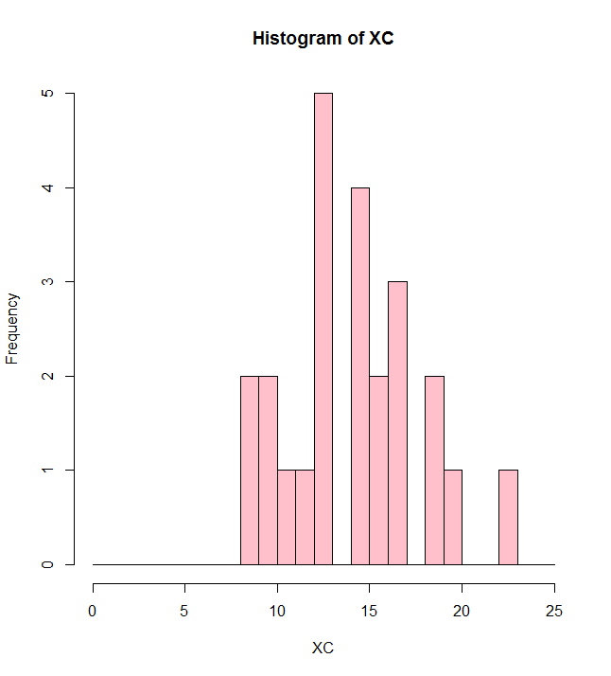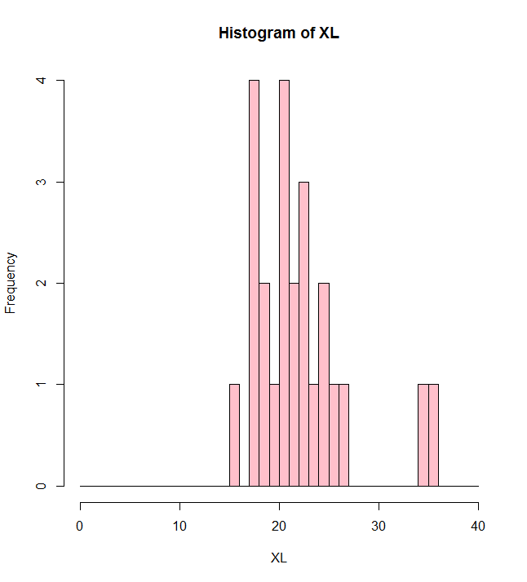

From the two histograms above, we could assume that the distributions are not highly skewed. So we can use t-test method. The sample mean of congruent condition seems to be less than that of incongruent condition.

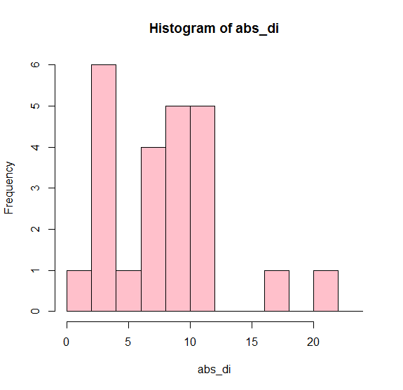

From the histogram of the absolute values of differences, we can find that most values fall between 2 and 12.

**Question 5: Perform the statistical test and interpret your results**

We define μd = μC – μL, and estimate $σ_{d}^{2}$ by $S_{d}^{2}$. We assume the differences of the random sample (d1, d2, ..., dn) to be normally distributed with mean μd and variance $σ_{d}^{2}$.The point estimator of μd is given by $\overline{d}$.

A 95% confidence interval for μd is:

-10.019 < μd < -5.911

* H0: μC = μL
* H1: μC < μL
* Set α = 0.05
* critical region: t < -t0.05 (i.e. t < -1.714) with 23 degrees of freedom
* test statistic: $T=\frac{\overline{d}-μ_{d}}{s_{d}∕\sqrt{n}}$
* computation: $\overline{d}=-7.96$, μd = 0, Sd = 4.8648, n = 24

t = -8.021 < -1.714

P-value < 0.0001

* conclusion: Reject H0, and we can conclude that the mean of time consuming in congruent condition is less than that in incongruent condition. So it takes longer to name the ink color at incongruent conditions.

**Question 6: Digging deeper and extending the investigation**

We could assume that the age of subjects is a kind of interference, which could be responsible for the effect observed. So we could choose different age groups as subjects, such as the young, the middle-aged and the old. Note that the sex should be treated as a control variable. Then, let the different age groups do the same Stroop effect task and calculate the time and errors.