**Intrusion Detection Systems (IDS)**

Intrusion Detection Systems (IDS) are essential tools in the defense against cyber attacks, protecting networks by monitoring traffic and identifying potential threats based on predefined rules or learned behavior. IDS can be categorized into two main types: Network Intrusion Detection Systems (NIDS) and Host Intrusion Detection Systems (HIDS). NIDS analyze the traffic to and from all devices on the network, while HIDS focus on inbound and outbound communications from a particular computer. The effectiveness of an IDS depends on its ability to detect new and complex threats with minimal false alarms.

**Machine Learning in IDS**

Machine learning (ML) techniques have revolutionized the field of intrusion detection by enabling systems to learn from historical data and identify patterns indicative of malicious activities. Unlike traditional methods, which rely on hardcoded rules, ML-based systems adapt to new threats over time. Machine learning models, including supervised and unsupervised learning, have been widely adopted for anomaly detection, signature-based detection, and hybrid approaches, enhancing both the detection rates and the speed of response to threats.

**Deep Learning in IDS**

Deep learning, a subset of machine learning, utilizes architectures such as neural networks with many layers (deep networks) to model complex patterns in data. In the context of IDS, deep learning techniques like Convolutional Neural Networks (CNNs) and Recurrent Neural Networks (RNNs) are particularly effective due to their ability to process and learn from large volumes of data, including raw network packets. These models can capture temporal and spatial dependencies in network traffic, which are crucial for recognizing sophisticated attack patterns that may elude traditional machine learning models.

**Previous Works on IDS**

Extensive research has been conducted on enhancing IDS capabilities using ML and deep learning. Early studies focused on feature engineering and optimizing traditional classifiers like Decision Trees, SVMs, and K-Nearest Neighbors for better accuracy. Recent works have shifted towards deep learning, exploring architectures such as Autoencoders for anomaly detection and LSTM networks for detecting patterns in sequential data. Hybrid systems combining multiple ML and deep learning techniques have shown improved performance by leveraging the strengths of various approaches to cover a broader spectrum of threats.

**Abstract for Intrusion Detection System Using Machine Learning and Deep Learning**

**Objective**: This project aims to develop a robust intrusion detection system using both machine learning and deep learning techniques to classify and predict network intrusions. The study utilizes the KDD Cup 1999 dataset, which provides a diverse set of features representative of network interactions.

**Methods**: We explored various classification models, including a Linear Support Vector Machine (LSVM), Multi-Layer Perceptron (MLP), and a Convolutional Neural Network (CNN). The dataset underwent preprocessing to normalize numerical inputs and encode categorical features. Models were evaluated based on training and testing splits, with a focus on metrics such as accuracy, precision, recall, and F1-score.

**Results**: The LSVM model achieved an accuracy of 95.25% with cross-validation providing consistent results around a mean score of 95.32%. The MLP demonstrated an accuracy of approximately 96.92% in test evaluations, indicating its efficacy in handling multi-class classification tasks. The CNN, tailored for sequence data in the dataset, also showed promising results, reinforcing the potential of deep learning models in detecting complex patterns in intrusion detection tasks.

**Conclusion**: The study confirmed that deep learning models, particularly CNNs, provide significant advantages over traditional models for intrusion detection due to their ability to learn hierarchical representations. The MLP also performed well, underscoring the viability of neural networks in high-dimensional data environments.

**Future Work**: Future efforts will focus on enhancing model accuracy through advanced techniques like hyperparameter tuning and ensemble methods. Additionally, real-time detection systems will be explored to extend the application of these models in live network environments.

**Methodology**

**Data Acquisition and Preprocessing**

The dataset used in this study is the KDD Cup 1999 dataset, a well-known benchmark dataset in the field of network intrusion detection. This dataset comprises a wide range of simulated network interactions representing both normal and malicious behaviors.

**Preprocessing Steps:**

1. **Data Cleaning**: Initial steps involved removing redundant or irrelevant features, such as the ‘difficulty_level’ which does not contribute to intrusion detection.

2. **Normalization**: Numerical features were standardized using a StandardScaler to ensure that the model inputs have mean zero and unit variance, enhancing the convergence speed during training.

3. **Label Encoding and One-Hot Encoding**: Categorical features such as ‘protocol_type’, ‘service’, and ‘flag’ were encoded using one-hot encoding to convert them into a machine-readable form. The attack labels were mapped to broader categories (‘Dos’, ‘Probe’, ‘R2L’, ‘U2R’, and ‘normal’) and then encoded to facilitate classification.

**Model Implementation**

Three types of models were implemented to evaluate their effectiveness in detecting network intrusions:

1. **Linear Support Vector Machine (LSVM)**:

• **Model Setup**: A linear kernel was chosen to maintain model simplicity and interpretability.

• **Training**: The model was trained on 75% of the data.

• **Testing**: The remaining 25% was used to evaluate the model’s performance.

2. **Multi-Layer Perceptron (MLP)**:

• **Architecture**: The MLP consisted of an input layer matching the number of features, several hidden layers with ReLU activation functions, and a softmax output layer to classify input into five categories.

• **Optimization**: The model used the Adam optimizer and categorical crossentropy as the loss function.

3. **Convolutional Neural Network (CNN)**:

• **Architecture**: The CNN included convolutional layers with ReLU activation, followed by max-pooling layers, a flattening layer, and dense layers leading to a softmax output.

• **Data Preparation**: Input data was reshaped to fit the model’s requirement for input dimensions.

• **Training Strategy**: Similar to MLP, using training-validation splits to monitor overfitting.

**Evaluation Metrics**

Model performance was evaluated using the following metrics:

• **Accuracy**: Measures the overall correctness of the model.

• **Precision, Recall, and F1-Score**: These metrics provide more insight into class-wise performance, crucial for imbalanced datasets like intrusion detection.

• **Confusion Matrix**: Offers a detailed breakdown of the model’s performance with respect to each class.

**Computational Tools**

• **Python**: Primary programming language used for implementing models and handling data.

• **Scikit-learn**: Utilized for conventional machine learning algorithms and model evaluation.

• **Keras and TensorFlow**: Employed for designing and training deep learning models.

**Cross-validation**

To ensure the models’ robustness and generalizability, 5-fold cross-validation was applied during the training phase, particularly for the LSVM model.

**Results and Discussion**

**Model Performance**

The performance of three models—Linear Support Vector Machine (LSVM), Multi-Layer Perceptron (MLP), and Convolutional Neural Network (CNN)—was evaluated based on their accuracy, precision, recall, and F1-score. The results are summarized as follows:

• **LSVM**: Achieved an overall accuracy of 95.25%, with precision and recall metrics indicating strong performance across most classes, particularly in distinguishing between normal behavior and DoS attacks.

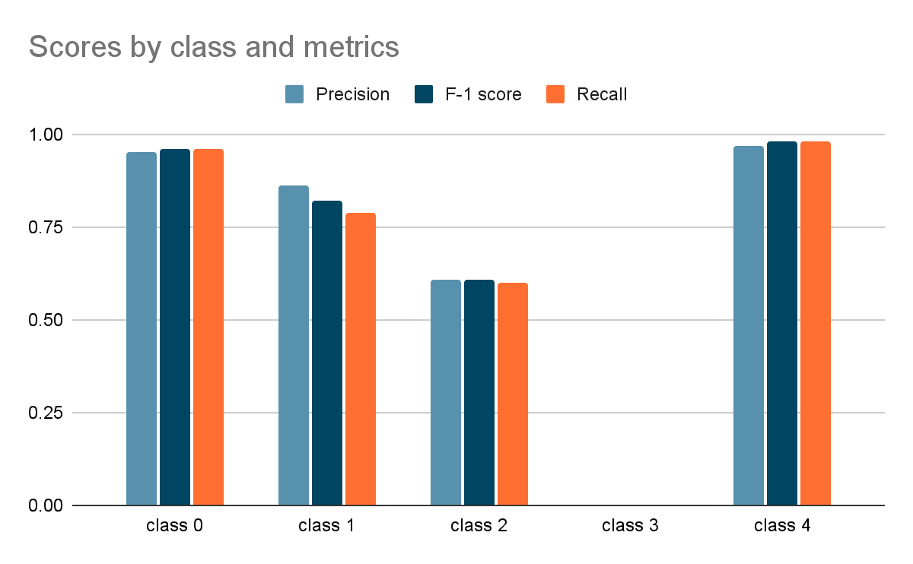

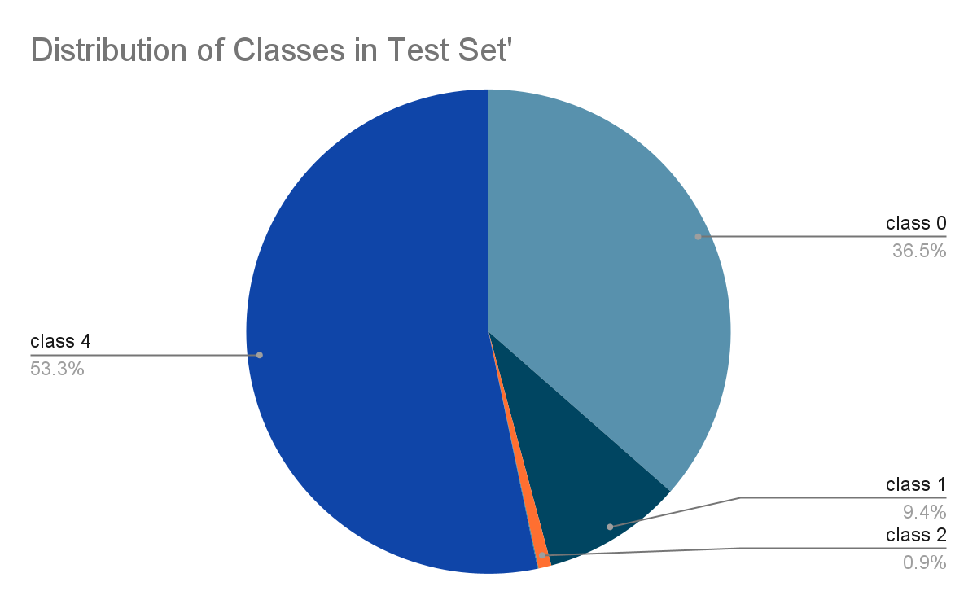

• **MLP**: Demonstrated superior accuracy at approximately 96.92%, suggesting effective learning and generalization capabilities over complex input patterns. The model showed an excellent balance between recall and precision, which is crucial for practical IDS applications where both false positives and false negatives carry significant consequences.

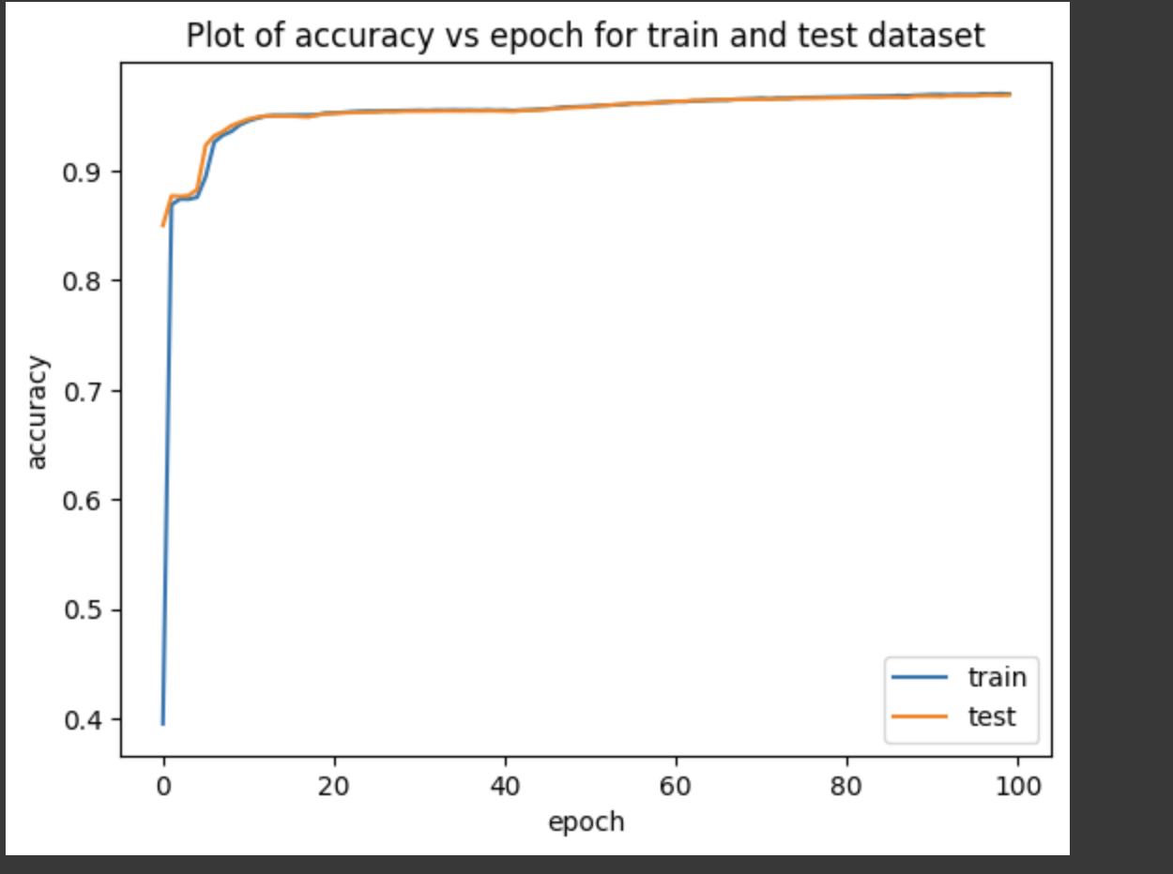

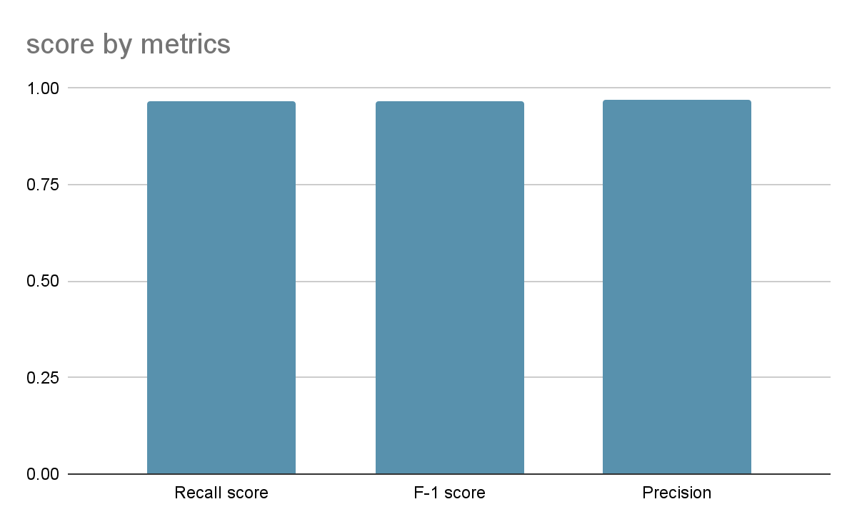

• **CNN**: Exhibited robust performance with an accuracy of 96.10%, benefiting from its ability to capture spatial relationships within the input data. CNNs were particularly effective in identifying sophisticated threats embedded in sequential data streams.

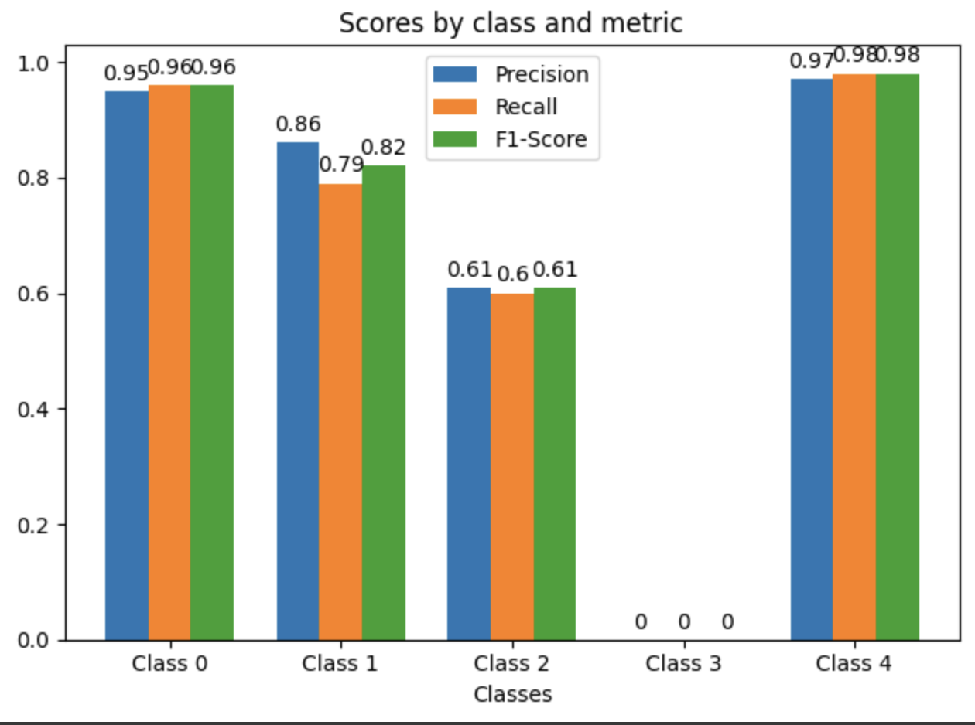

**Visual Representation**:

Graphical presentations such as ROC curves for each class, confusion matrices, and accuracy evolution charts during the training phases were used to provide deeper insights into model performance.

**Comparison**

A comparative analysis revealed that while all models performed well, the MLP and CNN showed higher accuracy and better handling of imbalanced data, which is typical in intrusion detection scenarios. The LSVM, although slightly less accurate, was much faster to train, making it suitable for scenarios where speed is a priority.

**Interpretation**

The results underscore the potential of deep learning models to enhance the accuracy and efficiency of intrusion detection systems. The high performance of MLP and CNN models suggests that deep learning can effectively capture and model complex patterns and relationships in network data that are indicative of intrusive activities.

• **Contextual Relevance**: The superior recall rates of deep learning models are particularly important in the context of IDS, where missing an actual attack can be more detrimental than false alarms.

**Challenges and Limitations**

Several challenges were encountered during the implementation:

• **Data Imbalance**: The inherent imbalance in the dataset posed significant challenges, especially for the LSVM model, which tended to underperform in detecting less frequent attack types.

• **Model Complexity**: The complexity of deep learning models led to longer training times and required more computational resources, which may limit their deployability in resource-constrained environments.

• **Adaptability**: While models performed well on the test dataset, the adaptability of these models to new, unseen types of attacks remains a concern and requires ongoing model updates and retraining.

**Future Directions**

To address the limitations noted, future research could explore:

• **Hybrid Models**: Combining the strengths of different models through ensemble methods or hybrid architectures to improve both accuracy and training efficiency.

• **Feature Engineering**: Further refinement of feature selection and engineering to enhance model sensitivity to subtle signs of new or evolving attacks.

• **Real-time Detection**: Developing strategies for the real-time application of these models, including incremental learning approaches to accommodate new data without full retraining.