Insights from the Titanic Dataset:

**1) Introduction:**

The Titanic dataset offers a detailed glimpse into the passengers aboard the iconic ship during its ill-fated voyage. With information on age, ticket class, survival outcomes, and more, this dataset provides a valuable resource for understanding the composition and fate of those onboard. Through analysis of this dataset, we aim to uncover insights into the factors that influenced survival rates and contribute to a deeper understanding of this historic maritime tragedy.

**2) Data Overview:**

The dataset consists of the following columns:

* PassengerId: Unique identifier for each passenger
* Survived: Survival status (0 = No, 1 = Yes)
* Pclass: Ticket class (1 = 1st, 2 = 2nd, 3 = 3rd)
* Name: Passenger's name
* Sex: Passenger's gender
* Age: Passenger's age
* SibSp: Number of siblings/spouses aboard
* Parch: Number of parents/children aboard
* Ticket: Ticket number
* Fare: Passenger fare
* Cabin: Cabin number
* Embarked: Port of embarkation (C = Cherbourg, Q = Queenstown, S = Southampton)

**3) Data Cleaning and Preprocessing:**

Data cleaning and preprocessing were carried out before the analysis. This involved addressing missing values and eliminating irrelevant columns.

**Handling Missing Values:**

* Age: There were **177** missing values in the 'Age' column. To address this, the missing age values were replaced with the mean age of the passengers.
* Embarked: There were **2** missing values in the 'Embarked' column. These missing values were filled with the port from which the majority of people embarked.
* Cabin: The 'Cabin' column contained **687** missing values. Since meaningful information couldn't be deduced from this column, it was removed from the dataset.

These steps ensured that the dataset was cleaned and ready for further analysis.

**4) Exploratory Data Analysis:**

Onboard the ship, there were a total of 891 passengers. Among them, 577 were male and 314 were female. This suggests that males accounted for approximately 64.8% of the passengers, while females constituted about 35.2% of the total passenger population.

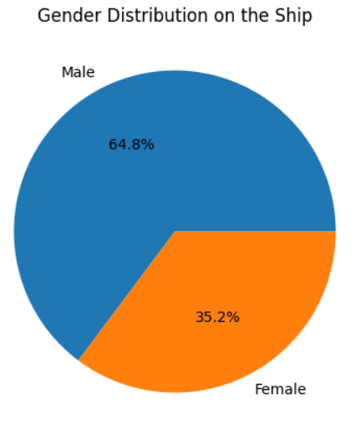

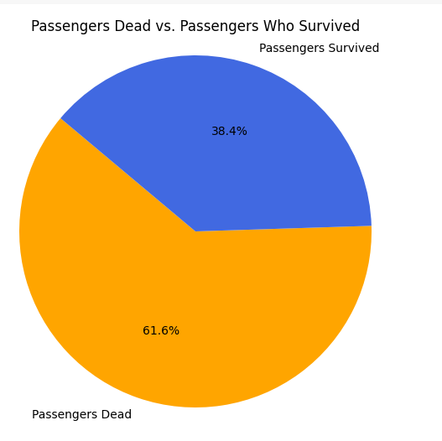

Of the **891** passengers aboard, **342** survived while **549** did not. This implies that the survival rate stood at approximately **38.4%,** while the death rate was approximately **61.6%.**

Out of the total passengers who survived, **233** were females and **109** were males. This indicates that approximately **68.1%** of the survivors were females, while about **31.9%** were males.

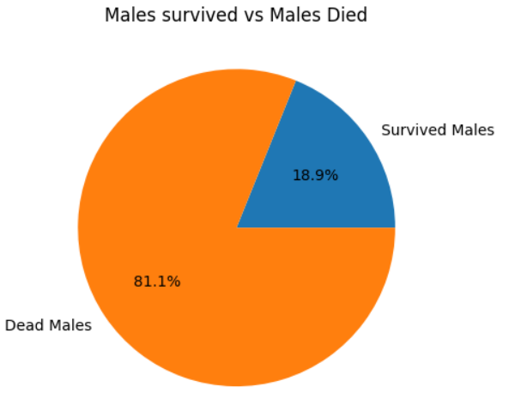

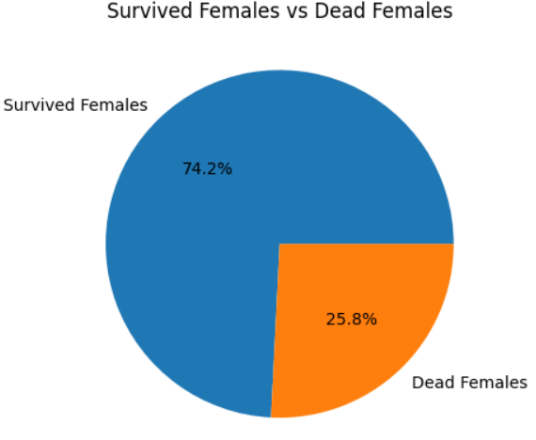

The survival rates for a**women on the ship is around 75% while that for men in around 18-19%.**

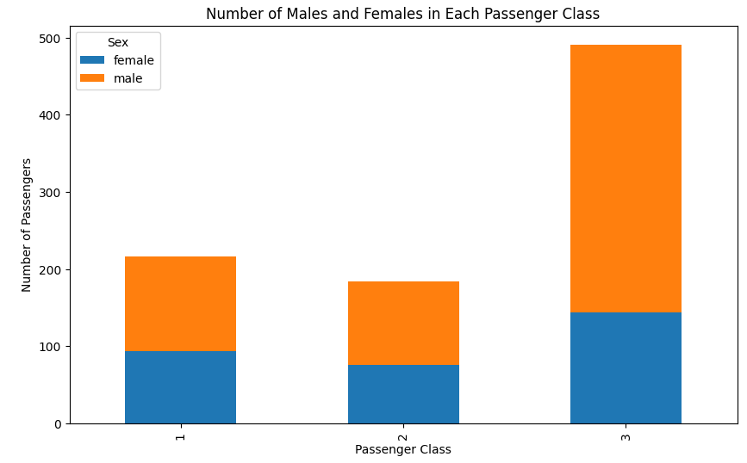

The stacked bar chart represents the distribution of male and female passengers across three passenger classes, designated as 1, 2, and 3. Notably, males outnumber females in all classes, with the discrepancy being most pronounced in the third class, which also holds the highest overall number of passengers. First and second classes have a more balanced distribution of genders but still maintain a male majority. The pattern suggests a potential socio-economic dynamic where a larger population, particularly males, travel in the lower passenger class, while higher classes attract fewer passengers overall.

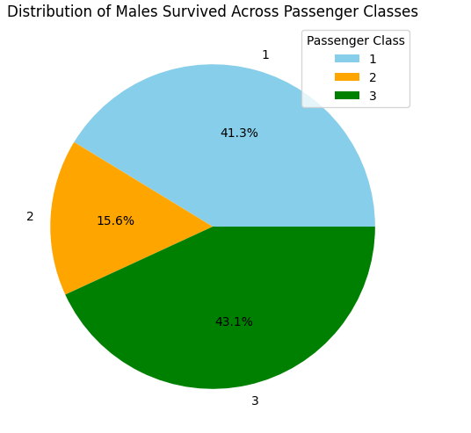

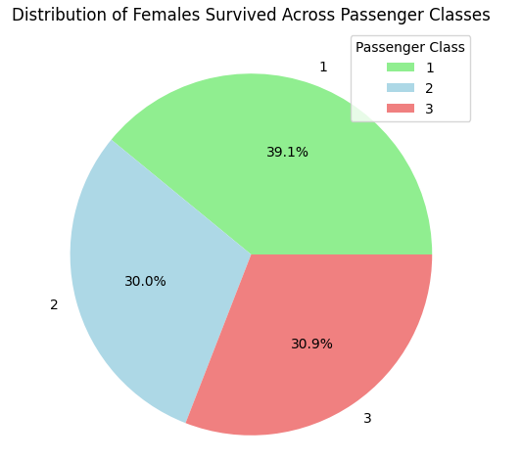

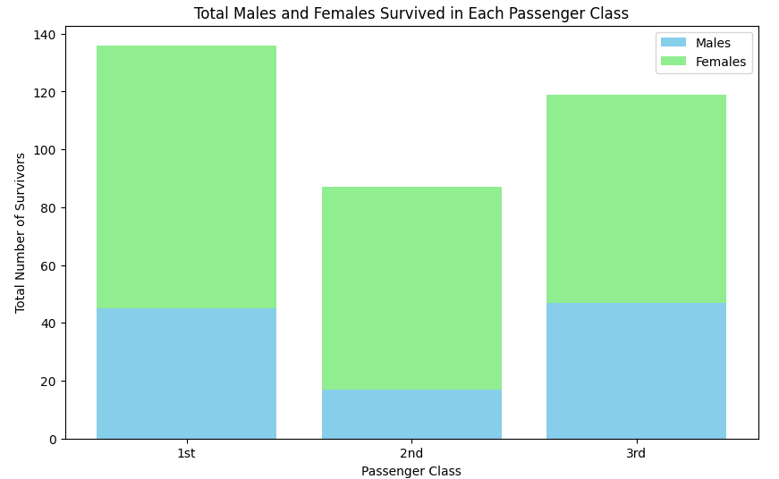

This graph indicates a higher survival rate for females than males across all passenger classes on the Titanic, with the most survivors in the 1st class, followed by the 3rd and then the 2nd. The stark disparity between male and female survivors is most pronounced in the 1st and 3rd classes, where female survivors more than double the males.

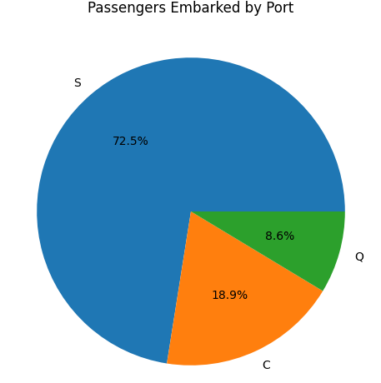

This pie chart illustrates the distribution of Titanic passengers based on their port of embarkation. The largest segment, colored blue and labeled 'S', represents 72.5% of passengers who embarked from Southampton. The second segment, in orange and labeled 'C', shows that 18.9% of passengers boarded at Cherbourg. The smallest segment, in green and labeled 'Q', indicates that 8.6% of the passengers embarked from Queenstown. The chart clearly shows that Southampton was the primary port of departure for the majority of the passengers.

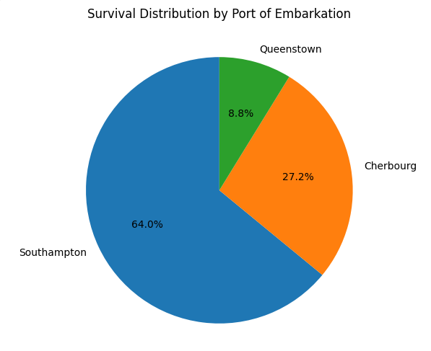

217 passengers who got on the ship at Southampton (S) made it through. 93 passengers who boarded at Cherbourg (C) survived. 30 passengers who embarked from Queenstown (Q) also survived.

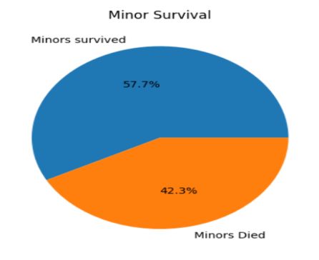

There were 78 kids on the ship. Only 45 of them made it.

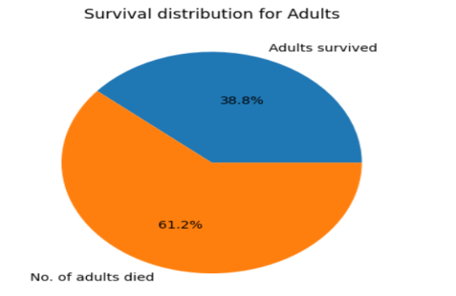

There were 726 grown-ups on the ship, but only 265 survived. 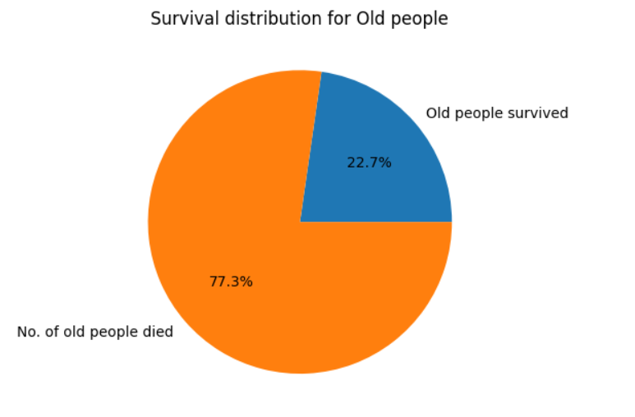

There were 22 elderly folks on the ship, but sadly only 5 lived through.

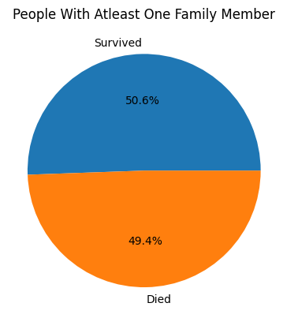

The number of people who had family members aboard was 354. Out of those, only 175 survived.

**Conclusion:**

* The dataset presents a greater proportion of male passengers in comparison to their female counterparts.
* First-class passengers exhibited a superior survival rate relative to those in second and third classes.
* Children displayed markedly higher survival rates in contrast to other age demographics.
* Females demonstrated a notably superior survival rate when compared with males.
* A substantial number of toddlers, aged under five years, were rescued, indicative of their prioritization during the evacuation process.
* The demographic most impacted by fatalities fell within the age bracket of 30 to 40 years, emphasizing the tragedy's toll on adults in their prime.