

|  |  |  |  |
| --- | --- | --- | --- |
| **Academic Year** | **Module** | **Assessment Number** | **Assessment Type** |
| **A19** | [**Database Design and Implementation**](https://classroom.google.com/u/1/c/NDc0MDM3MTgwNjJa) **(ADipIT03)** | **A1** | **Individual Report** |

[Herald College Kathmandu]

Student Id : [NP03A180163]

Student Name : [Sangam Pokharel]

Section : [ADC9]

Module Leader : [Jnaneshwar Bohara]

Lecturer : [Hemanga Gautam]

Submitted on : <dd-mm-yy>

# Conceptual Data Model

## Entity Types

|  |  |
| --- | --- |
| **Entity** | **Type** |
| Student | Supertype |
| Teacher | Supertype |
| Class | Supertype |
| Assessment | Supertype |
| Subject | Supertype |
| Part time teacher | Subtype (Weak) of teacher entity |
| Full time teacher | Subtype(Weak) of teacher entity |
| Lecture class | Subtype(Weak) of class entity |
| Workshop class | Subtype(Weak) of class entity |
| Tutorial class | Subtype(Weak) of class entity |

## Relationship Types

|  |  |
| --- | --- |
| **Relation** | **Type** |
| Subject and Teacher | (One or zero) to (one or many) |
| Subject and Assessment | (zero or many) to (one or many) |
| Student and Assessment | (one or many) to (one or many) |
| Class and Student | (one or many) to (one or many) |
| Teacher and Class | (zero or many) to (one or many) |
| Full Time Teacher and Teacher | Is a relationship |
| Part Time Teacher and Teacher | Is a relationship |
| Tutorial and Class | Is a relationship |
| Lecture and Class | Is a relationship |
| Workshop and Class | Is a relationship |

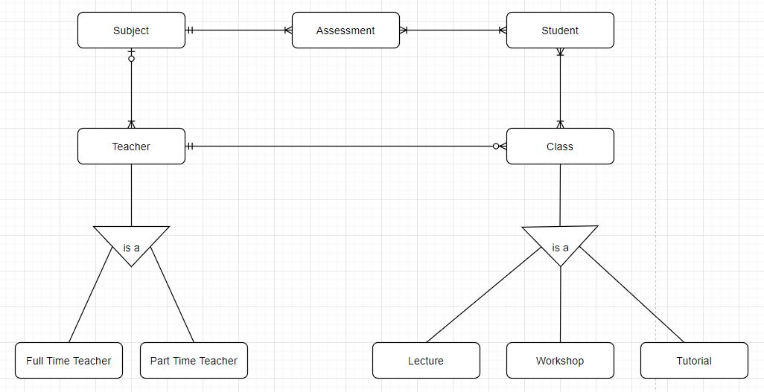

*Figure 1: Entity Relationship Diagram*

## Associating attributes with entity or relationship types

* Teacher

|  |  |
| --- | --- |
| **Attribute** | **Type** |
| Teacher_id | int(5) |

* Part Time Teacher

|  |  |
| --- | --- |
| **Attribute** | **Type** |
| part_time_teacher_id | int(5) |
| teacher_name | varchar(20) |
| teacher_DOB | date |
| teacher_joined_date | date |

|  |  |
| --- | --- |
| **Attribute** | **Type** |
| full_time_teacher_id | int(5) |
| teacher_name | varchar(20) |
| teacher_DOB | date |
| teacher_joined_date | date |

* Full Time Teacher
* Class

|  |  |
| --- | --- |
| **Attribute** | **Type** |
| class_id | int(5) |

* Lecture

|  |  |
| --- | --- |
| **Attribute** | **Type** |
| lecture_id | int(5) |
| class_location | int(5) |
| class_level | int(5) |
| class_time | varchar(10) |
| class_day | varchar(10) |

* Workshop

|  |  |
| --- | --- |
| **Attribute** | **Type** |
| workshop_id | int(5) |
| class_location | int(5) |
| class_level | int(5) |
| class_time | varchar(10) |
| class_day | varchar(10) |

* Tutorial

|  |  |
| --- | --- |
| **Attribute** | **Type** |
| tutorial_id | int(5) |
| class_location | int(5) |
| class_level | int(5) |
| class_time | varchar(10) |
| class_day | varchar(10) |

* Student

|  |  |
| --- | --- |
| **Attribute** | **Type** |
| student_id | int(5) |
| student_name | varchar(20) |
| student_DOB | date |
| student_joining_date | date |

* Assessment

|  |  |
| --- | --- |
| **Attribute** | **Type** |
| assessment_id | int(5) |
| assessment_type | varchar(10) |
| marks_obtained | int(10) |

* Subject

|  |  |
| --- | --- |
| **Attribute** | **Type** |
| subject_id | int(5) |
| subject_name | varchar(20) |

## Attribute Domain

* Teacher

|  |  |  |
| --- | --- | --- |
| **Attribute** | **Type** | **Domain** |
| teacher_id | int(5) | 1-99 |

* Part Time Teacher

|  |  |  |
| --- | --- | --- |
| **Attribute** | **Type** | **Domain** |
| part_time_teacher_id | int(5) | 1-99 |
| teacher_name | varchar(20) | (a-z), (A-Z) |
| teacher_DOB | date | Date |
| teacher_joined_date | date | Date |

* Full Time Teacher

|  |  |  |
| --- | --- | --- |
| **Attribute** | **Type** | **Domain** |
| full_time_teacher_id | int(5) | 1-99 |
| teacher_name | varchar(20) | (a-z), (A-Z) |
| teacher_DOB | date | Date |
| teacher_joined_date | date | Date |

* Class

|  |  |  |
| --- | --- | --- |
| **Attribute** | **Type** | **Domain** |
| class_id | int(5) | 1-99 |

* Lecture

|  |  |  |
| --- | --- | --- |
| **Attribute** | **Type** | **Domain** |
| lecture_id | int(5) | 1-99 |
| class_location | int(5) | (a-z),(A-Z) |
| class_level | int(5) | 1-10 |
| class_time | varchar(10) | Time |
| class_day | varchar(10) | (a-z),(A-Z) |

* Workshop

|  |  |  |
| --- | --- | --- |
| **Attribute** | **Type** | **Domain** |
| workshop_id | int(5) | 1-99 |
| class_location | int(5) | (a-z),(A-Z) |
| class_level | int(5) | 1-10 |
| class_time | varchar(10) | Time |
| class_day | varchar(10) | (a-z),(A-Z) |

* Tutorial

|  |  |  |
| --- | --- | --- |
| **Attribute** | **Type** | **Domain** |
| tutorial_id | int(5) | 1-99 |
| class_location | int(5) | (a-z),(A-Z) |
| class_level | int(5) | 1-10 |
| class_time | varchar(10) | Time |
| class_day | varchar(10) | (a-z),(A-Z) |

* Student

|  |  |  |
| --- | --- | --- |
| **Attribute** | **Type** | **Domain** |
| student_id | int(5) | 1-999 |
| student_name | varchar(20) | (a-z), (A,Z) |
| student_DOB | date | Dd/mm/yy |
| student_joining_date | date | Dd/mm/yy |

* Assessment

|  |  |  |
| --- | --- | --- |
| **Attribute** | **Type** | **Domain** |
| assessment_id | int(5) | 1-99 |
| assessment_type | varchar(10) | (a-z),(A-Z) |
| marks_obtained | int(10) | 1-100 |

* Subject

|  |  |  |
| --- | --- | --- |
| **Attribute** | **Type** | **Domain** |
| subject_id | int(5) | 1-99 |
| subject_name | varchar(20) | (a-z), (A-Z) |

## Candidate, primary, and alternate key attributes

|  |  |  |  |
| --- | --- | --- | --- |
| **Table Name** | **Primary key** | **Candidate key** | **Alternate key** |
| Student | student_id | student_id |  |
| Teacher | teacher_id | teacher_id |  |
| Class | class_id | class_id |  |
| Assessment | assessment_id | assessment_id |  |
| Full Time teacher | full_time_teacher_id | full_time_teacher_id |  |
| Part Time Teacher | part_time_teacher_id | part_time_teacher_id |  |
| Lecture | lecture_id | lecture_id |  |
| Tutorial | tutorial_id | tutorial_id |  |
| Workshop | workshop_id | workshop_id |  |
| Assessment | assessment_id | assessment_id |  |

# Validation of logical data model

### Relations for logical data model

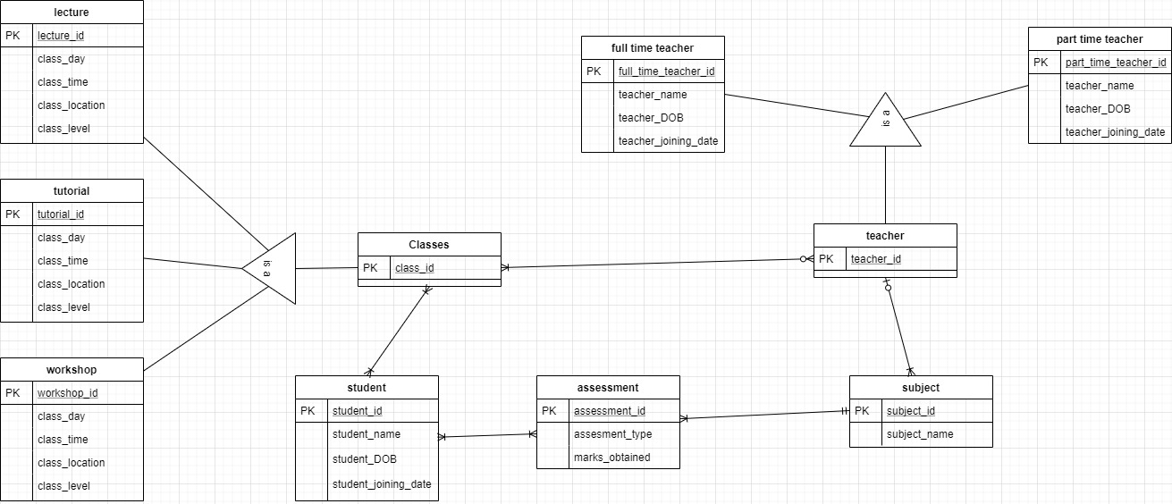

*Figure 2: Relations for logical data model*

## Validate Relations using normalization

## normalization.jpg

*Figure 3: Relations using normalization*

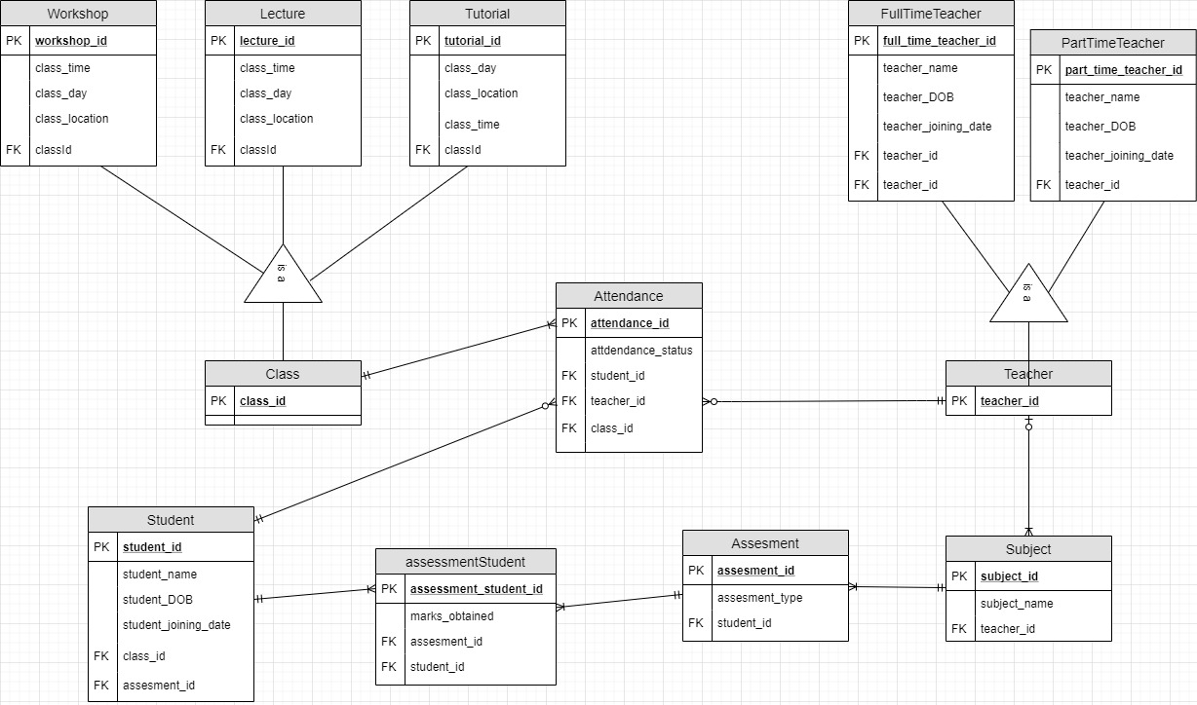

*Figure 4: validating relations using normalization*