Q. 1. Take a input integer n.

2. Generate output as Square of 1 to n integers in list.

Example:

x=5

Output:

[1,4,9,16,25]

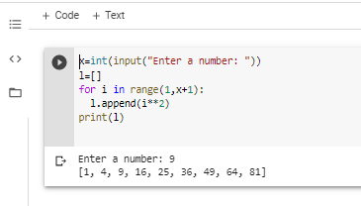

Q. Create a function to generate a list of the first Fibonacci numbers, 0 being the first number. Then, cube each Fibonacci number and

print and return the list.

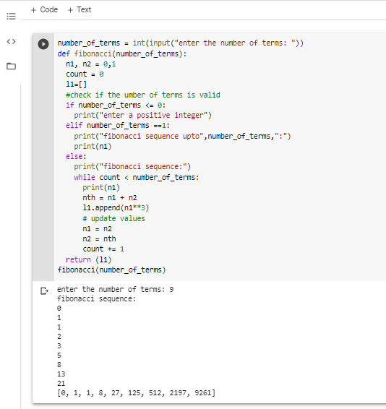

Q. Check whether a given number is prime or not.

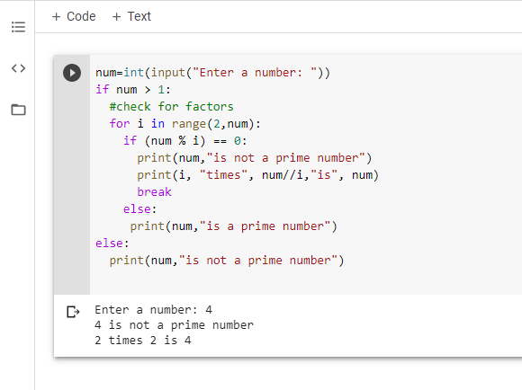

Q. Stages of Life: Write an if - elif - else chain that determines a person’s stage of life. Set a value for the

variable age , and then:

1. If the person is less than 13, print a message that the person is a kid.

2. If the person is at least 13 years old but less than 20, print a message that the person is a teenager.

3. If the person is at least 20 years old but less than 65, print a message that the person is an adult.

4. If the person is age 65 or older, print a message that the person is an elder.

