Bayesian Analysis for the Gender, Status, and Emotions Project - Study 1

Suzanne Hoogeveen1 & Julia M. Haaf1

1 University of Amsterdam

Version 1, 03/2021

Author note

Correspondence concerning this article should be addressed to Suzanne Hoogeveen, . E-mail: [suzanne.j.hoogeveen@gmail.com](mailto:suzanne.j.hoogeveen@gmail.com)

Abstract

*Keywords:*

Bayesian Analysis for the Gender, Status, and Emotions Project - Study 1

# Theoretical Perspectives

1. The *Gender Stereotyping* perspective predicts female managers suffer backlash and decrements in status for expressing anger because they have violated prescriptive norms (Brescoll & Uhlmann, 2008).
2. The *Status Signaling* perspective predicts that anger projects dominance and status for both men and women.
3. The *Cultural Change* perspective predicts that anger expressions lead to favorable evaluations of women relative to men, due to exposure to feminist messages. (Effects are driven by internal motivations and beliefs related to gender inequality, and female evaluators should be more likely to exhibit reverse gender biases, since women are more likely to support #MeToo and feminist beliefs.)
4. The *Study Savviness* perspective similarly predicts that angry women are favorably evaluated, but due to awareness of the study topic, external motivation not to appear prejudiced, and previous research experience. (Effects are driven by external motivations related to self-presentation goals to avoid appearing sexist, and should apply to male participants more so than female participants, since the former are more concerned about appearing sexist.)
5. The *Cultural Differences* perspective predicts that anger may have positive effects in Western cultures but negative effects in more harmony-oriented Eastern cultures.

These theoretical perspectives lead to the following predictions:

1. Anger increases status conferral to male targets across all cultures, and decreases status conferral to female targets across all cultures.
2. Anger increases status conferral to all targets across all cultures.
3. Anger increases status conferral to female targets only, across all cultures, and female targets are generally accorded more status.
4. Anger increases status conferral to female targets only, across all cultures, and female targets are generally accorded more status.
5. Anger increases status conferral to all targets, for all raters in Western societies, and decreases status conferral to all targets, for all raters in Eastern societies.

Note that perspectives 3 and 4 predict the same general pattern. Only in the follow-up moderation analyses will we be able to separate between these two perspectives.

# Methods

## Participants

For the primary analyses, we included the full sample of 3563 participants who completed the relevant measures for the main analyses. Participants from Iran are excluded from these main analyses, as they could not be readily classified as culturally ‘Westsern’ or ‘Eastern’.

## Material

As preregistered, we assessed the reliablity of the individual differences scale by calculating Cronbach’s alpha. All five scales were internally consistent and surpassed the threshold of alpha > 0.4; the alpha values were 0.84 (news exposure scale), 0.84 (internal motivation not to be sexist), 0.86 (beliefs about gender inequality in the workplace), 0.78 (sexist beliefs), and 0.85 (external motivation not to appear sexist). The variable *number of studies previously participated in* was heavily right-skewed and was therefore binned into 6 groups: “0”, “1-2”, “3-5”, “6-10”, “11-20”, “20+”.

## Procedure

## Data analysis

All analyses were conducted in R.[1] We constructed hierarchical Bayesian regression models that reflect the predictions from the 5 substantive theories[2], as well as the null-model and an unconstrained model that includes all main parameters from the separate theories, which are free to vary in size and direction. In the primary analysis, we used different ordinal constraints to capture the different theoretical predictions (see Appendix for details). The relative predictive adequacy of these models as well as the unconstrained model was compared using Bayes factors, following the approach by Haaf and Rouder (2017), Rouder, Haaf, Davis-Stober, and Hilgard (2019) and Haaf, Klaassen, and Rouder (2018).

In addition, we assessed the robustness of the findings to somewhat arbitrary analysis decisions by conducting a multiverse analysis (Steegen, Tuerlinckx, Gelman, & Vanpaemel, 2016): We intended to apply different data exclusion criteria related to language experience, a manipulation check, and the validity of responses (straigthlining on the included scales). However, as described below, the language experience and straightlining criteria did not affect a substantial proportion of the sample (less than 2%) and were thus omitted as separate paths in the multiverse analysis. This meant that we only used one robustness check in which we excluded participants who incorrectly recalled the gender of the target. The preregistration for the analysis can be found at .

***Prior settings.*** We think small effects in the predicted direction may still be meaningful, especially with regard to gender bias where small biases can accumulate in terms of their consequences over time. We therefore used a scale of 0.25 for the effect of interest. A scale of 0.25 assumes an size effect that is 25% of the sampling noise (standard deviation), which is generally considered a small effect. For the variation between labs in the intercepts, we used a scale of 1. In the random-effects models we used a scale of 0.15 for site-specific variation in the effects of interest.

# Results

## Manipulation check

As a manipulation check, we assessed whether the target in the *anger* condition was indeed perceived as more angry than the target in the *sadness* condition and vice versa for sadness.

The independent samples Bayesian t-test gives infinite evidence in favor of the hypothesis that targets with anger expressions are perceived as more angry than targets with sad expressions (BF, = 1.48). Similarly, the independent samples Bayesian t-test gives infinite evidence in favor of the hypothesis that targets with sadness expressions are perceived as more sad than targets with angry expressions (BF, = -1.46). See Figure 4 for a plot of the data.

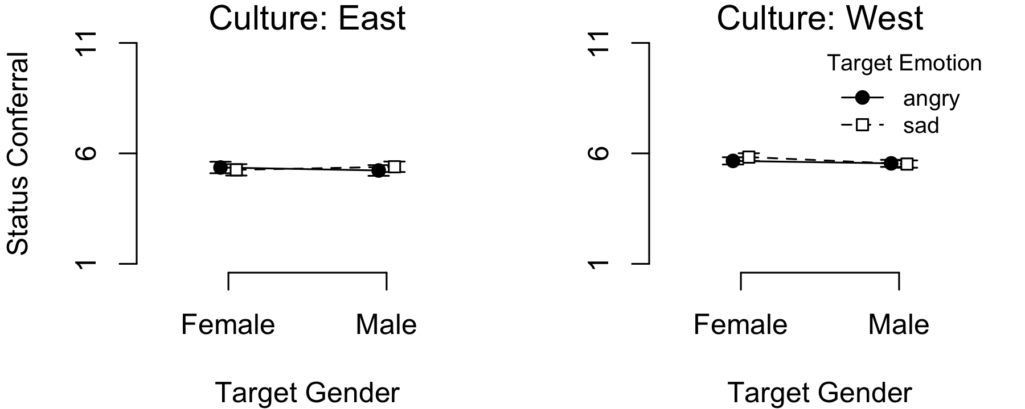

*Figure* *1.*  Status conferral per target gender, emotion, and culture.

## Bayesian Models

Table 1:

*Evidence for the null model vs. the theoretical models.*

|  |  |
| --- | --- |
| Comparison | Bayes factor |
| Null vs. Gender Stereotyping | 33.8 |
| Null vs. Status Signalling | 173 |
| Null vs. Culture Change/Study Savviness | 40.5 |
| Null vs. Cultural Differences | 95,375 |
| Null vs. Unconstrained | 10,571 |

*Note.* The Bayes factors reflect the evidence in favor of the null model (intercept only) versus the different theoretical perspectives. As becomes evident, the null model outperforms all other models.

Based on the Bayes factor model comparison, we find no evidence for any of the theoretical predictions. Instead, the data are best explained by the null-model that assumes only a varying intercept per site but no experimental effects of target gender and emotion (either as main effects or an interaction). Specifically, the null-model outperforms the Gender Stereotyping model by a factor of 33.8, the Status Signalling model by a factor of 173, the Culture Change/Study Savviness model (reversed gender stereotyping) by a factor of 40.5, and the Cultural Differences model by a factor of 95,375. Finally, the null model also fits the data much better than the unconstrained model (BF 10,571). Figure 1 and 3 visualize the absence of any experimental effect.

***Varying effects model.*** For the primary analyses, we constructed simple common effect models that assume that the effects of interest are of equal size across different sites. However, it could be that the effects differ substantially per site (or country), perhaps in a pattern that is different from that postulated by the cultural differences perspective. To explore this possibility, we also built a varying effects model that allows the main effects of target gender and target emotion, as well as the interaction, to vary between sites. Data from Iran was also included in this model.[3]

As visualized in Figure 2, however, there is no indication that the effects vary substantially across data collection sites. Rather, the 95% credible interval includes zero for across all but one site for the main effects of target gender and target emotion, as well as the interaction effect. Also note that the estimates do not suggest a difference between Western and Eastern countries with regards to any of the effects (nor a special position for Iran). Corroborating the visual pattern, the Bayes factor analysis suggests that the null-model that includes only varying intercepts strongly outperforms the unconstrained random effects model; BF 2,898.

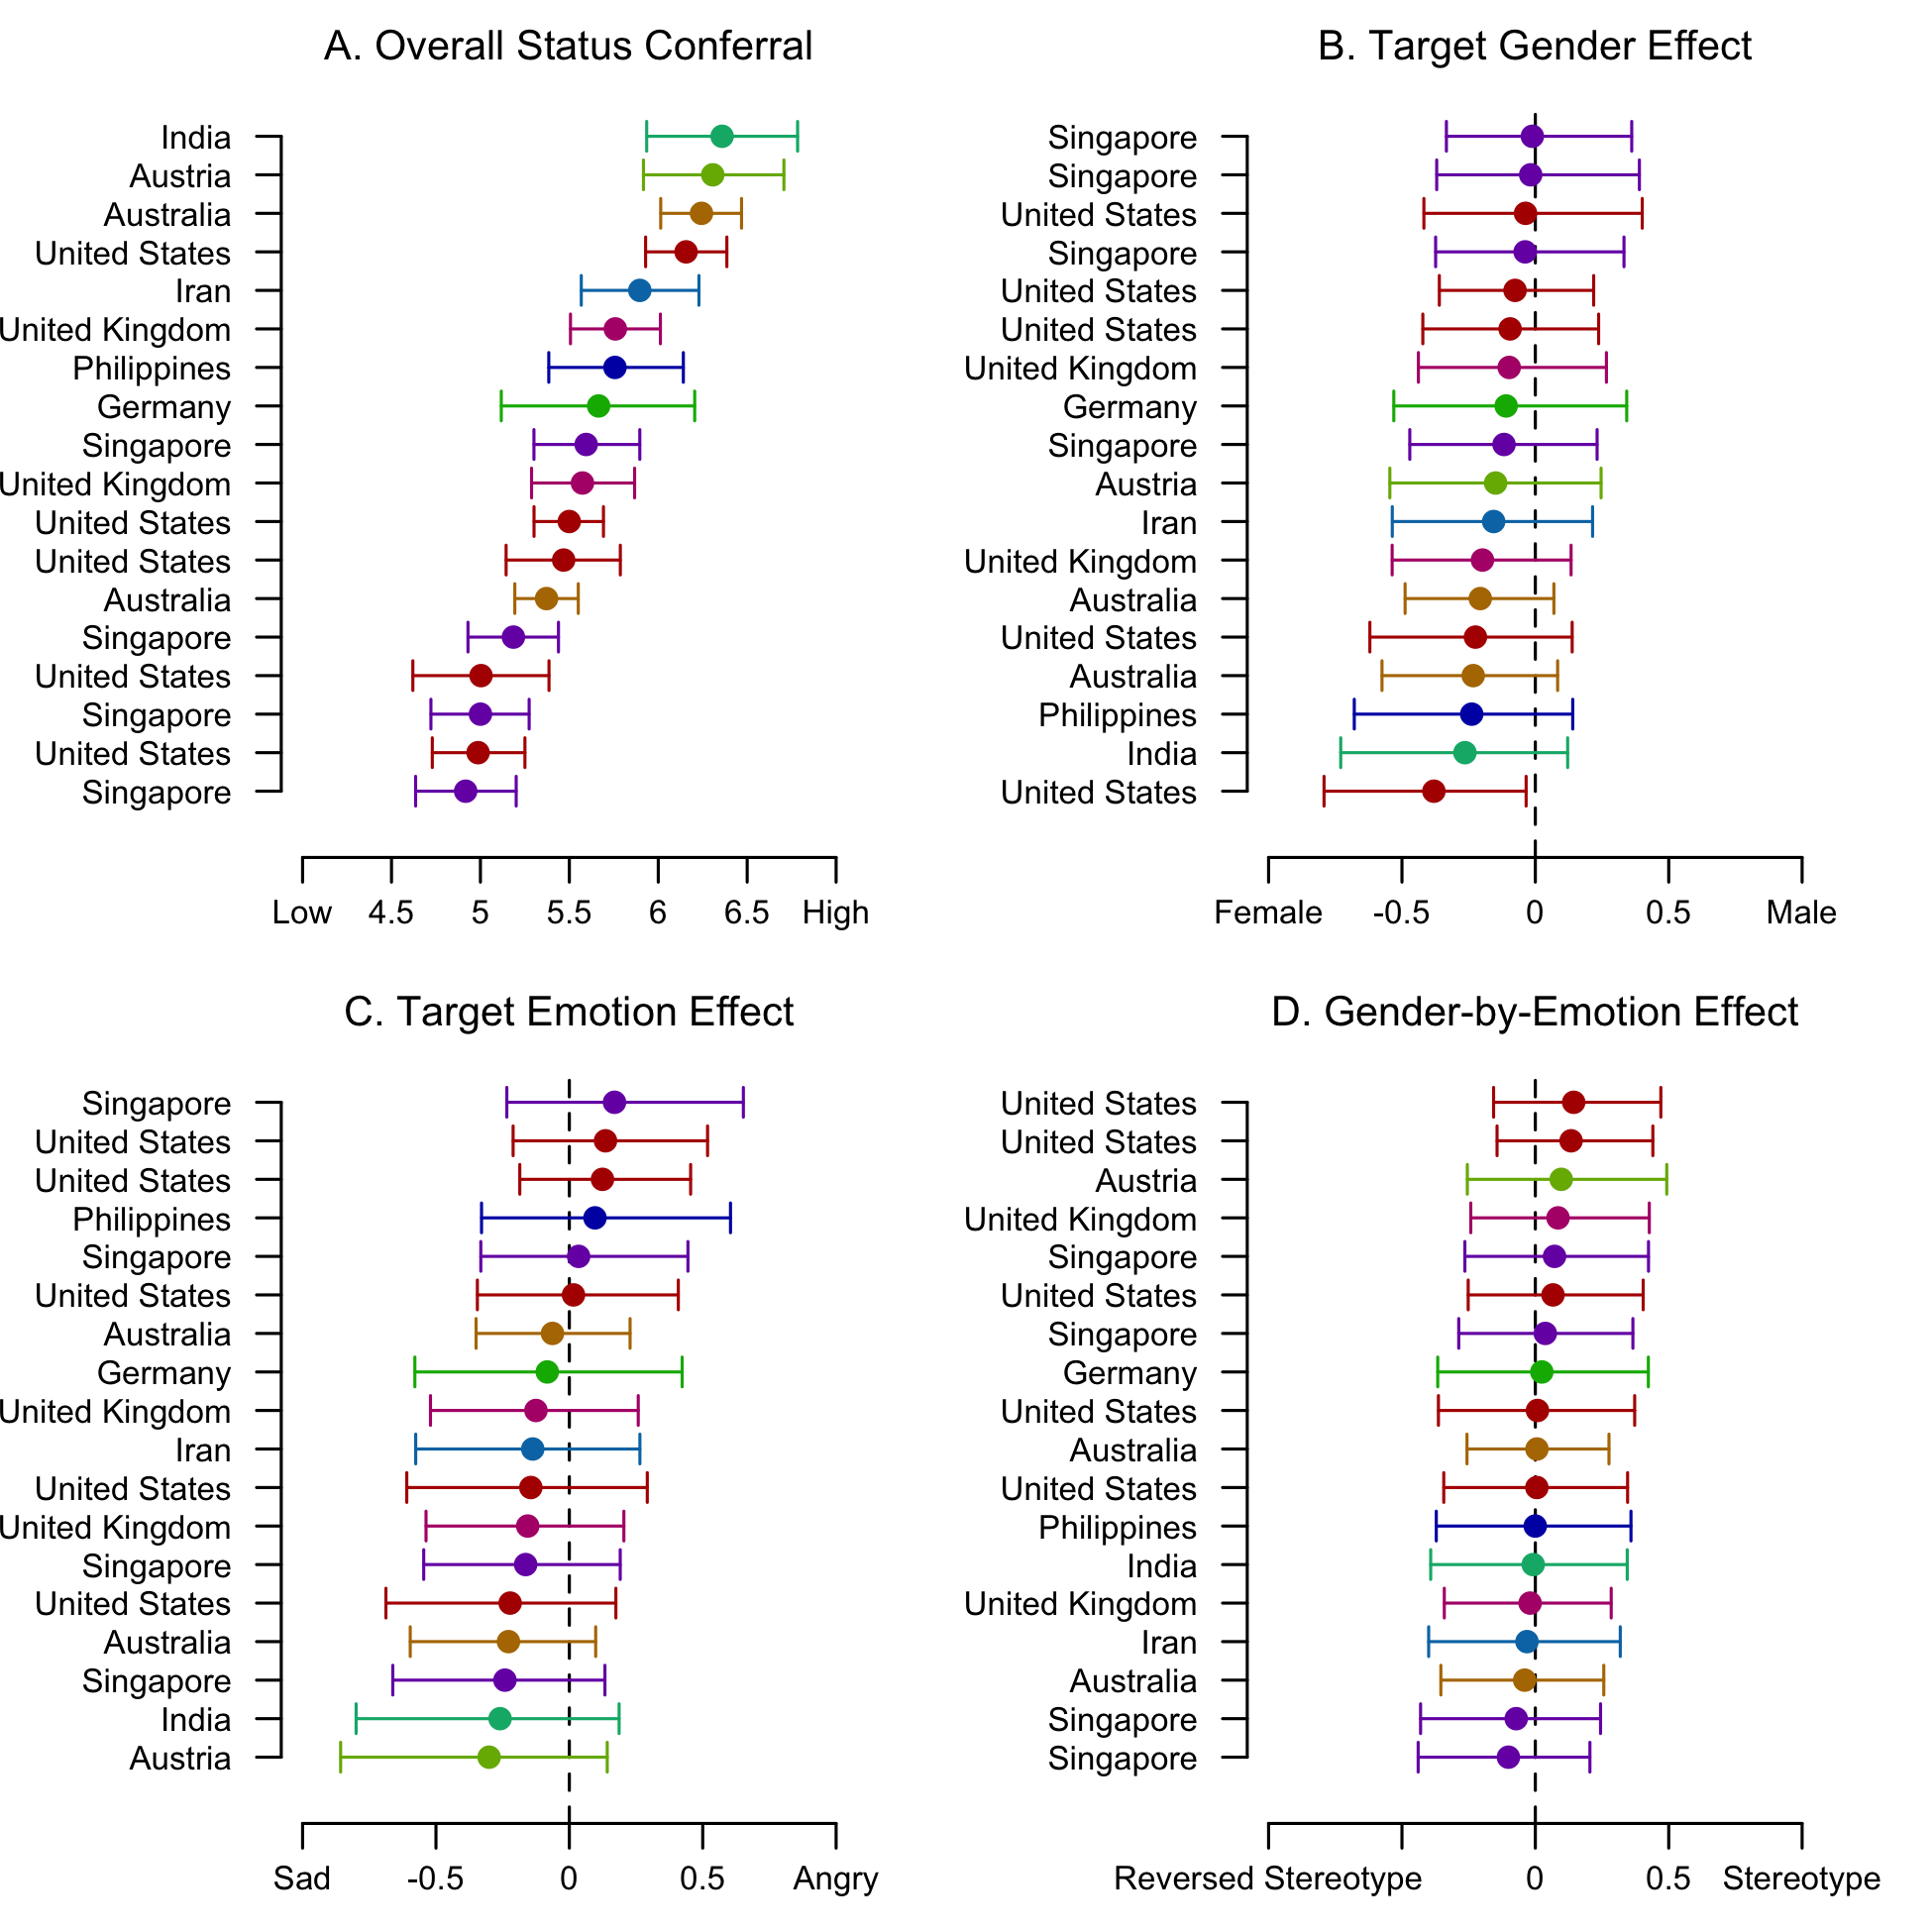

*Figure* *2.*  Estimated country-level effects (posterior means) on status conferral, in increasing order. **A.** Intercepts. **B.** Target gender effects. **C.** Target emotion effects. **D.** Gender-by-emotion interaction effects. Each dot represents a country. The horizontal lines denote the 95% credible intervals. None of the effects seem to differ from zero across countries.

## Follow-up Analyses

As preregistered, we inspected the several additional effects and analyses.

***Main effect of target.*** Are male or female targets generally accorded more status? We ran a simple independent-samples t-test to answer this question. The Bayes factor analysis provides some slight evidence in favor of the null-hypothesis that there is no difference in status conferral between male and female targets: BF 0.46; BF 2.17.

***Gender of the rater.*** Do male and female raters differentially display the main effects or interactions derived from the theoretical perspectives (e.g., do male or female raters particularly show gender stereotyping effects or reversed gender biases?). Figure 5 might suggest a hint of a threeway rater gender by target gender by target emotion interaction, such that female raters confer more status to a sad female target while male raters confer more status to an angry female target. However, the Bayes factor analysis indicates that the data is at least equally plausible under the (simple) null-model as under the (complex) moderator interaction model; BF 1.68.

***Alternative dependent variables.*** We also used competence ratings, likeability, and hiring rates as secondary dependent variables, in addition to the primary dependent variable of status conferral. Table 2 gives the results of these additional analyses. For competence ratings, the results are qualitatively similar to those of the main analysis (i.e., most evidence for the null-model). For likeability, the unconstrained model outperforms the null-model, as there is a strong main effect of emotion (in the opposite direction of the status signalling perspective): quite understandably, angry targets are liked less than sad targets. This same pattern (albeit less strongly) holds for hiring rates (see Figure 3). Also note that for hiring rates, there is some slight evidence in favor of the Gender Stereotyping perspective: the data provides 1.79 times more support for the model reflecting that sad women are preferred over angry women, while angry men are preferred over sad men compared to the null-model.

Table 2:

*Evidence for the null models vs the theoretical models for the different dependent variables.*

|  |  |  |  |  |
| --- | --- | --- | --- | --- |
| Comparison | Status | Competence | Likeability | Hiring |
| Null vs. Gender Stereotyping | 33.84 | 441.74 |  | 0.56 |
| Null vs. Status Signalling | 173.03 | 43.28 |  |  |
| Null vs. Culture Change | 40.54 | 13.01 |  |  |
| Null vs. Cultural Differences | 95,375.28 | 5,216.94 |  |  |
| Null vs. Unconstrained | 10,570.74 | 5,442.36 | 0.00 | 0.47 |

***Individual differences.*** Various individual difference moderators were included in the study in order to unpack any observed experimental effects. Specifically, scales related to beliefs about gender (in)equality as well as about self-presentation concerns were added to distinguish between perspective 3 and 4, which predict the same overall pattern of responses, yet driven by different factors.

Table 3:

*Evidence for gender equality beliefs and experimental effects on status conferral (perspective 3).*

|  |  |  |  |  |
| --- | --- | --- | --- | --- |
|  | BF | BF | BF | BF |
| Beliefs Gender Workplace |  | 88.2 | 575 | 1,098 |
| Sexist Beliefs |  | 67.4 | 3,516 | 4,421 |
| News Exposure |  | 86.4 | 358 | 706 |
| Internal Motivation |  | 111 | 214 | 415 |

*Note.* The Bayes factors reflect evidence for the individual differences only model vs the interaction effects models. BF gives the evidence for the individual differences only model (indicated by the subscript ) versus the null-model (intercept only; indicated by the subscript ). Subscript refers to the experimental effects model, subscript refers to the moderation model, and subscript refers to the unconstrained model. See text for details about the different models.

Table 4:

*Evidence for self-presentation concerns and experimental effects on status conferral (perspective 4).*

|  |  |  |  |  |
| --- | --- | --- | --- | --- |
|  | BF | BF | BF | BF |
| External Motivation No Sexism | 528 | 85.4 | 2,597 | 3,640 |
| Research Study Experience | 2.93 | 89.6 | 4,608 | 4,712 |
| Participated in Similar Study | 3,124 | 92.2 | 59.6 | 113 |
| Taken Psychology Course | 1.01 | 89.5 | 207 | 391 |
| Awareness of Target Gender |  | 68.7 | 1,691 | 2,710 |
| Awareness of Target Emotion | 0.06 | 91.0 | 786 | 1,272 |

*Note.* The Bayes factors reflect evidence for the individual differences only model vs the interaction effects models. BF gives the evidence for the individual differences only model (indicated by the subscript ) versus the null-model (intercept only; indicated by the subscript ). Subscript refers to the experimental effects model, subscript refers to the moderation model, and subscript refers to the unconstrained model. See text for details about the different models.

For the moderator analyses, we constructed different models to reflect theoretical predictions. We start again from the null-model () that includes only a random intercept per site. The second model () additionally includes the *individual differences* variable of interest (e.g., sexist beliefs) but without any experimental effects or interactions. This model might be considered the baseline model for the moderation analyses. The third model () extends the individual differences model by adding the main *experimental effects* of target emotion, target gender and its interaction. The fourth model () is the critical moderation model that adds the interaction term between the individual differences variable and target gender, as well as the threeway interaction between the individual difference variable, target gender, and target emotion. Based on the moderation hypotheses, the sign of the interaction between the moderator and target gender was restricted (e.g., sexist beliefs are expected to be associated with a *decrease* in status conferral to female targets relative to male targets). Finally, we constructed a fully unconstrained model () that includes the same terms as the moderation model but does not put any ordinal constraints on the parameters.

The results of the individual differences moderation analyses are given in Table 3 (for moderation effects related to beliefs about gender (in)equality; perspective 3) and Table 4 (for moderation effects related to self-presentation concerns and study savviness; perspective 4).[4] As the Bayes factors show, there is evidence that most of the individual difference measures are related to status conferral in general (main effects of individual differences), but strong evidence *against* moderation effects of the individual differences on the experimental target gender, target emotion, or target gender-by-emotion effects (BF).

***General public vs. students.*** Finally, we assessed whether students and adults from the general public differed in the extent to which they applied (reversed) gender stereotyping.[5] However, again the individual differences-only model (main effect of student status) outperformed all other models including those with a moderating effect of student status (BF 124; see also Figure 6).

## Multiverse Analysis

In the preregistration we specified that we would only analyze a specific exclusion-based multiverse path when the exclusion affect at least 5% of the sample. However, both the language experience criterion and the straightlining criterion did not reach this threshold; only 2.30% was excluded because they had less than 5 years of English/German experience and 1.04% was excluded because of straightlining across all 5 scales. Only the target gender manipulation check item resulted in a meaningful proportion of exclusions (13.80%).

Table 5:

*Evidence for the main analyses including only participants who correctly recalled the target gender.*

|  |  |
| --- | --- |
| Comparison | Bayes factor |
| Null vs. Gender Stereotyping | 67.3 |
| Null vs. Status Signalling | 357 |
| Null vs. Culture Change/Study Savviness | 59.9 |
| Null vs. Cultural Differences |  |
| Null vs. Unconstrained | 4,299 |

*Note.* The Bayes factors reflect the evidence in favor of the null model (intercept only) versus the different theoretical perspectives.

Table 5 gives the results of the only viable multiverse path for the main analysis in which the models corresponding to the different theoretical perspectives are compared. The pattern of results is qualitatively identical to that of the main analysis including all participants. In other words, the null-model outperforms all theory-driven models.

# Discussion

# References

Aust, F., & Barth, M. (2020). *papaja: Prepare reproducible APA journal articles with R Markdown*. Retrieved from <https://github.com/crsh/papaja>

Barth, M. (2020). *Tinylabels: Lightweight variable labels*. Retrieved from <https://CRAN.R-project.org/package=tinylabels>

Bates, D., & Maechler, M. (2021). *Matrix: Sparse and dense matrix classes and methods*. Retrieved from <https://CRAN.R-project.org/package=Matrix>

Brescoll, V. L., & Uhlmann, E. L. (2008). Can an Angry Woman Get Ahead?: Status Conferral, Gender, and Expression of Emotion in the Workplace. *Psychological Science*, *19*, 268–275. doi:[10.1111/j.1467-9280.2008.02079.x](https://doi.org/10.1111/j.1467-9280.2008.02079.x)

Haaf, J. M., Klaassen, F., & Rouder, J. N. (2018). Capturing Ordinal Theoretical Constraint in Psychological Science. *PsyArXiv*. doi:[10.31234/osf.io/a4xu9](https://doi.org/10.31234/osf.io/a4xu9)

Haaf, J. M., & Rouder, J. N. (2017). Developing constraint in Bayesian mixed models. *Psychological Methods*, *22*, 779–798. doi:[10.31234/osf.io/ktjnq](https://doi.org/10.31234/osf.io/ktjnq)

Long, J. A. (2019). *Interactions: Comprehensive, user-friendly toolkit for probing interactions*. Retrieved from <https://cran.r-project.org/package=interactions>

Morey, R. D., & Rouder, J. N. (2018). *BayesFactor: Computation of bayes factors for common designs*. Retrieved from <https://CRAN.R-project.org/package=BayesFactor>

Pedersen, T. L. (2020). *Patchwork: The composer of plots*. Retrieved from <https://CRAN.R-project.org/package=patchwork>

Plummer, M., Best, N., Cowles, K., & Vines, K. (2006). CODA: Convergence diagnosis and output analysis for mcmc. *R News*, *6*(1), 7–11. Retrieved from <https://journal.r-project.org/archive/>

R Core Team. (2020). *R: A language and environment for statistical computing*. Vienna, Austria: R Foundation for Statistical Computing. Retrieved from <https://www.R-project.org/>

Rouder, J. N., Haaf, J. M., Davis-Stober, C. P., & Hilgard, J. (2019). Beyond overall effects: A Bayesian approach to finding constraints in meta-analysis. *Psychological Methods*, *24*, 606–621. doi:[10.1037/met0000216](https://doi.org/10.1037/met0000216)

Steegen, S., Tuerlinckx, F., Gelman, A., & Vanpaemel, W. (2016). Increasing Transparency Through a Multiverse Analysis. *Perspectives on Psychological Science*, *11*, 702–712. doi:[10.1177/1745691616658637](https://doi.org/10.1177/1745691616658637)

Wickham, H. (2016). *Ggplot2: Elegant graphics for data analysis*. Springer-Verlag New York. Retrieved from <https://ggplot2.tidyverse.org>

Wickham, H., François, R., Henry, L., & Müller, K. (2021). *Dplyr: A grammar of data manipulation*. Retrieved from <https://CRAN.R-project.org/package=dplyr>

Wickham, H., & Seidel, D. (2020). *Scales: Scale functions for visualization*. Retrieved from <https://CRAN.R-project.org/package=scales>

Zhu, H. (2020). *KableExtra: Construct complex table with ’kable’ and pipe syntax*. Retrieved from <https://CRAN.R-project.org/package=kableExtra>

# Appendix

## Model Specification

1. Null Model: angry men, sad men, angry women and sad women are all accorded equal status.

Let be the status rating of the th lab, the th participant in the th target gender condition (, for female and male targets, respectively) and the th target emotion condition (, for sadness and anger expressions, respectively). Then

where is the baseline status conferral rating for th lab.

1. Gender Stereotyping: while angry men are accorded higher status than sad men, angry women are accorded lower status than sad women.
2. where parameter is the effect of the target gender, parameter is the effect of the target emotion, and parameter is the gender-by-emotion interaction effect. Effect coding is used to quantify the different conditions. The indicator variables are (-1/2 for female targets and 1/2 for male targets), (-1/2 for sadness and 1/2 for anger), and (-1/2 for angry women and sad men, 1/2 for sad women and angry men).

The ordinal constraints based on the theoretical perspective are put on the cell means, rather than on the parameters. Specifically, the cell mean of the angry men condition needs to be higher than the sad men condition and the cell mean of the sad women condition needs to be higher than the cell mean of the angry women condition. Cell means are calculated based using the estimated parameters; for the sad women condition, for instance, this results in the following:

To satisfy the theoretical predictions, the following inequality constraints have to hold:

1. Status Signaling: angry men are accorded higher status than sad men and angry women are accorded higher status than sad women.

The status signaling perspective applies the same model and parameters as the gender stereotyping model. Here, the cell mean of the angry men condition needs to be higher than the sad men condition and the cell mean of the angry women condition needs to be higher than the cell mean of the sad women condition. To meet this condition, the following inequality constraints have to hold:

1. Culture Change/ Study Savviness: angry women are accorded more status than sad women, angry men and sad men. There is no effect of emotion for men.
2. where parameter is the effect of emotion for female targets, parameter is the effect of angry women versus men (both sad and angry). The indicator variables are (-1/2 for sad female targets and 1/2 for angry female targets, and 0 for men) and (-1/3 for men, 2/3 for angry women and 0 for sad women).

The theoretical perspective entails that the cell mean of the angry women condition needs to be higher than the sad women condition and higher than the cell means of the angry men and the sad men conditions. To meet this condition, we will put inequality constraints on the parameters:

1. Cultural Differences: in Western cultures, angry men and women are accorded more status than sad men and women, while in Eastern cultures, sad men and women are accorded more status than angry men and women.  
   This model builds on the model for perspectives 2 and 3 and is extended by parameters for the main effect and interactions of culture (with , for Western and Eastern cultures, respectively):

where the additional parameter is the effect of culture, parameter is the culture-by-gender interaction effect, parameter is the culture-by-emotion interaction effect, and parameter is the culture-by-gender-by-emotion three-way interaction. The additional indicator variables are (-1/2 for Western cultures and 1/2 for Eastern cultures), (-1/2 for men in Western cultures and women in Eastern cultures, and 1/2 for women in Western cultures and men in Eastern cultures), (-1/2 for anger in Western cultures and sadness in Eastern cultures, and 1/2 for sadness in Western cultures and anger in Eastern cultures), and (-1/2 for sad women and angry men in Western cultures and angry women and sad men in Eastern cultures, and 1/2 for angry women and sad men in Western cultures and sad women and angry men in Eastern cultures).

The ordinal constraints are again put on the cell means, rather than on the parameters. Specifically, the cell mean of the angry men condition needs to be higher than the sad men condition and the cell mean of the sad women condition needs to be higher than the cell mean of the angry women condition. Cell means are calculated using the estimated parameters; for the sad women in Western cultures condition, for instance, this results in the following: .

To satisfy the theoretical ordinal constraints, the following has to hold:

1. Unconstrained model: all effects are included, without any ordinal constraints (this is the same model as in perspective 4).

## Additional Figures

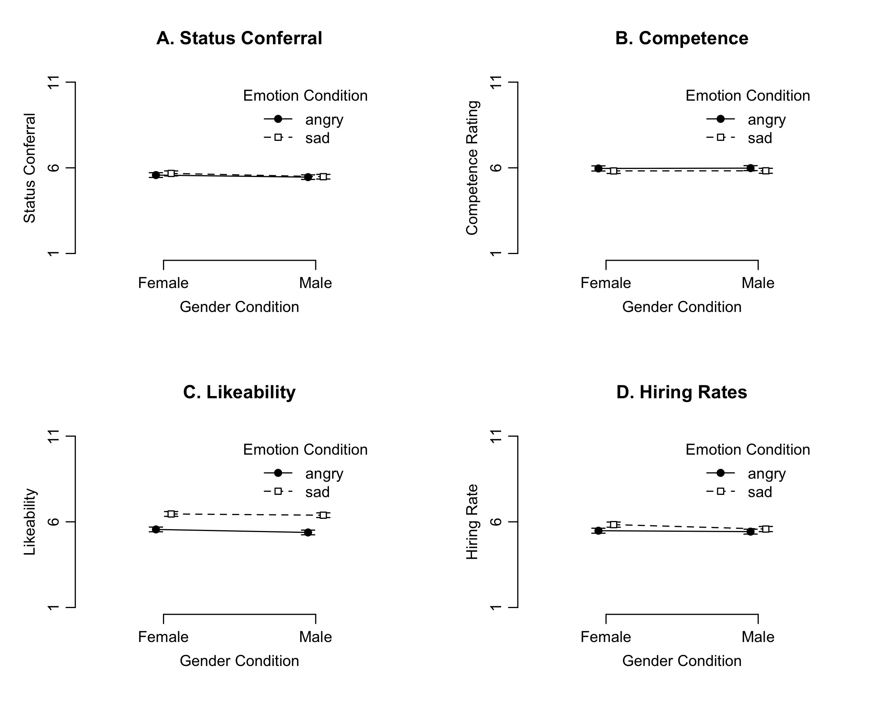

*Figure* *3.*  Descriptive plots of **A.** status conferral, **B.** competence, **C.** likeability, and **D.** hiring rates per target gender and emotion.

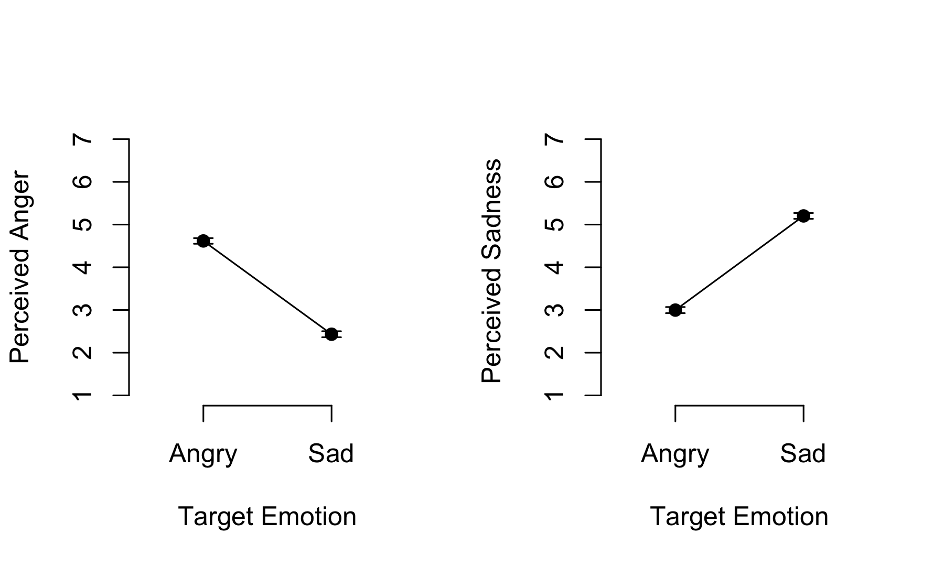

*Figure* *4.*  Manipulation checks.

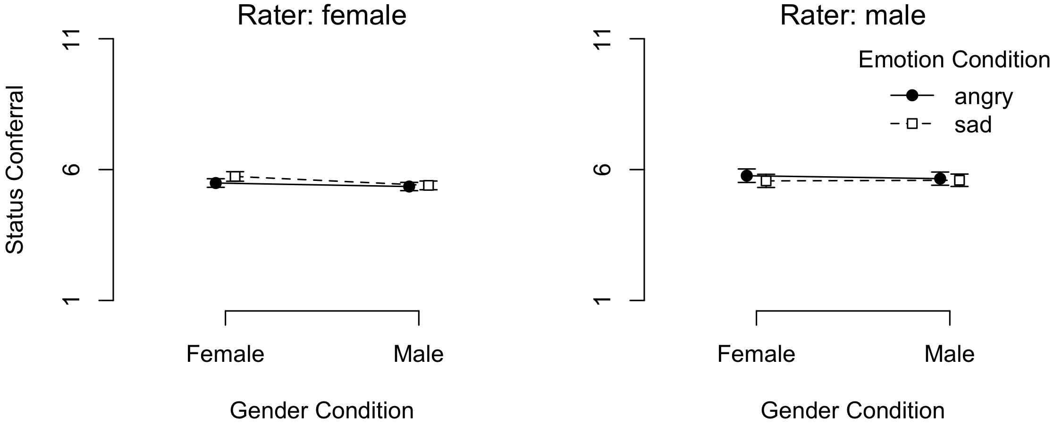

*Figure* *5.*  Status conferral per target gender, emotion, and rater gender.

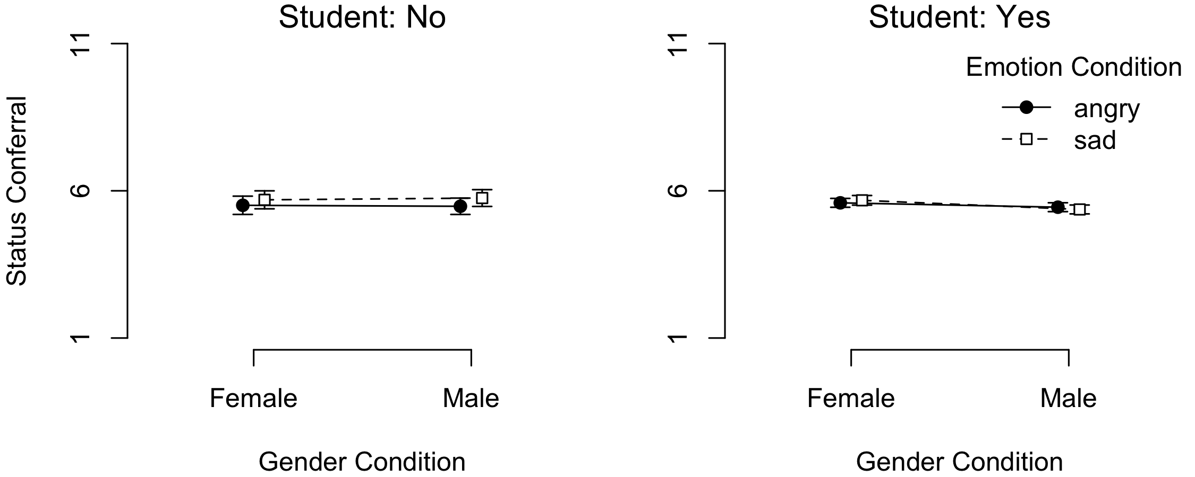

*Figure* *6.*  Status conferral per target gender, emotion, and student status.

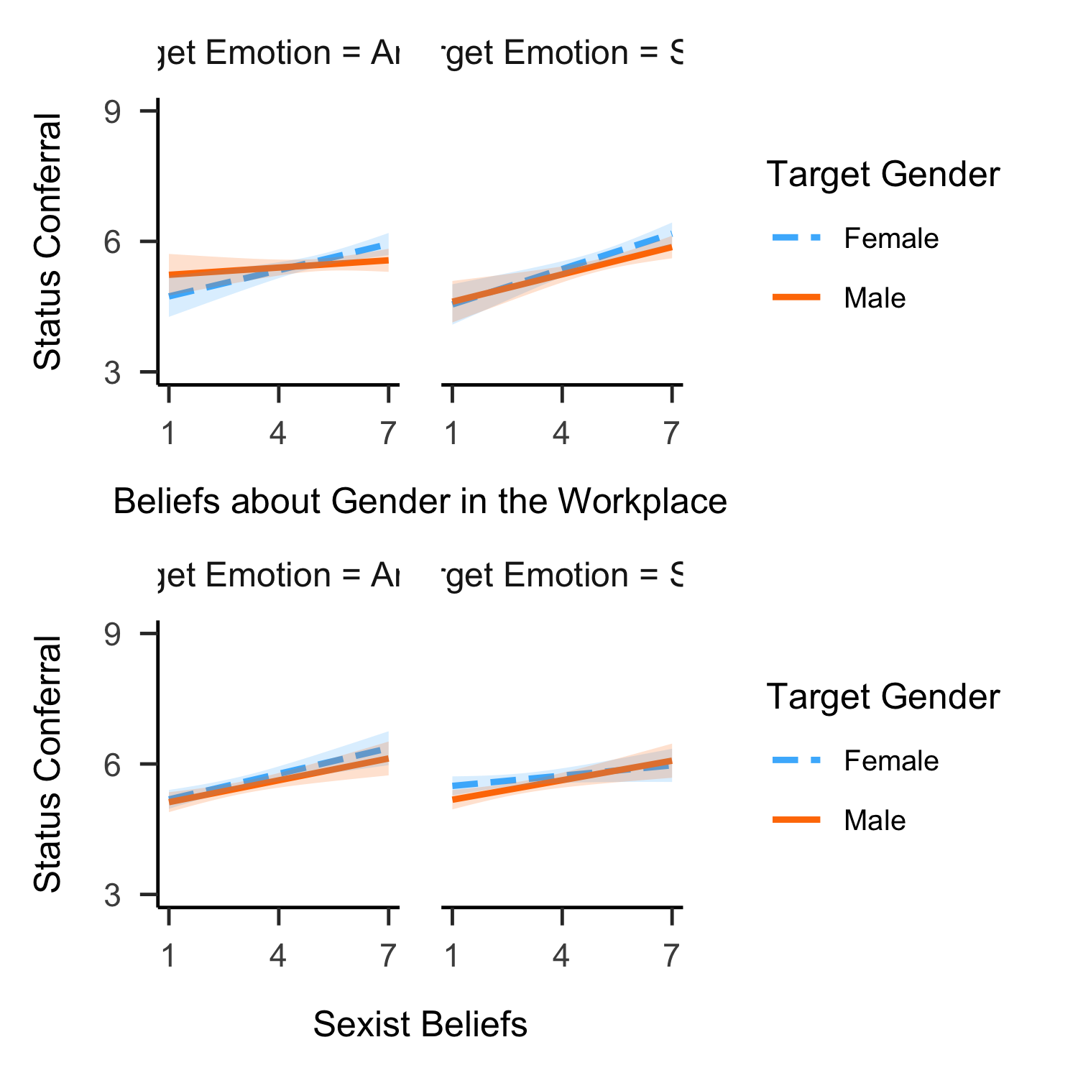

*Figure* *7.*  Moderation effects of beliefs about gender equality on status conferral.

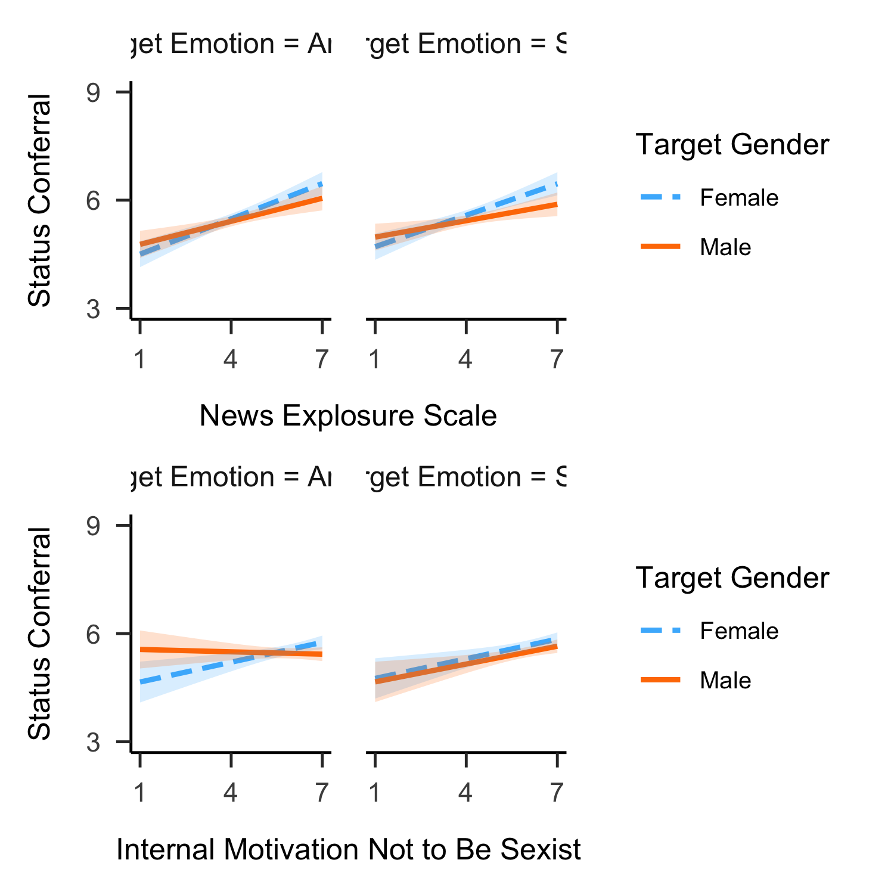

*Figure* *8.*  Moderation effects of beliefs about gender equality on status conferral.

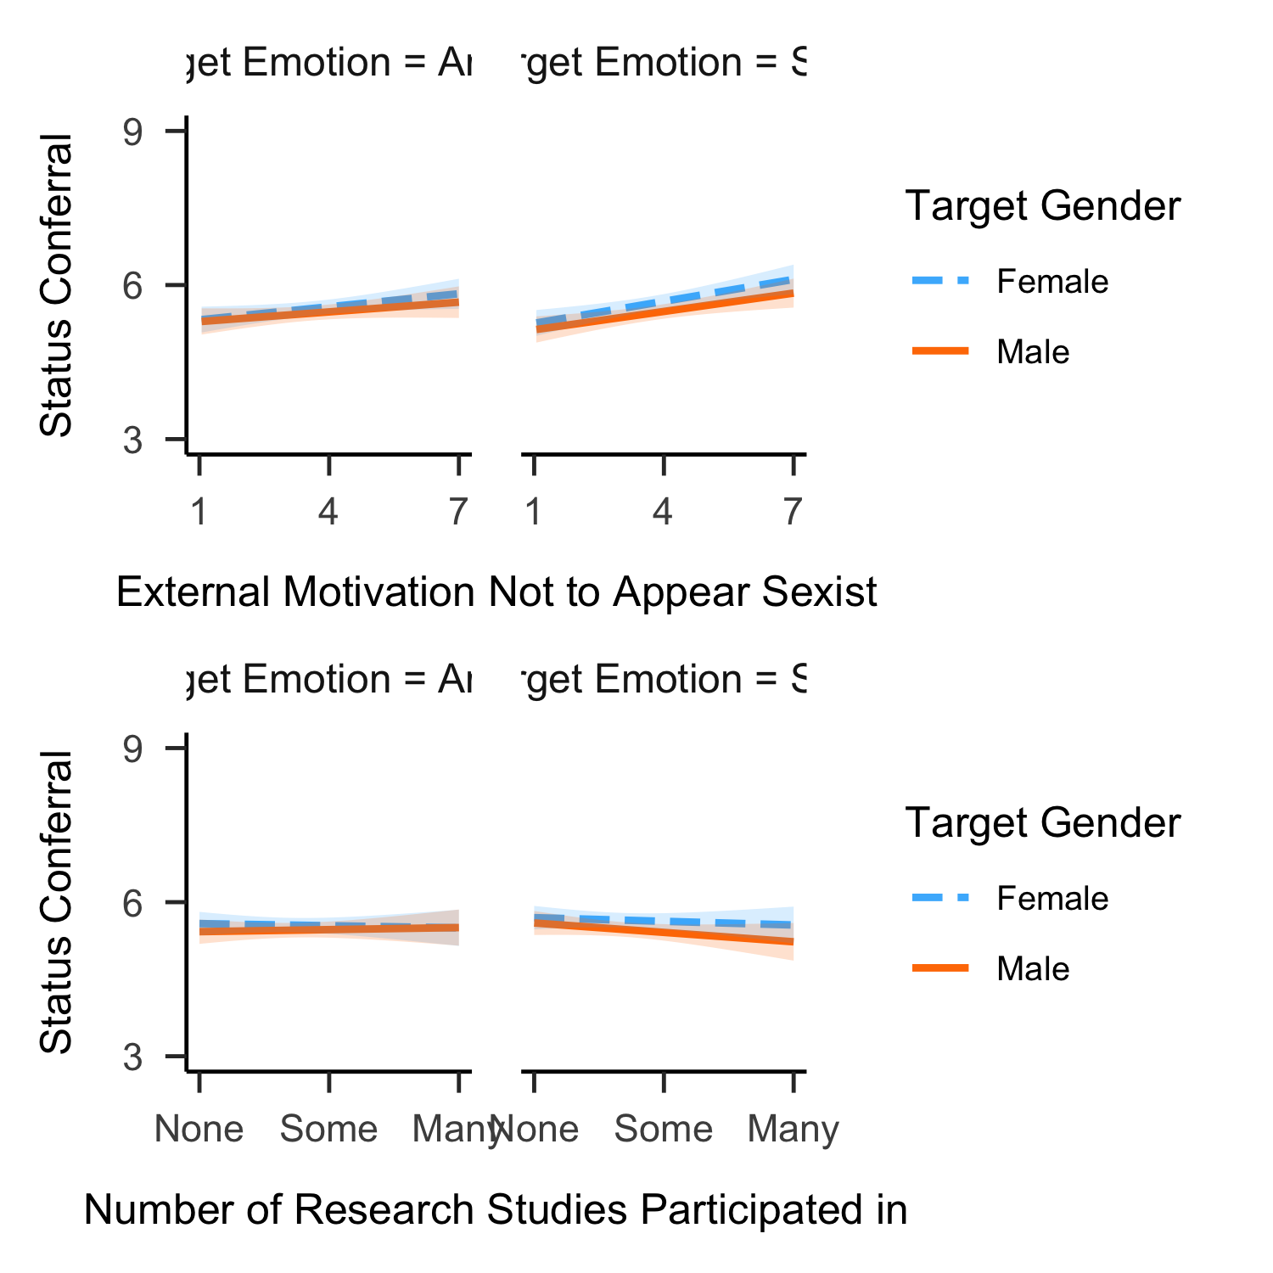

*Figure* *9.*  Moderation effects of self-presentation goals on status conferral.

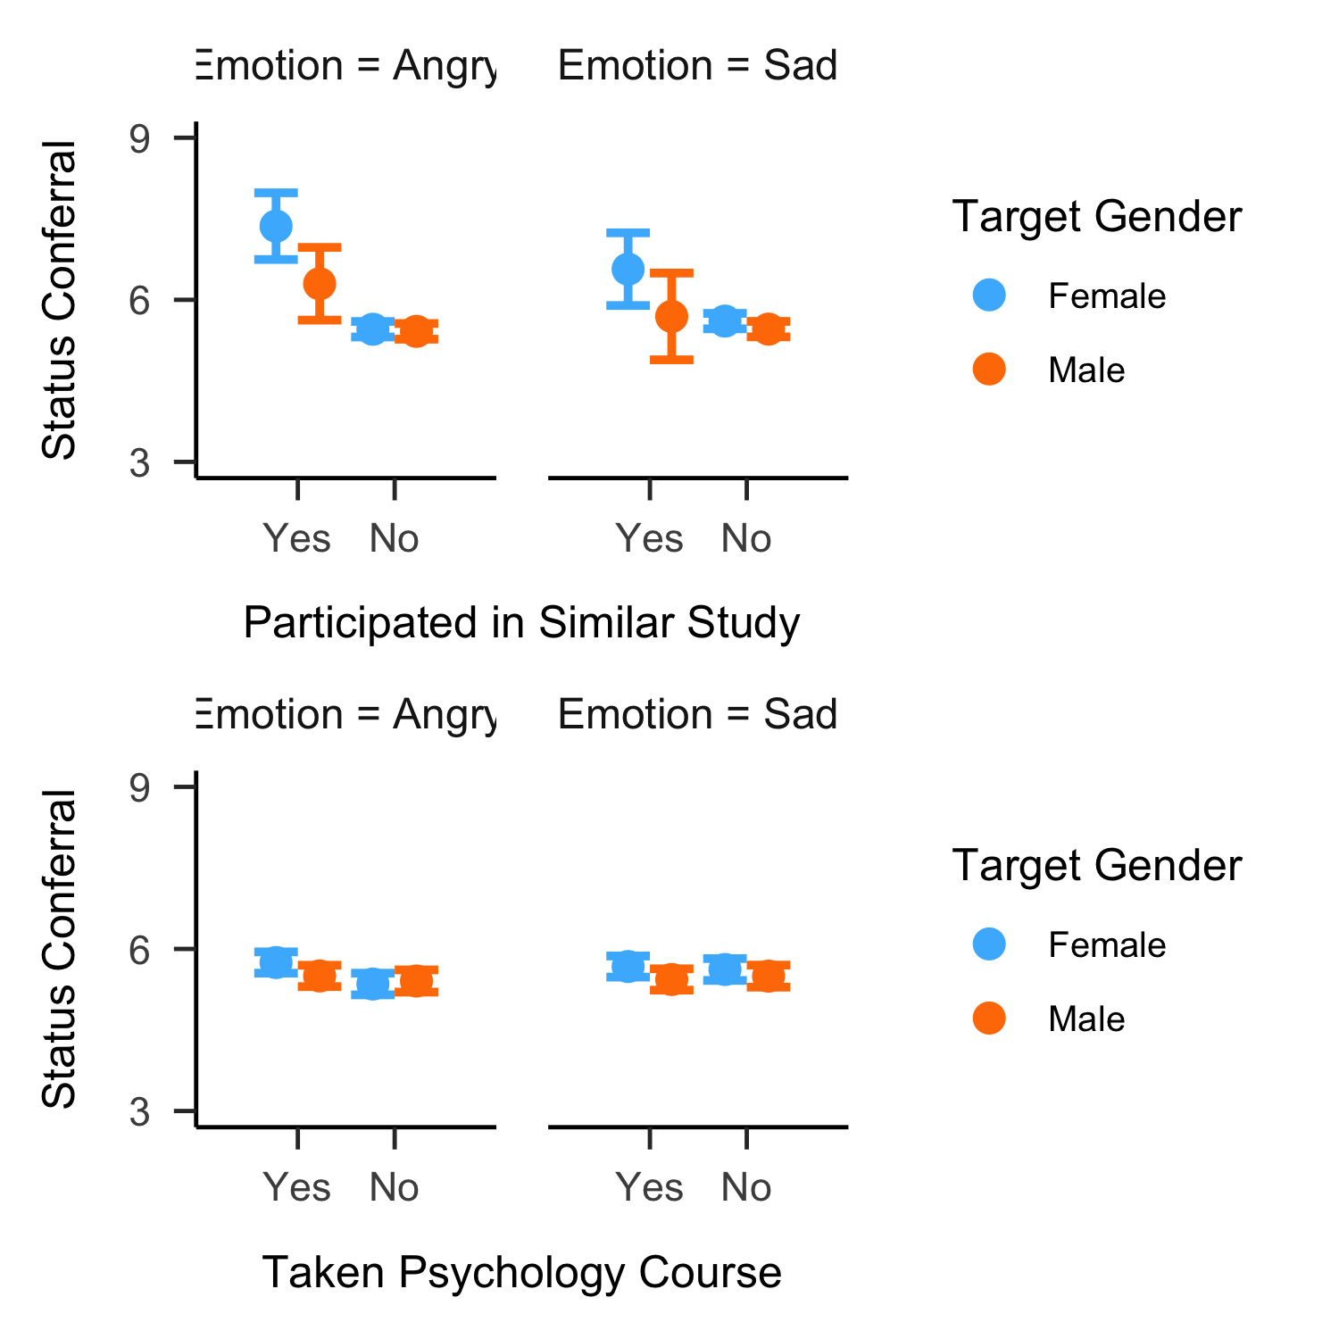 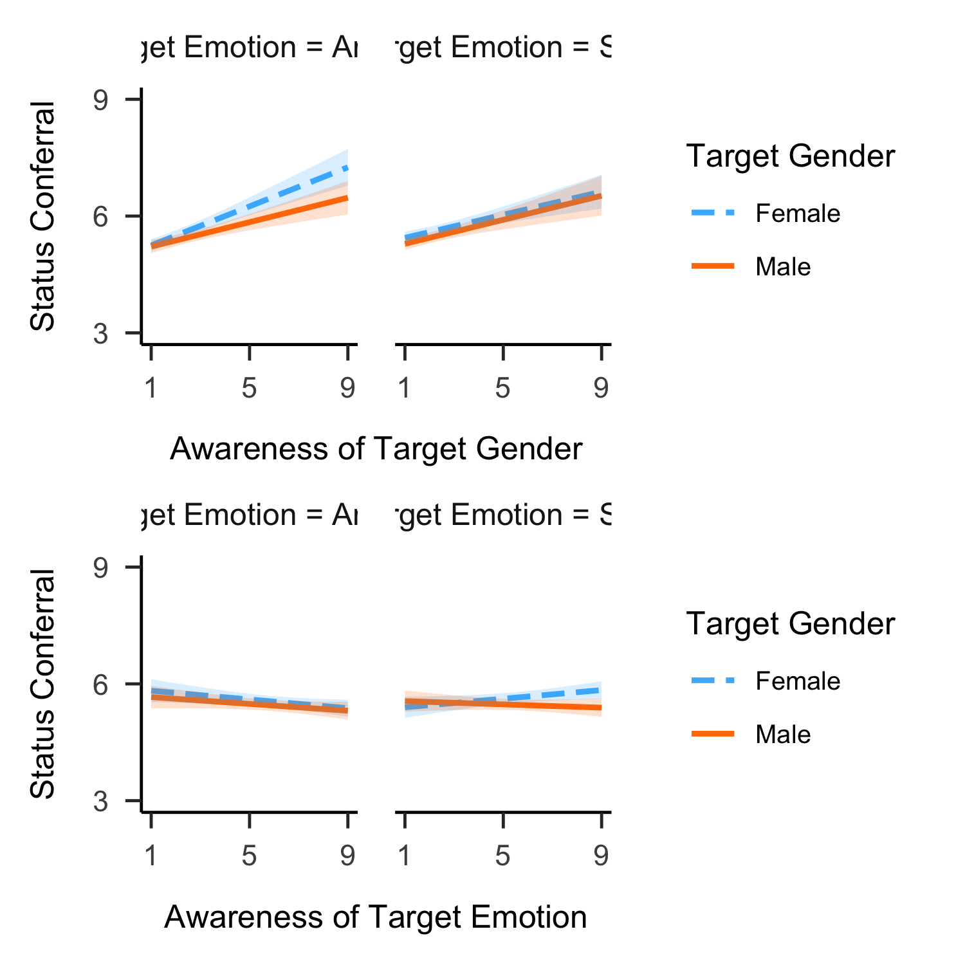

1. For all analyses, we used R (Version 4.0.2; R Core Team, 2020) and the R-packages *BayesFactor* (Version 0.9.12.4.2; Morey & Rouder, 2018), *coda* (Version 0.19.4; Plummer, Best, Cowles, & Vines, 2006), *dplyr* (Version 1.0.3; Wickham, François, Henry, & Müller, 2021), *ggplot2* (Version 3.3.3; Wickham, 2016), *interactions* (Version 1.1.3; Long, 2019), *kableExtra* (Version 1.3.1; Zhu, 2020), *Matrix* (Version 1.3.2; Bates & Maechler, 2021), *papaja* (Version 0.1.0.9997; Aust & Barth, 2020), *patchwork* (Version 1.1.1; Pedersen, 2020), *scales* (Version 1.1.1; Wickham & Seidel, 2020), and *tinylabels* (Version 0.1.0; Barth, 2020).
2. As perspectives 3 and 4 make equal predictions regarding the overall pattern, there were 4 different theoretical models in total.
3. Note that the reason for removing the Iranian data from the main analyses was that Iran could not straigthforwardly be classified as either a Western or Eastern country.
4. Note that ‘suspicion of the hypothesis being about gender’ was not included as a predictor, as only 1.67% of participants mentioned any of the terms ‘gender’, ‘sex’, ‘female’, ‘woman’, ‘women’, ‘male’, ‘man’, ‘men’ in the free response to the question what the study was about.
5. The student vs. general public status was determined at the individual level (rather than the sample level) based on responses to the item ‘Are you currently a university student?’.