Theoritcal overview of Docker and Containerization

1. Install Docker and create Dockerfiles to containerize applications?
=>
Installing Docker
ON windows/macOS
1. Download docker Desktop from the official website
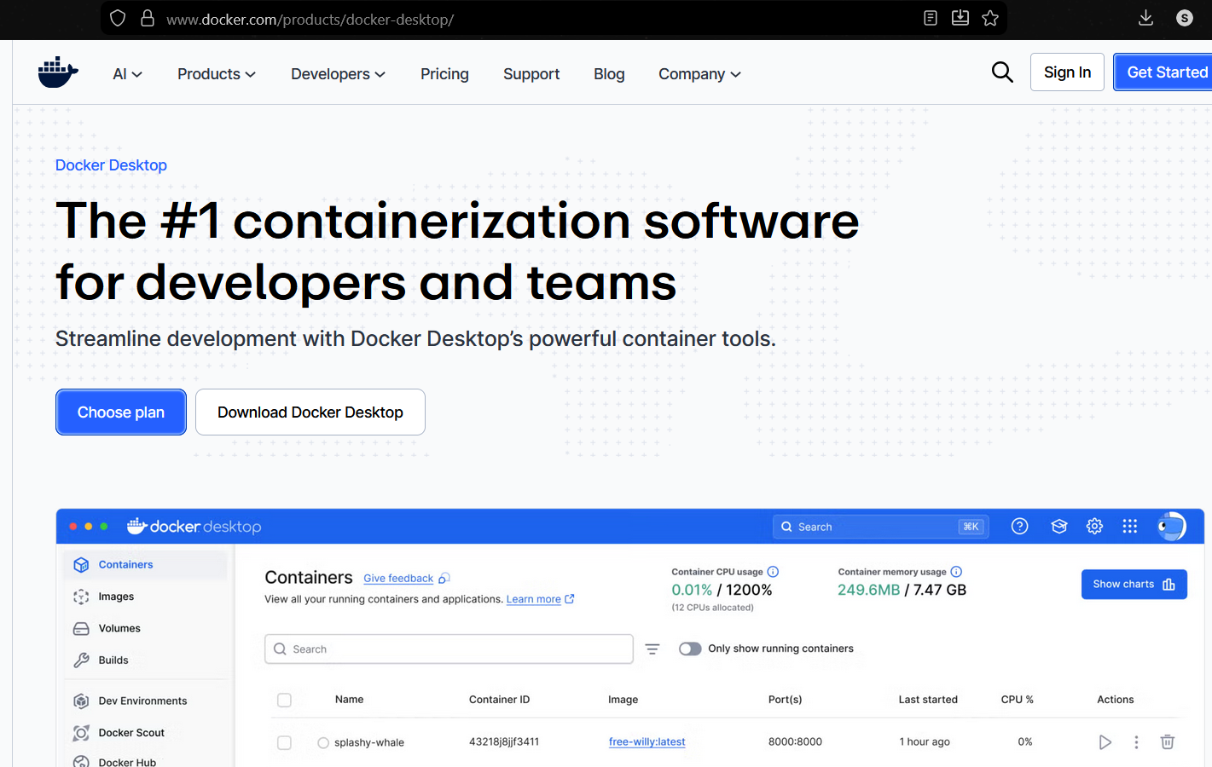

2. Install and start Docker desktop
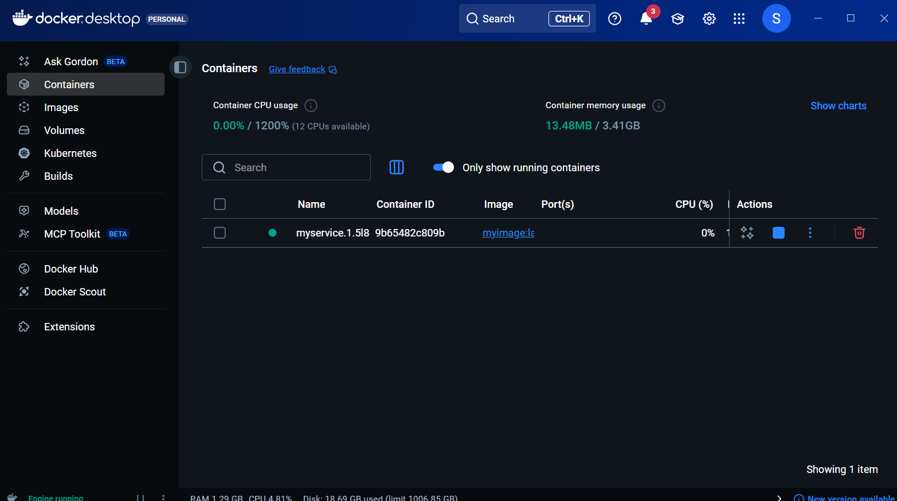
3. verify installation
docker –version
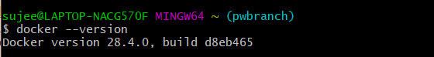

On linux (ubuntu)
sudo apt update
sudo apt install docker.io –y
docker –version

Start docker:
sudo systemctl start docker
sudo systemctl enable docker

Creating a Docker file
Example 1: (Python-app)
1. Created a simple app using flask

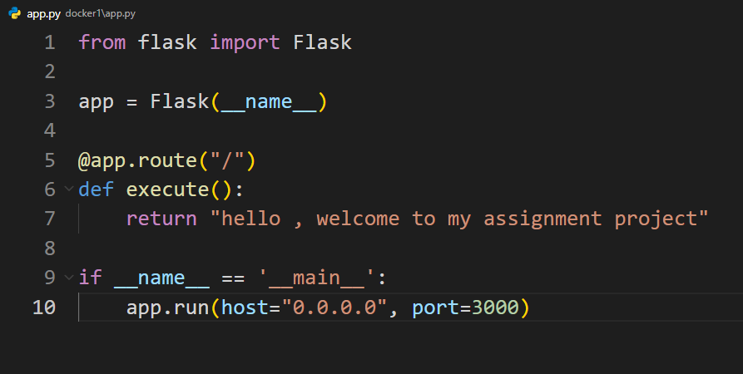

2. Dockerfile:
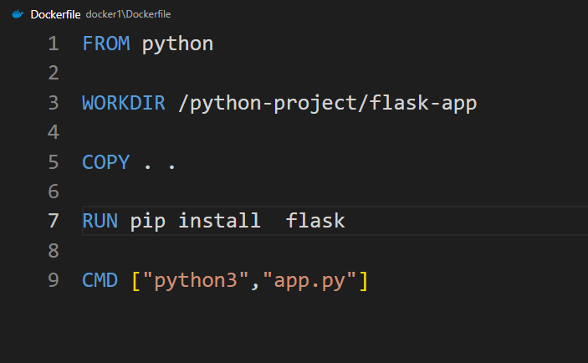
3. Build and Run:
docker build –t python-app .
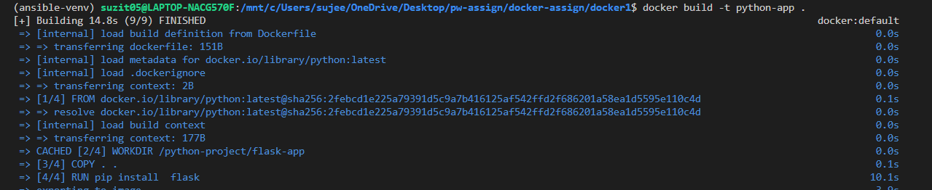

docker run –it –init –publish 3000:3000 python-app:latest
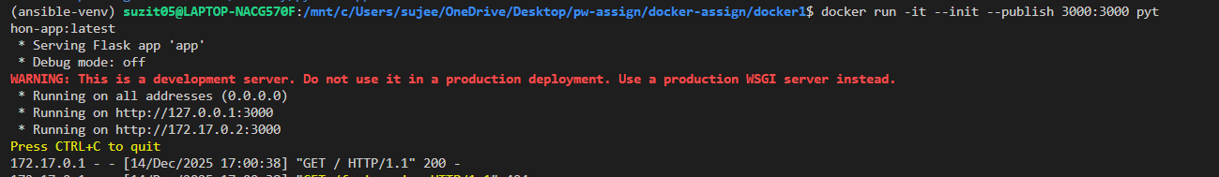

4. Visit the url to verify:
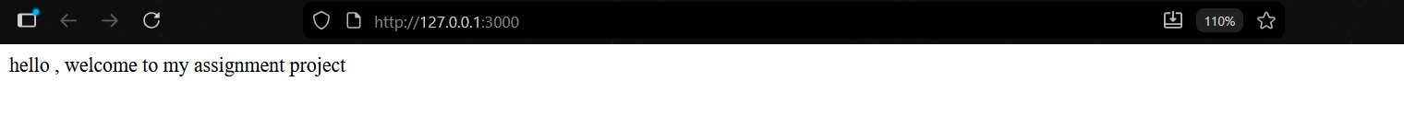
Example 2 : Node Project
1. lets create a simple node project , where by accessing the url , you can get the respond
2. Some package to install:

- npm I express dotenv
3. app.js :
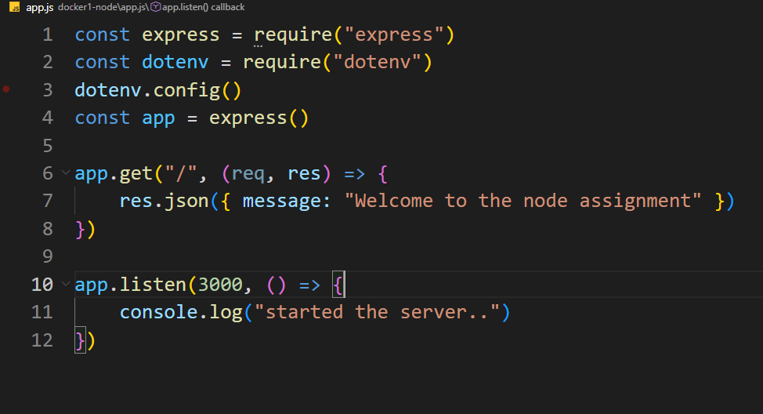
4. Dockerfile:
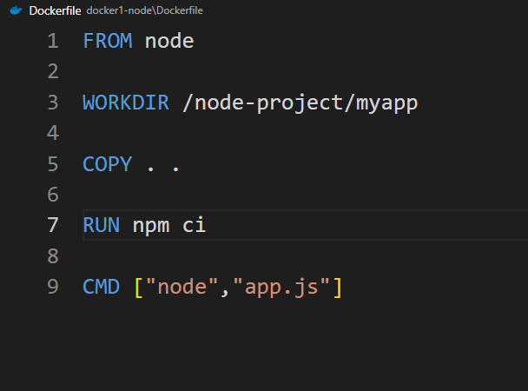
5. Build and Run:
docker build –t node-app .
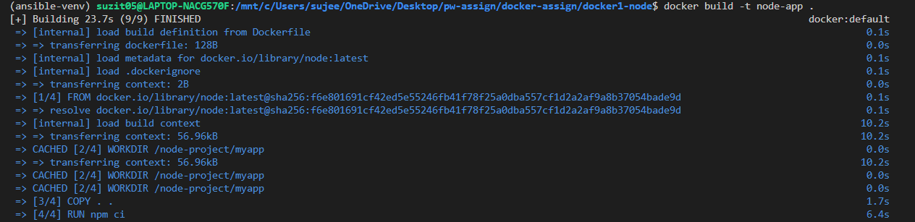
docker run –it –init –publish 3000:3000 node-app:latest
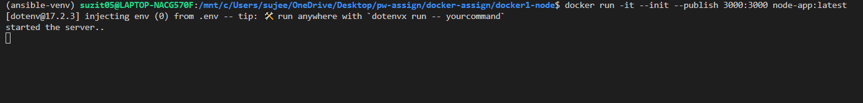

5.Visit the url to verify:
