DOCKER FUNDAMENTALS

1. Use docker Compose to define and run multi-container applications?
=> Here is a python application which run on mutliple container and everytime the page is revisited the counter increased.:
1. The file structure :
-app
- app.py
- requirements.txt
- Dockerfile
-Dokcer-compose.yml

/app-
App.py:
from flask import Flask
import mysql.connector
import os
import time

app = Flask(__name__)

# Database configuration from environment variables
db_config = {
"host": os.getenv("DB_HOST"),
"user": os.getenv("DB_USER"),
"password": os.getenv("DB_PASSWORD"),
"database": os.getenv("DB_NAME")
}

def get_db_connection():
# Retry logic to wait for DB container
for _ in range(10):
try:
return mysql.connector.connect(**db_config)
except:
time.sleep(2)
return None

@app.route("/")
def home():
conn = get_db_connection()
if conn is None:
return "Database connection failed"

cursor = conn.cursor()
cursor.execute("CREATE TABLE IF NOT EXISTS visits (count INT)")
cursor.execute("SELECT count FROM visits")

row = cursor.fetchone()
if row is None:
count = 1
cursor.execute("INSERT INTO visits VALUES (1)")
else:
count = row[0] + 1
cursor.execute("UPDATE visits SET count = %s", (count,))

conn.commit()
cursor.close()
conn.close()

return f"<h1>Hello from Docker Compose!</h1><p>Visits: {count}</p>"

if __name__ == "__main__":
app.run(host="0.0.0.0", port=5000)

requirements.txt:


Dockerfile:
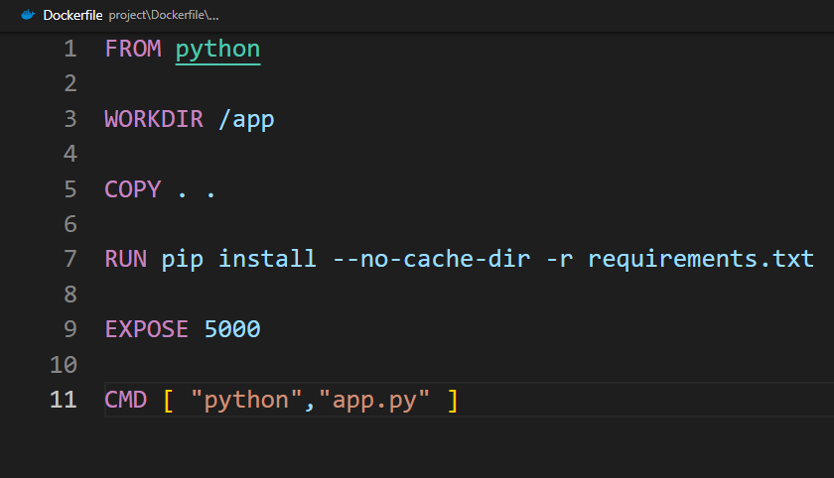
Docker-compose.yml:
version: "3.9"

services:
web:
build: ./app
ports:
- "8080:5000"
depends_on:
- db
environment:
DB_HOST: db
DB_USER: root
DB_PASSWORD: root
DB_NAME: mydb

db:
image: mysql:8.0
environment:
MYSQL_ROOT_PASSWORD: root
MYSQL_DATABASE: mydb
volumes:
- db_data:/var/lib/mysql

volumes:
db_data:

2 . Build and Start containers:
Docker compose up –d --build
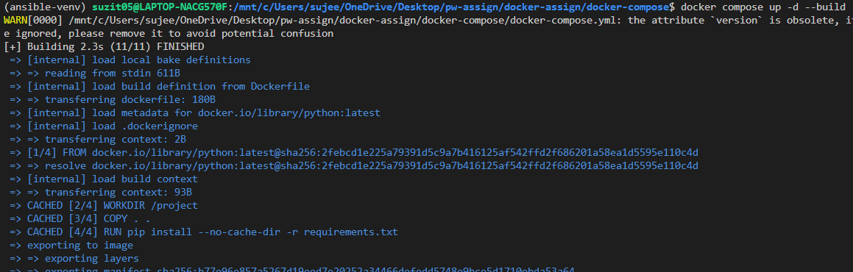

Visit the page to verify and refresh to increase the counter:
Note: the page is visited three times


3.Stop the container:
Docker compose down
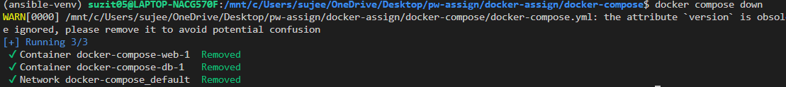

4.Stop and remove database data
Docker compose down -v

