Introduction to kubernetes

1. Kubernetes Setup: Set up a local Kubernetes cluster using Minikube or a managed kubernete services?
=> For local kubernetes cluster setup, we should have these prequisites:
- Docker
- Kubectl
- Minikube
After installing these on my system , the steps are:
1. Start minikube
=> minikube start
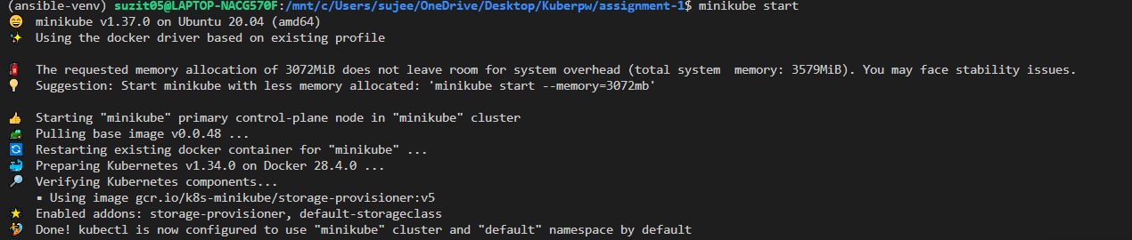
2. Verify cluster status
=> minikube status
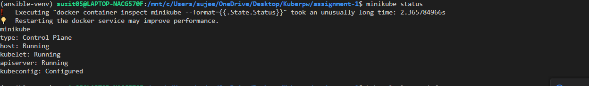
3. Check cluster info
=> minikube cluster-info

2. Application Deployment: Deploy a simple application to your kubernetes cluster?
=> Steps:
- My nginx-deployment.yml file:
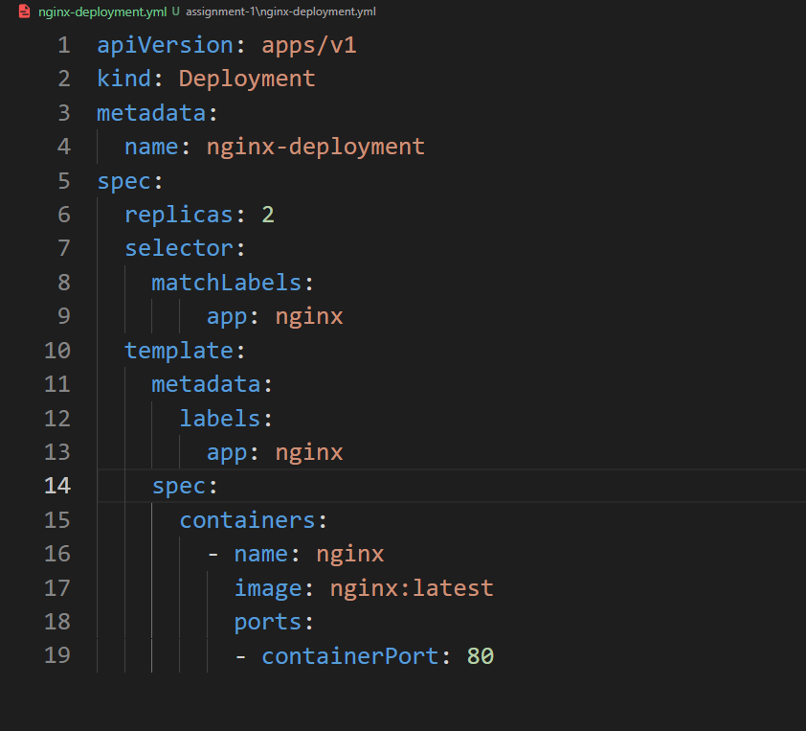

- Deploy it:
kubectl apply –f nginx-deployment.yml

- expose it via a service:
kubectl expose deployment nginx-deployment –type=NodePort –port=80

- Check running pods:
kubectl get pods

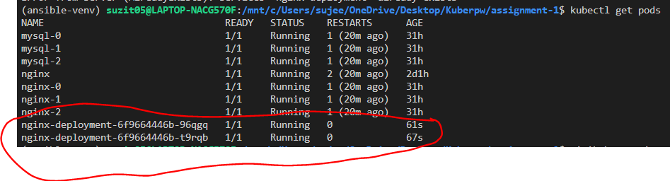
- Access the app:
minikube service nginx-deployment

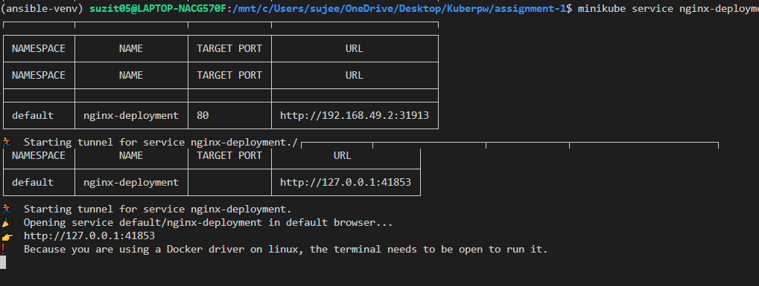

The link will open the nginx welcome page:

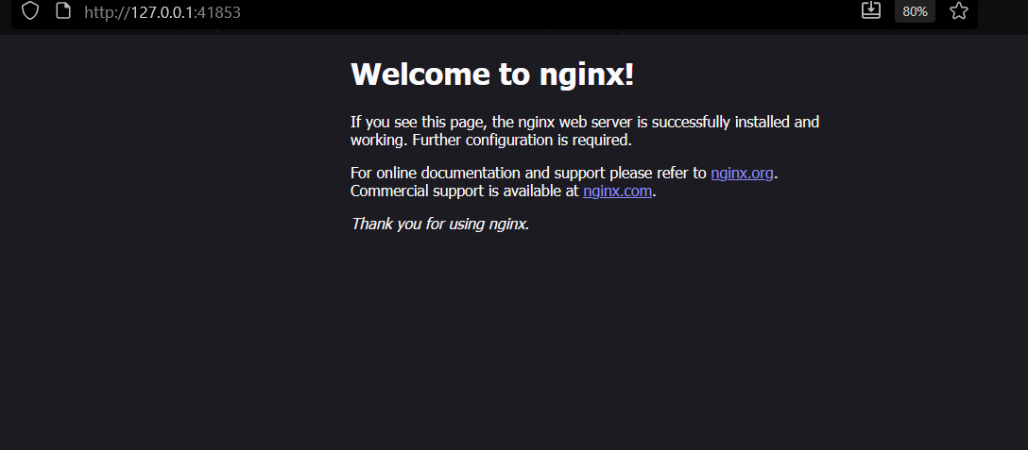

3. Resouce Management: Practice managing kubernetes resources like Pods, Services,and Deployments?
=> Pods:
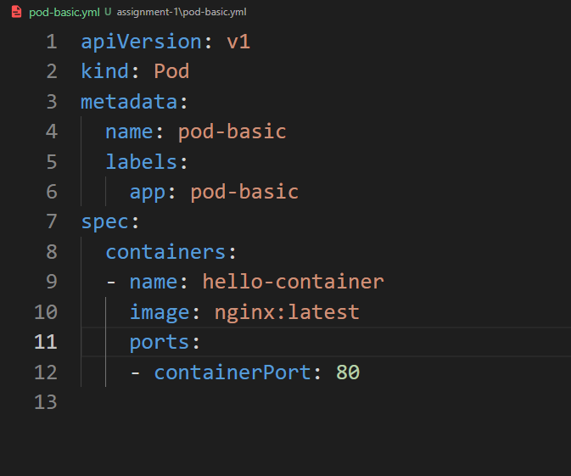

1. Kubectl apply –f pod-basic.yml: Creates a Pod defined in a YAML file.

2. kubectl get pods: List all the pods in the current name space.
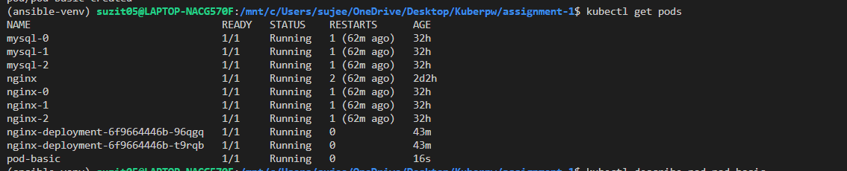

3. kubectl describe pod pod-basic: Show detail info about a specific Pod including events, status and resource usage.
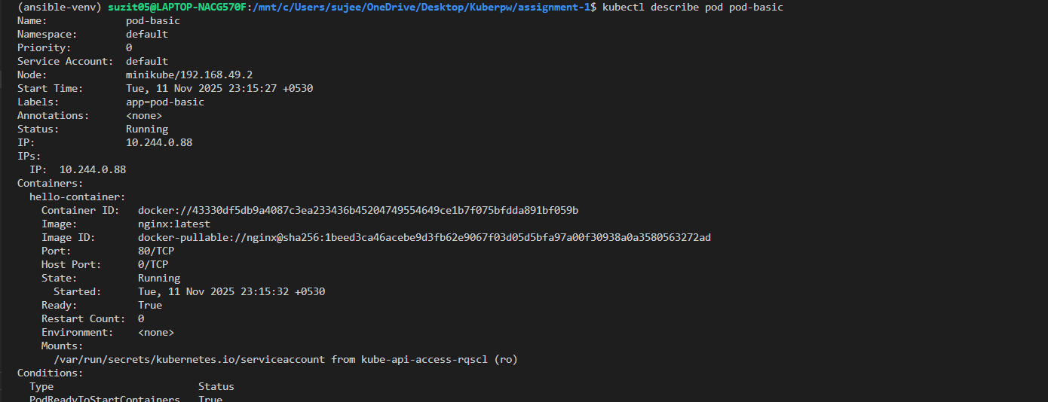

4. kubectl logs pod-basic: Print the logs for a container in the Pod
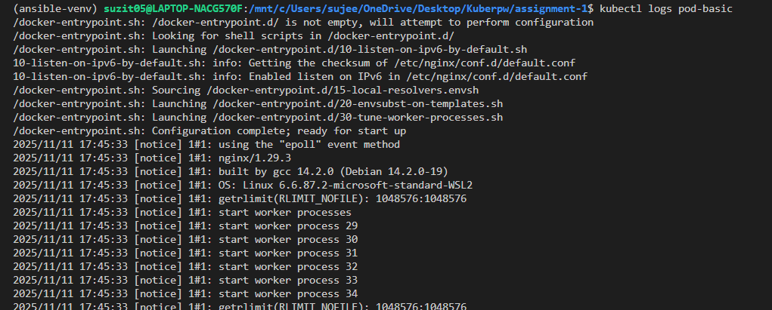

5. kubectl delete pod pod-basic: Delete the specific pod.

Deployments:
1. kubectl apply –f nginx-deployment.yml : Creates or update a deployment
2. kubectl get deployments: List all deployments

3. kubectl describe deployment nginx-deployment: Show detail status of the deployment including replicaset , pods and more.
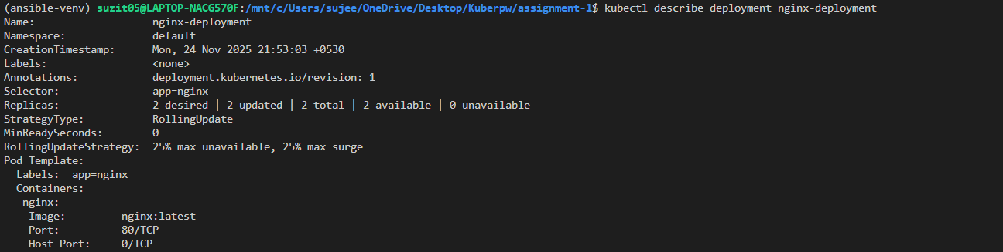

4. kubectl scale deployment nginx-deployment –replicas=5 : Set the number of desired pod replicas to 5

5. kubectl set image deployment nginx-deployment nginx=nginx:1.24 : updates the container image, triggering a rolling update.

6. kubectl rollout undo deployment nginx-deployment : reverts the deployment to the previous revision.

7. kubectl delete deployment nginx-deployment : delete the deployment and all associated pods and replicas.

Services
Nginx-service.yml :
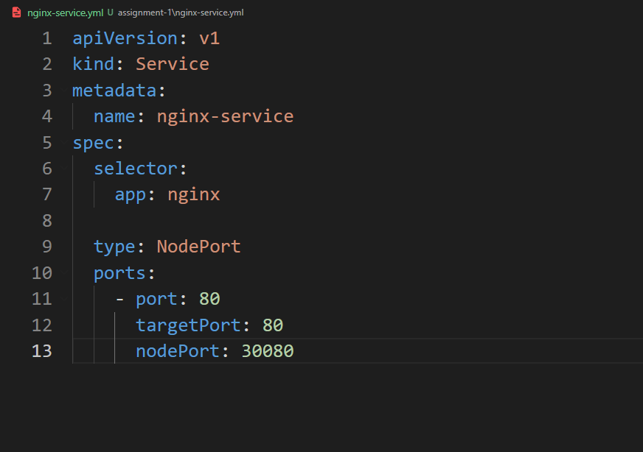
1. kubectl apply –f nginx-service.yml: Create a service defined in yaml file
2. kubectl get services: list all services
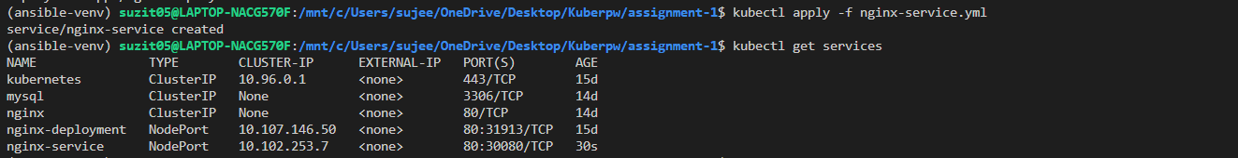
3. kubectl describe service nginx-service: Show the detail status of the service including ip, ports and more.
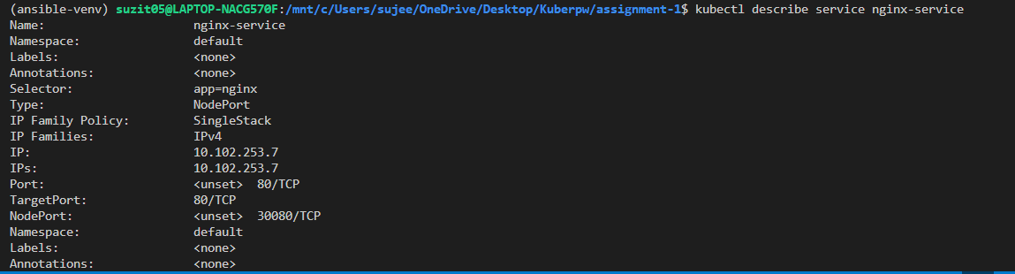
4. kubectl port-forward svc/nginx-service 8080:80 : Forwards local port 8080 to the Service's port 80 (useful for local testing of ClusterIP Services).
5. kubectl delete service nginx-service : Delete the service.

4. Helm Charts: Use Helm to package and deploy applications on Kubernetes?
=>
1. Package an application with helm:
helm create my app
2. deploy the application:
helm install myapp-release ./myapp
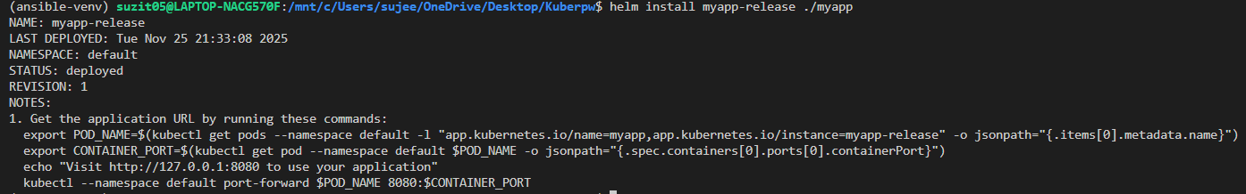
3. Updating a deployment:
Changing the tag of the image to “1.25.0”
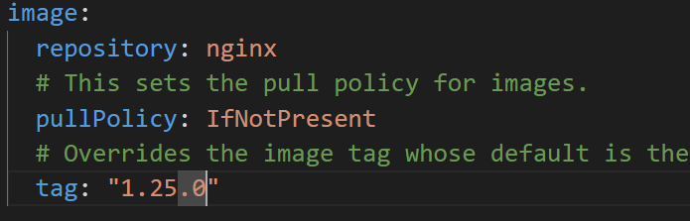
Now upgrading:
helm upgrade myapp-release ./mapp
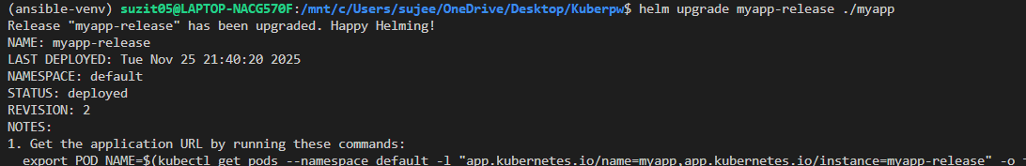

4. Rollback (if needed):helm history myapp-release