VIDHYADEEP INSTITUTE OF COMPUTER & INFORMATION TECHNOLOGY, ANITA-KIM.

VEER NARMAD SOUTH GUJARAT UNIVERSITY (VNSGU)

PROJECT REPORT ON

“**DG-Estate**”

as a partial requirement for the degree of

bachelor of computer applications

[b.c.a]

3 YEARS integrated cource

YEAR: 2019 – 2022

SUBMITTED BY:

Darshan Nariya

(E19110403000110036)

GUIDED BY:

Drashti Bhatt

(Internal Guide)

ORGANIZATION:

KG Krunch

Solutions

VIDHYADEEP INSTITUTE OF COMPUTER & INFORMATION TECHNOLOGY, ANITA-KIM.

VEER NARMAD SOUTH GUJARAT UNIVERSITY (VNSGU)

PROJECT REPORT ON

“**DG-Estate**”

as a partial requirement for the degree of

bachelor of computer applications

[b.c.a]

3 YEARS integrated cource

YEAR: 2019 – 2022

SUBMITTED BY:

Darshan Nariya

(E19110403000110036)

GUIDED BY:

Drashti Bhatt

(Internal Guide)

ORGANIZATION:

KG Krunch

Solutions

# Acknowledgement

I

n successfully completing of this project, many websites, blogs, posts, videos, discussions have helped me.[1] I would like to thank all these, I have also upvoted these blogs, videos whenever it was possible.

Every single problem in this project gave me a challenge, and I like challenges, it gave me huge confidence boost whenever I solved any challenging problem.

The Company where I worked (KG Krunch Solutions) was also a big help, while I didn’t make my project there, but I learned a lot while working there.[2] I will be always thankful to the company and team.

This project doesn’t just show how much I know it also shows how much I don’t know. So, I’m looking forward to learn new things every day.

Now let’s come to the college “VIDHYADEEP INSTITUTE OF COMPUTER & INFORMATION TECHNOLOGY”, while admin department was a pain to work with, where I had some uneasy experiences, our department’s professors were easy on us, gave us lot of freedom. It was an experience in its own, and I thank all the faculty. [3]

For upcoming days and new things, I’m ready, one day at a time, finally thanks to all the people and things that helped me directly or indirectly.

Darshan Nariya

# Index

Acknowledgement I

Index II

1 Introduction Profiles 1

1.1 Project Profile 1

1.2 Company Profile 2

2 Objective of Project 3

2.1 User 3

2.2 Admin 3

2.3 Root 3

3 Environment Description 4

3.1 Hardware Requirements 4

3.1.1 Server 4

3.1.2 Client 4

3.2 Software Requirements 5

3.2.1 Server 5

3.2.2 Client 5

3.3 Development Environment 6

3.3.1 Hardware 6

3.3.2 Software 6

3.3.3 Dependencies 7

3.4 Methods & Technologies 8

3.4.1 PHP 8

3.4.2 MySQL 8

3.4.3 Laravel 9

3.4.4 MVC 9

3.4.5 Bootstrap 11

3.4.6 JQuery 11

3.4.7 Composer 11

4 System Planning 12

4.1 Feasibility Study 12

4.1.1 Summary 12

4.1.2 Technological Considerations 13

4.2 Requirement Specification 14

4.2.1 User 14

4.2.2 Admin 14

4.2.3 Root 14

5 Analysis Report 16

6 Design Report 17

7 Testing Reports 18

8 Limitations of the System 19

9 Future Enhancement of the project 20

10 References 21

# Introduction Profiles

## Project Profile

|  |  |
| --- | --- |
| Title | DG-Estate |
| Organization | KG-Krunch Solutions |
| Category | Local Property listing Website |
| Duration | 3 Months |
| Front-End | Blade (Laravel Framework) |
| Back-End | Laravel Framework (PHP) + MySQL |
| Guide | Drashti Bhatt (Internal Guide) |
| Submitted by | Darshan Arvind Bhai Nariya  (E19110403000110036) |
| Submitted to | Vidhyadeep Institute of Computer & Information Technology |

## Company Profile

|  |  |
| --- | --- |
| Company Name | KG Krunch Solutions |
| Proprietor Name | Ashish Gajera |
| Business Type | Solutions Provider |
| Address |  |
| Contact No |  |
| Website |  |
| Email |  |
| Service Range |  |

# Objective of Project

## User

The main User side Objectives are:

* To enable users to surf all listed properties.
* Users can surf properties without the need of creating account.
* Users can filter properties by category, city, and search by property title.
* Users can create account and manage their profile, save properties, review properties, and change their password.

## Admin

The main Admin side Objectives are:

* Admin can add, and update existing category, facilities, city, property.
* Admin can add and delete images in property gallery.
* Admin can delete user reviews.
* Admin can give other users admin access.

## Root

The main Root side Objectives are:

* Root has access to all above features.
* Root is only one who can delete existing category, facility, city, property, and users.
* Root can manage website’s Home, About, FAQ, Terms page in CMS.
* Root can manage website’s other settings in Site Settings option.

# Environment Description

## Hardware Requirements

### Server

|  |  |
| --- | --- |
| Processor | 3rd Gen and above |
| Memory | 4 GB and above |
| Storage | 6 GB and above |

### Client

|  |  |
| --- | --- |
| Processor | 3rd Gen and above |
| Memory | 4 GB and above |
| Storage | 6 GB and above |

## Software Requirements

### Server

|  |  |
| --- | --- |
| Operating System | Windows 7 or above (10 recommended),  any Linux based, 64bit arch. |
| Server | Apache v 2.4 and above |
| Php | Php v 6 and above |
| MySQL | MySQL v 7 and above |

### Client

|  |  |
| --- | --- |
| Operating System | Windows 7 or above (10 recommended), 64bit arch. |
| Browser | Any Chromium based Browsers |

## Development Environment

### Hardware

|  |  |
| --- | --- |
| Processor | Ryzen 5 3550H |
| Memory | 8 GB |
| Storage | 256 GB |

### Software

|  |  |
| --- | --- |
| Windows | 10/11 64bit |
| WAMP server | V 4.1 |
| Chrome | V 99.0.4844.82 64bit |
| Git | Windows V 2.34.1 |
| Composer | V 2.2.3 |
| VS Code | V 1.50^ |
| Diagrams.net/Draw.io | V 17.2.3 |

### Dependencies

|  |  |
| --- | --- |
| Laravel | V 8.x |
| Bootstrap | V 5.1.3 |
| Bootstrap Examples | V 5.1 |
| JQuery | V 3.6.0 |
| Font Awesome | V 4 & V 5 |
| Data Tables | V 1.11.4 |
| Data Tables Bootstrap | V 1.11.4 |
| Fancy Apps | V 4 Fancy Box & Carousal |
| CKEditor | V 4 |

## Methods & Technologies

### PHP

PHP is a general-purpose scripting language geared toward web development. It was originally created by Danish-Canadian programmer Rasmus Lerdorf in 1994.The PHP reference implementation is now produced by The PHP Group. PHP originally stood for Personal Home Page, but it now stands for the recursive initialism PHP: Hypertext Pre-processor.

PHP code is usually processed on a web server by a PHP interpreter implemented as a module, a daemon or as a Common Gateway Interface (CGI) executable. On a web server, the result of the interpreted and executed PHP code which may be any type of data, such as generated HTML or binary image data would form the whole or part of an HTTP response. Various web template systems, web content management systems, and web frameworks exist which can be employed to orchestrate or facilitate the generation of that response.

### MySQL

My SQL is an open-source relational database management system (RDBMS). Its name is combinations of “My”, the name of co-founder Michael Widenius' daughter, and "SQL", the abbreviation for Structured Query Language. The MySQL development project has made its source code available under the terms of the GNU General Public License, as well as under a variety of proprietary agreements. MySQL was owned and sponsored by a single for-profit firm, the Swedish company MySQL AB, now owned by Oracle Corporation. For proprietary use, several paid editions are available, and offer additional functionality.

MySQL is a central component of the LAMP open-source web application software stack (and other "AMP" stacks). LAMP is an acronym for "Linux, Apache, MySQL, and Perl/PHP/Python". Applications that use the MySQL database include: TYPO3, Mode, Joomla, WordPress, php DB, MyDB, and Dural. MySQL is also used in many high-profile, large-scale websites, including Google (though not for searches), Facebook, Twitter, Flicker, and YouTube.

### Laravel

Laravel is a free, open-source PHP web framework, created by “Taylor Otwell” and intended for the development of web applications following the model-view-controller (MVC) architectural pattern and based on Symfony. Some of the features of Laravel are a modular packaging system with a dedicated dependency manager, different ways for accessing relational databases, utilities that aid in application deployment and maintenance, and its orientation toward syntactic sugar.

### MVC

Model-view-controller (MVC) is a software design pattern commonly used for developing user interfaces that divide the related program logic into three interconnected elements. This is done to separate internal representations of information from the ways information is presented to and accepted from the user.

Traditionally used for desktop graphical user interfaces (GUIs), this pattern became popular for designing web applications. Popular programming languages have MVC frameworks that facilitate implementation of the pattern.

**The Model** component corresponds to all the data-related logic that the user works with. This can represent either the data that is being transferred between the View and Controller components or any other business logic-related data. For example, a Customer object will retrieve the customer information from the database, manipulate it and update it data back to the database or use it to render data.

**The View** component is used for all the UI logic of the application. For example, the Customer view will include all the UI components such as text boxes, dropdowns, etc. that the final user interacts with.

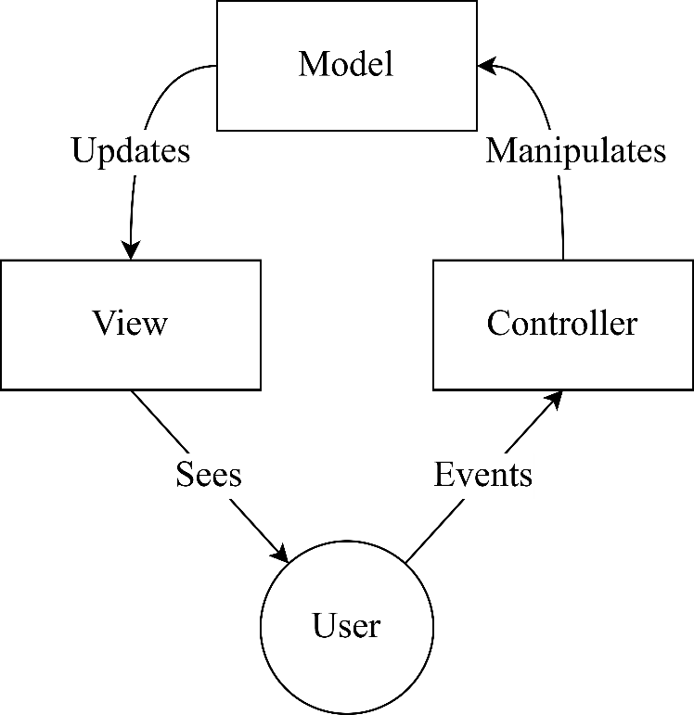

**Controllers** act as an interface between Model and View components to process all the business logic and incoming requests, manipulate data using the Model component and interact with the Views to render the final output. For example, the Customer controller will handle all the interactions and inputs from the Customer View and update the database using the Customer Model. The same controller will be used to view the Customer data.

### Bootstrap

Bootstrap is a free and open-source CSS framework directed at responsive, mobile-first front-end web development. It contains HTML, CSS and (optionally) JavaScript-based design templates for typography, forms, buttons, navigation, and other interface components.

### JQuery

**jQuery** is a JavaScript library designed to simplify HTML DOM tree traversal and manipulation, as well as event handling, CSS animation, and Ajax. It is free, open-source software using the permissive MIT License. As of May 2019, jQuery is used by 73% of the 10 million most popular websites. Web analysis indicates that it is the most widely deployed JavaScript library by a large margin, having at least 3 to 4 times more usage than any other JavaScript library.

**jQuery'**s syntax is designed to make it easier to navigate a document, select DOM elements, create animations, handle events, and develop Ajax applications. jQuery also provides capabilities for developers to create plug-ins on top of the JavaScript library. This enables developers to create abstractions for low-level interaction and animation, advanced effects and high-level, theme-able widgets. The modular approach to the jQuery library allows the creation of powerful dynamic web pages and Web applications.

### Composer

**Composer** is an application-level package manager for the PHP programming language that provides a standard format for managing dependencies of PHP software and required libraries. It was developed by Nils Adermann and Jordi Boggiano, who continue to manage the project. They began development in April 2011 and first released it on March 1, 2012. Composer is strongly inspired by Node.js's “npm” and Ruby's “bundler”. The project's dependency solving algorithm started out as a PHP-based port of openSUSE's libzypp satsolver.

# System Planning

## Feasibility Study

### Summary

DG-Estate is property listing website where properties can only be listed by admin and root, while common users can surf through verity of properties by category, city, and search them by their title, logged in users can save properties, give reviews and manage their profile.

Real Estate website has so much potential to grow up in future, website can be upgraded into a platform where common users can also post their property for rent/sale, but these are future possibilities so we have to make this project scalable for the future.

For future scalability we can opt for Frameworks of any particular language, MVC architecture is preferable for such objectives mentioned above.

### Technological Considerations

For these objectives described in summary we have to handle a database for that and all these handling have to be done on server side for security purpose. below are few server-side languages can be considered.

**Server-Side Languages**:

* Node.js (JavaScript)
* PHP
* Java
* Ruby
* Python

From above list **PHP** is great option because it can be embedded inside HTML syntax, and has many frameworks which makes many tasks easy.

**PHP Frameworks**:

* Laravel
* CodeIgniter
* Symfony

Above three are most popular framework of PHP and using one of these will also make changes in website later easier, because they use MVC architecture.

**Laravel** is huge consideration because of its eloquent modelling method which makes database queries more human readable, also its syntax is convenient once you get hang of it.

## Requirement Specification

Requirements of client describe as follow:

* System should be easy to operate.
* System should provide secure and accurate data.

### User

Login

Signup

Test

### Admin

Login

* Root has its own credentials email and password to login into the admin panel.
* After entering correct username and password

### Root

**Root** is super user of this website who has access to all the features and functionalities available on the website.

* Root can perform all following tasks related in user side and admin side.

Login

* Root has its own credentials email and password to login into the admin panel.
* After entering correct username and password

# Analysis Report

# Design Report

# Testing Reports

# Limitations of the System

# Future Enhancement of the project

# References

1. Because I’m introvert I didn’t really ask someone else to help me actually.
2. Because I only learn things when I’m under pressure.
3. Fun fact: every semester there was one new faculty replacing other.