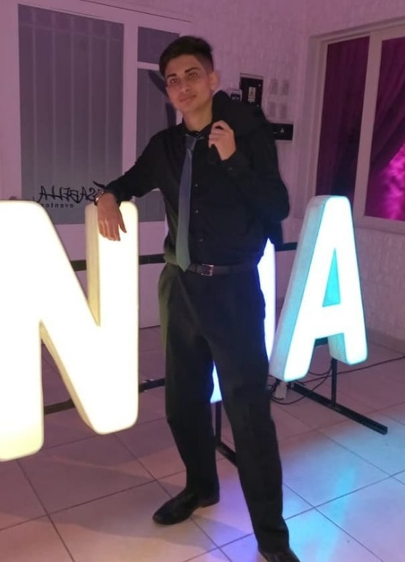

**ESTEBAN N. CARRIZO**

**Full Stack Developer**

**DIPLOMAS Y HOBBIES**

**Formaciones :** Diplomados, Congresos, xxxxxxxxxx xxxxxx xxxxxxxxx xxxxxxxxxxxxxxxxx

**Hobbies:** xxxxxxxxxxxxxxxxxxxxxxxxxxxxxx



I have been dedicated to web design and development for 2 years, I am constantly learning the technologies that I already master, I am also looking to learn new technologies to enrich my skills and improve my good practices





**Skills**

+54 3815360966 estebancarrizo619@gmail.com Tucumán/Argentina



Node.JS

Express

MongoDB

HTML

CSS

Java Script

xxx

Bootstrap

Sass

React

**LANGUAGES**

**WORK EXPERIENCE**

Español: Natal

Inglés: Intermedio

De 23/06/2021

04/03/2022

Remote

**SoyFreelancer**

FreeLancer

Tasks performed: Development of websites, following the ideas and style that the client proposes.

Database update and repair.

Logo design for companies



* Communication/Social
* Agile learning
* Initiative
* Innovative
* Troubleshooting
* Flexible and adaptable

**WORK SKILLS**

2021

Web development

*Google activate*

2021

React (Hooks y MERN)

*Udemy*

2022

Back End Developer

*Freecodecamp*

2022

Full Stack Developer

*Henry*

**STUDIES**

github.com/Nahuel61920

porfolioNahuel61920.com

perfil.linkedin

**SOCIAL**