Lab Assignment 6

CMPE 146 Section 1
Professor Bhawandeep Singh Harsh
Andrew Bertch
Robert Trinh
Table of Contents
Exercise 1 – UART 3
Exercise 1.1 – Echo 3
Exercise 1.2 – Send text string 4
Exercise 1.3 – Emulate UART 5
Exercise 2 – EnergyTrace 9
Exercise 2.1 – Simple Checksum 9
Exercise 2.2 – Shutdown LPM 11
Appendix A – MCU Source Code 12

Exercise 1 – UART
In this exercise, we will communicate with the LaunchPad from our laptops over the UART protocol. After downloading and installing PuTTY, we can launch a terminal window to monitor COM5 at 115200 baud to see the output from the MCU in the following exercises.

Exercise 1.1 – Echo
In this exercise, we will echo what is input on the laptop keyboard in the PuTTY terminal back to the terminal. When the program is not running, when typing in the terminal nothing will appear. However, with the program running on the MCU, when we type, the text will now appear on the terminal window. This can be seen below in a screenshot of the PuTTY terminal.
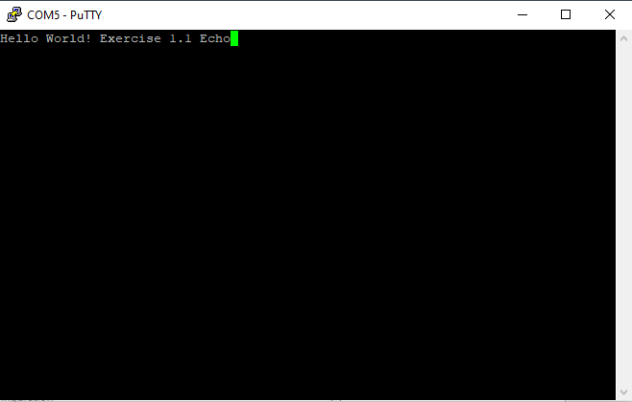
Figure 1.1

The control loop for the echoing is shown below. The whole control loop sits inside the forever while loop with an if statement to check if the receive buffer is not empty. If it isn’t empty it will then transmit what is in the receive buffer.
while (1) {
if (!DL_UART_isRXFIFOEmpty(UART0)) {
DL_UART_Main_transmitData(UART0, DL_UART_Main_receiveData(UART0));
}
}

Exercise 1.2 – Send text string
In this exercise, we will expand upon the echo exercise to first send a function to transmit a character string before starting the echo. The character string is null terminated so the function must look for the last character in the string, which is denoted by a 0x00 char. The function to send a message is included below and uses similar logic to the echo with some minor tweaks. The while loop will continue as long as the current char isn’t 0x00, and will transmit the data as long as the transmission buffer isn’t full.
void send_message(char* msg) {
int i = 0;
while (msg[i] != 0x00) {
if (!DL_UART_isTXFIFOFull(UART0)) {
DL_UART_Main_transmitData(UART0, msg[i]);
i++;
}
}
}

A screenshot of the terminal window with the message and echo is included below.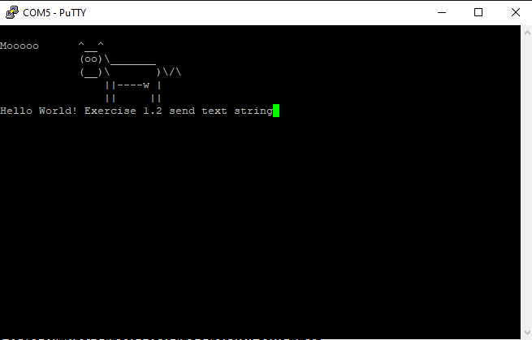
Figure 1.2

Exercise 1.3 – Emulate UART
In this exercise, we will be bypassing the UART controller and emulating UART communication by sending and managing each of our data bits ourselves. We will have to send our data on the correct GPIO pin, PA10, and generate a UART frame with start and stop bits. We also will focus on only the send_message() function and will not implement the echo functionality. The send_message() function is shown below.
void send_message(char* msg) {
int count = 0;

DL_GPIO_enablePower(GPIOA);
DL_GPIO_initDigitalOutput(IOMUX_PINCM21); //UART TX
DL_GPIO_enableOutput(GPIOA, DL_GPIO_PIN_10);
DL_GPIO_initDigitalInput(IOMUX_PINCM22); //UART RX

DL_GPIO_setPins(GPIOA, DL_GPIO_PIN_10);
delay_cycles(3200000);

while (msg[count] != 0x00) {
char data = msg[count];

DL_GPIO_clearPins(GPIOA, DL_GPIO_PIN_10);
delay_cycles((CPUCLK_FREQ / BAUD_RATE));
for (int i = 0; i < 8; i++) {
if (data & 1) {
DL_GPIO_setPins(GPIOA, DL_GPIO_PIN_10);
delay_cycles(CPUCLK_FREQ / BAUD_RATE);
}
else {
DL_GPIO_clearPins(GPIOA, DL_GPIO_PIN_10);
delay_cycles(CPUCLK_FREQ / BAUD_RATE);
}
data >>= 1;
}
DL_GPIO_setPins(GPIOA, DL_GPIO_PIN_10);
delay_cycles(CPUCLK_FREQ / BAUD_RATE);
count++;
}
}
The function begins with initial pin setup and delays for a set time to establish the idle state for the UART communication. The while loop from the previous send_message() loop is used again and the start bit sent. All delays are calculated using the defined BAUD_RATE global that divides the CPUCLK_FREQ global that TI’s firmware keeps updated. Since we are sending char sized data, we must send 8 bits in each data segment of the UART frame. This can be done with a right shift of 1 after each bit has been sent and logical AND to check if a 1 or 0 should be sent.
Included below is a screenshot of the PuTTY terminal with the program using a baud rate of 9600.
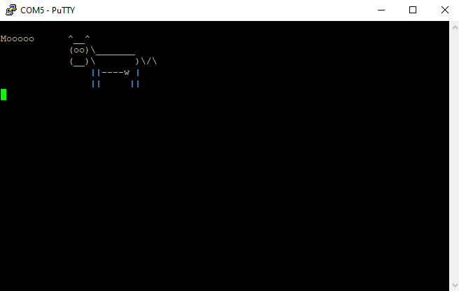
Figure 1.3

Included below is a screenshot of the PuTTY terminal with the program using a baud rate of 115200. No major changes were needed to make the program work.
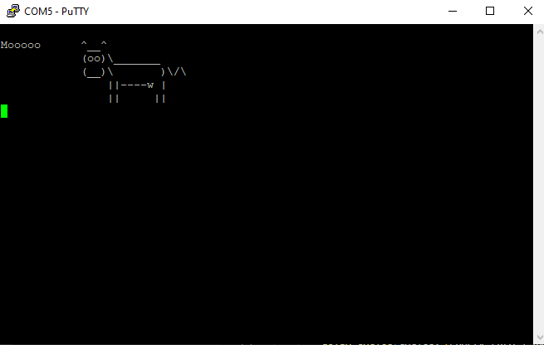
Figure 1.4

Exercise 2 – EnergyTrace
In this exercise, we will use EnergyTrace to measure a display an application’s energy profile. This can be used to help us optimize power consumption of the system. The circuitry that supports EnergyTrace is on the debug probe side of the LaunchPad and it measures the current of the MCU in real time.
To use EnergyTrace, CCs v12.8 had to be installed.

Exercise 2.1 – Simple Checksum
In this exercise, we compute the CRC-32 checksum using different methods and measure the total energy consumption required. Using the files provided and using the procedure listed in the lab manual, we made the following table and bar graphs of the data.
 | Energy 1 | Mean Current 1 | Energy 2 | Mean Current 2 | Energy 3 | Mean Current 3 | Average Energy | Average Mean Current
SW method | 2760.179 mJ | 12.2109 mA | 2761.697 mJ | 12.2217 mA | 2758.043 mJ | 12.2220 mA | 2759.97 mJ | 12.2182 mA
HW method | 606.112 mJ | 12.2476 mA | 605.571 mJ | 12.2366 mA | 608.266 mJ | 12.2332 mA | 606.65 mJ | 12.2391 mA
DMA method | 85.704 mJ | 12.2649 mA | 88.594 mJ | 12.2672 mA | 88.515 mJ | 12.2618 mA | 87.60 mJ | 12.2646 mA
DMA LPM method | 73.367 mJ | 11.3752 mA | 73.317 mJ | 11.3675 mA | 74.214 mJ | 11.3669 mA | 73.63 mJ | 11.3699 mA
Table 2.1

Figure 2.1

Figure 2.2
The energy graphs show that the software method uses the most energy while using similar current to the hardware and DMA methods. The higher energy usage is most likely due to the software method taking longer to compute the CRC compared to the hardware and DMA methods. The low power mode of the DMA method uses even less power compared to the DMA method. Since both methods use the same principles to calculate the CRC the low power mode method likely uses less energy since it uses almost 1 mA less current than the normal DMA method.

Exercise 2.2 – Shutdown LPM
In this exercise, we will compare the energy consumption of two different LED blinking implementations. One will use polling to check if S1 has been pressed to blink the LED while the other will use Shutdown Mode to shutdown the MCU while it is idling. The data collected of the two different methods is included in the table below.
 | Energy 1 | Mean Current 1 | Energy 2 | Mean Current 2 | Energy 3 | Mean Current 3 | Average Energy | Average Mean Current
Shutdown mode | 1.293 mJ | 0.7477 mA | 1.313 mJ | 0.7795 mA | 1.013 mJ | 0.6432 mA | 1.206 mJ | 0.7235 mA
Run mode | 75.346 mJ | 2.2830 mA | 75.838 mJ | 2.2979 mA | 76.199 mJ | 2.3088 mA | 75.794 mJ | 2.2966 mA
Table 2.2
The energy savings can be calculated by using the following formula.
$$\%Energy saved= \frac{Run mode avg- Shutdown mode avg}{Run mode avg}×100$$
Plugging in the numbers from the table results in an energy savings of ~98.4%.

Appendix A – MCU Source Code

echo.c
#include "ti_msp_dl_config.h"

int main(void)
{
SYSCFG_DL_init();

static const DL_UART_Main_ClockConfig gUART_0ClockConfig = {
.clockSel = DL_UART_MAIN_CLOCK_BUSCLK,
.divideRatio = DL_UART_MAIN_CLOCK_DIVIDE_RATIO_1
};
static const DL_UART_Main_Config gUART_0Config = {
.mode = DL_UART_MAIN_MODE_NORMAL,
.direction = DL_UART_MAIN_DIRECTION_TX_RX,
.flowControl = DL_UART_MAIN_FLOW_CONTROL_NONE,
.parity = DL_UART_MAIN_PARITY_NONE,
.wordLength = DL_UART_MAIN_WORD_LENGTH_8_BITS,
.stopBits = DL_UART_MAIN_STOP_BITS_ONE
};
DL_UART_Main_reset(UART0);
DL_UART_Main_enablePower(UART0);
delay_cycles(POWER_STARTUP_DELAY);
DL_UART_Main_setClockConfig(UART0, (DL_UART_Main_ClockConfig *)
&gUART_0ClockConfig);
DL_UART_Main_init(UART0, (DL_UART_Main_Config *) &gUART_0Config);
DL_UART_Main_setOversampling(UART0, DL_UART_OVERSAMPLING_RATE_16X);
DL_UART_Main_setBaudRateDivisor(UART0, 17, 23);
DL_UART_Main_enable(UART0);
DL_GPIO_initPeripheralOutputFunction(IOMUX_PINCM21, IOMUX_PINCM21_PF_UART0_TX);
DL_GPIO_initPeripheralInputFunction(IOMUX_PINCM22, IOMUX_PINCM22_PF_UART0_RX);

while (1) {
if (!DL_UART_isRXFIFOEmpty(UART0)) {
DL_UART_Main_transmitData(UART0, DL_UART_Main_receiveData(UART0));
}
}
}

message.c
#include "ti_msp_dl_config.h"

void send_message(char* msg) {
int i = 0;
while (msg[i] != 0x00) {
if (!DL_UART_isTXFIFOFull(UART0)) {
DL_UART_Main_transmitData(UART0, msg[i]);
i++;
}
}
}

int main(void)
{
SYSCFG_DL_init();

static const DL_UART_Main_ClockConfig gUART_0ClockConfig = {
.clockSel = DL_UART_MAIN_CLOCK_BUSCLK,
.divideRatio = DL_UART_MAIN_CLOCK_DIVIDE_RATIO_1
};
static const DL_UART_Main_Config gUART_0Config = {
.mode = DL_UART_MAIN_MODE_NORMAL,
.direction = DL_UART_MAIN_DIRECTION_TX_RX,
.flowControl = DL_UART_MAIN_FLOW_CONTROL_NONE,
.parity = DL_UART_MAIN_PARITY_NONE,
.wordLength = DL_UART_MAIN_WORD_LENGTH_8_BITS,
.stopBits = DL_UART_MAIN_STOP_BITS_ONE
};
DL_UART_Main_reset(UART0);
DL_UART_Main_enablePower(UART0);
delay_cycles(POWER_STARTUP_DELAY);
DL_UART_Main_setClockConfig(UART0, (DL_UART_Main_ClockConfig *)
&gUART_0ClockConfig);
DL_UART_Main_init(UART0, (DL_UART_Main_Config *) &gUART_0Config);
DL_UART_Main_setOversampling(UART0, DL_UART_OVERSAMPLING_RATE_16X);
DL_UART_Main_setBaudRateDivisor(UART0, 17, 23);
DL_UART_Main_enable(UART0);
DL_GPIO_initPeripheralOutputFunction(IOMUX_PINCM21, IOMUX_PINCM21_PF_UART0_TX);
DL_GPIO_initPeripheralInputFunction(IOMUX_PINCM22, IOMUX_PINCM22_PF_UART0_RX);

static char something[] =
{0x0d,0x0a,0x4d,0x6f,0x6f,0x6f,0x6f,0x6f,0x20,0x20,0x20,0x20,0x20,0x20,0x5e,0x5f,0x5f,0x5e,0x0d,0x0a,0x20,0x20,
0x20,0x20,0x20,0x20,0x20,0x20,0x20,0x20,0x20,0x20,0x28,0x6f,0x6f,0x29,0x5c,0x5f,0x5f,0x5f,0x5f,0x5f,0x5f,0x5f,
0x0d,0x0a,0x20,0x20,0x20,0x20,0x20,0x20,0x20,0x20,0x20,0x20,0x20,0x20,0x28,0x5f,0x5f,0x29,0x5c,0x20,0x20,0x20,
0x20,0x20,0x20,0x20,0x29,0x5c,0x2f,0x5c,0x0d,0x0a,0x20,0x20,0x20,0x20,0x20,0x20,0x20,0x20,0x20,0x20,0x20,0x20,
0x20,0x20,0x20,0x20,0x7c,0x7c,0x2d,0x2d,0x2d,0x2d,0x77,0x20,0x7c,0x0d,0x0a,0x20,0x20,0x20,0x20,0x20,0x20,0x20,
0x20,0x20,0x20,0x20,0x20,0x20,0x20,0x20,0x20,0x7c,0x7c,0x20,0x20,0x20,0x20,0x20,0x7c,0x7c,0x0d,0x0a,0x00};
send_message(something);

while (1) {
if (!DL_UART_isRXFIFOEmpty(UART0)) {
DL_UART_Main_transmitData(UART0, DL_UART_Main_receiveData(UART0));
}
}
}

emulate.c
#include "ti_msp_dl_config.h"

#define BAUD_RATE 9600

void send_message(char* msg) {
int count = 0;

DL_GPIO_enablePower(GPIOA);
DL_GPIO_initDigitalOutput(IOMUX_PINCM21); //UART TX
DL_GPIO_enableOutput(GPIOA, DL_GPIO_PIN_10);
DL_GPIO_initDigitalInput(IOMUX_PINCM22); //UART RX

DL_GPIO_setPins(GPIOA, DL_GPIO_PIN_10);
delay_cycles(3200000);

while (msg[count] != 0x00) {
char data = msg[count];

DL_GPIO_clearPins(GPIOA, DL_GPIO_PIN_10);
delay_cycles((CPUCLK_FREQ / BAUD_RATE));
for (int i = 0; i < 8; i++) {
if (data & 1) {
DL_GPIO_setPins(GPIOA, DL_GPIO_PIN_10);
delay_cycles(CPUCLK_FREQ / BAUD_RATE);
}
else {
DL_GPIO_clearPins(GPIOA, DL_GPIO_PIN_10);
delay_cycles(CPUCLK_FREQ / BAUD_RATE);
}
data >>= 1;
}
DL_GPIO_setPins(GPIOA, DL_GPIO_PIN_10);
delay_cycles(CPUCLK_FREQ / BAUD_RATE);
count++;
}
}

int main(void)
{
SYSCFG_DL_init();

static char something[] =
{0x0d,0x0a,0x4d,0x6f,0x6f,0x6f,0x6f,0x6f,0x20,0x20,0x20,0x20,0x20,0x20,0x5e,0x5f,0x5f,0x5e,0x0d,0x0a,0x20,0x20,
0x20,0x20,0x20,0x20,0x20,0x20,0x20,0x20,0x20,0x20,0x28,0x6f,0x6f,0x29,0x5c,0x5f,0x5f,0x5f,0x5f,0x5f,0x5f,0x5f,
0x0d,0x0a,0x20,0x20,0x20,0x20,0x20,0x20,0x20,0x20,0x20,0x20,0x20,0x20,0x28,0x5f,0x5f,0x29,0x5c,0x20,0x20,0x20,
0x20,0x20,0x20,0x20,0x29,0x5c,0x2f,0x5c,0x0d,0x0a,0x20,0x20,0x20,0x20,0x20,0x20,0x20,0x20,0x20,0x20,0x20,0x20,
0x20,0x20,0x20,0x20,0x7c,0x7c,0x2d,0x2d,0x2d,0x2d,0x77,0x20,0x7c,0x0d,0x0a,0x20,0x20,0x20,0x20,0x20,0x20,0x20,
0x20,0x20,0x20,0x20,0x20,0x20,0x20,0x20,0x20,0x7c,0x7c,0x20,0x20,0x20,0x20,0x20,0x7c,0x7c,0x0d,0x0a,0x00};
send_message(something);

while (1) {
}
}

lpm.c
/* DriverLib Includes */
#include "ti_msp_dl_config.h"

/* Standard Includes */
#include <stdint.h>
#include <stdbool.h>
#include <stdio.h>

#define USE_POLLING

// Set up GPIO output pins
void setup_LEDs(bool set_state)
{
// LED
DL_GPIO_initDigitalOutput(IOMUX_PINCM57); // For PB26, red LED in LED2
DL_GPIO_initDigitalOutput(IOMUX_PINCM58); // For PB27, green LED in LED2
DL_GPIO_initDigitalOutput(IOMUX_PINCM50); // For PB22, blue LED in LED2

DL_GPIO_enableOutput(GPIOB, DL_GPIO_PIN_26); // PB26, red LED
DL_GPIO_enableOutput(GPIOB, DL_GPIO_PIN_27); // PB27, green LED
DL_GPIO_enableOutput(GPIOB, DL_GPIO_PIN_22); // PB22, blue LED

if (set_state) // Do not set to known states if returning from LPM. Need to preserve them
{
DL_GPIO_clearPins(GPIOB, DL_GPIO_PIN_26);
DL_GPIO_clearPins(GPIOB, DL_GPIO_PIN_27);
DL_GPIO_clearPins(GPIOB, DL_GPIO_PIN_22);
}
}

// Set up for push buttons
void setup_push_buttons()
{
DL_GPIO_initDigitalInput(IOMUX_PINCM49); // For PB21, push button S2
DL_GPIO_initDigitalInput(IOMUX_PINCM40); // For PA18, push button S1
DL_GPIO_initDigitalInputFeatures(IOMUX_PINCM49, DL_GPIO_INVERSION_DISABLE, DL_GPIO_RESISTOR_PULL_UP, DL_GPIO_HYSTERESIS_DISABLE, DL_GPIO_WAKEUP_DISABLE); //S2

#ifdef USE_POLLING
DL_GPIO_initDigitalInputFeatures(IOMUX_PINCM40, DL_GPIO_INVERSION_DISABLE, DL_GPIO_RESISTOR_NONE, DL_GPIO_HYSTERESIS_DISABLE, DL_GPIO_WAKEUP_DISABLE); // S1
return;
#else
DL_GPIO_initDigitalInputFeatures(IOMUX_PINCM49, DL_GPIO_INVERSION_DISABLE, DL_GPIO_RESISTOR_PULL_UP, DL_GPIO_HYSTERESIS_DISABLE, DL_GPIO_WAKEUP_DISABLE); //S2
DL_GPIO_initDigitalInputFeatures(IOMUX_PINCM40, DL_GPIO_INVERSION_DISABLE, DL_GPIO_RESISTOR_NONE, DL_GPIO_HYSTERESIS_DISABLE, DL_GPIO_WAKEUP_ON_1); // S1
#endif
}

// Blink briefly an LED
void blink_LED(GPIO_Regs * port, uint32_t pin)
{
DL_GPIO_setPins(port, pin);
delay_cycles(CPUCLK_FREQ / 100); // 10 ms at 32 MHz
DL_GPIO_clearPins(port, pin);
}

// Function if need to stay in Run mode for better communication with the debugger
void check_to_stay_in_Run_Mode()
{
if (DL_GPIO_readPins(GPIOB, DL_GPIO_PIN_21) == 0) // S2 being pressed while starting the program
{
while (1) // Blink the green LED to indicate it is in Run mode
{
DL_GPIO_togglePins(GPIOB, DL_GPIO_PIN_27);
delay_cycles(CPUCLK_FREQ / 5);
}
}
}

int main(void)
{
volatile DL_SYSCTL_RESET_CAUSE resetCause;

SYSCFG_DL_init();

resetCause = DL_SYSCTL_getResetCause();
if (DL_SYSCTL_RESET_CAUSE_BOR_WAKE_FROM_SHUTDOWN == resetCause) // Woken up from a SHUTDOWN state
{
setup_LEDs(false);
setup_push_buttons();
DL_SYSCTL_releaseShutdownIO();
DL_GPIO_disableWakeUp(IOMUX_PINCM40);
check_to_stay_in_Run_Mode();

if (DL_GPIO_readPins(GPIOA, DL_GPIO_PIN_18) != 0) // S1 is pressed
{
blink_LED(GPIOB, DL_GPIO_PIN_22); // Blink blue LED
while (DL_GPIO_readPins(GPIOA, DL_GPIO_PIN_18) != 0) {} // Wait until S1 is released
}

DL_SYSCTL_setPowerPolicySHUTDOWN();
DL_GPIO_enableWakeUp(IOMUX_PINCM40);
while(1) // Go back to Shutdown Mode
{
__WFI();
}
}

// Not coming back from Shutdown Mode
setup_LEDs(true);
setup_push_buttons();
check_to_stay_in_Run_Mode();

while(1)
{
#ifdef USE_POLLING
if (DL_GPIO_readPins(GPIOA, DL_GPIO_PIN_18) != 0) // S1 is pressed
{
blink_LED(GPIOB, DL_GPIO_PIN_22); // Blink blue LED
while (DL_GPIO_readPins(GPIOA, DL_GPIO_PIN_18) != 0) {} // Wait until S1 is released
}

#else
DL_SYSCTL_setPowerPolicySHUTDOWN();
{
__WFI();
}
#endif
}
}

