**NOISE POLLUTION MONITORING**

**PROBLEM STATEMENT:**

The IoT-based noise pollution project aims to collect real-time data on noise levels in various locations and use that information for analysis and potential mitigation. This project typically involves the deployment of sensors, data processing, and reporting mechanisms

**INFORMATION PLATFORM:**

* **Firebase database**: Firebase is a mobile and web application development platform that offers various tools and services like

Real-time Data Sync to maintain a real-time connection between the server and clients. This means that any changes made to the database are instantly reflected in all connected clients without the need for manual refreshes.

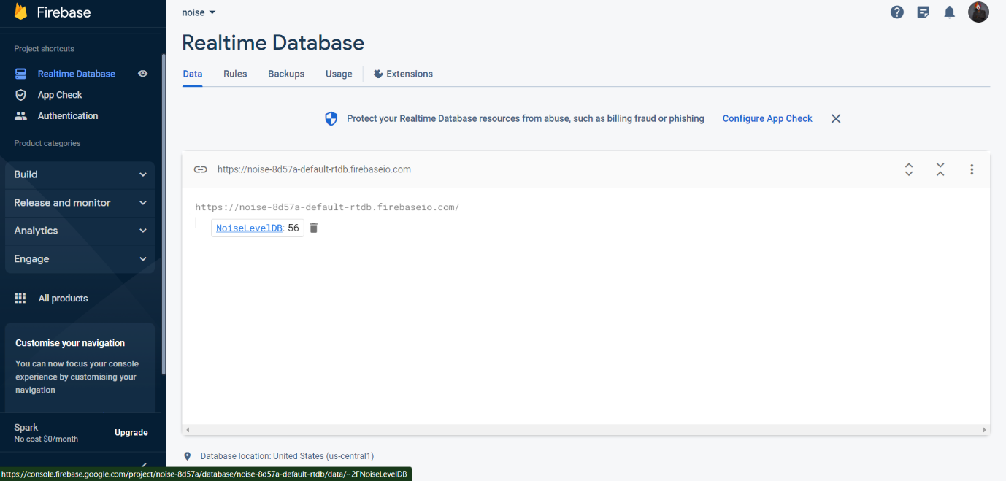

The realtime database of firebase that linked to wokwi simulator by

* Database_url: <https://noise-8d57a-default-rtdb.firebaseio.com/>
* Database_secret: 'yNMFBSvuZi4I8lEu9LjRCoT2qoVuAyOgwjl8F0si'

**APP DEVELOPMENT:**

Utilizing "MIT 21 app inventor," create a mobile application.

**MIT app inventor:** MIT App Inventor is a visual programming environment that allows people with little to no programming experience to create mobile apps for Android devices. App Inventor uses a block-based coding approach, where you can visually drag and drop components and program them using a set of predefined blocks, making app development accessible to a wider audience.

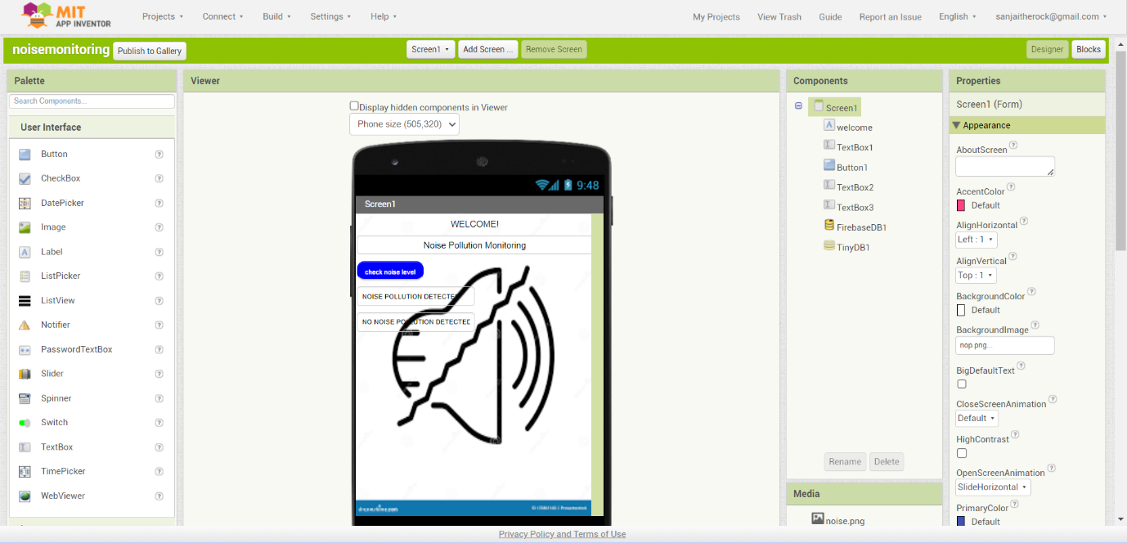

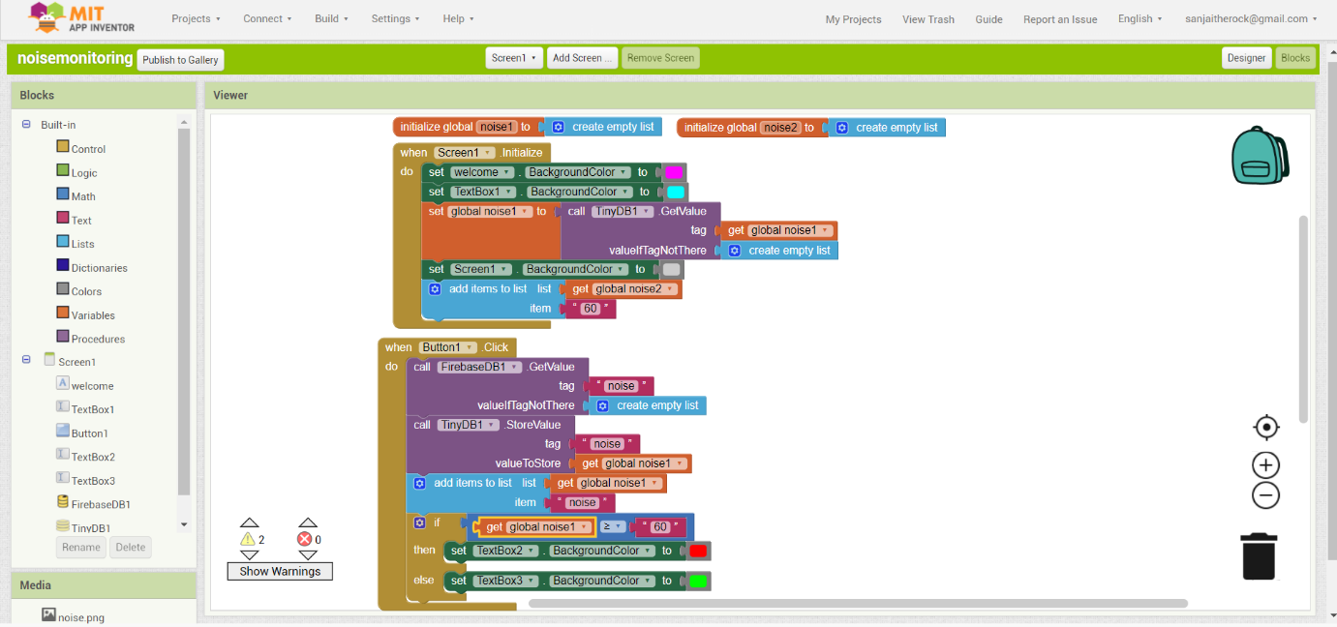

Using "Mit App Inventor," we can use our generated application on our mobile device by either scanning the QR code or entering the six digits.

