Generative AI Foundations: From Models to Applications

Email prompt ,
“Act as a professional academic coordinator.
Draft a formal launch email for a one-day workshop titled "Generative AI Foundations: From Models to Applications".
Target audience: Undergraduate Computer Science and Engineering students.
Include:
Workshop objective
Date, time, and mode
Key topics covered
Registration details
Contact information
Tone: Professional and motivating
Word limit: 200–250 words
”
Result,
Subject: Introducing “Generative AI Foundations” – A One-Day Workshop for CSE Students
Dear Students,
As Artificial Intelligence continues to reshape industries and redefine the future of computing, a strong foundation in Generative AI has become essential for aspiring engineers. To help you understand this rapidly evolving domain, the Department of Computer Science and Engineering is pleased to announce a one-day workshop titled “Generative AI Foundations: From Models to Applications.”
Workshop Objective
This workshop aims to provide students with a clear understanding of how generative models work and how they are applied in real-world systems. Participants will gain conceptual clarity along with practical insights into modern AI workflows.
Event Details
- Date: February 24, 2026
- Time: 9:00 AM – 4:00 PM
- Mode: Hybrid (Seminar Hall A / MS Teams)
Key Topics Covered
- Introduction to Generative AI and its evolution
- Overview of models such as GANs, VAEs, and Transformers
- Real-world applications in text, image, and code generation
- Ethical considerations and responsible AI practices
Registration & Contact
Participation is free, with limited seats available. Interested students are requested to register by February 20, 2026 using the link below:
[Register Here]
For further information, contact the Academic Coordination Office at coord@university.edu or visit Room 302.
We look forward to your enthusiastic participation.
Best regards,
Academic Coordinator
Department of Computer Science and Engineering

Image ,
“A professional digital poster for a university workshop titled "Generative AI Foundations: From Models to Applications" scheduled on February 24, 2026 (9:00 AM – 4:00 PM).
Visuals: An undergraduate Computer Science student working on a laptop in a modern, futuristic classroom. Soft blue and white lighting. Transparent AI holograms showing neural networks, transformers, data flows, and abstract generative models floating in the background.
Text Layout:
- Bold title at the top
- Side panel displaying Date, Time, and Hybrid Mode (Seminar Hall A / MS Teams)
- Section highlighting Key Topics: Generative Models, Applications, Ethics
- Footer with “Register Now”, QR code placeholder, and university logo labeled Department of CSE
Style: High-resolution, realistic digital illustration, clean academic minimalism, futuristic AI aesthetic, professional university poster design.”

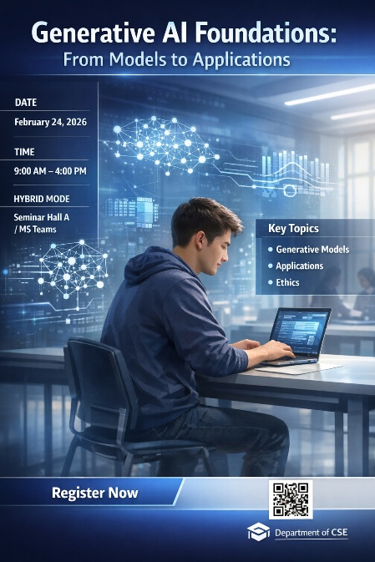
Video,
Tool: veo-3.1 fast

Workshop Title
Generative AI Foundations: From Models to Applications

Video Prompt
Create a professional promotional video for a university-level workshop titled
"Generative AI Foundations: From Models to Applications".

Workshop Details
- Date: February 24, 2026
- Time: 9:00 AM – 4:00 PM
- Mode: Hybrid (Seminar Hall A & MS Teams)
- Organized by: Department of CSE

Target Audience
Undergraduate Computer Science and Engineering students.

Video Style
- Professional, modern, academic tone
- Futuristic AI-inspired visuals
- Blue and white color palette
- Smooth cinematic camera movements
- Clean animated transitions
- Soft ambient background music
- Confident, motivating narration
- Cinematic flow (not slideshow-style)

Video Script Flow

Scene 1 – Opening Introduction
On-screen Title:
Generative AI Foundations
Subtitle:
Understanding Models. Building Applications.
Visuals:
A futuristic university classroom with soft blue lighting. Students working on laptops. Transparent AI holograms showing neural networks and flowing data streams. Slow cinematic push-in camera movement.

Scene 2 – About the Workshop
Narration:
"Generative Artificial Intelligence is transforming how machines create text, images, and intelligent systems. This one-day workshop is designed to introduce students to the core foundations behind modern generative AI technologies."
Visuals:
Animated AI interfaces, flowing data visualizations, and abstract representations of generative models. Slow pan movement across the classroom.

Scene 3 – Core Learning Areas
Narration:
"Participants will explore the principles behind generative models and understand how these technologies are applied across real-world domains."
Visuals:
Animated keywords appear one by one with subtle glow effects:
- Generative Models
- Real-World Applications
- Ethical AI
- Hands-on Concepts

Scene 4 – Date, Time and Mode
On-screen Animated Text:
February 24, 2026
9:00 AM – 4:00 PM
Hybrid Mode: Seminar Hall A & MS Teams
Narration:
"Join us on February twenty-fourth for a full day of immersive learning through a flexible hybrid format."
Visuals:
An animated calendar flipping to the event date. The classroom scene transitions smoothly into an online meeting interface.

Scene 5 – Who Should Attend
Narration:
"This workshop is ideal for undergraduate engineering students who want to understand how generative AI systems are built, trained, and responsibly deployed."
Visuals:
Diverse students collaborating and discussing ideas, interacting with floating AI user interface overlays. Smooth orbit camera motion.

Scene 6 – Call to Action
On-screen Text:
Register Now
Narration:
"Build a strong foundation in generative AI and prepare yourself for the future of intelligent systems. Register now."
Visuals:
Glowing interface elements, light pulses, and a smooth zoom-in toward the registration prompt.

End Frame
On-screen Text:
Organized by Department of CSE
Generative AI Foundations: From Models to Applications
Visuals:
A calm futuristic background with soft glowing particles and a slow zoom-out fade.

