Lab Practical: Prompt Engineering Techniques in Generative AI
Date: 03-02-2026
Subject: Generative AI
Title: Study and Application of Advanced Prompt Engineering Patterns

1. Aim of the Experiment
To understand and apply different prompt engineering techniques such as Persona Prompt, Root Prompt, Cognitive Verifier Pattern, Question Refinement Pattern, Chain of Thought, RGC framework, and various prompting strategies (Zero-shot, One-shot, Few-shot) for improving the quality, accuracy, and reliability of responses generated by AI models.
2. Objective
- To design structured prompts for effective AI interaction
- To compare different prompting techniques
- To analyze how reasoning quality improves using Chain of Thought
- To understand role-based and context-based prompting

3. Use of Persona Prompt (Text)
Definition
A Persona Prompt assigns a specific role, expertise, tone, and behavior to the AI model to control its responses.
Prompt Example
You are a senior Artificial Intelligence professor with more than 15 years of experience.
Explain the concept of Machine Learning to undergraduate engineering students.
Use simple language, step-by-step explanation, and real-world examples.
Avoid complex mathematics.
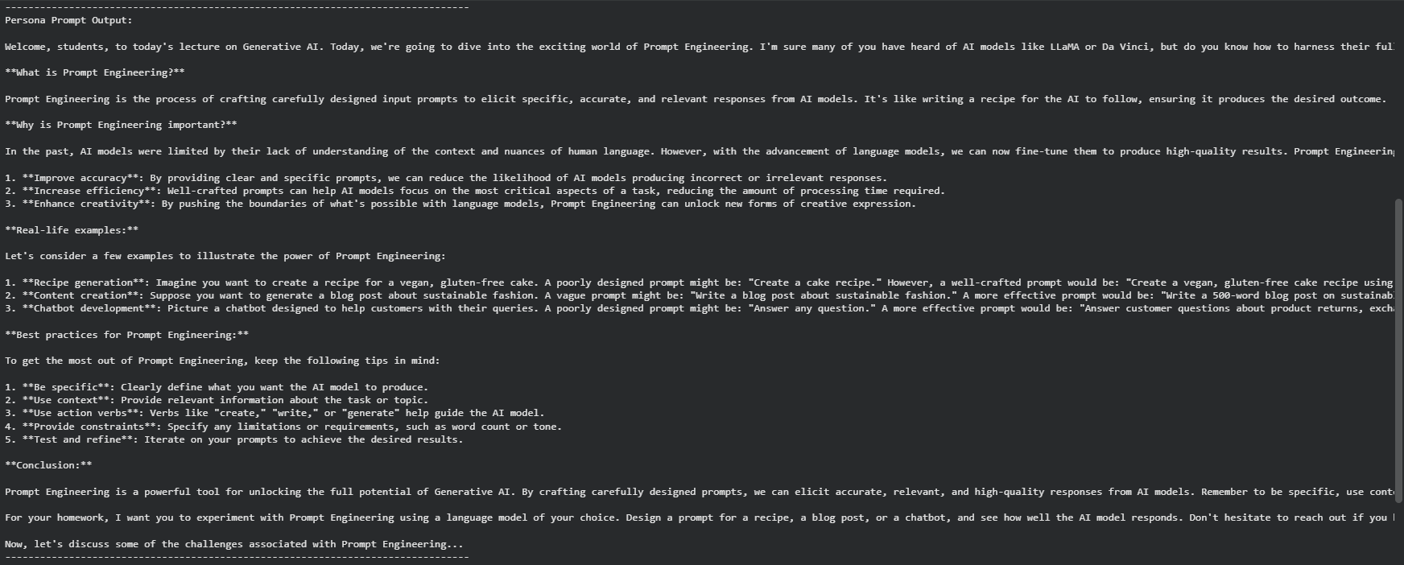

Observation
The AI generates responses aligned with the defined role and audience.
4. Use of Root Prompt (Text)
Definition
A Root Prompt acts as a base instruction that governs the AI’s behavior throughout the interaction.
Prompt Example
You are an academic AI assistant designed for university-level coursework.
Provide accurate, structured, and formal responses.
Explain concepts step by step and refine unclear questions before answering.
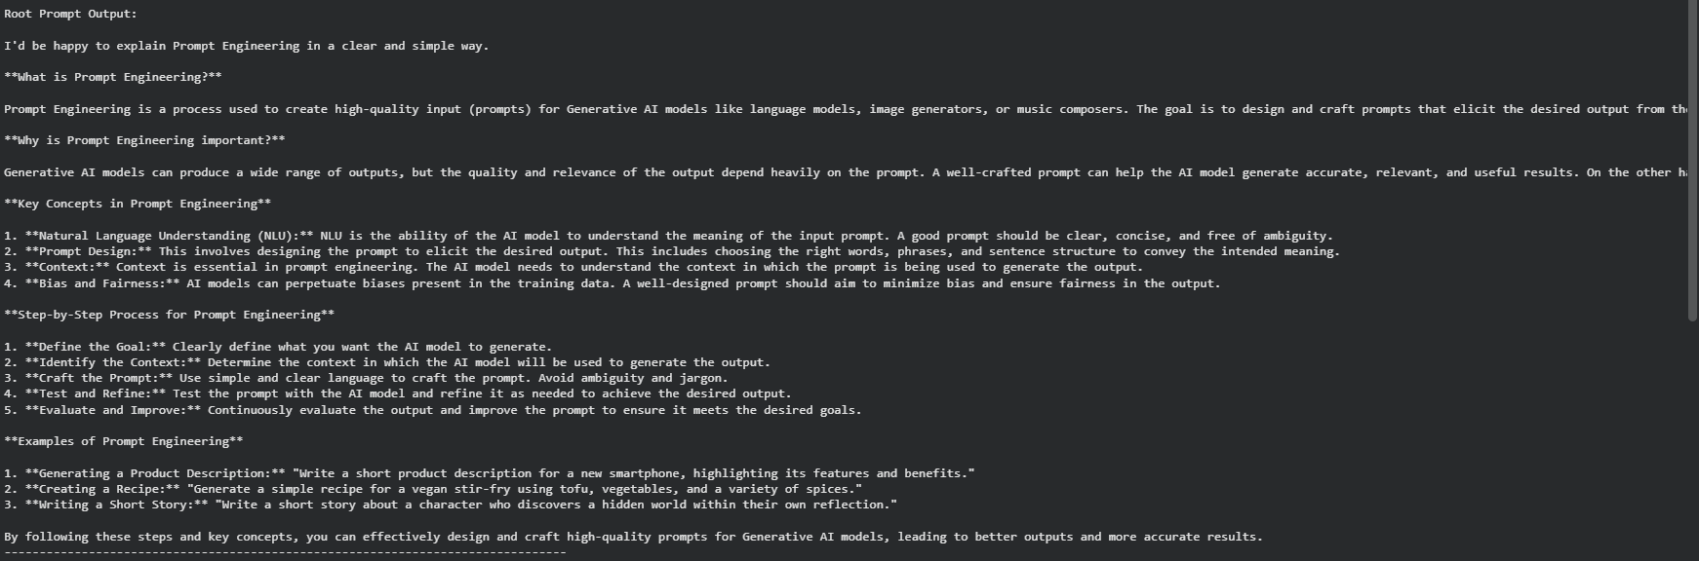
Observation
Ensures consistency, clarity, and academic tone in responses.

5. Exercise 3 – Cognitive Verifier Pattern (Python Coding)
Aim : To implement the Cognitive Verifier Pattern, where the system verifies its own answer before finalizing it.
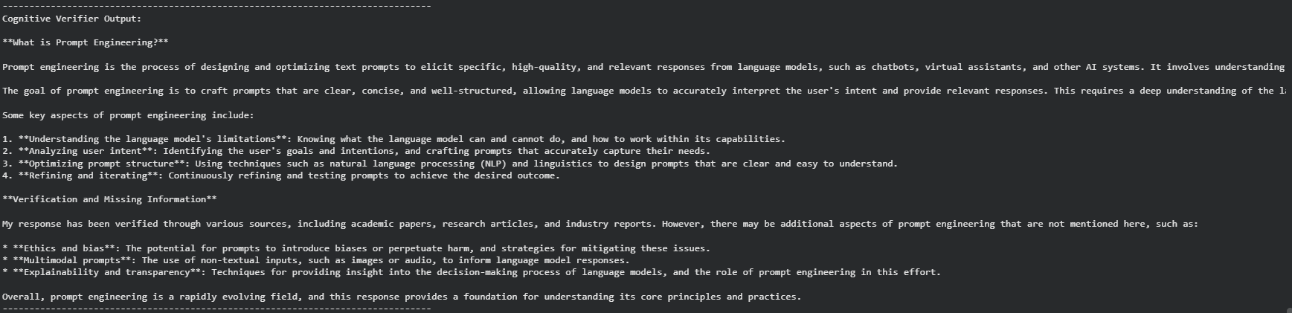
Inference
The system verifies its reasoning before confirming the final result, demonstrating the Cognitive Verifier Pattern.

6. Exercise 4 – Question Refinement Pattern (Python Coding)
Aim
To implement the Question Refinement Pattern, where an unclear question is refined before answering.
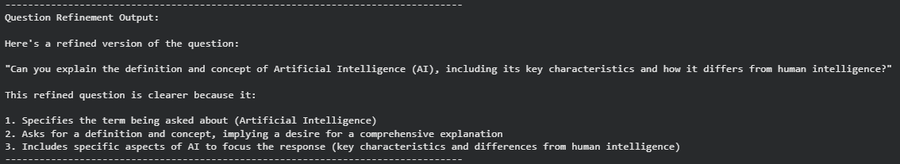
Inference
Refining the question improves clarity and quality of the final response.

7. Provide New Information and Ask Questions Pattern (Text)
Prompt Example
Explain Neural Networks in a beginner-friendly manner.
Include definition, components, and a simple example.
After the explanation, ask three follow-up questions to test understanding.
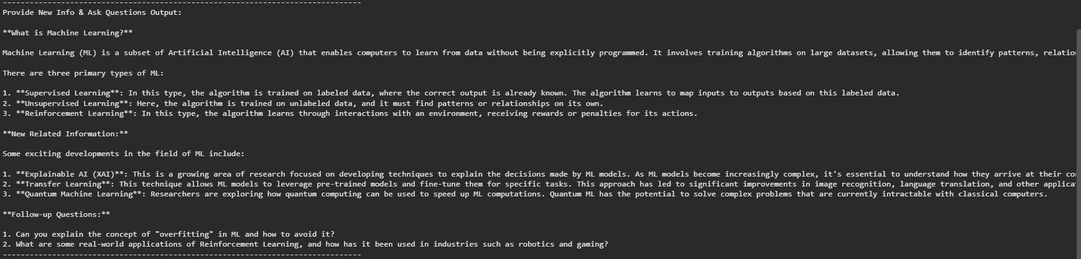
Purpose
Encourages interactive learning and deeper understanding.
8. Practice Chain of Thought Prompting (Text)
Definition : Chain of Thought prompting forces the AI to reason step by step before answering.
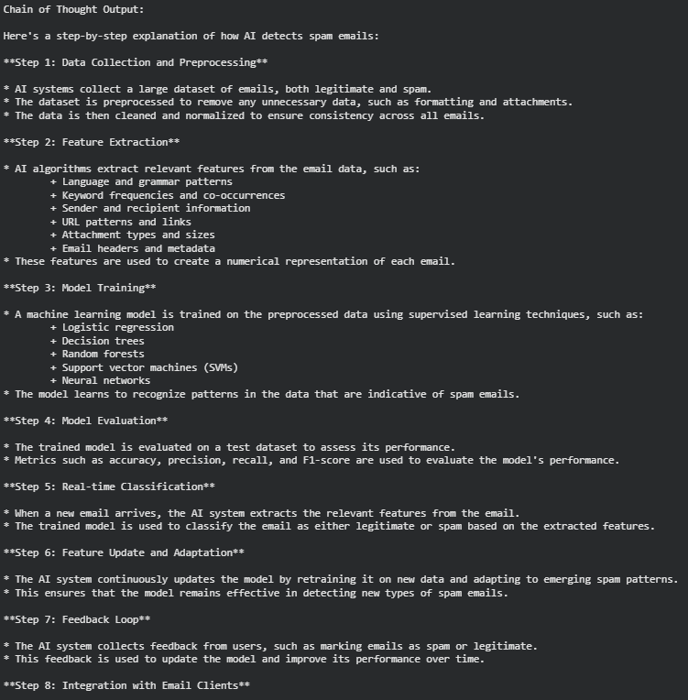
Prompt Example
Solve the given problem step by step.
Explain each reasoning stage clearly.
Do not skip intermediate steps.
Summarize the final answer.
Benefit
Improves logical reasoning and accuracy.

9. Tabular Comparison of Prompting Techniques
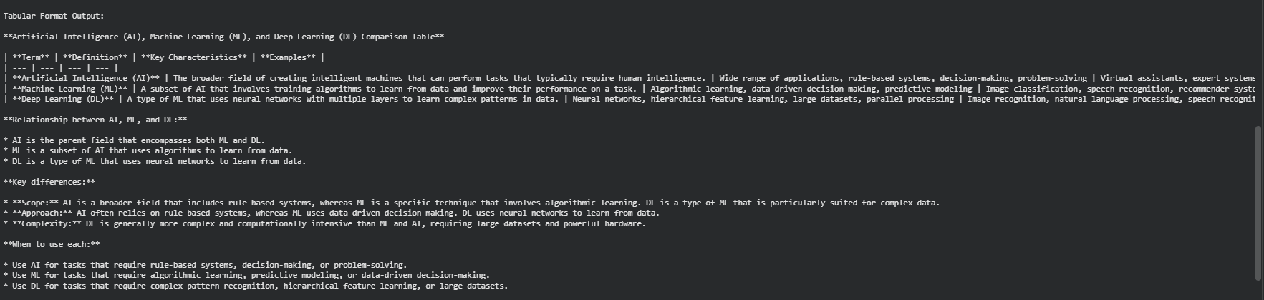
10. Fill in the Blanks
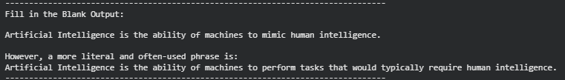

11. RGC Framework (Role – Goal – Context)
Example Prompt
Role: You are a data scientist.
Goal: Explain overfitting and underfitting.
Context: Audience is first-year engineering students with basic programming knowledge.
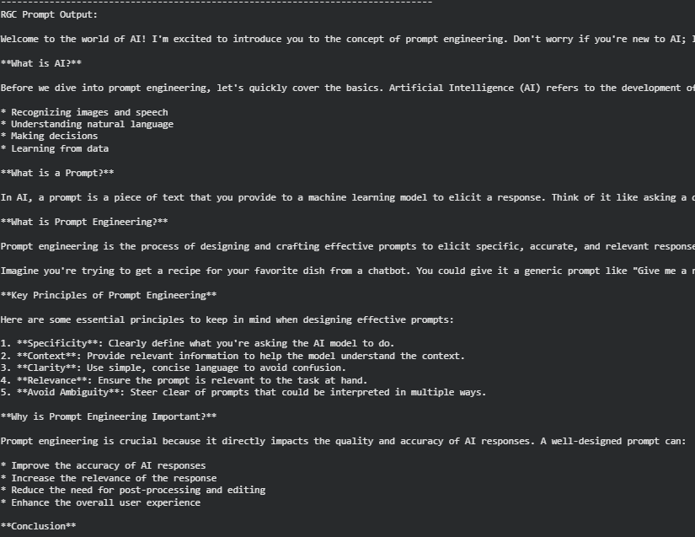
12. Zero-Shot Prompting
Definition
The model is given no examples, only a task.
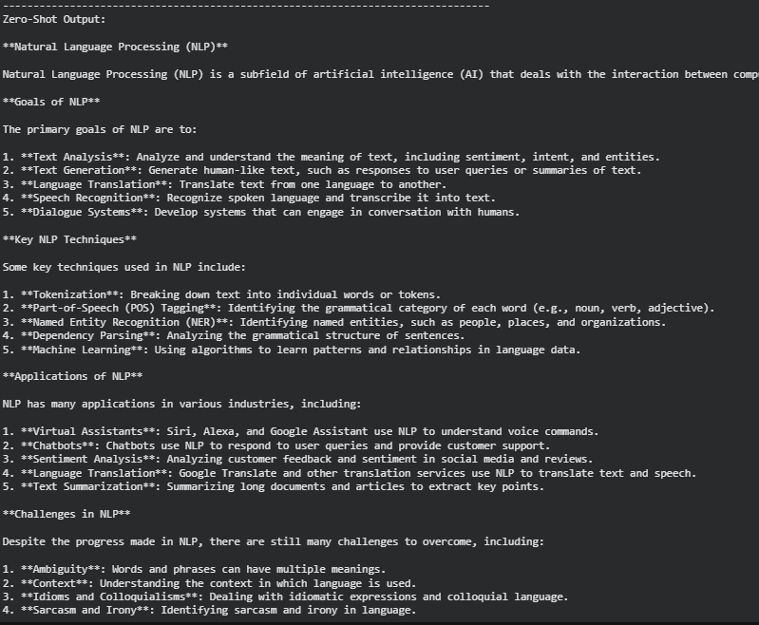
Example
Explain the concept of blockchain technology with its applications.
13. One-Shot Prompting
Example
Example:
Question: What is Artificial Intelligence?
Answer: Artificial Intelligence refers to machines that simulate human intelligence.
Now answer:
What is Machine Learning?
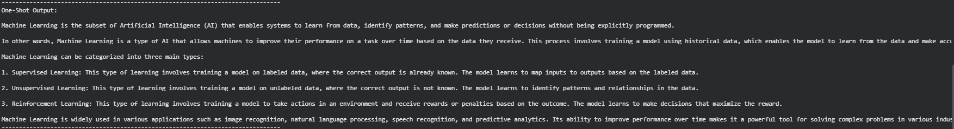
14. Few-Shot Prompting
Example
Input: Dog
Output: Mammal
15. Result
All prompt engineering techniques were successfully studied and implemented. Cognitive Verifier and Question Refinement patterns were implemented using Python, while other techniques were analyzed theoretically.
16. Conclusion
This lab practical demonstrates that structured prompt engineering significantly improves the quality, reliability, and reasoning capability of Generative AI systems. Combining text-based prompts with executable Python logic provides a strong foundation for real-world AI applications.

