BIU 8688697201: Data Science, Design Document
Literature search over arXiv (math) + trend analytics and advisor finder

Task and dataset
The main goal is to help a math student find literature. The user writes a topic in natural language. The system returns papers that are really relevant, with answers based on real sources. Trend analytics and the advisor finder are extra features on top of the same index.
We use the arXiv metadata dataset from Cornell University and Kaggle. It has 2.2 million papers in JSON format, with id, title, authors, categories, abstract and dates. For our project we only keep four categories: math.PR, math.ST, math.CO and math.OC, from the last 3 years. This gives us 57,155 papers. Some parts are free text, like the abstract. Some parts are nested lists, like versions and categories. So the data is semi-structured.

Architecture and data flow
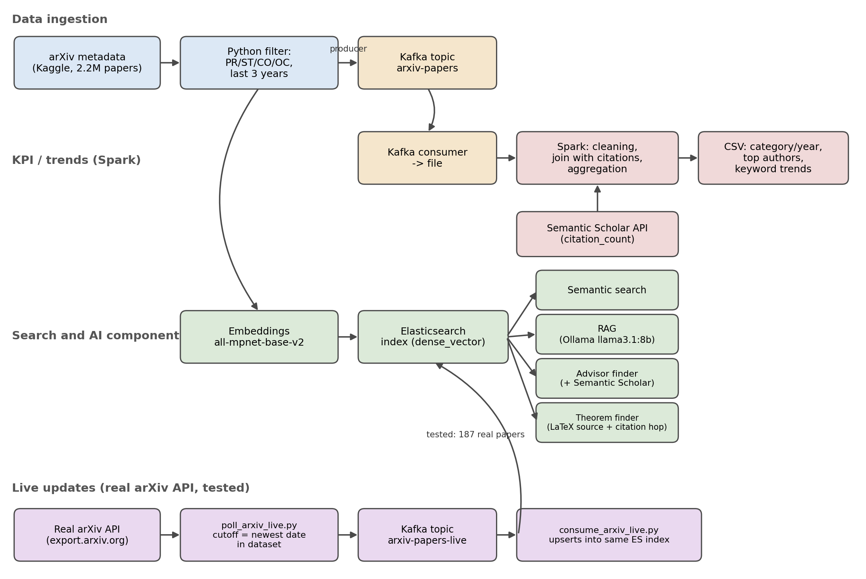
- The filtered metadata is published to a Kafka topic called arxiv-papers. A producer sends it, and a consumer reads it back into a file. We chose this real producer and consumer setup because the direct Spark-Kafka connector is fragile and too heavy for a project this size.
- Spark reads that file, joins it with citation data from the Semantic Scholar API, and computes the KPIs. This includes papers per category and year, top authors, and keyword trends.
- The same filtered file is also turned into vectors with all-mpnet-base-v2 and indexed in Elasticsearch as dense_vector. This index is the base for semantic search, RAG and the advisor finder.
- Separately, poll_arxiv_live.py checks the real arXiv API for papers published after our dataset's newest date. It sends new papers to a second Kafka topic, arxiv-papers-live. consume_arxiv_live.py reads them, embeds them, and adds them to the same index. An early version of this consumer indexed everything twice, 374 entries instead of 187, because it was missing a group_id. It was a one-line fix. We tested it end to end and found 187 real new papers this way.

Course technologies
NoSQL / Elasticsearch. Elasticsearch is a document-oriented NoSQL store built on Apache Lucene. Each paper is stored as a JSON document with a flexible schema. This means we do not need to design a relational schema or write migrations in advance. Title and abstract fields are indexed automatically as inverted indices, so each term points to a list of documents, which is why keyword search is fast. The dense_vector field works in a different way: it is indexed with HNSW, or Hierarchical Navigable Small World graphs, a structure built for approximate nearest-neighbor search. Without it, kNN search over our 768-dimensional embeddings would need to scan all 57,000 documents one by one. With it, results come back in milliseconds. We only run one node for this project, but Elasticsearch shards data automatically, so the same index could scale to a full cluster with no changes to our code.
Docker. Elasticsearch and Kafka both run as containers. A container is an isolated process that shares the host's kernel, using Linux namespaces for isolation and cgroups to limit resources. A virtual machine works differently: it emulates a whole separate operating system. For us, the main benefit is reproducibility. Both services have complex setup and dependencies, and a container image behaves the same way no matter what is installed on the host machine. If something breaks, we can delete the whole environment and rebuild it from scratch with one docker run command.
Apache Spark. spark_kpis.py runs in local[*] mode, so one machine works like a cluster, using every CPU core as a worker. Spark stores our data as a DataFrame, split into partitions. It builds a DAG, or directed acyclic graph, of steps like join, groupBy and explode. Nothing actually runs until an action is called. In our case, that action is writing the CSV file. Only then does Spark plan and optimize the full computation together. This is the main reason Spark is faster than classic Hadoop MapReduce, which writes results to disk after every stage.
- Streaming / Kafka: we use it for ingestion, through a producer and consumer pair on the topic arxiv-papers. We also built a second, separately tested live-update path that checks the real arXiv API, on the topic arxiv-papers-live.
- RESTful APIs: we call Semantic Scholar for citations and authors, the real arXiv API for live updates, and Ollama's local API for the LLM.

AI component
Embeddings + semantic search. We did not choose the embedding model randomly. We ran 3 rounds of testing on our own sample of 5,000 papers. The first round used a homemade rule, a made-up category overlap score, which we later saw did not measure very much. Later rounds switched to the standard metrics from the public MTEB and BEIR leaderboards, so our results can be compared with real, known baselines:
There are no manual relevance labels for this data. arXiv does not tell us which paper answers which question. So we build ground truth automatically. Each paper's own title becomes the query. That paper's own abstract becomes the one correct answer. Other sampled abstracts are used as wrong answers. This works because a title is already a short description of its own abstract. For clustering, we do something similar. We reuse a label that already exists in the metadata, the arXiv category, as a stand-in for topic. We did not create this label ourselves.
- MRR, or Mean Reciprocal Rank: the average of 1 divided by the rank of the first correct result. A correct answer at rank 5 is punished much more than a correct answer at rank 1.
- R@10, or Recall at 10: how often the correct document appears anywhere in the top 10 results. This shows if the user found the answer at all.
- nDCG@10: ranking quality, weighted by position. This is the main metric on MTEB and BEIR retrieval leaderboards, so we use it as our main score too.
- V-measure and NMI: standard metrics for clustering quality, from the MTEB Clustering task. We run k-means on the embeddings, then compare the clusters to the real arXiv category, used as a stand-in label. This shows if the embedding space understands topic structure in general. It is a broader test than looking at similarity between two papers alone.
Model | dim | MRR | R@10 | nDCG@10 | V-measure | NMI
all-MiniLM-L6-v2 | 384 | 0.892 | 0.962 | 0.908 | 0.485 | 0.485
all-mpnet-base-v2 (chosen) | 768 | 0.904 | 0.971 | 0.920 | 0.623 | 0.623
allenai-specter | 768 | 0.549 | 0.703 | 0.580 | 0.532 | 0.532
TF-IDF (baseline) | 21636 | 0.809 | 0.935 | 0.838 | 0.335 | 0.335

all-mpnet-base-v2 had the best score on every metric. Semantic search clearly beats the TF-IDF keyword baseline, especially for clustering (0.623 vs 0.335 V-measure). This means embeddings separate papers by their real subfield much better than shared words do.
RAG. For a user's question, we retrieve the top-k relevant abstracts with kNN. Then we ask a local LLM, through Ollama, to answer using only those abstracts, and to say which ones it used. We compared llama3.2 (3B) with llama3.1 (8B) on the same question. 8B was clearly better. It gave a deeper answer that used several sources together, and did not just copy one abstract. For a while rag_answer.py still pointed to llama3.2, the wrong default, after we had already chosen 8B. We found this during testing and fixed it with a one-line change.
Advisor finder (bonus). Given a user's stated interests, we look for the most active and most cited researchers through the Semantic Scholar API. We only show an institutional affiliation, including Israeli institutions, when the data actually confirms it. If it does not confirm it, the researcher is still recommended based on merit. We simply do not guess where they work.
Theorem finder (bonus). This feature downloads the LaTeX source directly from arXiv, for the top matching papers. It finds theorem, lemma and proof blocks using regex, and ranks them by their semantic similarity to the query. If a matched block cites another paper, we follow one citation hop. This way, if a result was only used in the matched paper but proved somewhere else, it gets flagged correctly instead of being credited to the wrong paper.

Results and insights
- Top authors and keyword trends, such as Markov chain, martingale, random graph and linear programming, are computed by year and category. As a check, we reran the analysis on a CO and OC only subset: PR-heavy topics dropped out, OC and CO topics stayed about the same, matching what we expected. This confirms the pipeline on both the technical and math side.
- Citation lag: average citations per year go down toward 2026. This makes sense, because recent papers have not had time yet to collect citations. We read this together with the paper-count trend, and do not look at it alone.
- 57,031 of 57,155 papers, or 99.8%, were matched successfully with Semantic Scholar's citation data.

