Valuation Funnel:

**Prior 1: Sectors mean revert in terms of relative valuations**

**Null Hypothesis**: Sector valuations do not exhibit mean reversion. Specifically, the time series of relative sector valuations follows a unit root process, indicating non-stationarity and no mean reversion.

**Alternative Hypothesis**: Sector valuations exhibit mean reversion. Specifically, the time series of relative sector valuations is stationary, indicating that deviations from the historical mean are temporary and valuations revert to the mean over time.

Statistical Tests to perform for testing these hypotheses:

**1. Unit Root Test (Augmented Dickey-Fuller Test)**

**Objective**: Determine if the time series of relative valuations is stationary (implying mean reversion).

**Null Hypothesis**: The relative valuation time series has a unit root (non-stationary).

**Alternative Hypothesis**: The relative valuation time series is stationary.

**Steps**:

* Collect time series data of relative valuations for a sector wrt Nifty500 Index.
* Perform the ADF test on the series.

**Interpretation: ADF Test** A significant p-value (< 0.05) indicates the series is stationary, implying mean reversion.

**Variance Ratio Test**:

**Objective**: Test for mean reversion in the time series of relative valuations.

* **Null Hypothesis**: The relative valuation time series follows a random walk (no mean reversion).
* **Alternative Hypothesis**: The relative valuation time series does not follow a random walk (mean-reverting).

**Steps:**

Compute the log returns of the relative valuation series wrt Nifty500 Index as benchmark.

Apply the variance ratio test to the log returns.

**Interpretation**

A variance ratio significantly different from 1 suggests mean reversion.

**Cointegration Test** (if comparing with CNX500 such as the market index):

Objective: Check if the relative valuation of a sector is cointegrated with the Nifty 500 Index indicating a long-term equilibrium relationship.

* **Null Hypothesis**: There is no cointegration (no long-term equilibrium relationship).
* **Alternative Hypothesis**: There is cointegration (indicating a long-term relationship and mean reversion).

**Steps:**

* Collect time series data for the sector and the Index (or other sectors; we can pair one sector with another as well in the second step).
* Perform the Engle-Granger two-step cointegration test.

**Interpretation**

A significant p-value (< 0.05) suggests that the sector's valuation is cointegrated with the market or other sectors, supporting the hypothesis of mean reversion.

**Prior 2: US Inflation (Core PCE) and Indian Financial Sector (Bank Nifty)**

**Null Hypothesis:** There is no significant correlation between US Core PCE and the Indian Financial Sector returns

**Alternative Hypothesis:** There is a significant correlation between US Core PCE and the Indian Financial Sector returns *(Interpretation: The changes in US Core PCE have a statistically significant linear relationship with the changes in the Indian Financial Sector returns.)*

**Testing the Hypotheses:** To test these hypotheses, you would typically:

**Collect and Prepare Data:**

Obtain historical data for US Core PCE and the Indian Financial Sector Index.

Calculate the returns for both datasets over the same period.

**Perform Statistical Analysis:**

Calculate the Pearson correlation coefficient between the two return series.

Use a statistical test to determine the significance of the correlation coefficient (e.g., a t-test for correlation).

**Interpret Results:**

If the p-value from the statistical test is less than the chosen significance level (e.g., 0.05), reject the null hypothesis in favour of the alternative hypothesis.

If the p-value is greater than the significance level, do not reject the null hypothesis.

**Prior 3: Financial sector outperforms in late bear markets**

**Null Hypothesis:** The financial sector does not outperform other sectors in late bear markets.

**Mathematical Formulation:** The average returns of the financial sector during late bear markets are equal to or less than the average returns of other sectors.

**Alternative Hypothesis (H1):**

**Statement:** The financial sector outperforms other sectors in late bear markets.

**Mathematical Formulation:** The average returns of the financial sector during late bear markets are greater than the average returns of other sectors.

**Testing the Hypotheses**

To test these hypotheses, follow these steps:

1. **Identify Late Bear Markets:**
   * Define the criteria for what constitutes a "late bear market" i.e. the last 20% of a bear market period.
   * Use historical market data to identify periods that fit this definition.
2. **Collect Data:**
   * Obtain historical returns data for the financial sector (NIFTY Financial Services Index) and for other sectors (Lets use CNX500 Index as a proxy for broader mkts-sectors).
   * Ensure the data spans multiple bear markets for robust analysis. Lets take this data for last 30 years
3. **Calculate Returns:**
   * Calculate the average returns of the financial sector and other sectors during the identified late bear market periods.
4. **Perform Statistical Analysis:**
   * Use a statistical test to compare the average returns. A t-test for comparing means can be appropriate here. Use a one-tailed t-test to compare the means, testing if the financial sector's returns are significantly higher than those of other sectors.

**Understand the Output:**

* **t-statistic:** This value indicates how many standard deviations the observed difference in means is away from the null hypothesis. A larger absolute value suggests a greater difference.
* **p-value:** This value indicates the probability of observing the test results under the null hypothesis. A smaller p-value suggests stronger evidence against the null hypothesis.

**Example Analysis in Context**

Let's assume the output from the Python script is:

* t-statistic: 2.35
* p-value: 0.01
* Significance level (α): 0.05

**Steps to Analyze:**

1. **Interpret t-statistic:**
   * The t-statistic of 2.35 indicates that the observed difference in means between the financial sector and other sectors during late bear markets is 2.35 standard deviations away from what we would expect if the null hypothesis were true.
2. **Compare p-value with α:**
   * Here, the p-value is 0.01, which is less than the significance level of 0.05.
3. **Decision:**
   * Since the p-value (0.01) is less than α (0.05), we reject the null hypothesis.
4. **Conclusion:**
   * There is significant evidence to conclude that the financial sector outperforms other sectors during late bear markets.

**Detailed Interpretation**

1. **Significance of Results:**
   * The p-value of 0.01 indicates that there is only a 1% chance that the observed difference (or more extreme) could occur if the null hypothesis were true. This low probability provides strong evidence against the null hypothesis.
2. Graphs

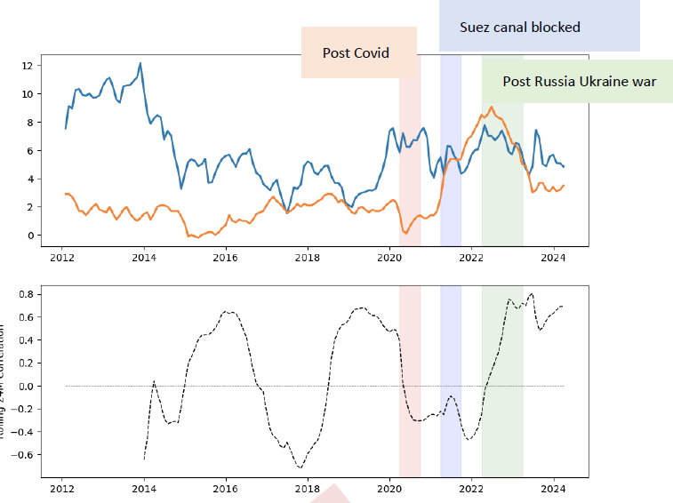

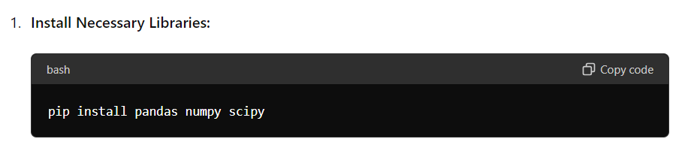

1. Python Script

import pandas as pd

import numpy as np from scipy.stats

import ttest_ind

# Load the datasets (ensure your CSVs have 'Date', 'Financial_Sector', and 'Other_Sectors' columns)

financial_sector = pd.read_csv('financial_sector_returns.csv', parse_dates=['Date']) other_sectors = pd.read_csv('other_sectors_returns.csv', parse_dates=['Date'])

# Merge datasets on Date

data = pd.merge(financial_sector, other_sectors, on='Date')

# Identify late bear market periods (for simplicity, this step is abstract)

# This step requires defining and identifying the late bear market periods

# For example purposes, assume 'Late_Bear' column exists with boolean values late_bear_market_data = data[data['Late_Bear']]

# Calculate returns during late bear markets

financial_returns = late_bear_market_data['Financial_Sector'] other_returns = late_bear_market_data['Other_Sectors']

# Perform t-test

t_stat, p_value = ttest_ind(financial_returns, other_returns, alternative='greater')

# Significance level

alpha = 0.05

# Hypothesis Testing

if p_value < alpha: print(f"Reject the null hypothesis: The financial sector outperforms other sectors (t-statistic = {t_stat}, p-value = {p_value})") else: print(f"Fail to reject the null hypothesis: No significant outperformance by the financial sector (t-statistic = {t_stat}, p-value = {p_value})")