

Þarfgreiningaskýrsla

Inngangur

Í þessu verkefni erum við að hanna þarfagreiningaskýrslu fyrir bílaleigu. Leigan þarf að bjóða upp á allavega þrjá mismunandi flokka af bílum, lágmarksleiga er einn dagur og greiða má með korti eða reiðufé. Við munum setja upp kröfulista, notendatilvik og lýsingu á notendahópum. Einnig munum við setja upp grunnmyndir og taka frumgerðarviðtöl út frá skissunum sem við bjuggum til og lögum til hönnunina út frá niðurstöðum frá þeim.

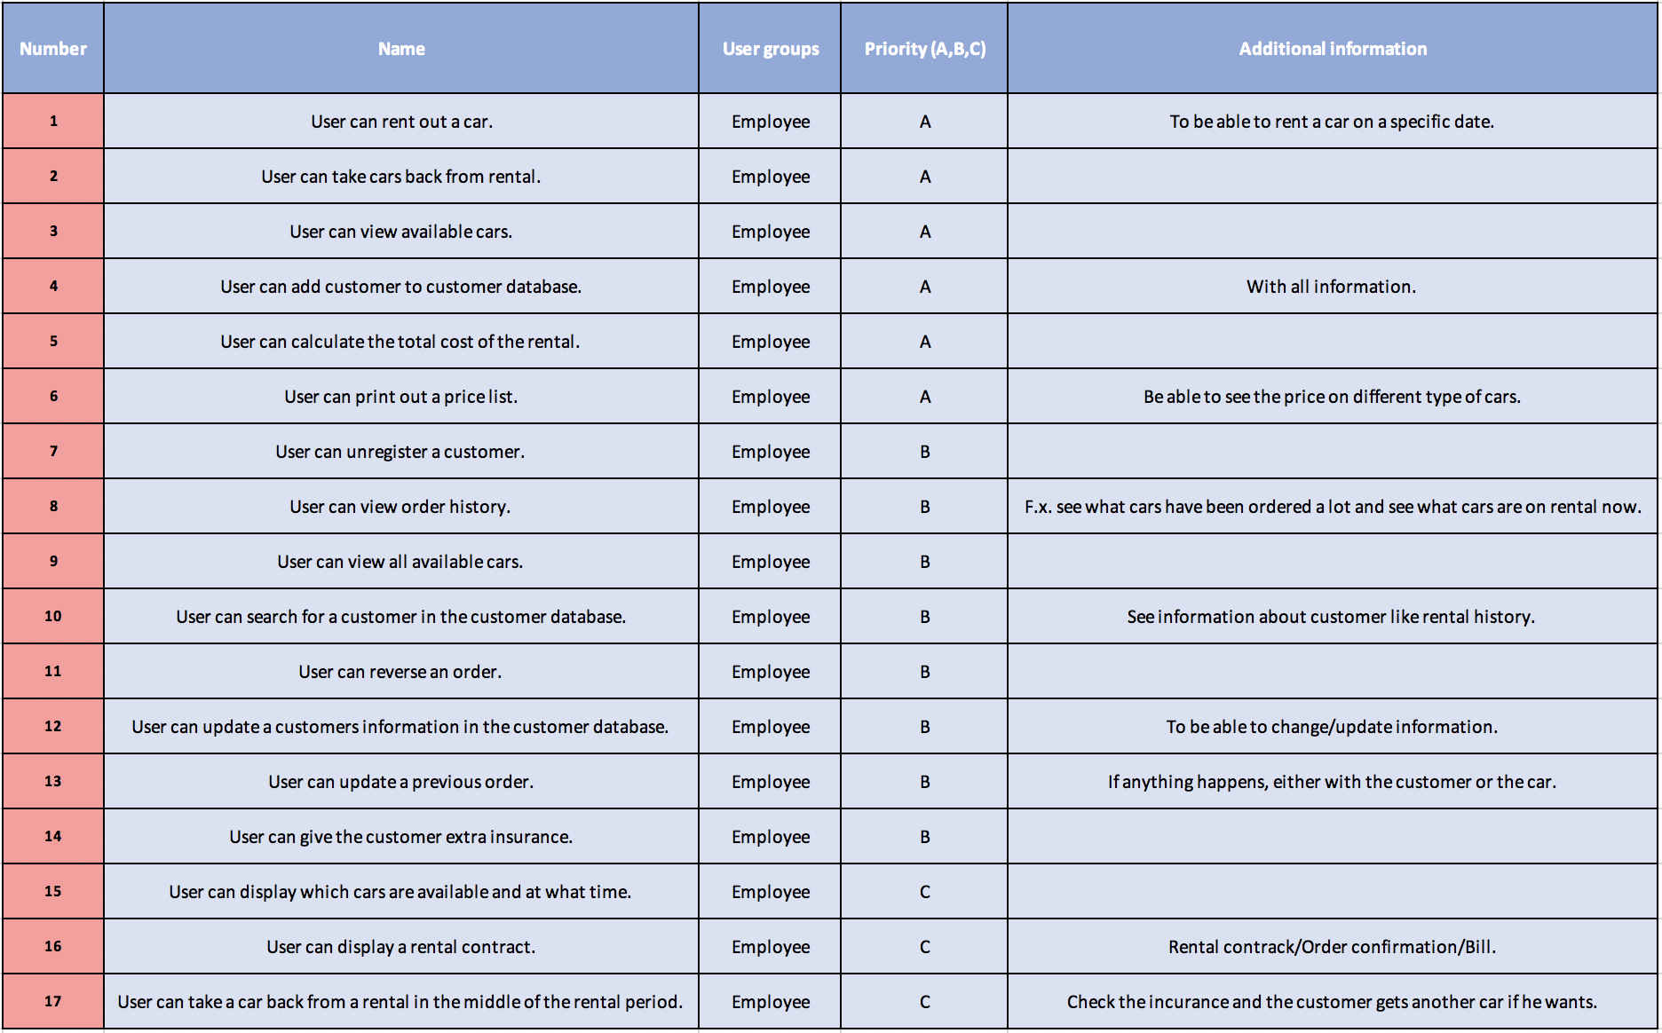Kröfulisti

Use Case

Use case 1

|  |  |
| --- | --- |
| Name | User rents out a car to customer. |
| Number | 1 |
| Priority | A |
| Precondition | * User is in the system. * Customer is registered in the customer database. |
| Description | * User selects “Rent a car” on the home screen. * Customer picks a certain type of car for rental. * User assigns the car to the customer for a certain time period. * User calculates the cost of the rental. * User prints out rental contract on the screen and shows the customer. * The user asks the customer how he will pay for the rental car. - Debit card/Credit card/Cash: User pays on the spot. |
| Alternative flow | * The car is not available for the wanted time period. - The user can offer him another car of a different type, if another car is available. - The user can offer him the same type of a car for another time period. * Customer wants extra insurance, go to 10. * The customer doesn’t have a way of paying. - The customer must come later when he can pay. |
| Post condition | * The car is now not available for other customers. * The rental of the car is assigned to the customers history, the car’s history and the company’s rental database. |
| Source | 1, 3, 5, 6, 14, 15, 16. |
| Actor | User and customer. |
| Author | Hlynur Magnússon and Sveinbjörn Jóhannesson. |

Use case 2

|  |  |
| --- | --- |
| **Name** | Customer returns a car. |
| **Number** | 2 |
| **Priority** | A |
| **Precondition** | * User is in the system. * Customer must have an active rental of a car. * Customer must be a registered customer. |
| **Description** | * User selects “Return a car” on the home screen. * User searches for customers rental information. * User checks for extra cost. - Time period was longer than agreed. - The car was damaged. - Car was not returned with a full tank of fuel. * User prints out the rental contract with any changes in extra cost and shows the customer on the screen. * Customer payment if needed. - Debit card/Credit card/Cash: User pays on the spot. |
| **Alternative flow** | * Customer doesn’t have the car anymore, lost/stolen. - Customer must contact his insurance company if he has one. He must pay for the car in one way or another. * Customer returns the car before deadline because of a damage to the car or malfunction, if the damage is not covered by insurance the customer must pay for it. Otherwise the company does. - The user can rent him another car for the rest of the time period, go to use case 1. * Customer has lost the car keys. - If the customer has the “lost car keys insurance”, he will only have to pay for the deductible insurance otherwise he’ll have to pay for a new car key. |
| **Post condition** | * Car will go through a maintenance schedule that takes one day. After that he will be available for rental. - If car was damaged the maintenance schedule will take 5 days. * Customer has payed for the rental of the car. And any extra cost if needed. |
| **Source** | 2, 5, 6, 16, 17. |
| **Actor** | User and customer. |
| **Author** | Hlynur Magnússon and Sveinbjörn Jóhannesson. |

Use case 3

|  |  |
| --- | --- |
| **Name** | User checks for available cars. |
| **Number** | 3 |
| **Priority** | A |
| **Precondition** | * User is in the system. |
| **Description** | * User selects “Available cars” on the home screen. * User gets a list of cars that are available for rental. |
| **Alternative flow** | * No cars are available for rental. - System prints out “No car available!” |
| **Post condition** |  |
| **Source** | 3, 15. |
| **Actor** | User |
| **Author** | Hlynur Magnússon and Sveinbjörn Jóhannesson. |

Use case 4

|  |  |
| --- | --- |
| **Name** | User adds customer to the customer database. |
| **Number** | 4 |
| **Priority** | A |
| **Precondition** | * User is in the system. * User has the customers information. |
| **Description** | * User selects “Customer database” on the home screen. * User selects “Add customer”. * User types in the customers information and saves it to the database. |
| **Alternative flow** | * Customer is already in the customers database. - The system prints out “Customer already exists, do you want to overwrite that customer?” |
| **Post condition** | * Customer is in the customer database. |
| **Source** | 4, 12. |
| **Actor** | User, customer. |
| **Author** | Hlynur Magnússon and Sveinbjörn Jóhannesson. |

Use case 5

|  |  |
| --- | --- |
| **Name** | User can calculate the cost of a rental. |
| **Number** | 5 |
| **Priority** | A |
| **Precondition** | * User is in the system. * User has information about the said rental. * User has access to the price list of rental cars. * User has a way of calculating the price. |
| **Description** | * User can give the customer an option for extra insurance, go to use case 10. * User compares the said rental information to the price list and calculates the total price. |
| **Alternative flow** | * User doesn’t have the rental information - User must get the rental information from the customer. |
| **Post condition** | * User has the total price of the said rental. With chance of extra cost when the car is returned. |
| **Source** | 5, 6, 14. |
| **Actor** | User. |
| **Author** | Hlynur Magnússon and Sveinbjörn Jóhannesson. |

Use case 6

|  |  |
| --- | --- |
| **Name** | User can print out price list. |
| **Number** | 6 |
| **Priority** | A |
| **Precondition** | * User in the system. * Price list is set up in the system. |
| **Description** | * User selects “Price list” on the home screen. |
| **Alternative flow** | * Price list is not set up in the system. - User must set up the price list in the system. |
| **Post condition** | * The price list is printed on the computer screen. |
| **Source** | 6. |
| **Actor** | User |
| **Author** | Hlynur Magnússon and Sveinbjörn Jóhannesson. |

Use case 7

|  |  |
| --- | --- |
| **Name** | User can search the customer database |
| **Number** | 7 |
| **Priority** | B |
| **Precondition** | * User must be in the system. * System must have a customer database. |
| **Description** | * User selects “Customer database” on the home screen. * User selects “search customer database”. * User searches for a customer by typing in name or SSN. * User gets numbered list of customers (basic info shown) that fit the search. * User picks the customer they want to view. - The computer prints out all the information about that customer. * User gets the option to select. - Change customer information. - Unregister customer. - Exit search. * If user picks change customer information, user will go to use case 8 and then refresh current use case (7). * If user picks unregister customer, user will go to user case 9 and then refresh current use case (7). * If user picks exit search, user will go to the “Customer database” page. |
| **Alternative flow** | * The search criteria the user typed in does not match any customer in the customer database. - The computer prints out “No match!” and refreshes current use case. |
| **Post condition** | System back to “Customer database” |
| **Source** | 10. |
| **Actor** | User |
| **Author** | Hlynur Magnússon and Sveinbjörn Jóhannesson. |

Use case 8

|  |  |
| --- | --- |
| **Name** | User can change a customer’s information in the customer database. |
| **Number** | 8 |
| **Priority** | B |
| **Precondition** | * User must be in the system. * User must have come from use case 8. |
| **Description** | * The computer prints out “What would you like to change?” on the screen. * The computer prints out a list of all attributes that can be changed with the option to change nothing and exit. * If the user selects to change anything, the computer asks for an input to change that. Then it asks you if you’re sure you want to change that information. If you accept the changes the information of the customer will be changed, and the user will be asked if he would like to change anything else or just exit. And that will happen again and again until the user doesn’t want to change anything more about the user. |
| **Alternative flow** | * You are not allowed to change something in the customers information f.x. the SSN. - The computer will print out: “You can’t change the SSN.” |
| **Post condition** | * If any changes were made to the customers information, they will be saved in the customers database. * The user will be sent back to the customer database page. |
| **Source** | 10, 12. |
| **Actor** | User |
| **Author** | Hlynur Magnússon and Sveinbjörn Jóhannesson. |

Use case 9

|  |  |
| --- | --- |
| **Name** | User can unregister customer from customer database |
| **Number** | 9 |
| **Priority** | B |
| **Precondition** | * User must be in the system. * User must have come from use case 8 |
| **Description** | * User searches for a customer by name or SSN. * User selects the option to unregister the customer. |
| **Alternative flow** | * The user is not in the system. - The user must open the system. * The customer is not in the database. - The computer prints out “Customer doesn’t exist.” and askes if you want to create a new customer. If user decides to create a new customer, he will go to user case 4.  - If the user doesn’t want to create a new customer he will go back to the previous page. |
| **Post condition** | * The costumer has been removed from the costumer database. * The user will be sent back to the customer database page. |
| **Source** | 7, 10. |
| **Actor** | User |
| **Author** | Hlynur Magnússon and Sveinbjörn Jóhannesson. |

Use case 10

|  |  |
| --- | --- |
| **Name** | User can give costumer further insurance |
| **Number** | 10 |
| **Priority** | B |
| **Precondition** | * User must be in the system. * Costumer must be in costumer database. |
| **Description** | * Costumer wants to rent a car and wants extra insurance. * User adds further insurance to the rented car. * Then costumer rents car, he will go to use case 1. |
| **Alternative flow** |  |
| **Post condition** | * Price of further insurance has been added to total price |
| **Source** | 1, 5, 6, 14. |
| **Actor** | User, Costumer |
| **Author** | Snorri Vignisson. |

Use case 11

|  |  |
| --- | --- |
| **Name** | User can display all cars that are out on rental |
| **Number** | 11 |
| **Priority** | B |
| **Precondition** | * User must be in system |
| **Description** | * User selects “Rental database” on the home screen. * User selects “Car’s on rental now”. * A display of all cars being currently rented pops up. * View all rented cars * Exit display |
| **Alternative flow** | * No cars are in a “rented” state and instead of displaying a list of rented cars it displays “No cars are rented at the moment” |
| **Post condition** | * Back to “Rental database” |
| **Source** | 8, 9. |
| **Actor** | User. |
| **Author** | Snorri Vignisson. |

Use case 12

|  |  |
| --- | --- |
| **Name** | User can display rental history of the company |
| **Number** | 12 |
| **Priority** | B |
| **Precondition** | * User must be in system |
| **Description** | * User selects “Rental database” * The computer prints out a list of all rentals made by the company. Listed by date of beginning of rental. * User can view the list for as long as wanted. After that he will select the exit option. |
| **Alternative flow** | * The company has no rental database. - The computer prints out: “No rental history!” |
| **Post condition** | * Back to home screen |
| **Source** | 8, 9. |
| **Actor** | User, Costumer |
| **Author** | Sveinbjörn Jóhannesson. |

Description of user groups

A screenshot of a cell phone


Wireframes and interviews

Other

* Comparison to similar systems
* Questionnaire
* Use case diagram