**TRAFFIC MANAGEMENT**

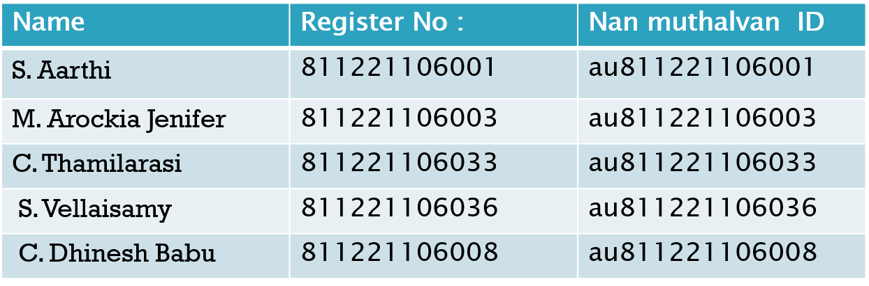

**ABSTRACT:**

* Traffic congestion is a major problem in many cities of India along with other countries.
* Failure of signals, poor law enforcement and bad traffic management has lead to traffic
* congestion. One of the major problems with Indian cities is that the existing
* infrastructure cannot be expanded more, and thus the only option available is better
* management of the traffic. Traffic congestion has a negative impact on economy, the
* environment and the overall quality of life. Hence it is high time to effectively manage
* the traffic congestion problem. There are various methods available for traffic
* management such as RFID, infrared sensors, inductive loop detection, wireless sensor
* network, etc. All these methods are effective methods of smart traffic management. But
* the problem with these systems is that the installation time, the cost incurred for the
* installation and maintenance of the system is very high. Hence a new technology using
* image processing with IOT is introduced which can be coupled with the existing
* signaling system that can act as a key to smart traffic management in real time. This
* new technology which will require less time for installation with lesser costs as
* compared to other methods of traffic congestion management. Use of this new
* technology will lead to reduced traffic congestion.

**COMPONENTS:**

• Radio signal detector

• Radio waves transmitter

• Ultra-sonic sensor/Hall Effect sensor

• Raspberry Pi

• Python programming

• Light Emitting Diode

**BLOCK DIAGRAM:**

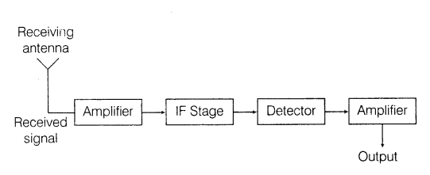

**HALL EFFECT SENSOR:**

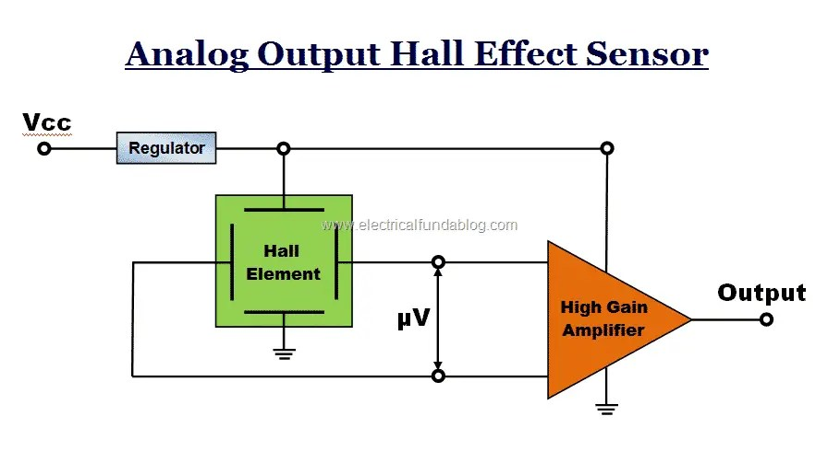

**PROCESS FLOW CHART:**

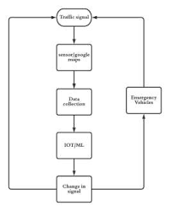

**PROGRAM :**

f = open("out.txt", "r")

no_of_vehicles=[]

no_of_vehicles.append(int(f.readline()))

no_of_vehicles.append(int(f.readline()))

no_of_vehicles.append(int(f.readline()))

no_of_vehicles.append(int(f.readline()))

baseTimer = 120 # baseTimer = int(input("Enter the base timer value"))

timeLimits = [5, 30] # timeLimits = list(map(int,input("Enter the time limits ").split()))

print("Input no of vehicles : ", *no_of_vehicles)

t = [(i / sum(no_of_vehicles)) * baseTimer if timeLimits[0] < (i / sum(no_of_vehicles)) * baseTimer < timeLimits[1] else min(timeLimits, key=lambda x: abs(x - (i / sum(no_of_vehicles)) * baseTimer)) for i in no_of_vehicles]

print(t, sum(t))

**WORKING PROTOTYPE**:

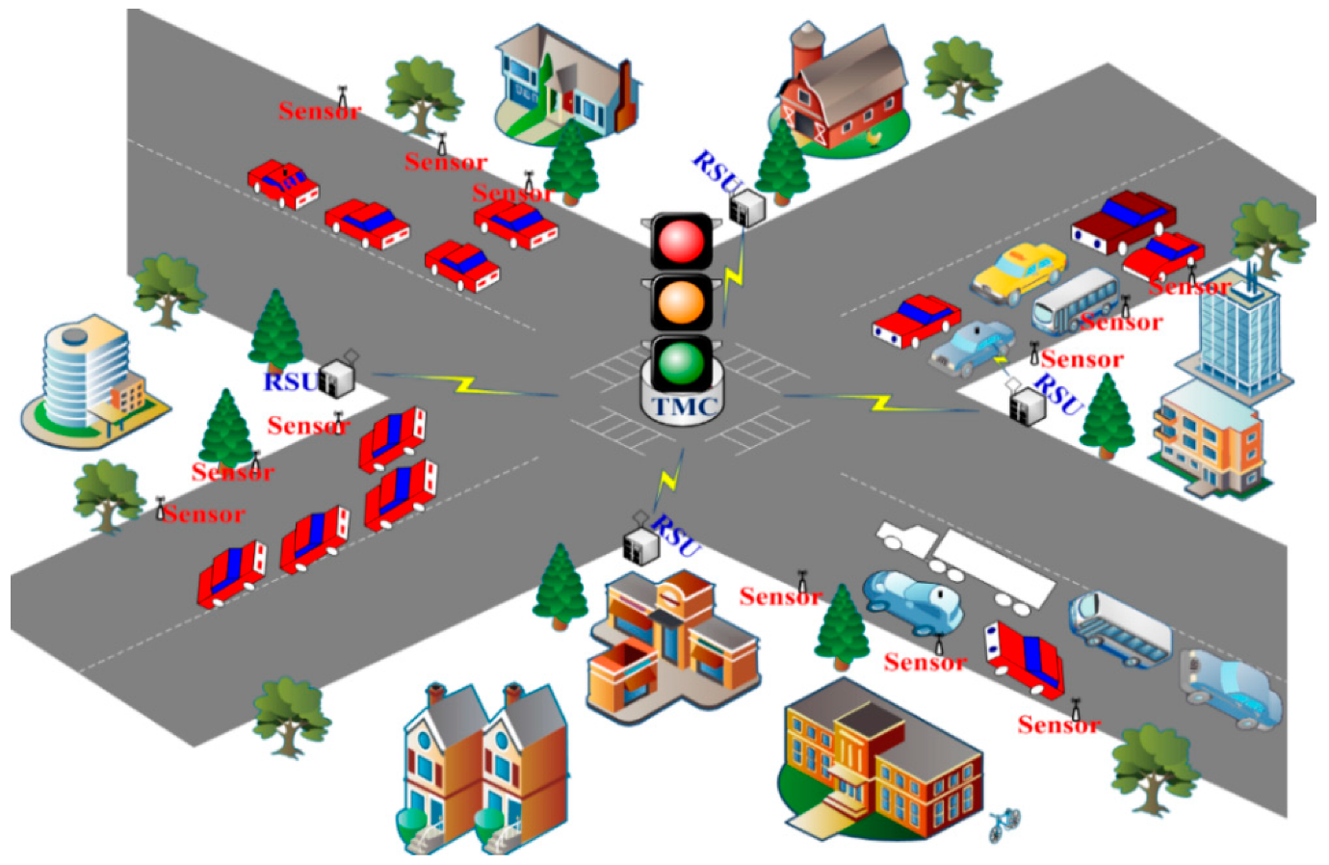

**CONCLUSION:**

*We are working with a python code to implement the above setup. The python code will be uploaded in the upcoming phases of the project.*

***THANK***

***YOU***