# Short Title: CO2 Recirculation Tests for Brunos Thesis Points

Datetime: 15.06.21 9:00

## Prerequisites:

All HOBO sensors should be started and running (Check Battery levels and replace) at 13:50 to 20:50

Login to Codesys, verify if the push-pull devices are operational

Verify REMUS login by the command (find the command)

Turn off the LED lights if they are on

## Aim of the Experiment:

The aim of these measurements is to quantify the recirculation in the Push-pull devices. A tracer gas is filled in indoor chamber and exchanged with the outdoor chamber to observe the behaviour of concentration in the aperture.

Other parameters like volume flow, pressure difference and air properties are measured by test stand. All these experimental data are used to calculate the recirculation and energy performance of push-pull devices.

## Medium AC setpoint settings (MLS):

|  |  |  |  |  |  |  |  |  |  |  |  |  |  |  |  |
| --- | --- | --- | --- | --- | --- | --- | --- | --- | --- | --- | --- | --- | --- | --- | --- |
| **Time** | 11:30 |  |  |  |  |  |  |  |  |  |  |  |  |  |  |
| **SET Temp. (°C)** | 18.5 |  |  |  |  |  |  |  |  |  |  |  |  |  |  |
| **SET Hum. (%)** | 65.0 |  |  |  |  |  |  |  |  |  |  |  |  |  |  |
| **SET V_flow (m³/h)** | 250. |  |  |  |  |  |  |  |  |  |  |  |  |  |  |
| **T120 (°C)** | ~20 |  |  |  |  |  |  |  |  |  |  |  |  |  |  |
| **MT120 (%)** | ~60 |  |  |  |  |  |  |  |  |  |  |  |  |  |  |

## Large AC setpoint settings (LLS):

|  |  |  |  |  |  |  |  |  |  |  |  |  |  |  |  |
| --- | --- | --- | --- | --- | --- | --- | --- | --- | --- | --- | --- | --- | --- | --- | --- |
| Time | 11:30 |  |  |  |  |  |  |  |  |  |  |  |  |  |  |
| V201 | 70 |  |  |  |  |  |  |  |  |  |  |  |  |  |  |
| V302 | 100 |  |  |  |  |  |  |  |  |  |  |  |  |  |  |
| FU Setpoint | 2000 |  |  |  |  |  |  |  |  |  |  |  |  |  |  |
| N_Loop | 4600 |  |  |  |  |  |  |  |  |  |  |  |  |  |  |
| N_TP | 2100 |  |  |  |  |  |  |  |  |  |  |  |  |  |  |
| Vs (m³/h) (teststand) | 60 |  |  |  |  |  |  |  |  |  |  |  |  |  |  |

## Thermal conditions of LLS:

|  |  |  |  |  |  |  |  |  |  |  |  |  |  |  |  |
| --- | --- | --- | --- | --- | --- | --- | --- | --- | --- | --- | --- | --- | --- | --- | --- |
| Time | 14:00 |  |  |  |  |  |  |  |  |  |  |  |  |  |  |
| SET Temp. (°C) | -1.8 |  |  |  |  |  |  |  |  |  |  |  |  |  |  |
| SET Hum. (gw/kgda) | 1.6 |  |  |  |  |  |  |  |  |  |  |  |  |  |  |
| Offset  (°C) | -2 |  |  |  |  |  |  |  |  |  |  |  |  |  |  |
| T_TP_IN  (°C) | -0.5 |  |  |  |  |  |  |  |  |  |  |  |  |  |  |
| Habs_TP_IN (gw/kgda) |  |  |  |  |  |  |  |  |  |  |  |  |  |  |  |
| T_N_Loop (°C) |  |  |  |  |  |  |  |  |  |  |  |  |  |  |  |
| Habs_N_Loop (gw/kgda) |  |  |  |  |  |  |  |  |  |  |  |  |  |  |  |
| T220  (°C) |  |  |  |  |  |  |  |  |  |  |  |  |  |  |  |
| X220 (gw/kgda) |  |  |  |  |  |  |  |  |  |  |  |  |  |  |  |

## Experiment Checklist:

|  |  |
| --- | --- |
| **Item** | **Status** |
| Close valves AD100 and AD 200 or we have positive pressure difference | XXX |
| Pressure difference between the chambers should be with -0.3 and +0.3 | ok |
| Pressure difference between chambers should be zero on average (instantaneous values may fluctuate) | ok |
|  |  |

## Testing conditions:

|  |  |  |
| --- | --- | --- |
| Parameter | Description | Remarks |
| Push-Pull device | Helios |  |
| Push-Pull device Level | Level 5 |  |
| Push-Pull device mode | Alternating |  |
| Indoor chamber volume flow | 60 m3/hr |  |
| Outdoor chamber volume flow | 60 m3/hr |  |
| Indoor temperature | 20 °C |  |
| Indoor relative humidity | 60 %rh |  |
| outdoor temperature | 2 °C |  |
| outdoor relative humidity | 34 %rh |  |
|  |  |  |
|  |  |  |

## Screenshot of the Test stand Circuit with timestamp:

Paste a screenshot of the circuit at the time when the desired volume and pressure values are reached

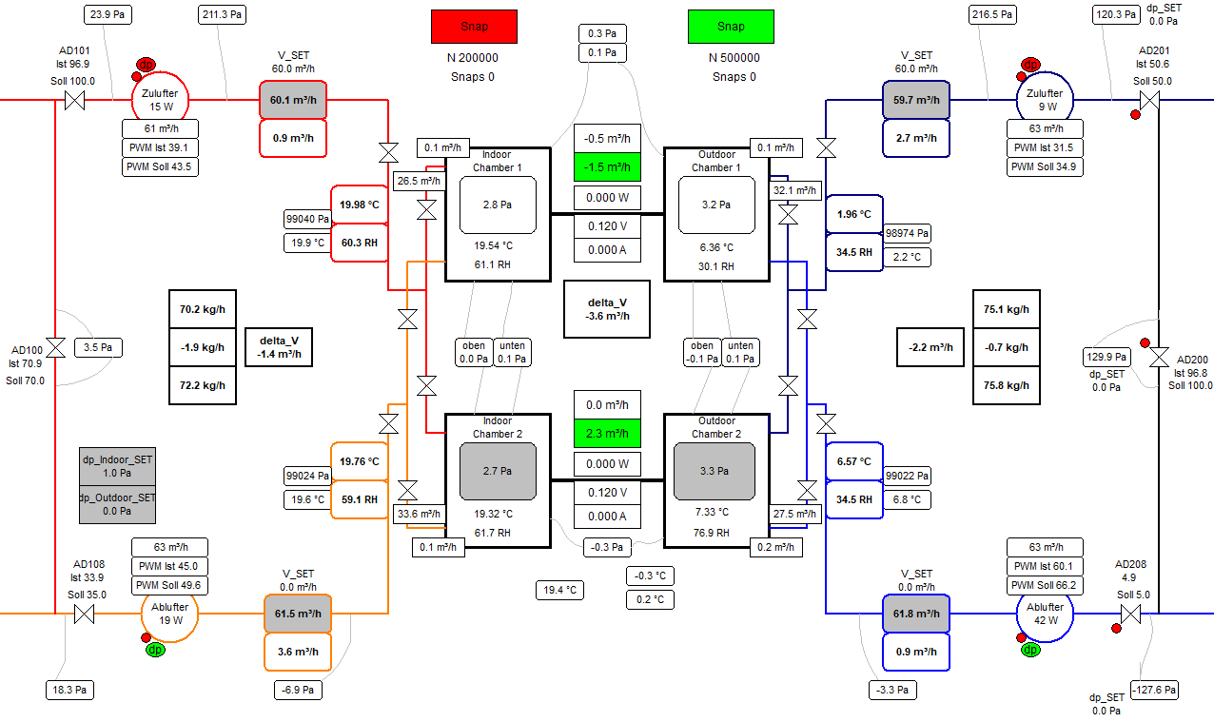

## Experimental procedure:

|  |  |  |
| --- | --- | --- |
| Time | Incident | Remarks |
| 14:12 | Devices are turned off | Codesys time is +11 minutes from real time |
| 14:16 | The devices are sealed with tape to stop leakages |  |
| 14:22 | CO2 is released for 30 seconds |  |
| 14:33 | CO2 is released again for 25 seconds |  |
|  | Wait for 20 minutes |  |
|  | Check for the valve positions AD 100 and AD 200 (closed) |  |
| 14:58 | The tape is removed, and the push-pull devices are turned on at 4100 ppm (Experiment Start) | Anomalies here |
| 15:26 | The final average concentration is 1000 ppm (Experiment End) |  |

## Data Management:

The data is saved in the following address: XXX

# Short Title: CO2 Recirculation Tests for Brunos Thesis Points

Datetime: 15.06.21 17:10

## Prerequisites:

All HOBO sensors should be started and running (Check Battery levels and replace) at 13:50 to 20:50

Login to Codesys, verify if the push-pull devices are operational

Verify REMUS login by the command (find the command)

Turn off the LED lights if they are on

## Aim of the Experiment:

The aim of these measurements is to quantify the recirculation in the Push-pull devices. A tracer gas is filled in indoor chamber and exchanged with the outdoor chamber to observe the behaviour of concentration in the aperture.

Other parameters like volume flow, pressure difference and air properties are measured by test stand. All these experimental data are used to calculate the recirculation and energy performance of push-pull devices.

## Medium AC setpoint settings (MLS):

|  |  |  |  |  |  |  |  |  |  |  |  |  |  |  |  |
| --- | --- | --- | --- | --- | --- | --- | --- | --- | --- | --- | --- | --- | --- | --- | --- |
| **Time** |  |  |  |  |  |  |  |  |  |  |  |  |  |  |  |
| **SET Temp. (°C)** |  |  |  |  |  |  |  |  |  |  |  |  |  |  |  |
| **SET Hum. (%)** |  |  |  |  |  |  |  |  |  |  |  |  |  |  |  |
| **SET V_flow (m³/h)** |  |  |  |  |  |  |  |  |  |  |  |  |  |  |  |
| **T120 (°C)** |  |  |  |  |  |  |  |  |  |  |  |  |  |  |  |
| **MT120 (%)** |  |  |  |  |  |  |  |  |  |  |  |  |  |  |  |

## Large AC setpoint settings (LLS):

|  |  |  |  |  |  |  |  |  |  |  |  |  |  |  |  |
| --- | --- | --- | --- | --- | --- | --- | --- | --- | --- | --- | --- | --- | --- | --- | --- |
| Time |  |  |  |  |  |  |  |  |  |  |  |  |  |  |  |
| V201 |  |  |  |  |  |  |  |  |  |  |  |  |  |  |  |
| V302 |  |  |  |  |  |  |  |  |  |  |  |  |  |  |  |
| FU Setpoint |  |  |  |  |  |  |  |  |  |  |  |  |  |  |  |
| N_Loop |  |  |  |  |  |  |  |  |  |  |  |  |  |  |  |
| N_TP |  |  |  |  |  |  |  |  |  |  |  |  |  |  |  |
| Vs (m³/h) (teststand) |  |  |  |  |  |  |  |  |  |  |  |  |  |  |  |

## Thermal conditions of LLS:

|  |  |  |  |  |  |  |  |  |  |  |  |  |  |  |  |
| --- | --- | --- | --- | --- | --- | --- | --- | --- | --- | --- | --- | --- | --- | --- | --- |
| Time |  |  |  |  |  |  |  |  |  |  |  |  |  |  |  |
| SET Temp. (°C) |  |  |  |  |  |  |  |  |  |  |  |  |  |  |  |
| SET Hum. (gw/kgda) |  |  |  |  |  |  |  |  |  |  |  |  |  |  |  |
| Offset  (°C) |  |  |  |  |  |  |  |  |  |  |  |  |  |  |  |
| T_TP_IN  (°C) |  |  |  |  |  |  |  |  |  |  |  |  |  |  |  |
| Habs_TP_IN (gw/kgda) |  |  |  |  |  |  |  |  |  |  |  |  |  |  |  |
| T_N_Loop (°C) |  |  |  |  |  |  |  |  |  |  |  |  |  |  |  |
| Habs_N_Loop (gw/kgda) |  |  |  |  |  |  |  |  |  |  |  |  |  |  |  |
| T220  (°C) |  |  |  |  |  |  |  |  |  |  |  |  |  |  |  |
| X220 (gw/kgda) |  |  |  |  |  |  |  |  |  |  |  |  |  |  |  |

## Experiment Checklist:

|  |  |
| --- | --- |
| **Item** | **Status** |
| Close valves AD100 and AD 200 or we have positive pressure difference | XXX |
| Pressure difference between the chambers should be with -0.3 and +0.3 | XXX |
| Pressure difference between chambers should be zero on average (instantaneous values may fluctuate) | XXX |
|  |  |

## Testing conditions:

|  |  |  |
| --- | --- | --- |
| Parameter | Description | Remarks |
| Push-Pull device | Helios |  |
| Push-Pull device Level | Level 5 |  |
| Push-Pull device mode | Alternating |  |
| Indoor chamber volume flow | 80 m3/hr |  |
| Outdoor chamber volume flow | 80 m3/hr |  |
| Indoor temperature | 20 °C |  |
| Indoor relative humidity | 60 %rh |  |
| outdoor temperature | 2 °C |  |
| outdoor relative humidity | 34 %rh |  |
|  |  |  |
|  |  |  |

## Screenshot of the Test stand Circuit with timestamp:

Paste a screenshot of the circuit at the time when the desired volume and pressure values are reached

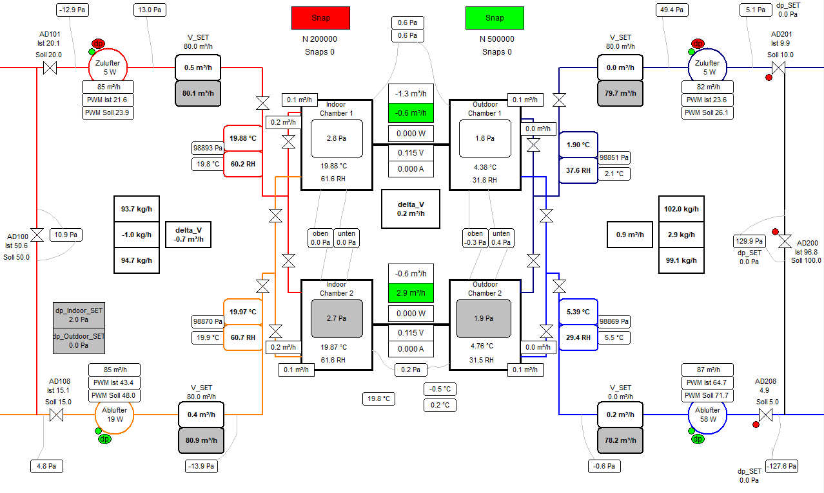

## Experimental procedure:

|  |  |  |
| --- | --- | --- |
| Time | Incident | Remarks |
|  | Devices are turned off | Codesys time is +11 minutes from real time |
| 17:00 | The devices are sealed with tape to stop leakages |  |
| 17:16 | CO2 is released for 50 seconds |  |
|  | Wait for 20 minutes |  |
|  | Check for the valve positions AD 100 and AD 200 (closed) |  |
| 18:07 | The tape is removed, and the push-pull devices are turned on at 4100 ppm (Experiment Start) | Anomalies here |
| 18:30 | The final average concentration is 1000 ppm (Experiment End) |  |

## Data Management:

The data is saved in the following address: XXX

# Appendix

## Sensor Positioning

1L is placed in the AC in the floor above

3a_50 is still in the outlet of the indoor chamber just before the valve (hard to access)

**17 sensors in total**

## DIN EN 13141-8 tests conditions

|  |  |  |  |  |
| --- | --- | --- | --- | --- |
| DIN EN 13141-8 tests conditions | | | | |
|  | 1 | 2 | 3 | 4 |
| Indoor |  |  |  |  |
| Dry Bulb Temperature  (°C) | 20 | 20 | 20 | 20 |
| Relative Humidity  (%) | 37,8 | 59,9 | 37,8 | 25,1 |
| Abslute Humidity  (gw/kgda) | 5,54 | 8,83 | 5,54 | 3,67 |
| Outdoor |  |  |  |  |
| Dry Bulb Temperature  (°C) | 7 | 2 | -7 | -15 |
| Relative Humidity  (%) | 88,4 | 89,5 | 75 | 95 |
| Abslute Humidity  (gw/kgda) | 5,55 | 3,95 | 1,69 | 1,12 |

# Appendix

## Sensor Positioning

1L is placed in the AC in the floor above

3a_50 is still in the outlet of the indoor chamber just before the valve (hard to access)

**17 sensors in total**

## DIN EN 13141-8 tests conditions

|  |  |  |  |  |
| --- | --- | --- | --- | --- |
| DIN EN 13141-8 tests conditions | | | | |
|  | 1 | 2 | 3 | 4 |
| Indoor |  |  |  |  |
| Dry Bulb Temperature  (°C) | 20 | 20 | 20 | 20 |
| Relative Humidity  (%) | 37,8 | 59,9 | 37,8 | 25,1 |
| Abslute Humidity  (gw/kgda) | 5,54 | 8,83 | 5,54 | 3,67 |
| Outdoor |  |  |  |  |
| Dry Bulb Temperature  (°C) | 7 | 2 | -7 | -15 |
| Relative Humidity  (%) | 88,4 | 89,5 | 75 | 95 |
| Abslute Humidity  (gw/kgda) | 5,55 | 3,95 | 1,69 | 1,12 |