**DEV**

**BUILDING & RUNNING**

* Go to the folder for each lib project:
  + mvn clean install
* Go to the folder for each microservice
  + mvn clean install -DskipTests
  + docker logs my-product-srv -f
* Root folder
  + docker-compose build
  + docker-compose up -d
  + docker-compose down

**GIT & GITHUB**

git status => status git repo

git log => overview of commits

git add . => add all untracked & modified files to STG

git commit -m "My first commit" -a => add + commit

git push -v => push local branch to github

git tag

git tag -a v3.0 -m "chapter 3 intial release"

git show v3.0

git push origin v3.0

Create release in GitHub:

Click on tags

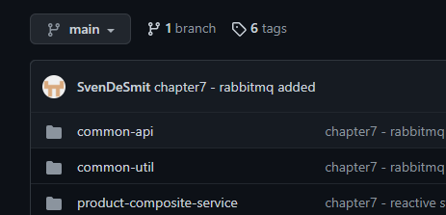

Click on tag name (v7.1)

Create release from tag:

Fill in … and create.

**PUSH IMAGES TO DOCKER HUB**

Only if you want to create a new version of the image! for each image:

* create new image for dockerhub svendesmit/springbootmicroservices2-product-composite:v? (put that image in docker-compose.yml)
* docker tag springbootmicroservices2-product-composite:latest svendesmit/springbootmicroservices2-product-composite:v1

Login: https://stackoverflow.com/questions/57108005/login-to-docker-hub-by-command-line

Push with same version:

In windows CMD window! (doen't work in git-bash)

docker login

docker-compose push

**Docker**

**POSTMAN**

Environments



**MongoDB**

**MySQL**

**SPRING BOOT ADMIN**

<http://localhost:1111>

[slydeveloper/spring-boot-admin - Docker Image | Docker Hub](https://hub.docker.com/r/slydeveloper/spring-boot-admin)

**RABBITMQ ADMIN**

<http://localhost:15672/#/queues>

**OFFSET EXPLORER - KAFKA TOOL**

