Observed signal transient times are in the order of 10 ns. Both for falling and rising edges.
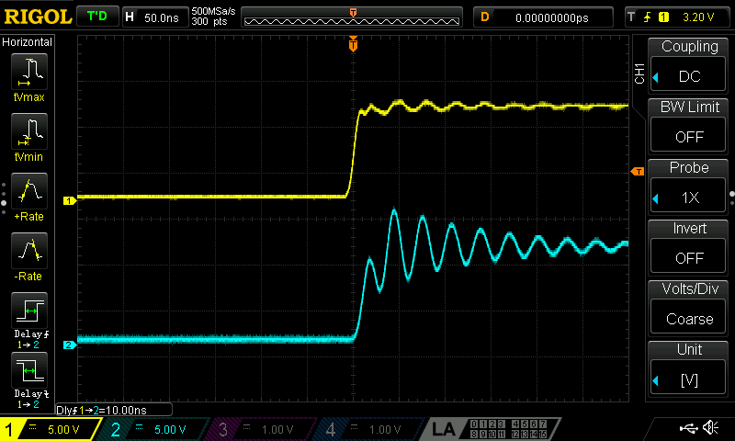Figure 1: Rising edge test. Channel 1: signal generator. Channel 2: Testec probe.
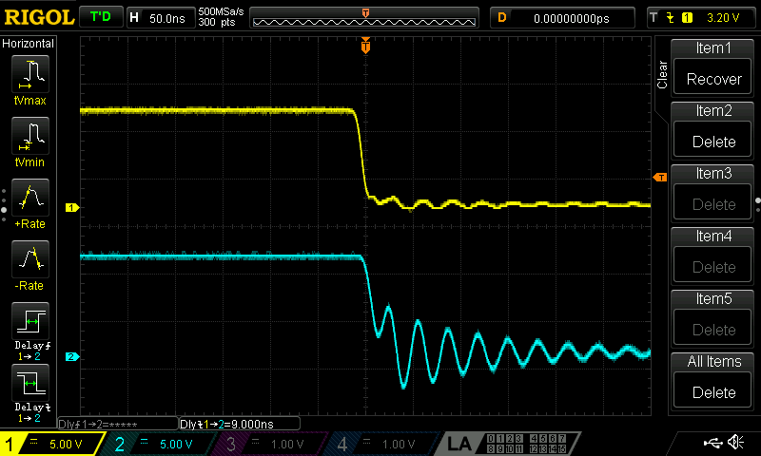Figure 2: Falling edge test. Channel 1: signal generator, Channel 2: Testec probe
Rx transient times: falling edge: 21.8 µs, rising edge: 4.15 µs
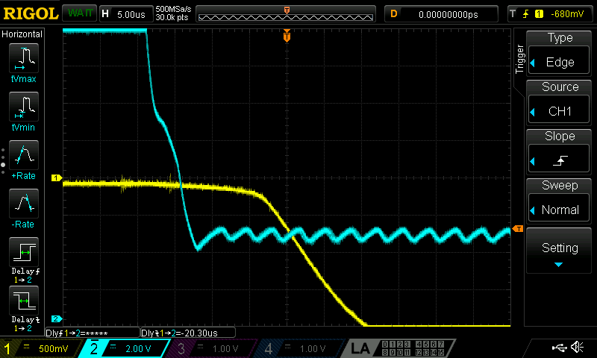Figure 3: Rx falling edge transient time: 21.8 µs, channel 1: pin OC, channel 2: DALI bus
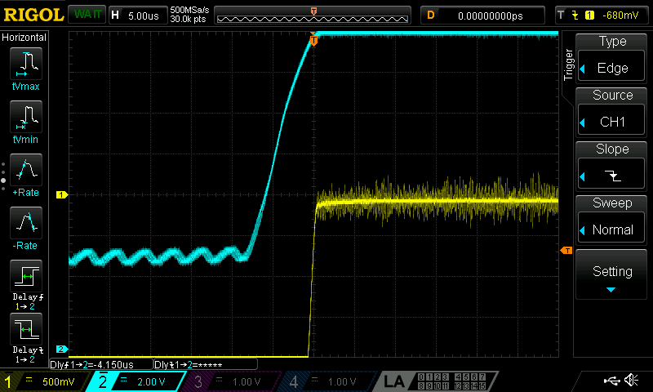Figure 4: Rx rising edge transient time: 4.15 µs, channel 1: pin OC, channel 2: DALI bus
Pulses on the Rx line are 21.8 µs – 4.15 µs = 17.65 µs shorter than those on the DALI bus

Tx transient times: 17.6 µs – 3.85 µs
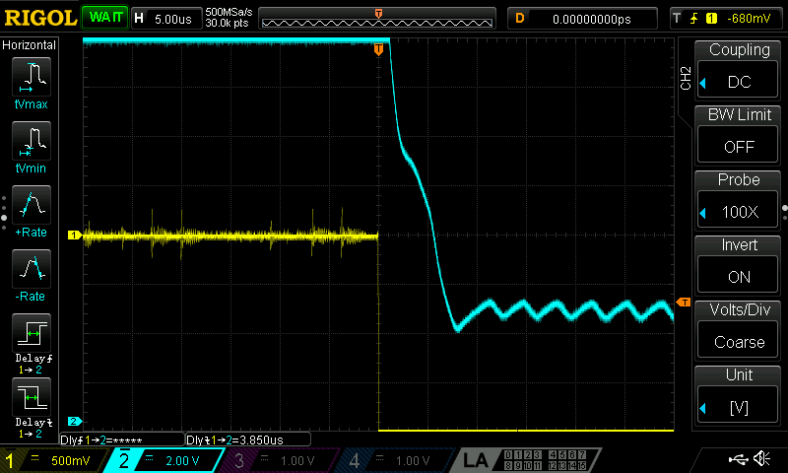Figure 5: Tx falling edge transient time: 3.85 µs
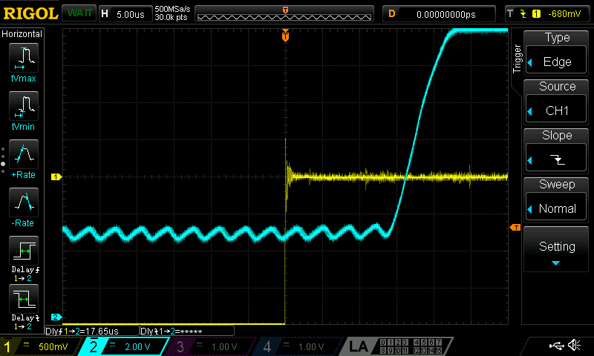Figure 6: Tx rising edge transient time: 17.65 µs

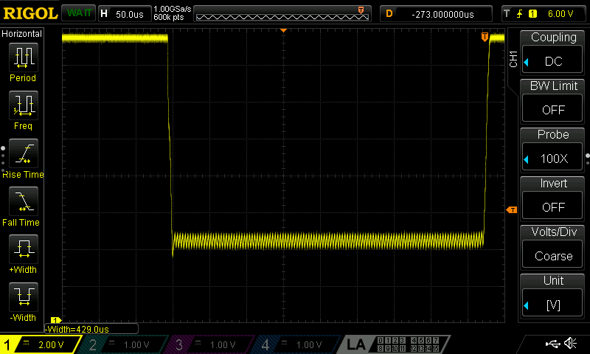Figure 7: Pulse on DALI bus, not corrected, nominal pulsewidth 416 µs

