Санкт-Петербургский политехнический университет Петра Великого
ИКНиК
Высшая школа / кафедра ______________________________

Отчёт по дисциплине
Инструменты программной инженерии
Автоматизация сборки и тестирования демонстрационного приложения с помощью GitHub Actions
Вариант А
Первый семестр

Выполнил(а) ______________________________
Группа ______________________________
Проверил(а) ______________________________

Санкт-Петербург
2026

1 Tool and task
This project uses GitHub Actions to build and test a small Java application. The goal is to set up the tool from the beginning and show how it detects a code error. The application is a command-line calculator with four operations.
Public repository: https://github.com/SvenKid/GitHub-Actions
Manual checks are easy to forget. GitHub Actions runs a build after a code change and shows the result next to the commit. This gives the developer feedback before the change is used by other people.

Project setup
The project targets Java 17 and uses Maven. JUnit 5 runs six unit tests. The tests cover addition, subtraction, multiplication with a negative number, division with a decimal result, decimal addition and division by zero.
Calculator contains the operations. Main reads three command-line arguments and prints the result. CalculatorTest checks the operations. The application needs no external service.
mvn --batch-mode --no-transfer-progress clean verify
java -jar target/calculator-1.0.0.jar add 2 3

2 Configuration files
The on block starts the workflow on pushes to main and demo branches, pull requests into main, or a manual request. The build job uses an Ubuntu runner and has a ten-minute limit.
Checkout gets the source code. Setup Java selects Temurin 17 and caches Maven dependencies. The Maven command compiles the source, runs tests and creates a JAR. The next step runs the application.
The test report step uses always(), so it also runs after a failed test. The JAR upload uses the default success condition. Both artifacts have a retention period of 14 days. The workflow token has read access to repository contents.

Workflow configuration
The workflow file is .github/workflows/ci.yml.
name: Java CI

on:
push:
branches: [main, 'demo/**']
pull_request:
branches: [main]
workflow_dispatch:

permissions:
contents: read

jobs:
build:
runs-on: ubuntu-latest
timeout-minutes: 10
steps:
- name: Get the source code
uses: actions/checkout@v6

- name: Set up Java 17
uses: actions/setup-java@v5
with:
distribution: temurin
java-version: '17'
cache: maven

- name: Build and test
run: mvn --batch-mode --no-transfer-progress clean verify

- name: Run the application
run: java -jar target/calculator-1.0.0.jar add 2 3

- name: Save test reports
if: always()
uses: actions/upload-artifact@v6
with:
name: test-reports
path: target/surefire-reports/
if-no-files-found: warn
retention-days: 14

- name: Save the application
uses: actions/upload-artifact@v6
with:
name: calculator-jar
path: target/calculator-1.0.0.jar
if-no-files-found: error
retention-days: 14

Maven configuration
pom.xml sets the Java target, the test dependency and the build plugins. Surefire runs the tests. The JAR plugin adds Main to the manifest.
<?xml version="1.0" encoding="UTF-8"?>
<project xmlns="http://maven.apache.org/POM/4.0.0"
xmlns:xsi="http://www.w3.org/2001/XMLSchema-instance"
xsi:schemaLocation="http://maven.apache.org/POM/4.0.0
https://maven.apache.org/xsd/maven-4.0.0.xsd">
<modelVersion>4.0.0</modelVersion>
<groupId>edu.demo</groupId>
<artifactId>calculator</artifactId>
<version>1.0.0</version>
<properties>
<maven.compiler.release>17</maven.compiler.release>
<project.build.sourceEncoding>UTF-8</project.build.sourceEncoding>
</properties>
<dependencies>
<dependency>
<groupId>org.junit.jupiter</groupId>
<artifactId>junit-jupiter</artifactId>
<version>5.11.4</version>
<scope>test</scope>
</dependency>
</dependencies>
<build>
<plugins>
<plugin>
<groupId>org.apache.maven.plugins</groupId>
<artifactId>maven-compiler-plugin</artifactId>
<version>3.13.0</version>
</plugin>
<plugin>
<groupId>org.apache.maven.plugins</groupId>
<artifactId>maven-surefire-plugin</artifactId>
<version>3.5.2</version>
</plugin>
<plugin>
<groupId>org.apache.maven.plugins</groupId>
<artifactId>maven-jar-plugin</artifactId>
<version>3.4.2</version>
<configuration>
<archive>
<manifest>
<mainClass>edu.demo.Main</mainClass>
</manifest>
</archive>
</configuration>
</plugin>
</plugins>
</build>
</project>

3 Results
The workflow was run in the public repository. The screenshots below show real runs from 17 September 2026. The successful main run used commit 44cb943.
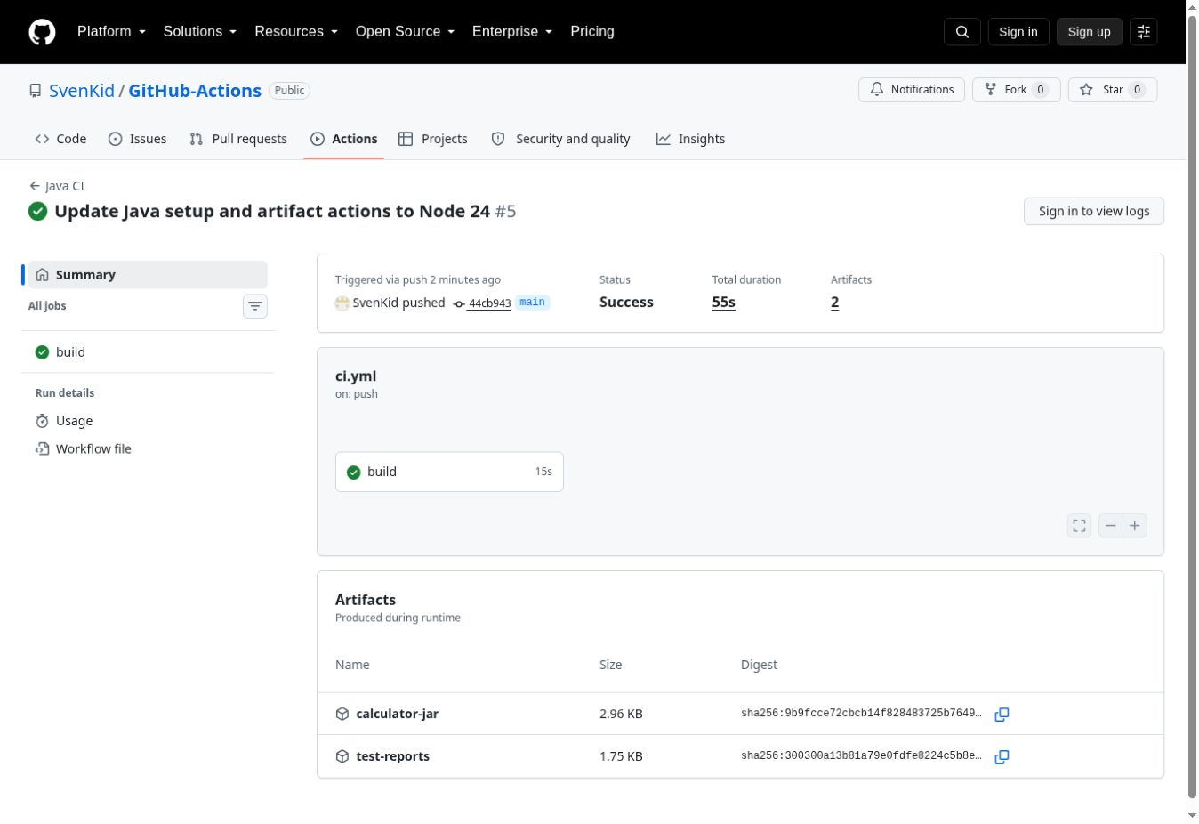
Figure 1. Successful build on main with two artifacts.
Run: https://github.com/SvenKid/GitHub-Actions/actions/runs/35244409538
The build completed successfully. The application started, and GitHub saved calculator-jar and test-reports. The downloaded JAR can run on a computer with Java 17 or later.

Failure case
In the demo/subtraction branch, return a - b was changed to return a + b. The test was left unchanged. For the input 8 and 3, the expected result was 5, but the application returned 11. The run below used commit 6dbeaea.
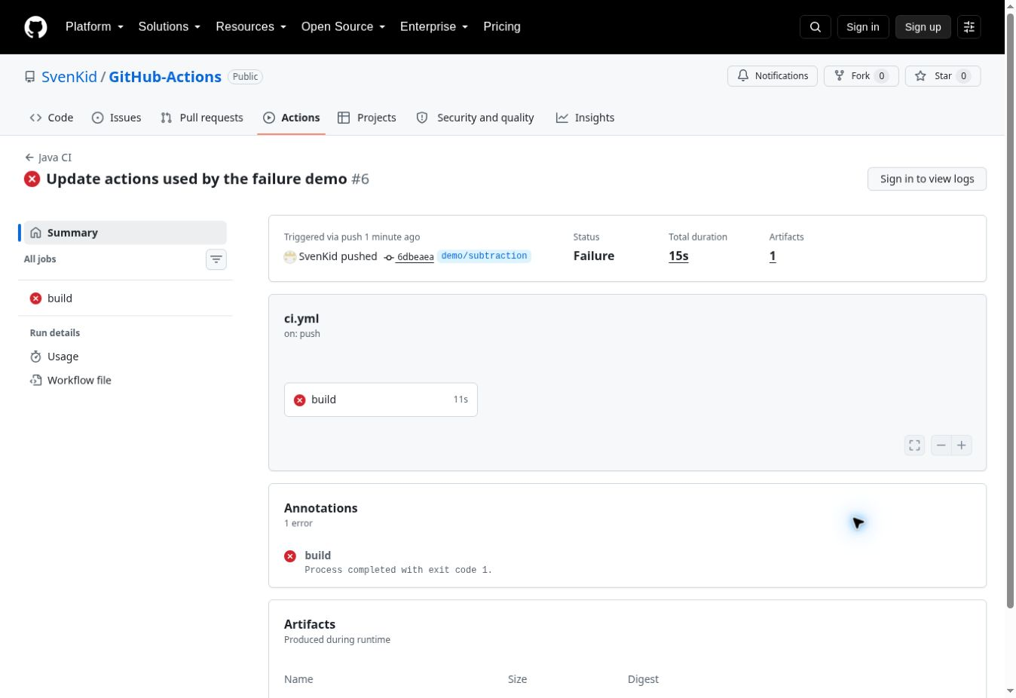
Figure 2. Failed build after a subtraction error.
Run: https://github.com/SvenKid/GitHub-Actions/actions/runs/35244422557
CalculatorTest.subtractsTwoNumbers
expected: <5.0> but was: <11.0>
Tests run: 6, Failures: 1, Errors: 0, Skipped: 0
BUILD FAILURE
These lines are from the job log. The job returned exit code 1. The application run and JAR upload were skipped. The test report upload passed.

Result after the fix
The subtraction expression was restored to a - b in commit c4c8269. The same tests were run again without changes to the expected results.
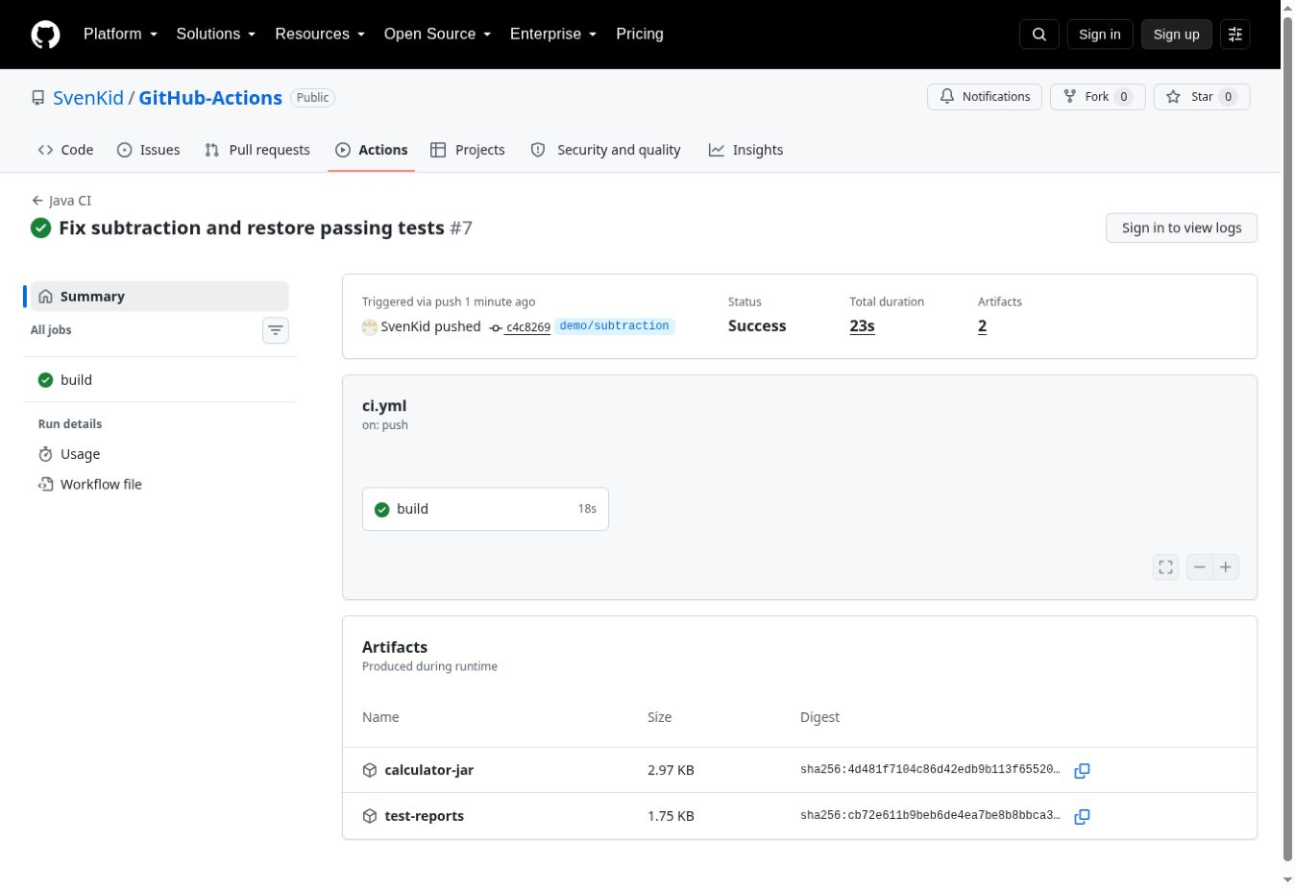
Figure 3. Successful run after restoring subtraction.
Run: https://github.com/SvenKid/GitHub-Actions/actions/runs/35244529628
Tests run: 6, Failures: 0, Errors: 0, Skipped: 0
BUILD SUCCESS
Result: 5.0
All six tests passed. The application started and printed five. Both artifacts were saved again. The demo branch now contains working code.

Conclusions
GitHub Actions automated the build and test process for the calculator. A small YAML file was enough to run the same Maven command after a code change. The failure case showed that a test can detect an incorrect operation. After the code was fixed, the same test passed.
The main benefit is automatic feedback with logs linked to a commit. Test reports help explain a failure, and the JAR artifact provides a runnable result. A green build only confirms the checks that were written. It does not prove that every possible input works.
The project demonstrates continuous integration. It does not deploy to a server. A failed check does not automatically block a merge unless the repository has a rule that requires it.

References
GitHub Docs. Building and testing Java with Maven.
https://docs.github.com/en/actions/tutorials/build-and-test-code/java-with-maven
Apache Maven. Introduction to the Build Lifecycle.
https://maven.apache.org/guides/introduction/introduction-to-the-lifecycle.html
JUnit 5.11.4 User Guide.
https://docs.junit.org/5.11.4/user-guide/

Appendix A Calculator
src/main/java/edu/demo/Calculator.java
package edu.demo;

public class Calculator {
public double add(double a, double b) {
return a + b;
}

public double subtract(double a, double b) {
return a - b;
}

public double multiply(double a, double b) {
return a * b;
}

public double divide(double a, double b) {
if (b == 0) {
throw new IllegalArgumentException("Cannot divide by zero.");
}
return a / b;
}
}

Appendix B Application entry point
src/main/java/edu/demo/Main.java
package edu.demo;

public class Main {
public static void main(String[] args) {
if (args.length != 3) {
System.err.println("Usage: java -jar calculator-1.0.0.jar
<add|sub|mul|div> <a> <b>");
System.exit(1);
}
try {
double a = Double.parseDouble(args[1]);
double b = Double.parseDouble(args[2]);
if (!Double.isFinite(a) || !Double.isFinite(b)) {
throw new IllegalArgumentException("Please enter finite numbers.");
}
Calculator calculator = new Calculator();
double result = switch (args[0]) {
case "add" -> calculator.add(a, b);
case "sub" -> calculator.subtract(a, b);
case "mul" -> calculator.multiply(a, b);
case "div" -> calculator.divide(a, b);
default -> throw new IllegalArgumentException("Unknown operation: "
+ args[0]);
};
System.out.println("Result: " + result);
} catch (IllegalArgumentException exception) {
System.err.println("Error: " + exception.getMessage());
System.exit(1);
}
}
}

Appendix C Unit tests
src/test/java/edu/demo/CalculatorTest.java
package edu.demo;

import org.junit.jupiter.api.Test;
import static org.junit.jupiter.api.Assertions.assertEquals;
import static org.junit.jupiter.api.Assertions.assertThrows;

class CalculatorTest {
private final Calculator calculator = new Calculator();

@Test
void addsTwoNumbers() {
assertEquals(5.0, calculator.add(2, 3), 0.000001);
}

@Test
void subtractsTwoNumbers() {
assertEquals(5.0, calculator.subtract(8, 3), 0.000001);
}

@Test
void multipliesNegativeNumber() {
assertEquals(-12.0, calculator.multiply(-3, 4), 0.000001);
}

@Test
void dividesWithFraction() {
assertEquals(2.5, calculator.divide(5, 2), 0.000001);
}

@Test
void addsDecimalNumbers() {
assertEquals(0.3, calculator.add(0.1, 0.2), 0.000001);
}

@Test
void rejectsDivisionByZero() {
assertThrows(IllegalArgumentException.class,
() -> calculator.divide(10, 0));
}
}

