Cute penguin models
Table of contents

Regression-like:

Model flipper length depending on weight
to dos:
- vizualize the data for the task (points, smoothies)
- build a model and put into variable
- print model output (tidy/ flextable?)
- test significance of model terms
- print significance
- check model??
- if suitable, visualize results
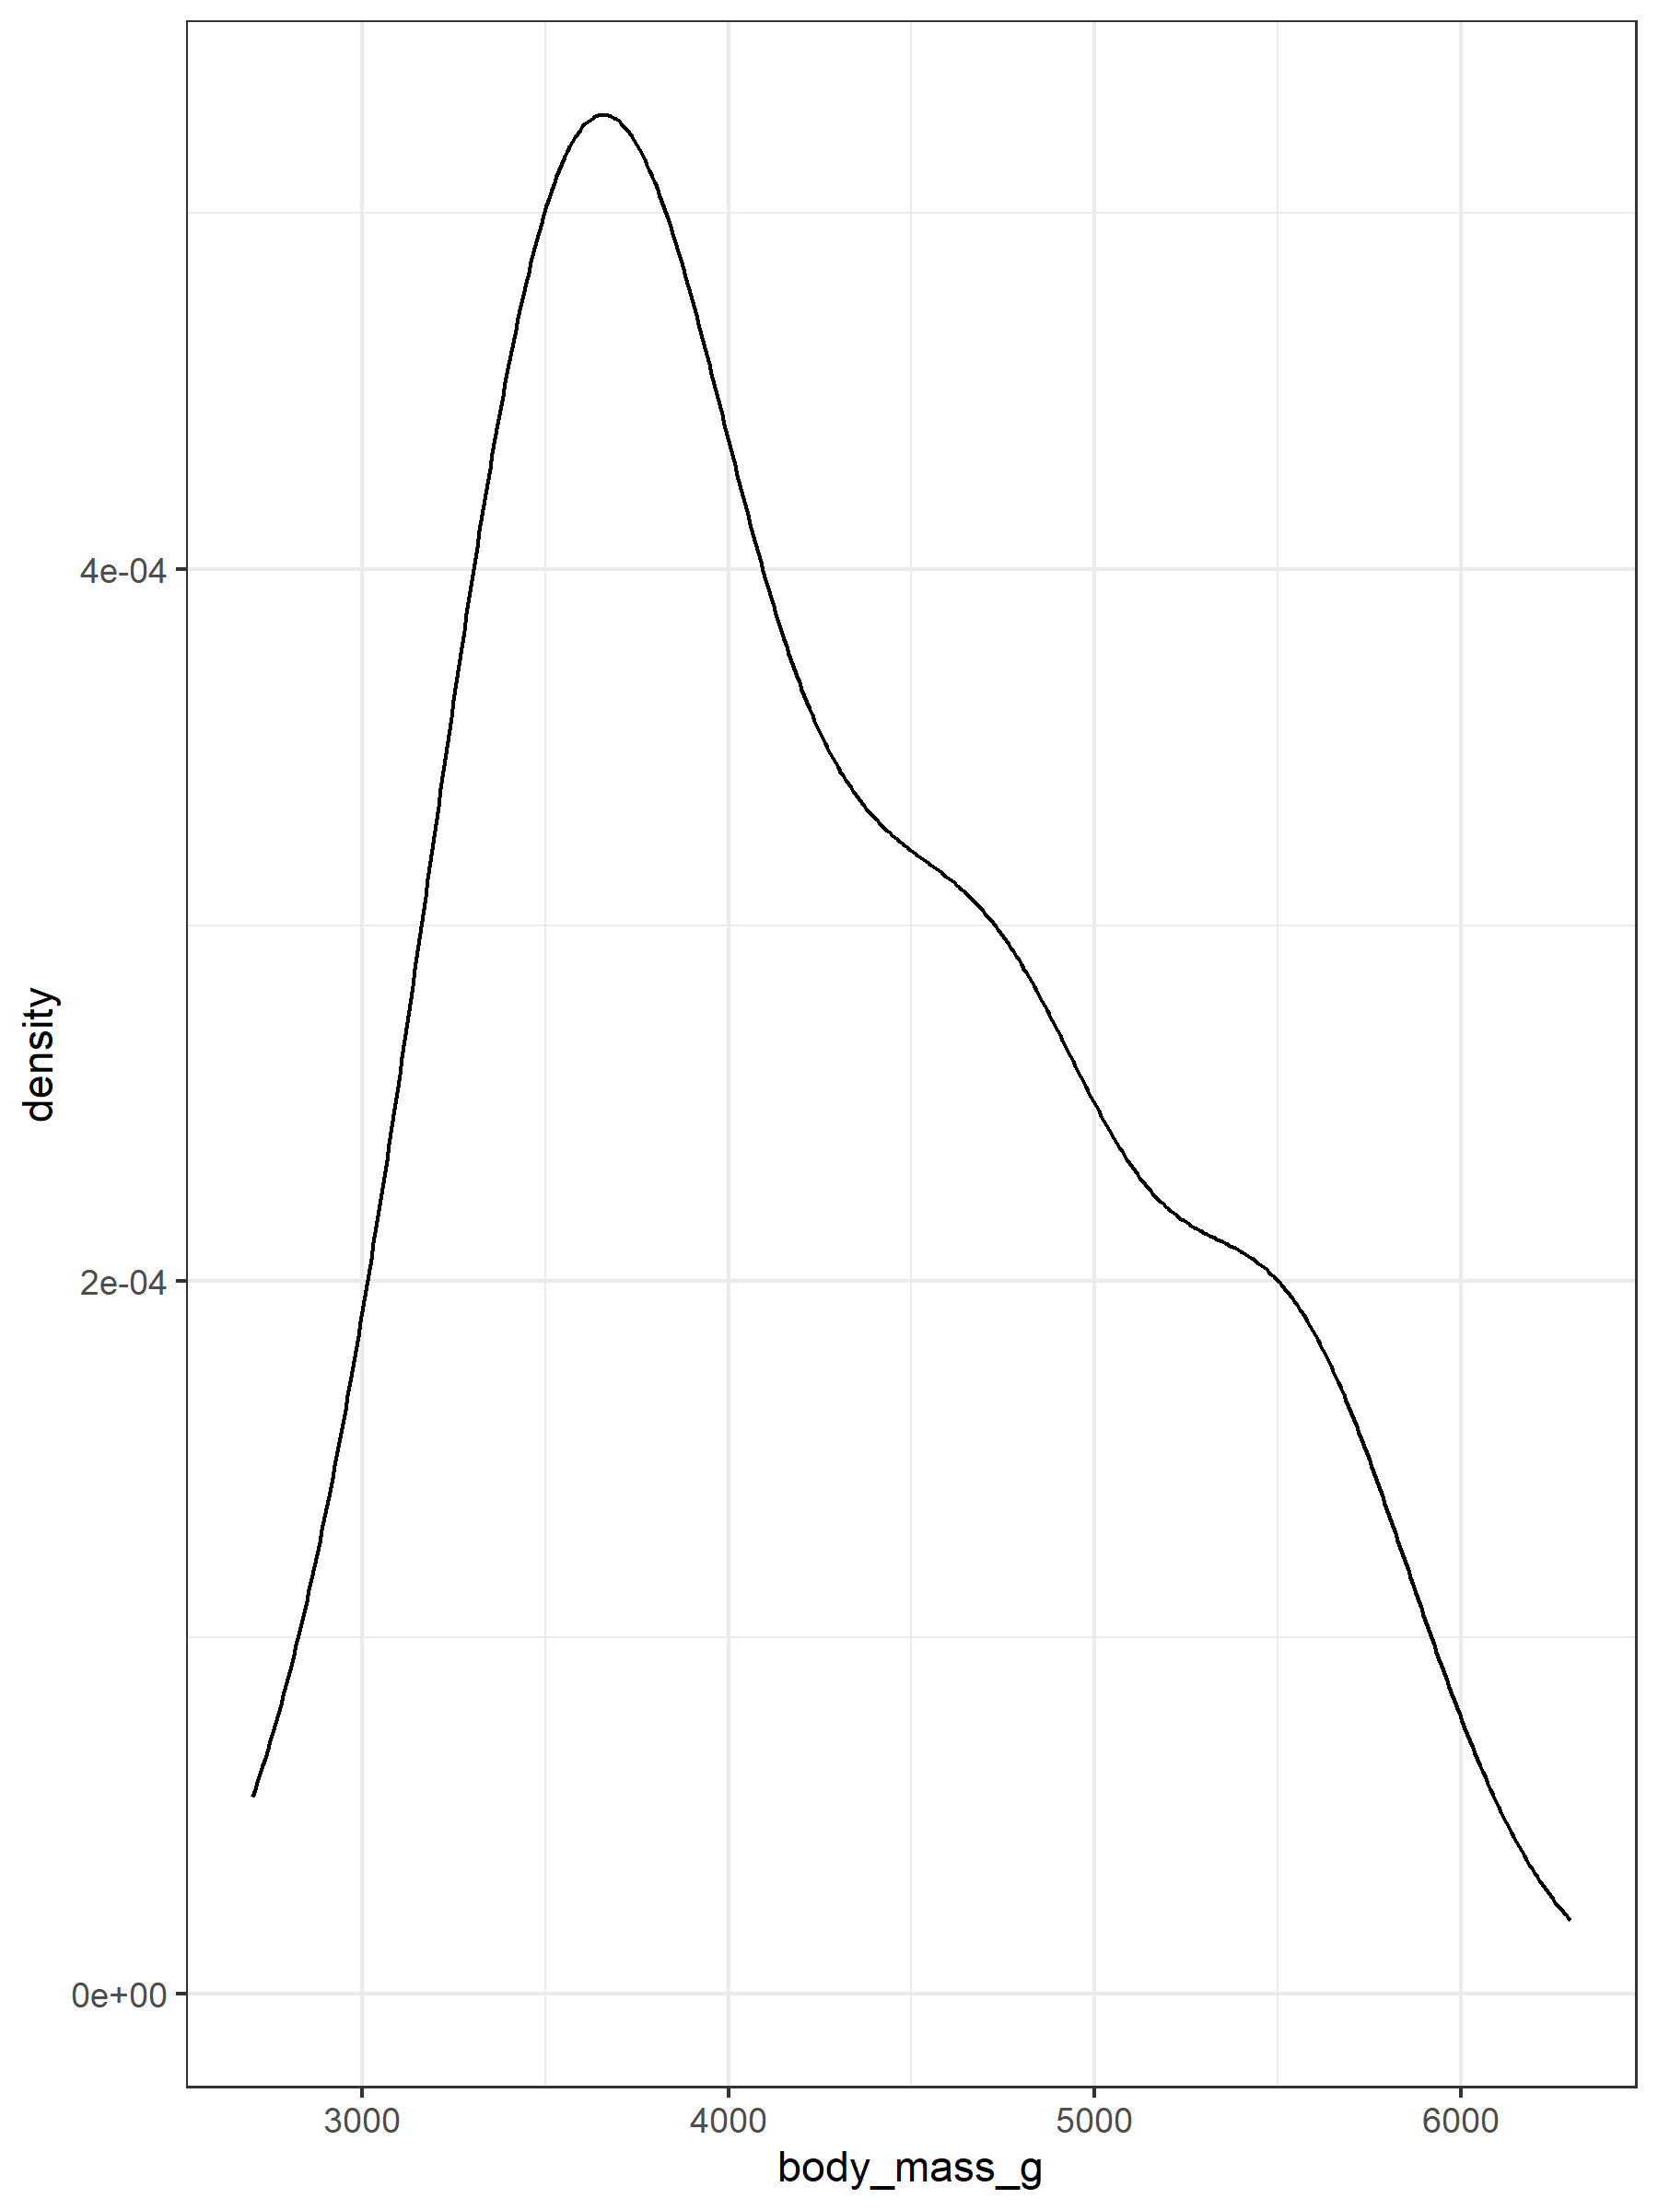
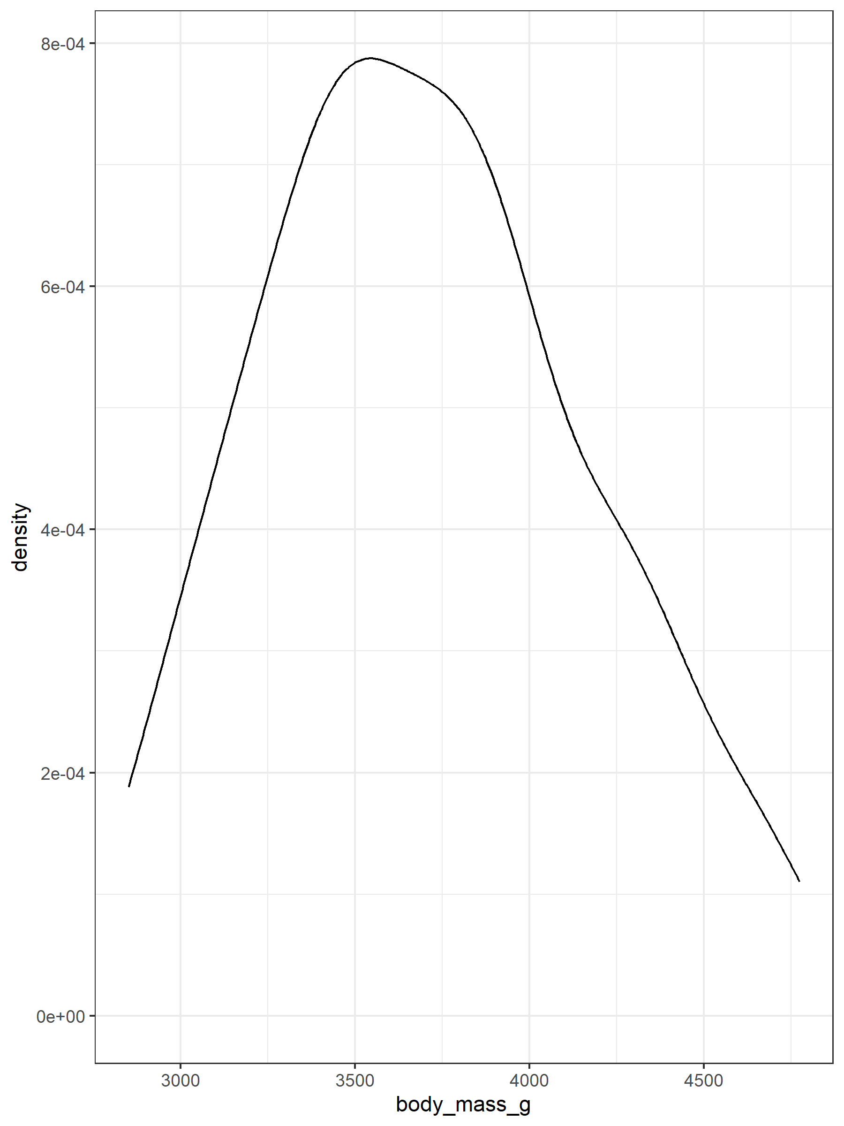
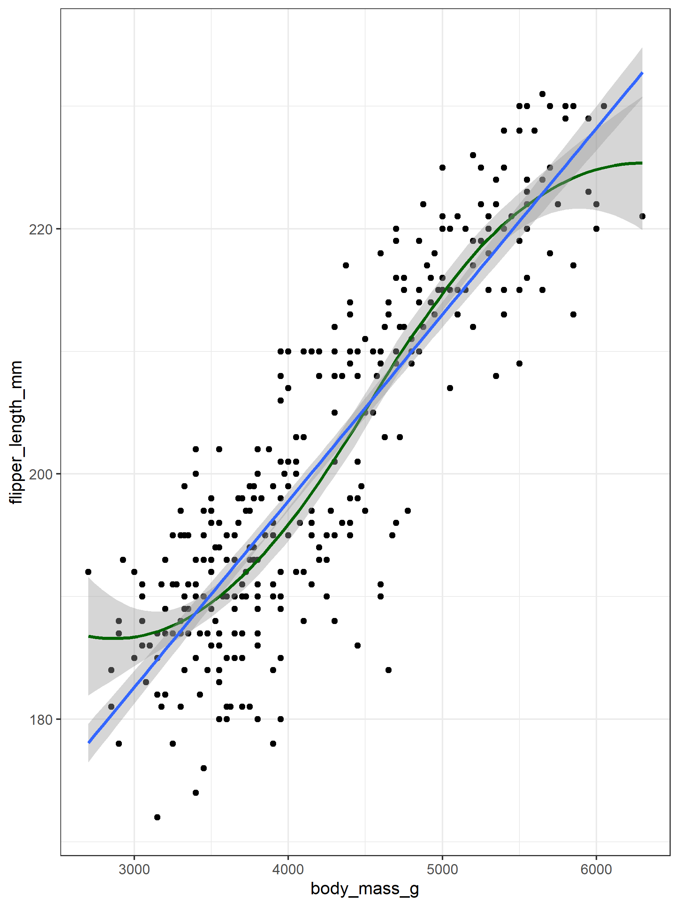
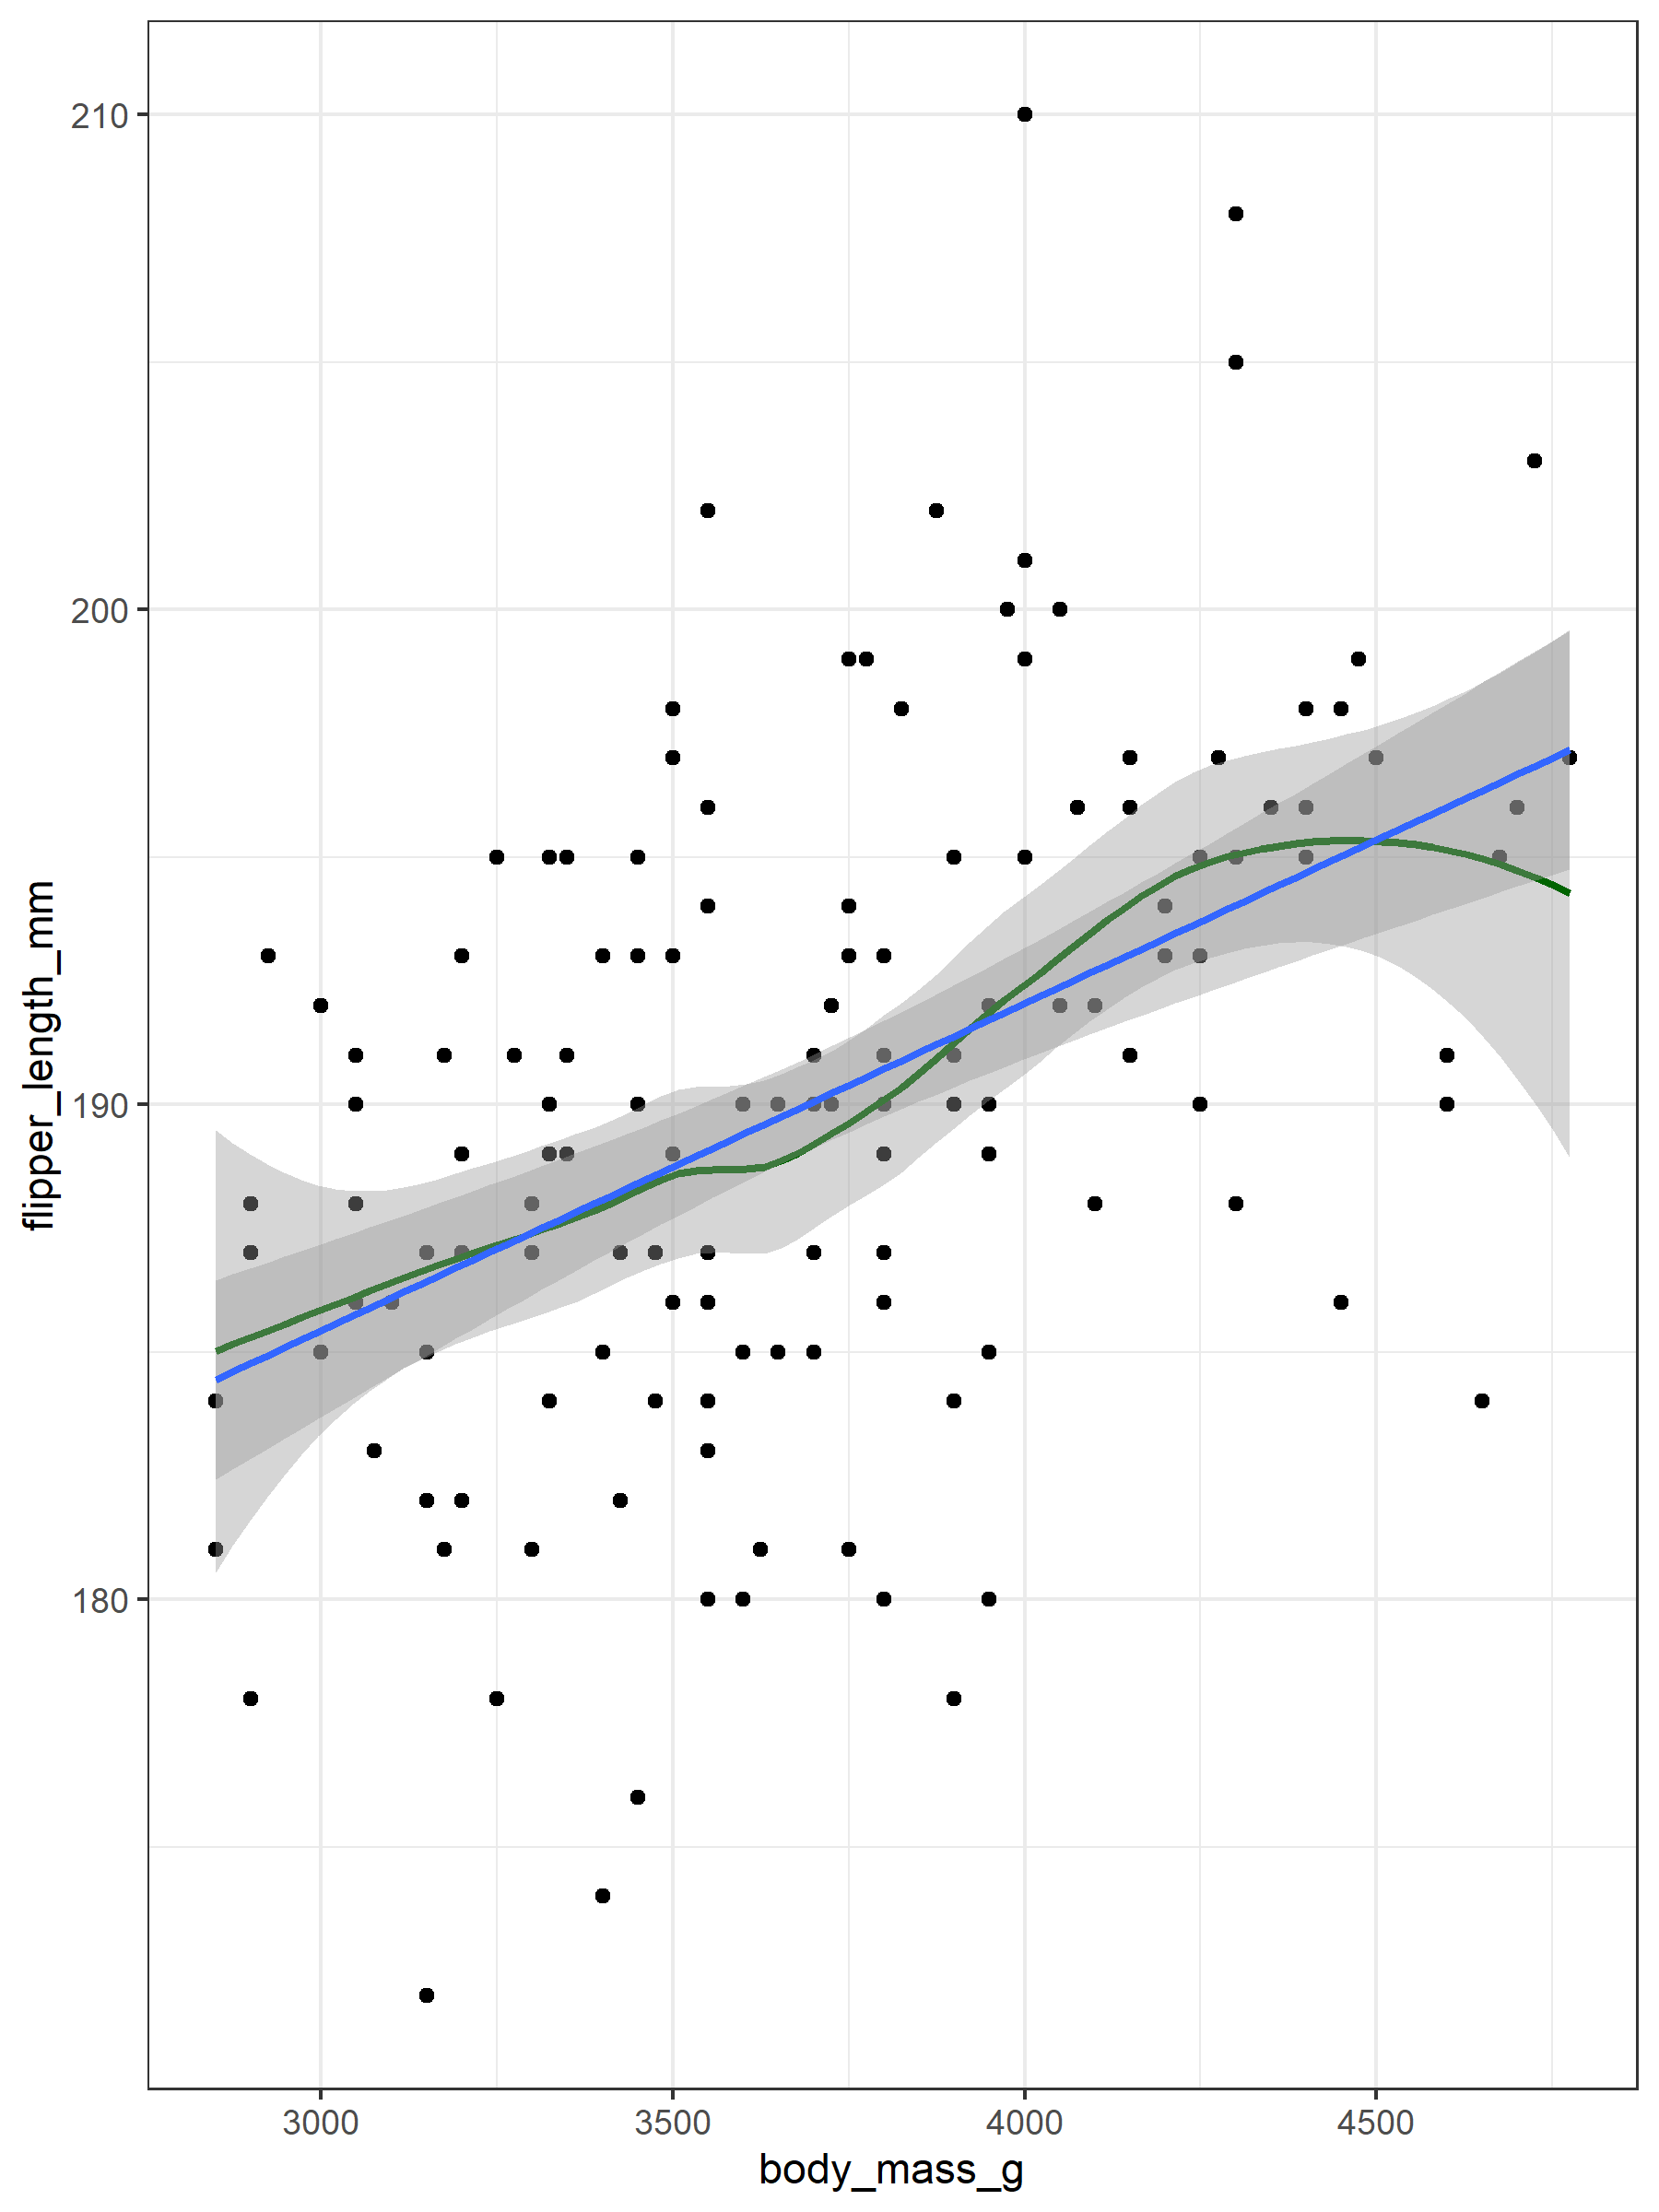
term | estimate
(Intercept) | 137.03962089
body_mass_g | 0.01519526

term | df | sumsq | meansq | statistic | p.value
body_mass_g | 1 | 49 702.61 | 49 702.61149 | 1 060.295 | 0.00001 ***
Residuals | 331 | 15 516.03 | 46.87621

prediction

A tibble: 20 × 1
flipper_length_mm 1 189. 2 208. 3 190. 4 188. 5 202. 6 199. 7 181. 8 186. 9 234. 10 217. 11 207. 12 209. 13 188. 14 187. 15 193. 16 191. 17 177. 18 188. 19 186. 20 198. 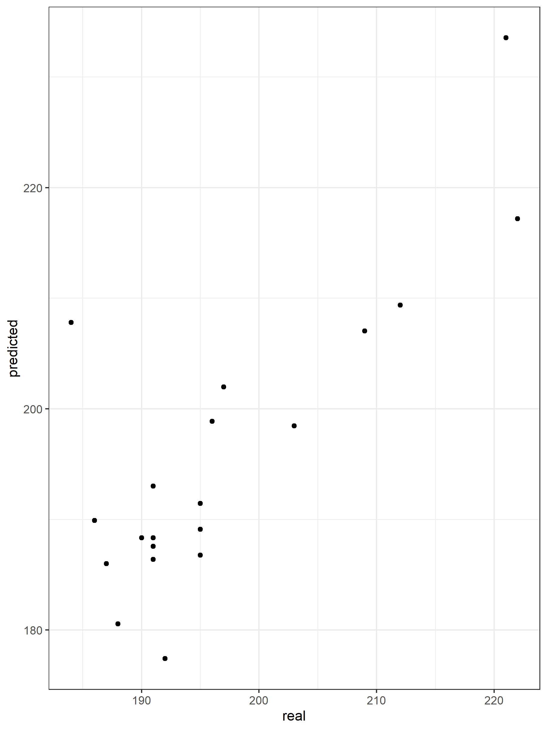

Change in units -> change in slope
term | estimate | std.error | statistic | p.value
(Intercept) | 137.03962 | 1.9987694 | 68.56200 | 0.00001 ***
`body weight [kg]` | 15.19526 | 0.4666539 | 32.56217 | 0.00001 ***

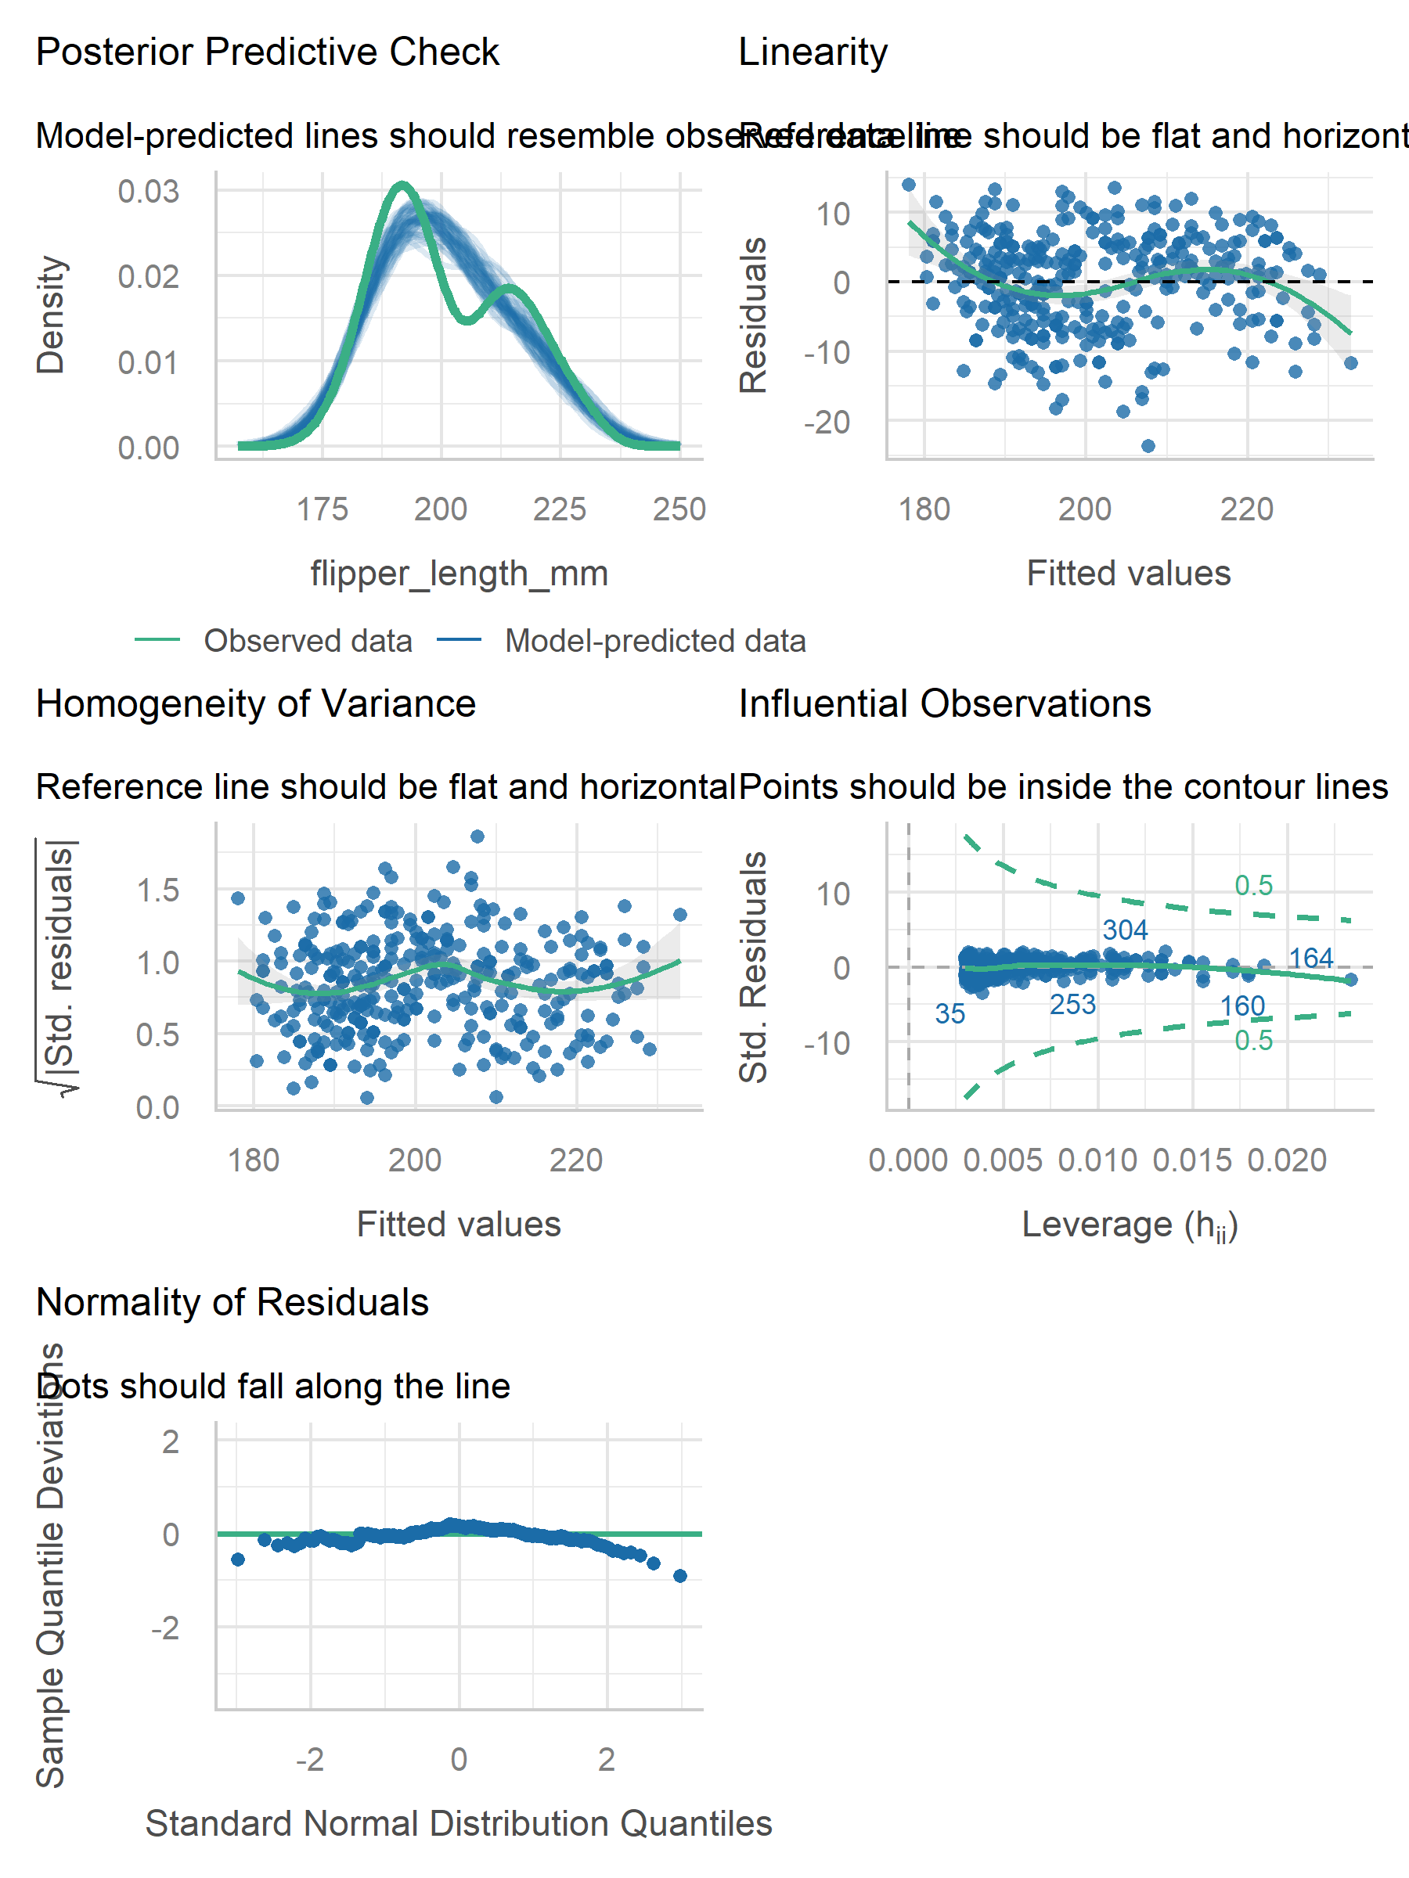
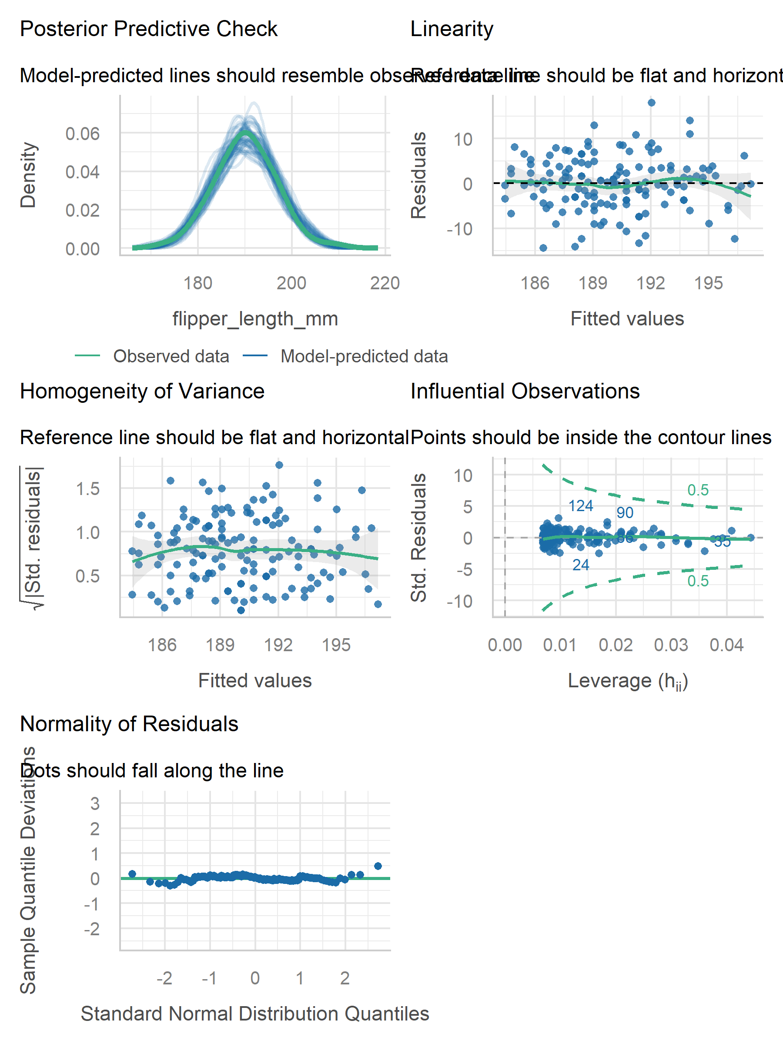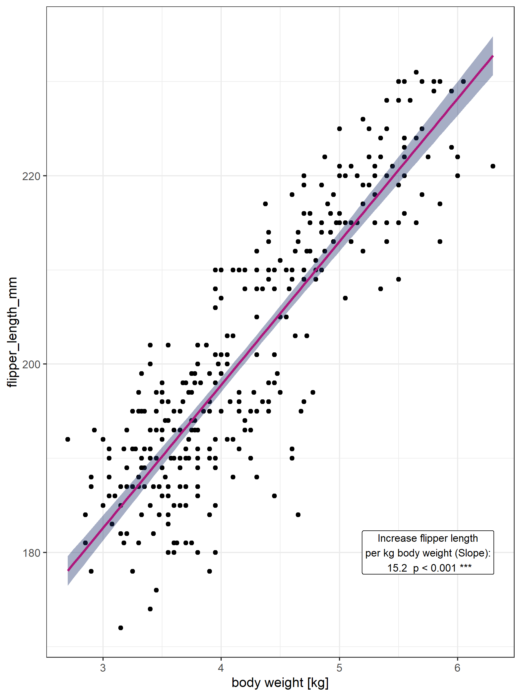

Model bill depth depending on weight
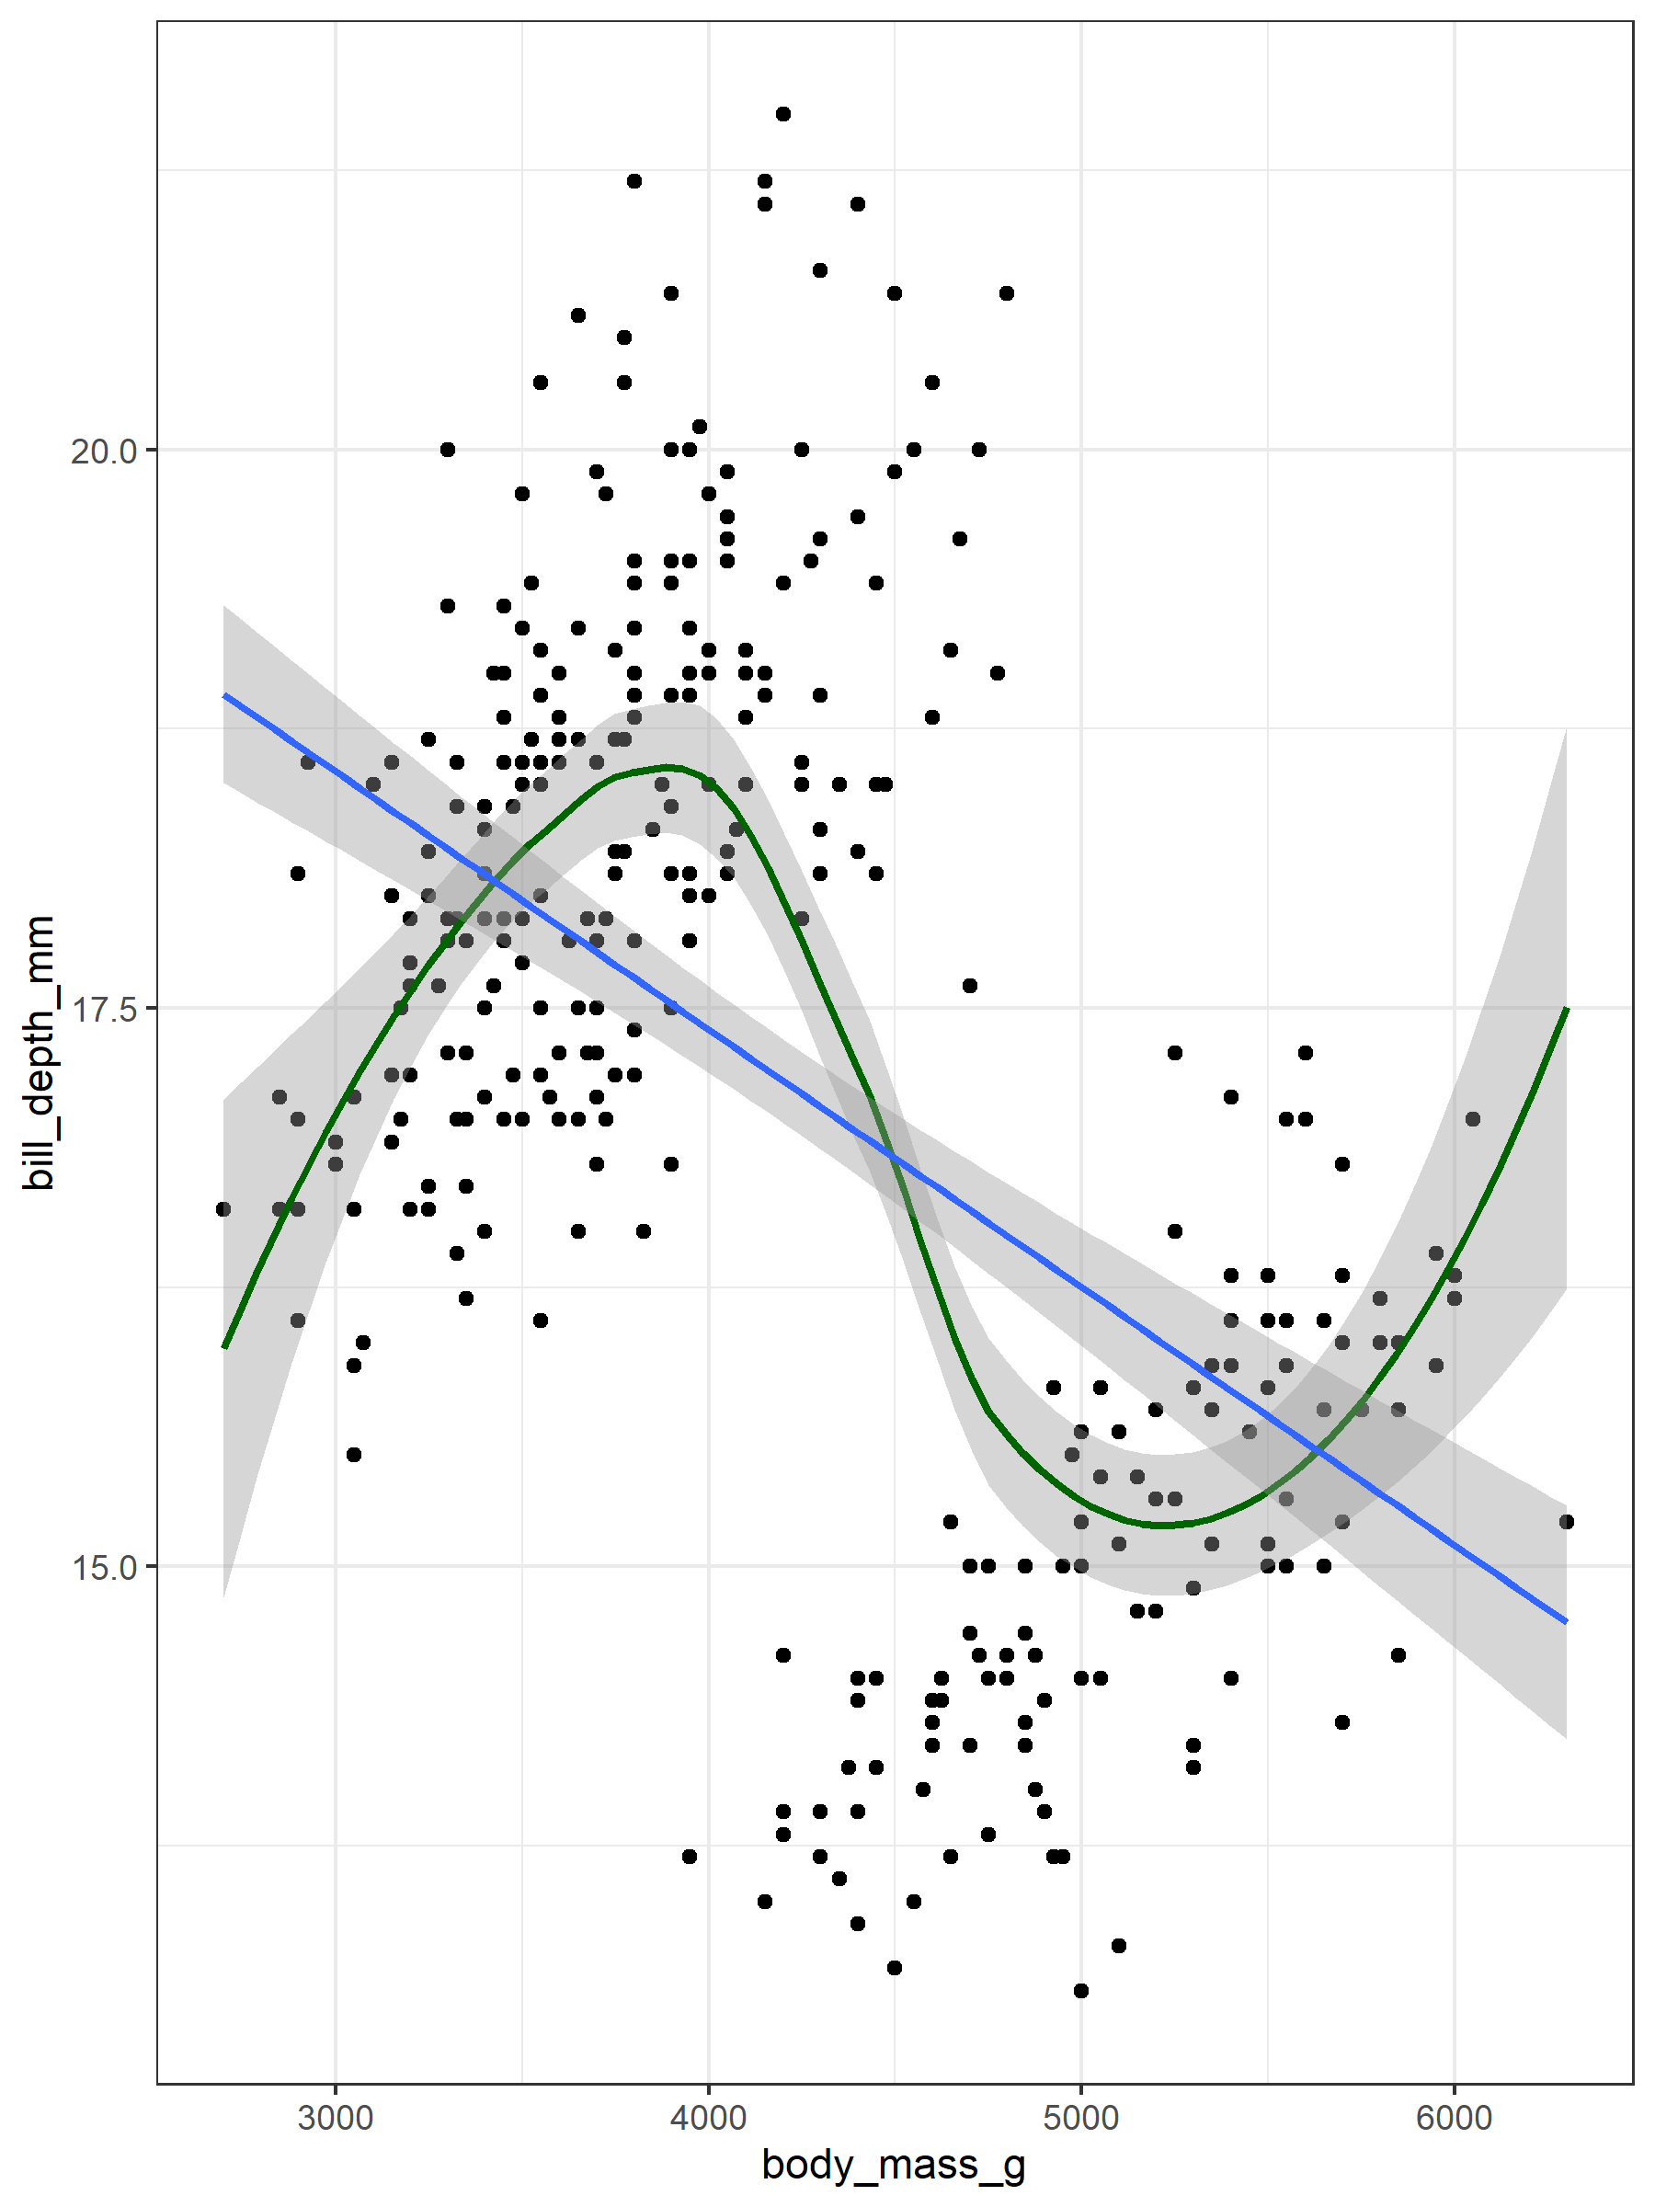
term | estimate
(Intercept) | 22.021328809
body_mass_g | -0.001154361

term | df | sumsq | meansq | statistic | p.value
body_mass_g | 1 | 286.8443 | 286.844281 | 94.88714 | 0.00001 ***
Residuals | 331 | 1 000.6146 | 3.023005

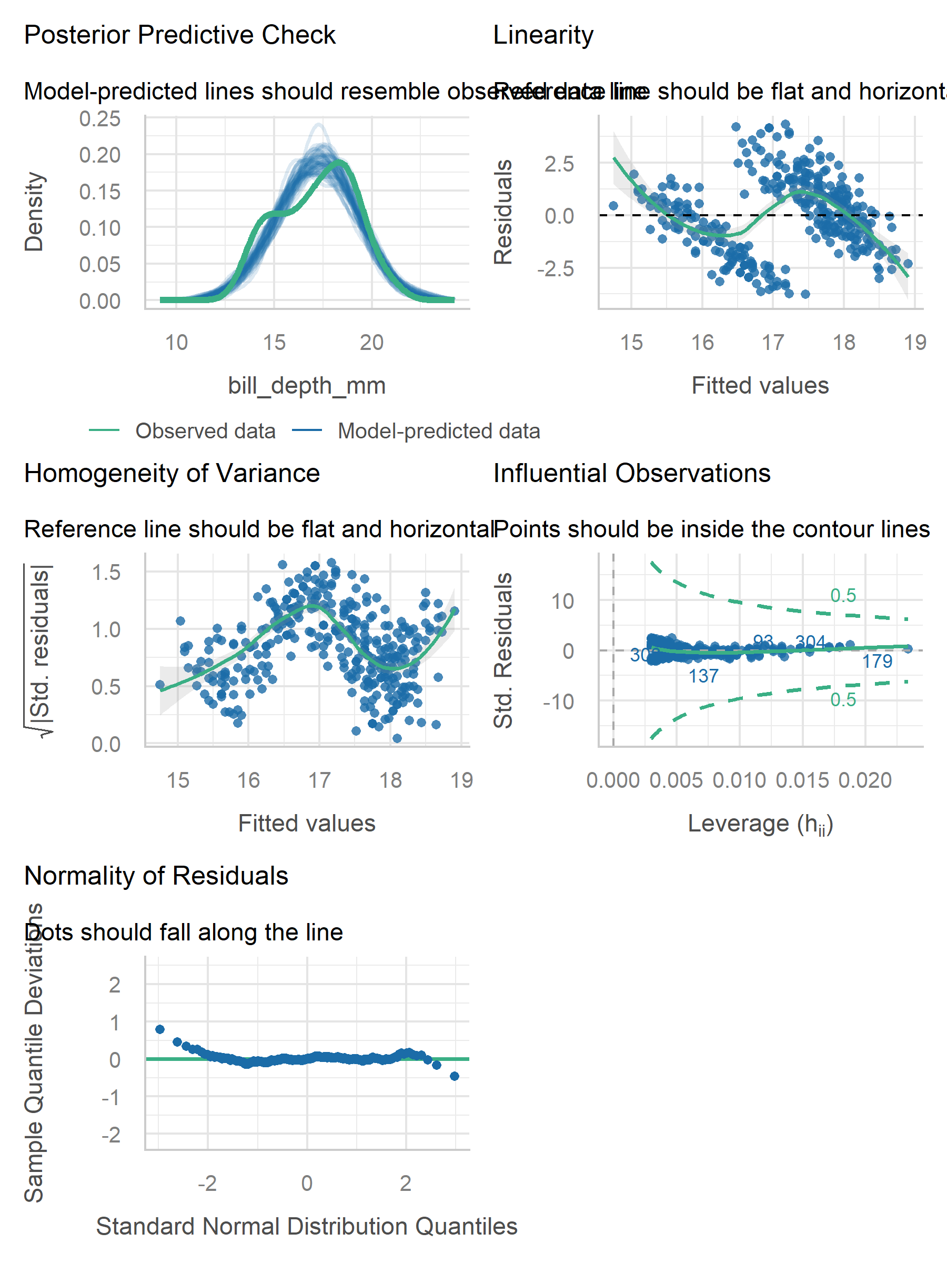
Adjust for species and sex first?
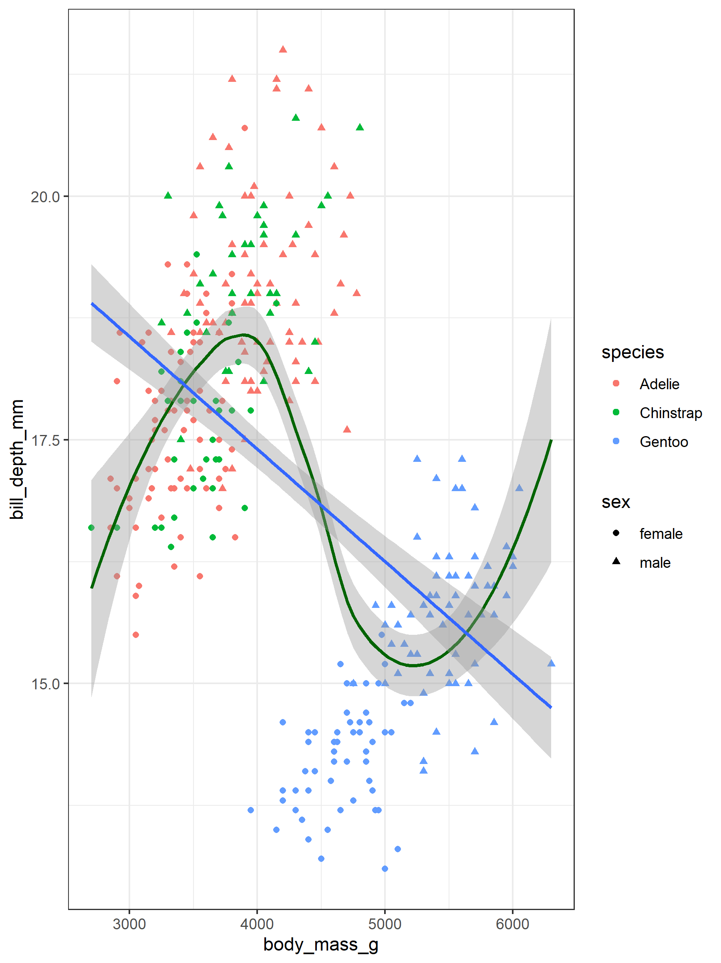
term | estimate
(Intercept) | 15.213885006
speciesChinstrap | 0.054319588
speciesGentoo | -4.342365646
sexmale | 1.033609608
body_mass_g | 0.000706005

term | df | sumsq | meansq | statistic | p.value
species | 2 | 870.78518 | 435.3925914 | 674.45879 | 0.00001 ***
sex | 1 | 188.49717 | 188.4971720 | 291.99756 | 0.00001 ***
body_mass_g | 1 | 16.43824 | 16.4382444 | 25.46419 | 0.00001 ***
Residuals | 328 | 211.73832 | 0.6455437

term | sumsq | df | statistic | p.value
species | 272.49681 | 2 | 211.05994 | 0.00001 ***
sex | 41.85139 | 1 | 64.83123 | 0.00001 ***
body_mass_g | 16.43824 | 1 | 25.46419 | 0.00001 ***
Residuals | 211.73832 | 328

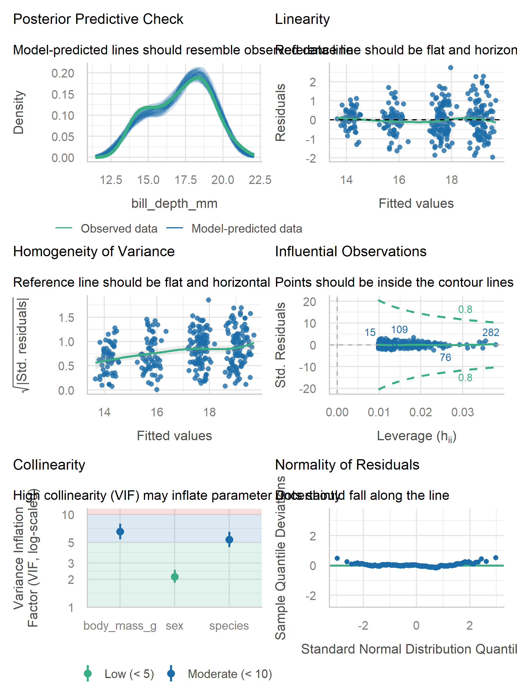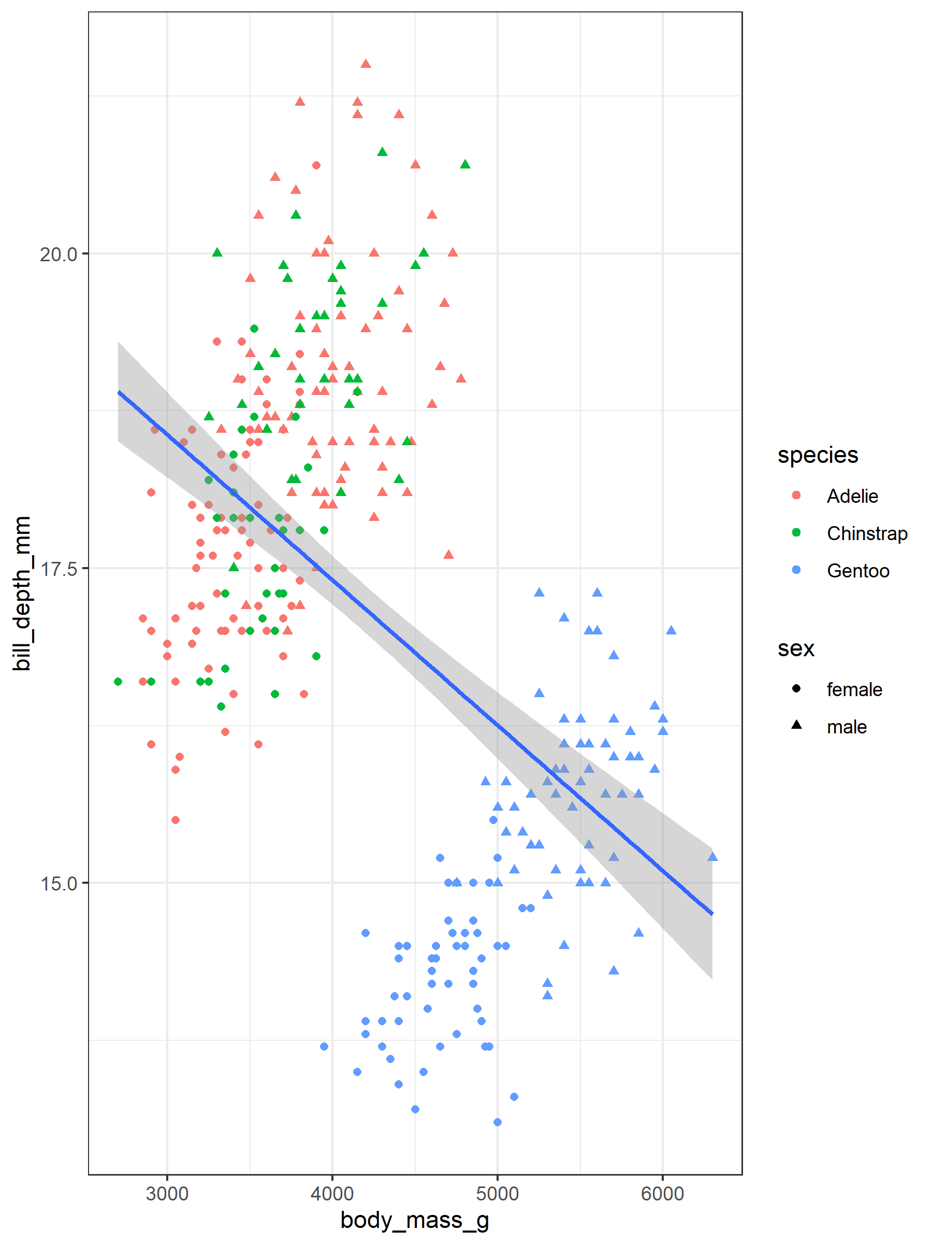

Anova-like:

flipper length by species
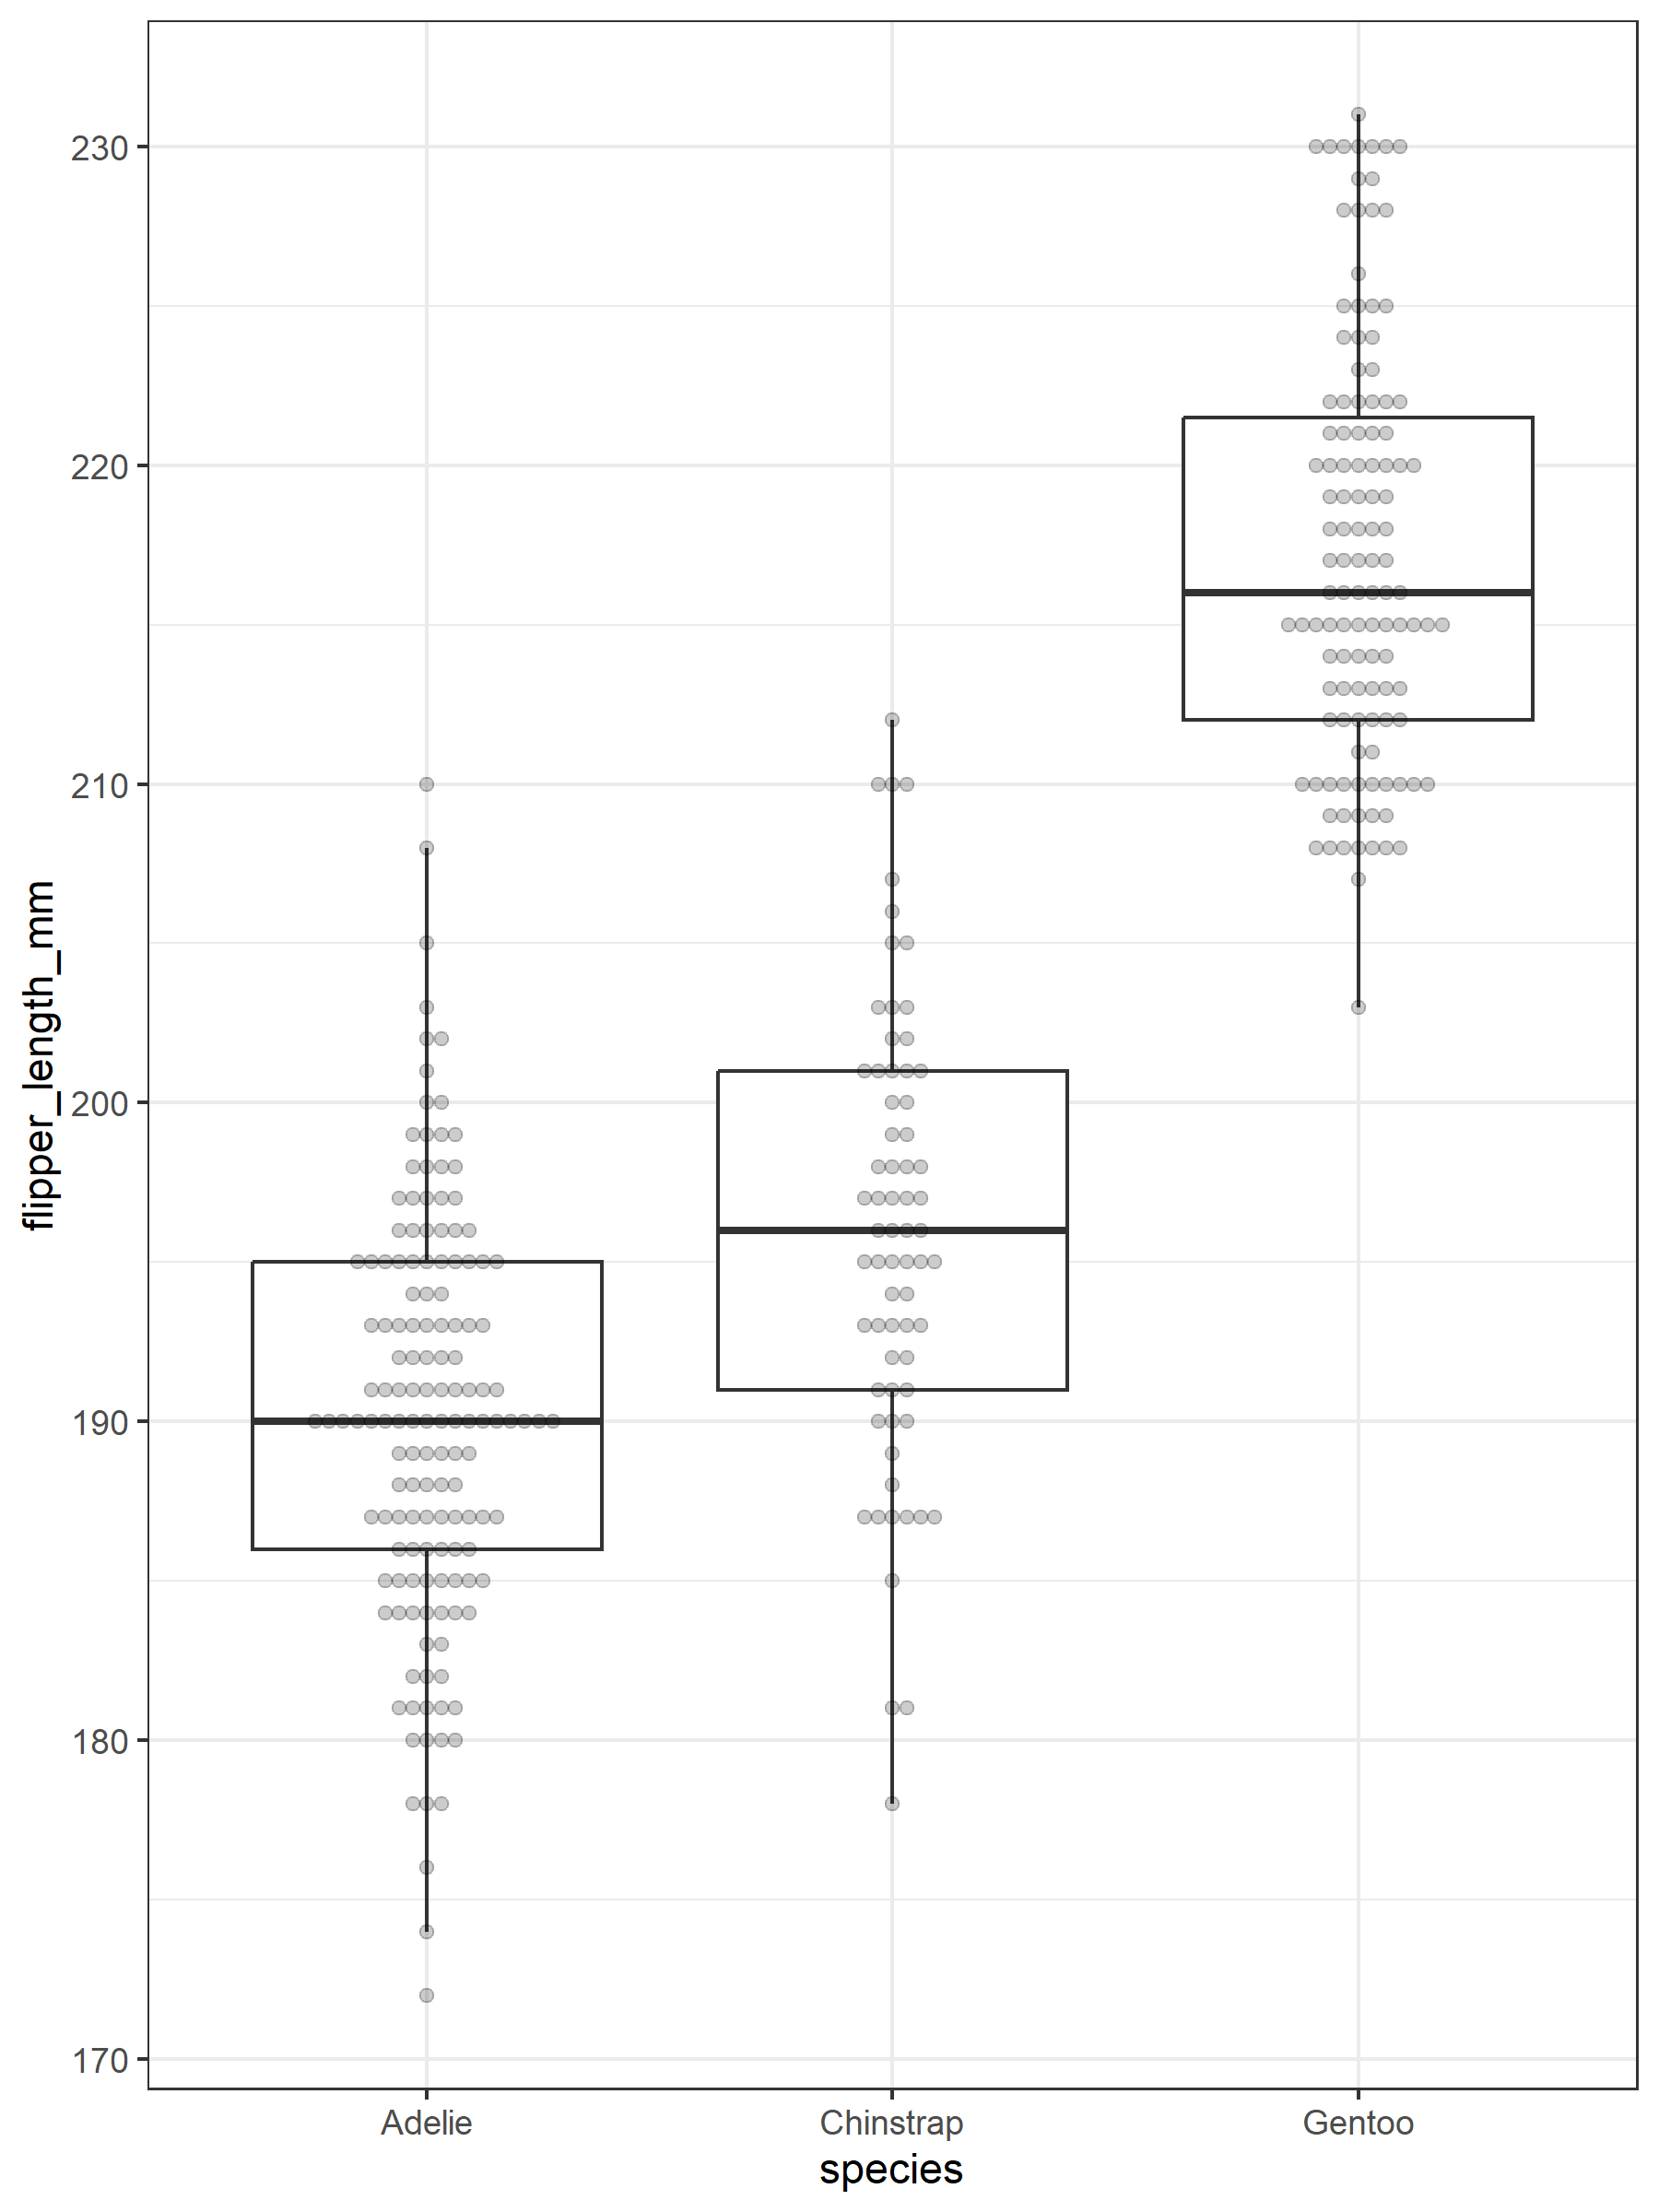
term | estimate | p.value
(Intercept) | 190.10274 | 0.001 ***
speciesChinstrap | 5.72079 | 0.001 ***
speciesGentoo | 27.13255 | 0.001 ***

term | df | sumsq | meansq | statistic | p.value
species | 2 | 50 525.88 | 25 262.94181 | 567.407 | 0.0001
Residuals | 330 | 14 692.75 | 44.52349

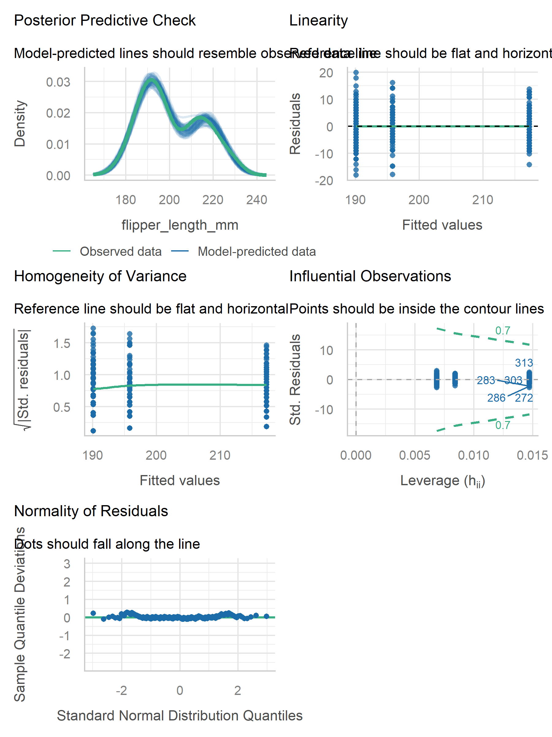
group1 | group2 | p.value
Chinstrap | Adelie | 0.00001 ***
Gentoo | Adelie | 0.00001 ***
Gentoo | Chinstrap | 0.00001 ***
[1] 4.955623e-08 0.000000e+00 0.000000e+00 attr(,“error”) [1] 6.836699e-08 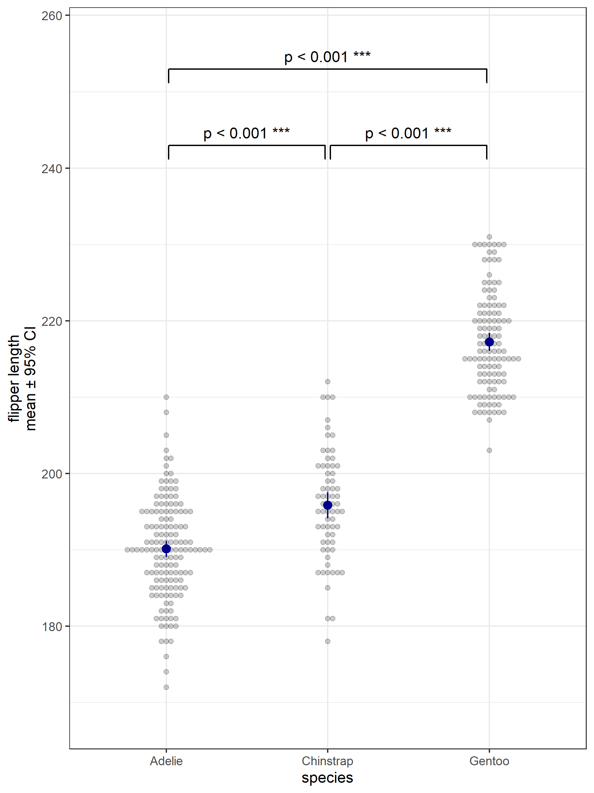

flipper by species and sex (and interaction?)
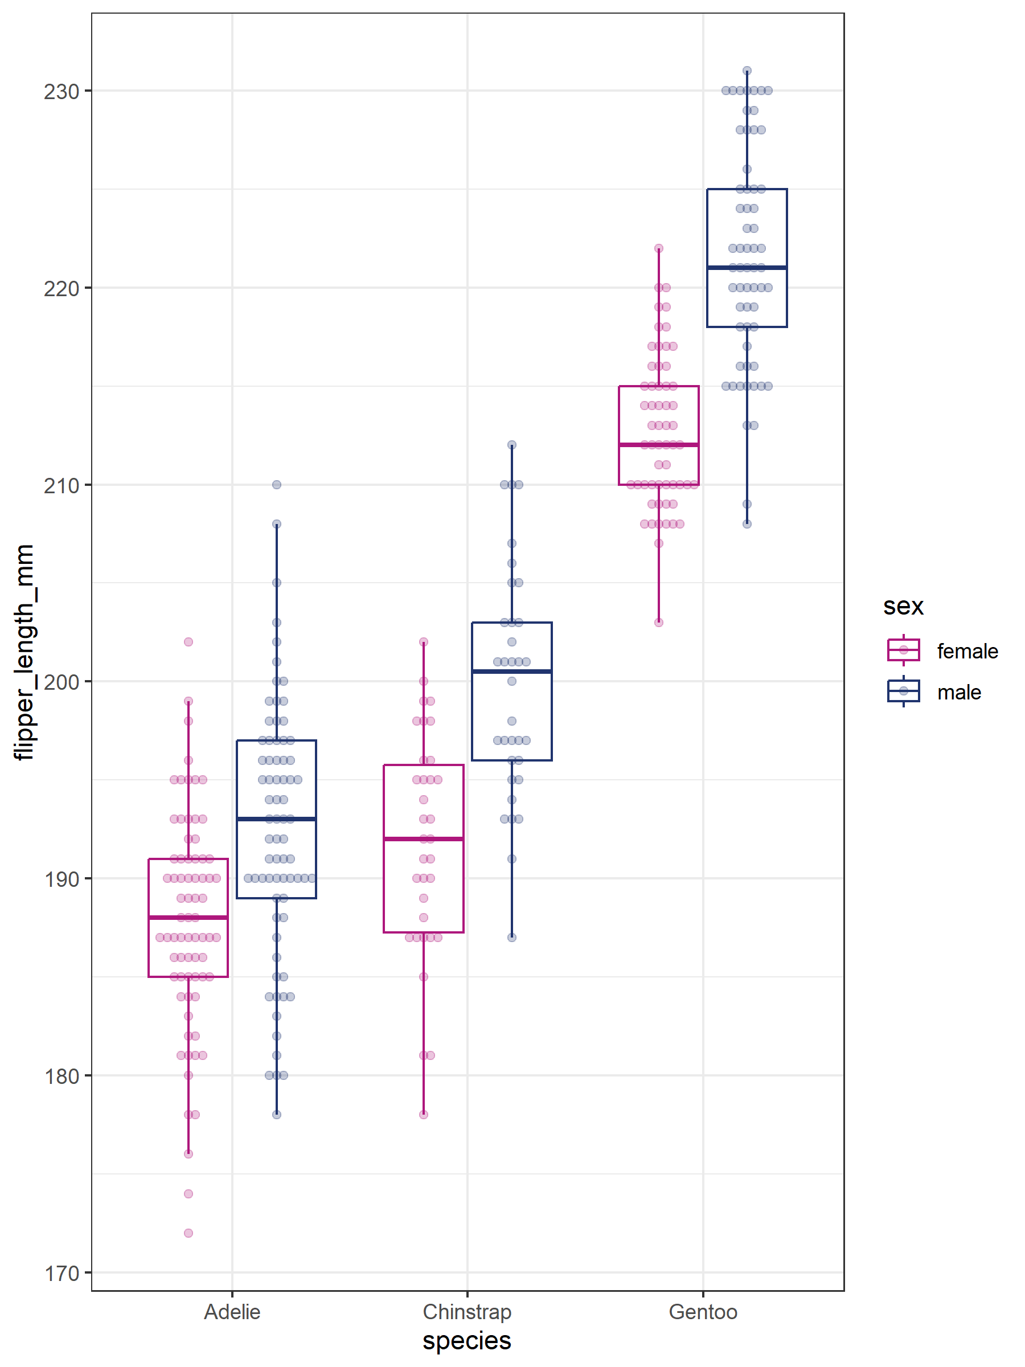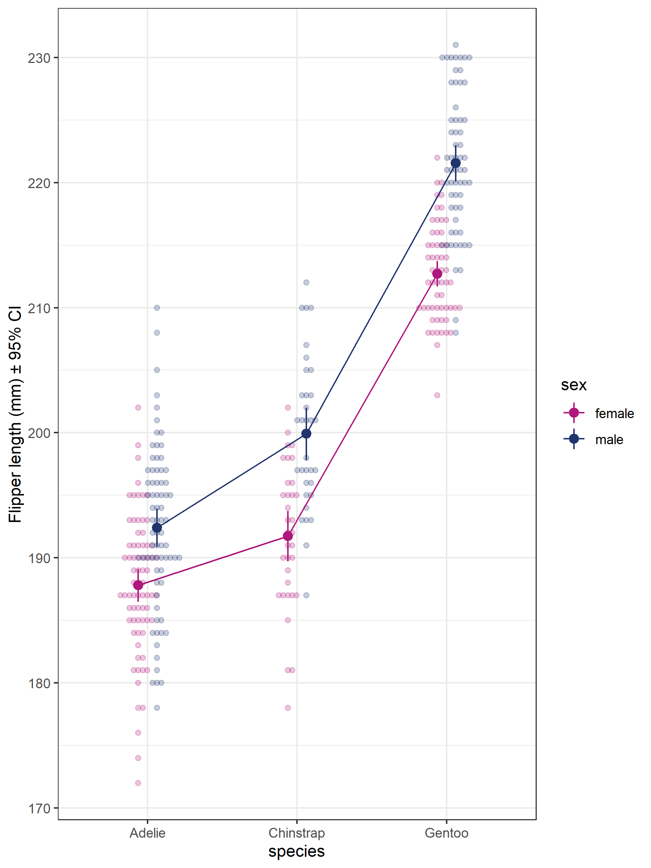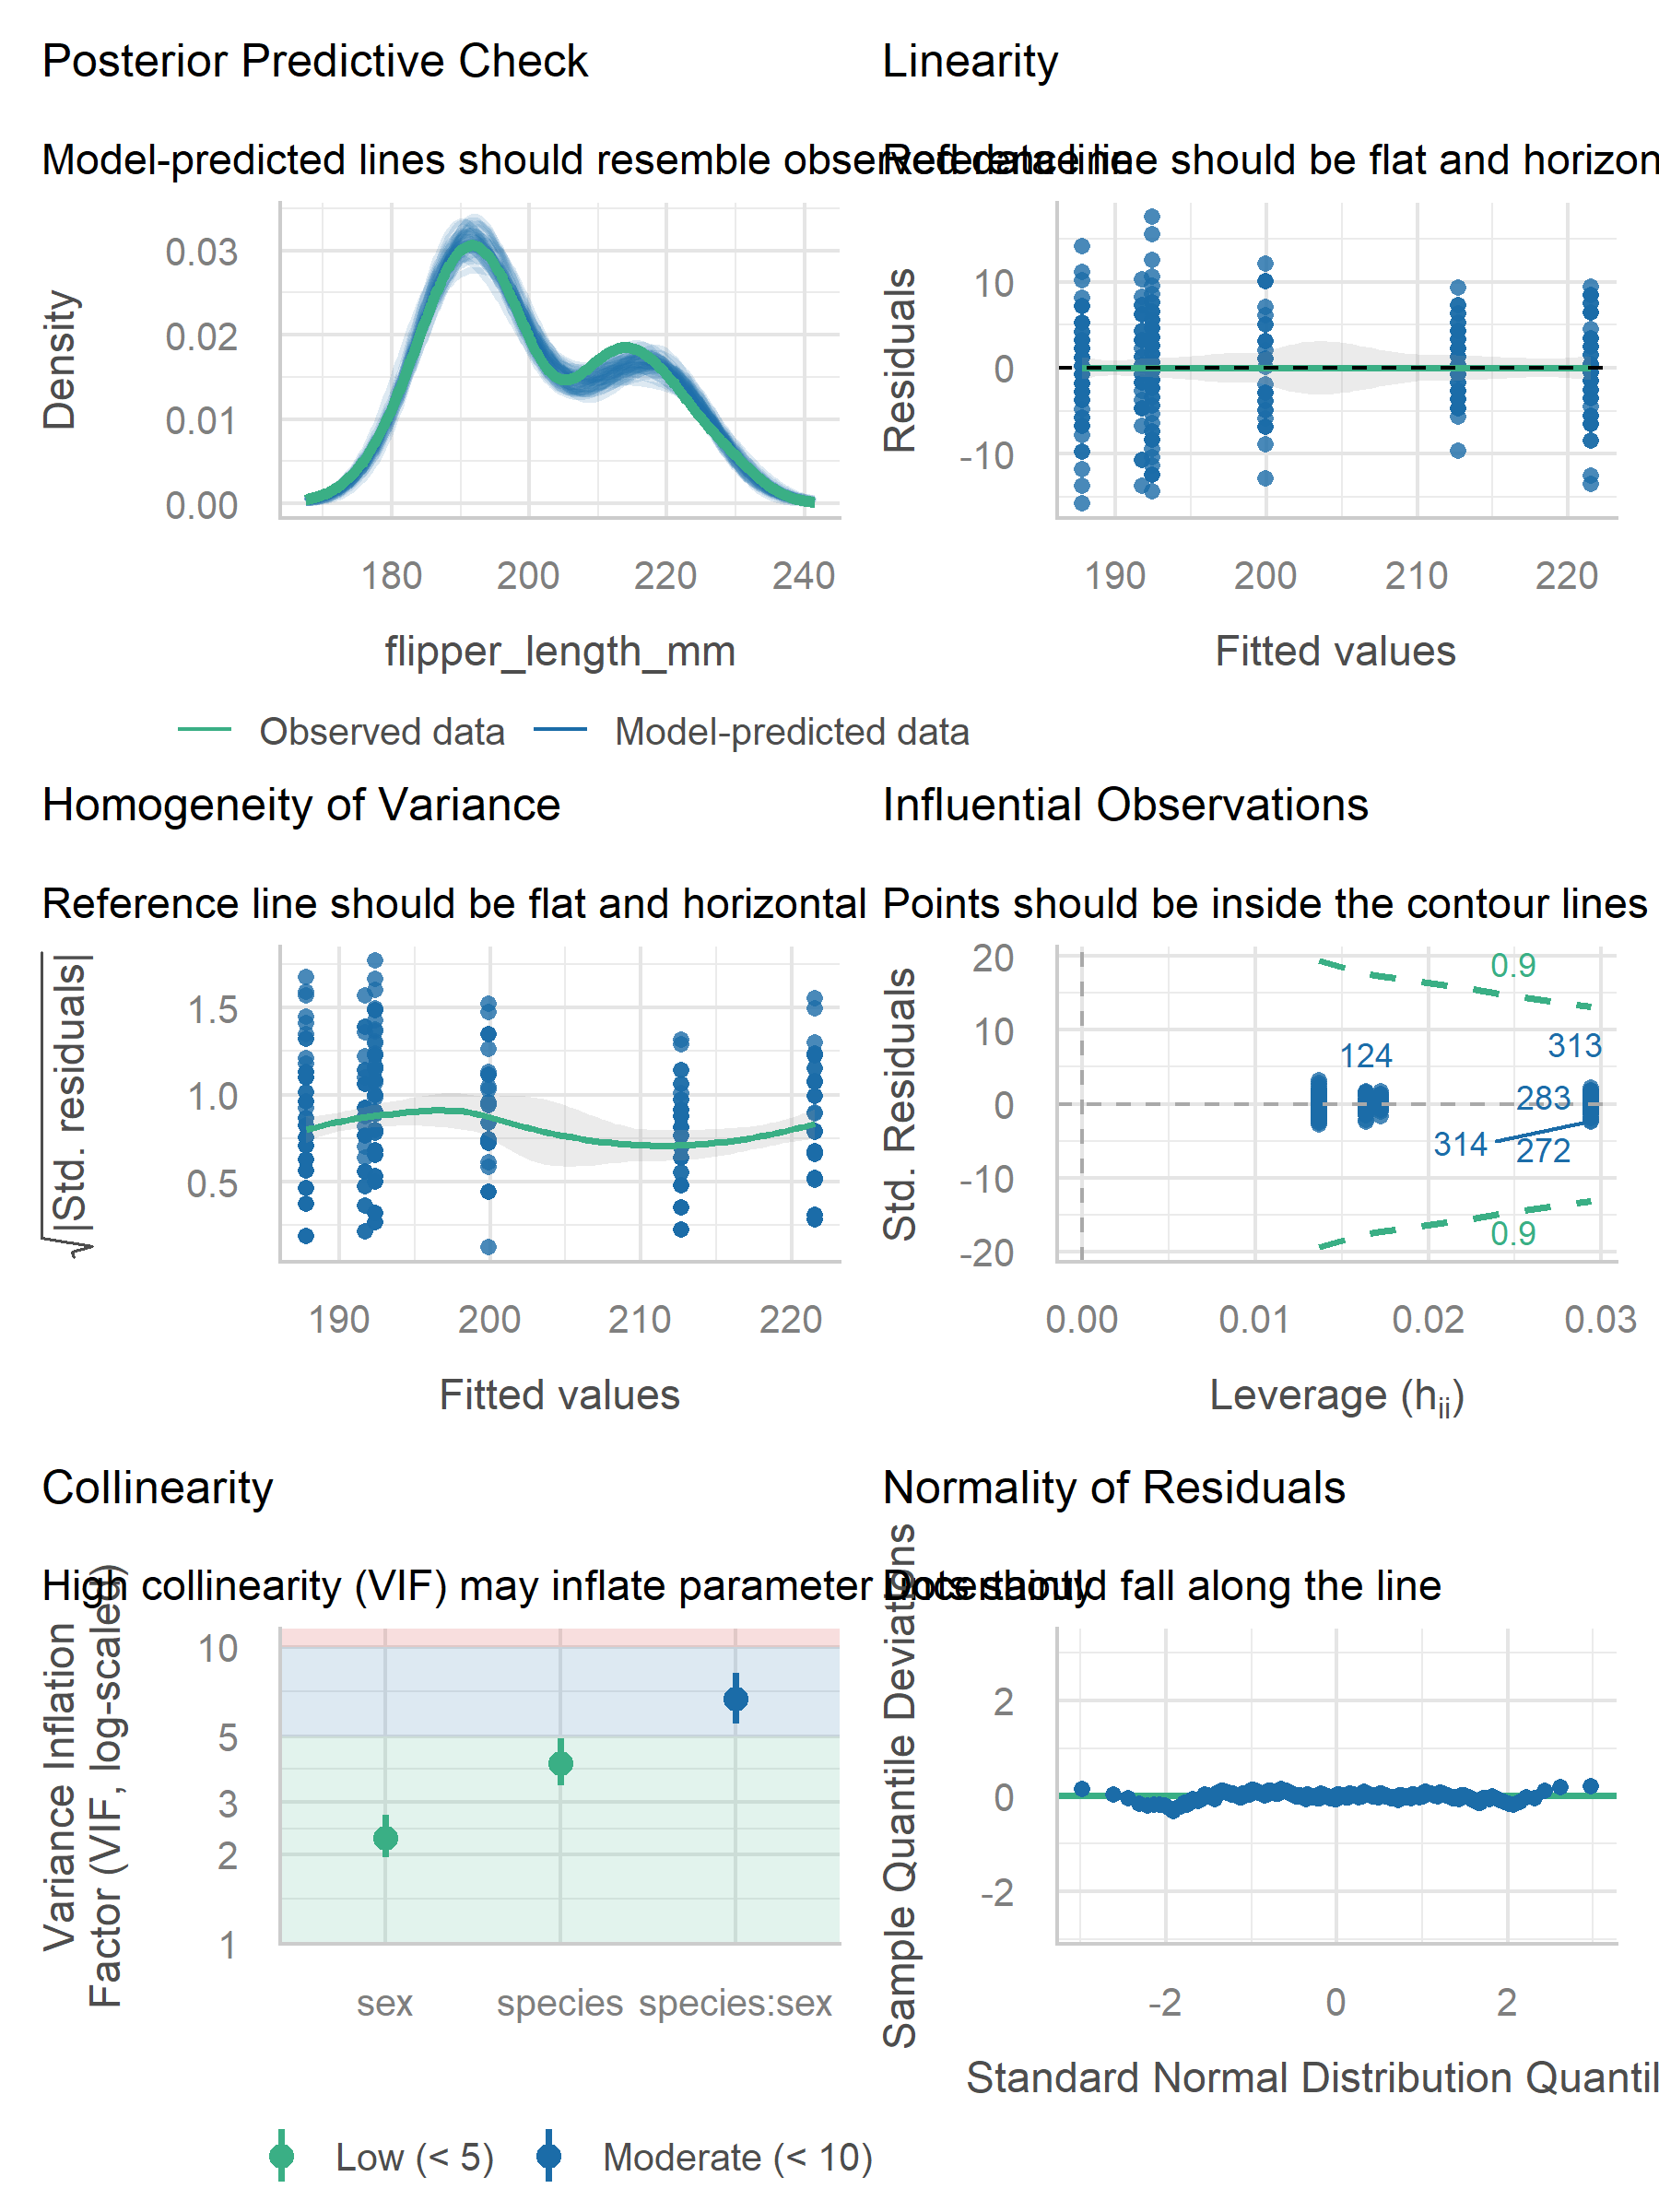# A tibble: 3 × 4 species sex flipper_length_mm body_mass_g 1 Adelie male 210 4000 2 Chinstrap female 178 3250 3 Chinstrap male 212 4300
term | estimate
(Intercept) | 187.794521
speciesChinstrap | 3.940774
speciesGentoo | 24.912376
sexmale | 4.616438
speciesChinstrap:sexmale | 3.560032
speciesGentoo:sexmale | 4.217649

term | sumsq | df | statistic | p.value
(Intercept) | 2 574 475.0822 | 1 | 80 497.681925 | 0.0001
species | 21 415.6291 | 2 | 334.807766 | 0.0001
sex | 777.8699 | 1 | 24.322131 | 0.0001
species:sex | 329.0425 | 2 | 5.144186 | 0.0063
Residuals | 10 458.1068 | 327

term | contrast | null.value | estimate | std.error | statistic | adj.p.value
species | Chinstrap - Adelie | 0 | 3.940774 | 1.1742043 | 3.356123 | 0.00346 **
species | Gentoo - Adelie | 0 | 24.912376 | 0.9947476 | 25.043918 | 0.00001 ***
species | Gentoo - Chinstrap | 0 | 20.971602 | 1.2214990 | 17.168743 | 0.00001 ***
sex | male - female | 0 | 4.616438 | 0.9360655 | 4.931747 | 0.00001 ***
term | estimate
(Intercept) | 187.794521
species_sexChinstrap.female | 3.940774
species_sexGentoo.female | 24.912376
species_sexAdelie.male | 4.616438
species_sexChinstrap.male | 12.117244
species_sexGentoo.male | 33.746463

term | sumsq | df | statistic | p.value
(Intercept) | 2 574 475.08 | 1 | 80 497.6819 | 0.0001
species_sex | 54 760.53 | 5 | 342.4462 | 0.0001
Residuals | 10 458.11 | 327

contrast | estimate | p.value
Chinstrap.female - Adelie.female | 3.9 | 0.011
Gentoo.female - Adelie.female | 24.9 | 0.001
Adelie.male - Adelie.female | 4.6 | 0.001
Chinstrap.male - Adelie.female | 12.1 | 0.001
Gentoo.male - Adelie.female | 33.7 | 0.001
Gentoo.female - Chinstrap.female | 21.0 | 0.001
Adelie.male - Chinstrap.female | 0.7 | 0.992
Chinstrap.male - Chinstrap.female | 8.2 | 0.001
Gentoo.male - Chinstrap.female | 29.8 | 0.001
Adelie.male - Gentoo.female | -20.3 | 0.001
Chinstrap.male - Gentoo.female | -12.8 | 0.001
Gentoo.male - Gentoo.female | 8.8 | 0.001
Chinstrap.male - Adelie.male | 7.5 | 0.001
Gentoo.male - Adelie.male | 29.1 | 0.001
Gentoo.male - Chinstrap.male | 21.6 | 0.001
Pairwise comparisons using t tests with pooled SD
data: tempdata$flipper_{l}ength_{m}mandtempdata$species_sex
Adelie.female Chinstrap.female Gentoo.female Adelie.male
Chinstrap.female 0.00088 - - -
Gentoo.female < 2e-16 < 2e-16 - -
Adelie.male 1.3e-06 0.56540 < 2e-16 -
Chinstrap.male < 2e-16 6.5e-09 < 2e-16 5.8e-10
Gentoo.male < 2e-16 < 2e-16 6.0e-16 < 2e-16
Chinstrap.male Chinstrap.female -
Gentoo.female -
Adelie.male -
Chinstrap.male -
Gentoo.male < 2e-16
P value adjustment method: none 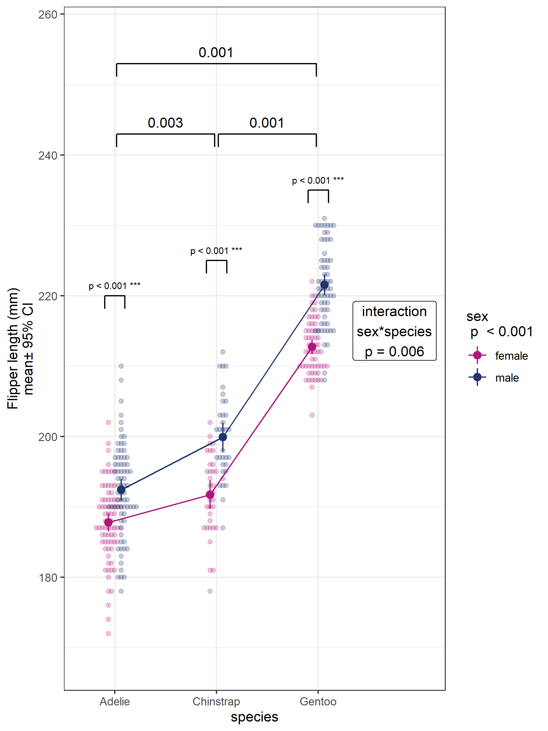
term | estimate
(Intercept) | 186.677655
speciesChinstrap | 5.720790
speciesGentoo | 27.046208
sexmale | 6.850169

term | df.residual | rss | df | sumsq | statistic | p.value
flipper_length_mm ~ species + sex | 329 | 10 787.15
flipper_length_mm ~ species * sex | 327 | 10 458.11 | 2 | 329.0425 | 5.144186 | 0.006314424
term | sumsq | df | statistic | p.value
species | 50 185.027 | 2 | 765.3029 | 0.0001
sex | 3 905.604 | 1 | 119.1180 | 0.0001
Residuals | 10 787.149 | 329

combined:

flipper len by species/sex/weight
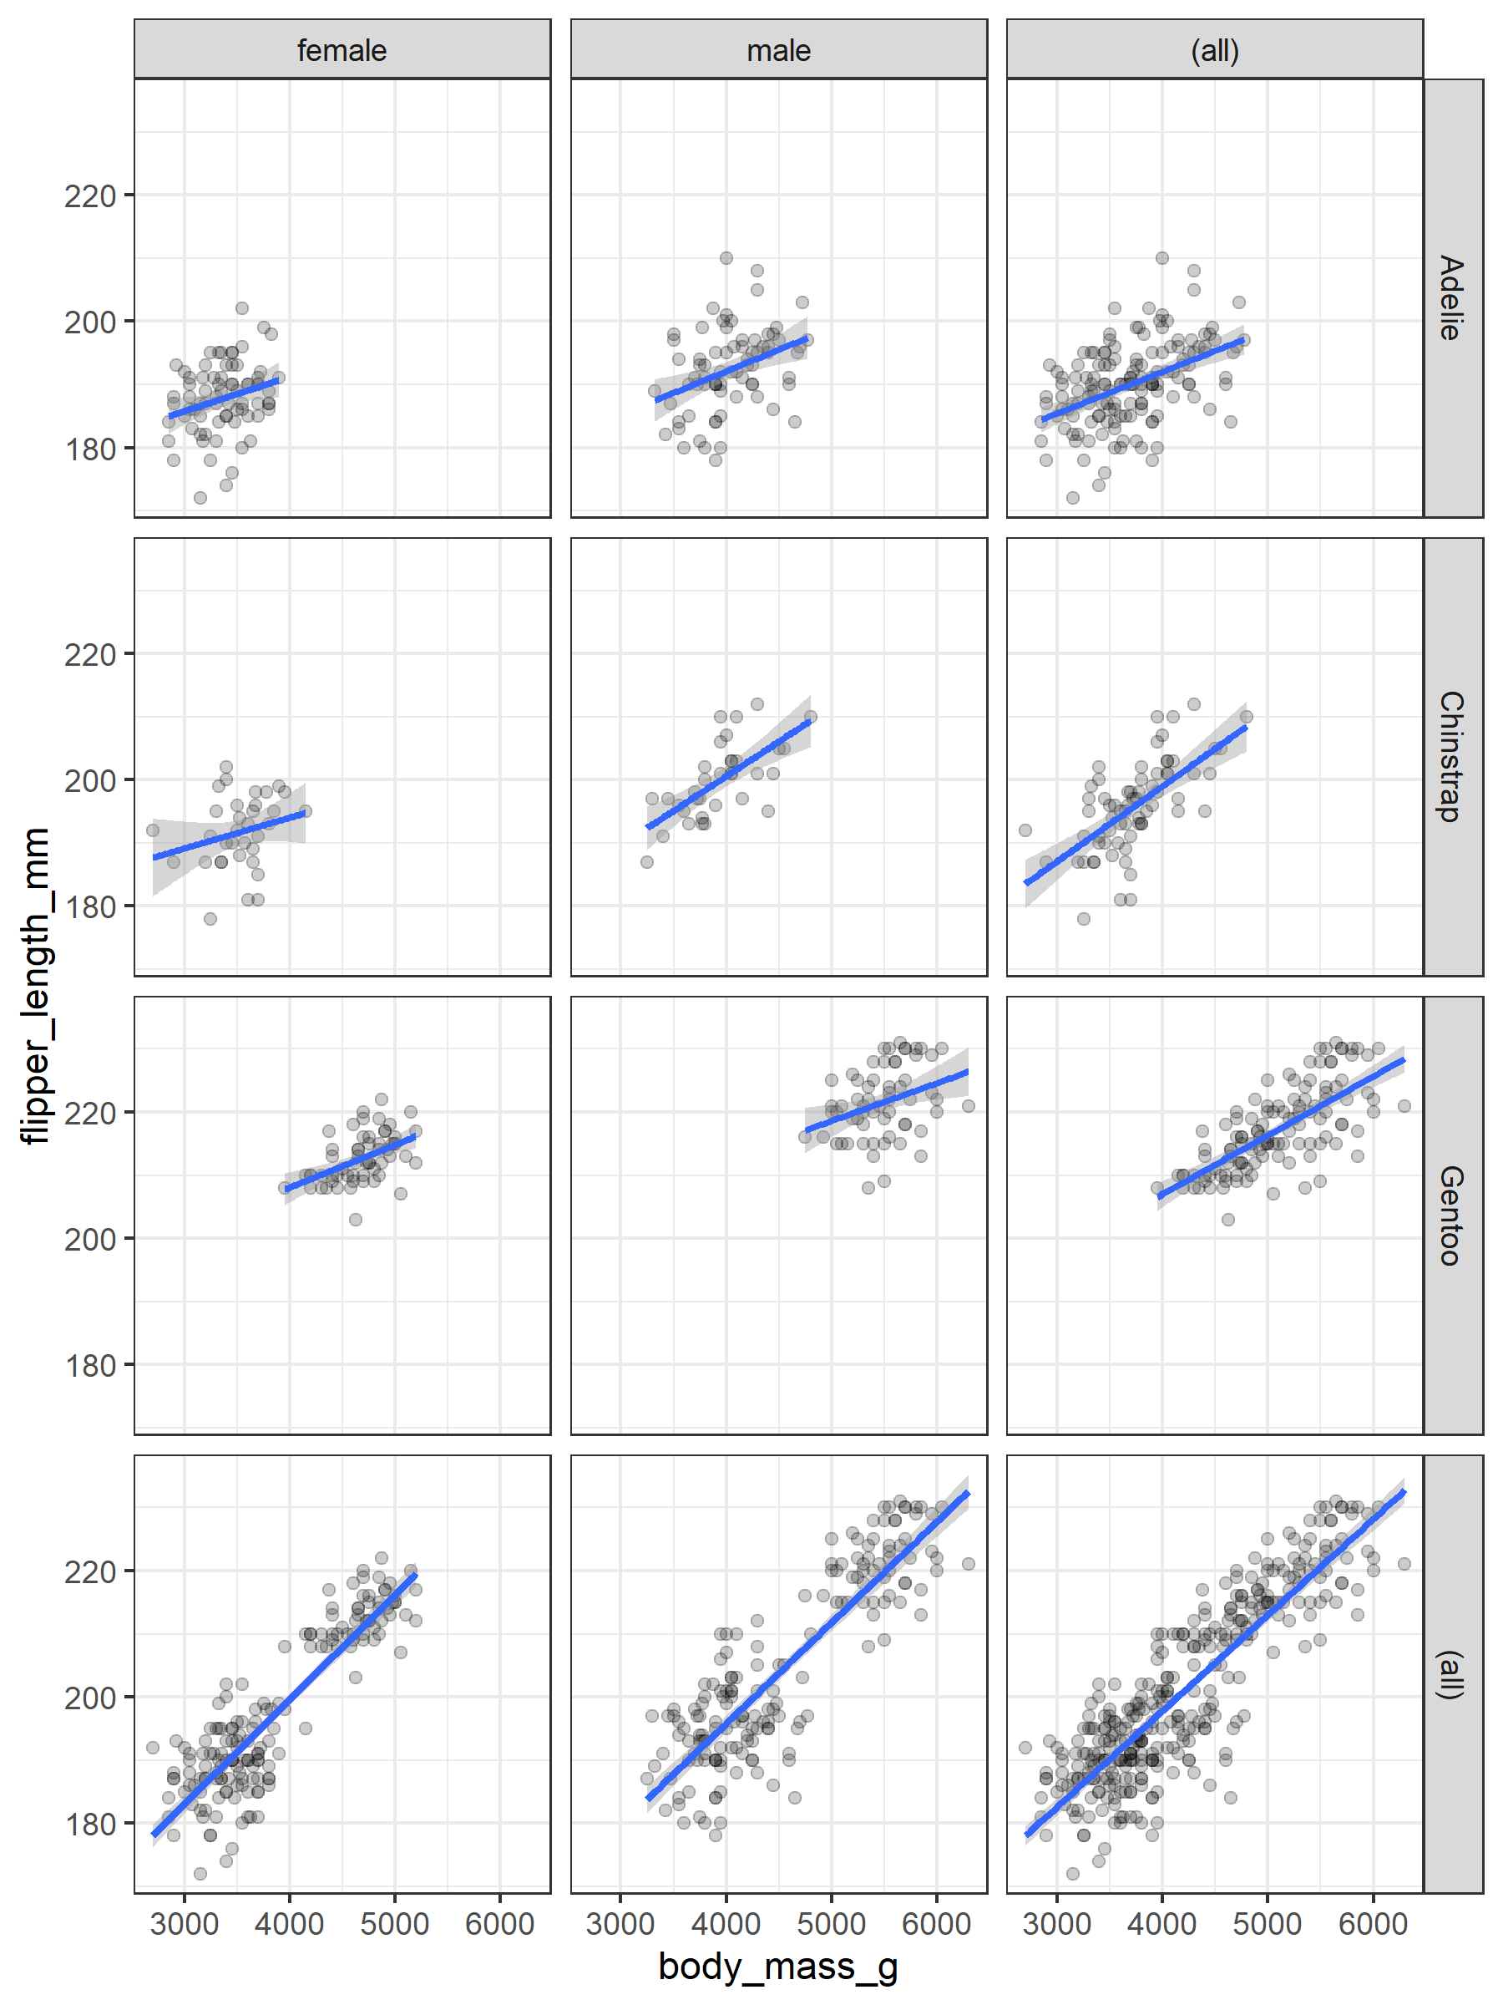
term | estimate
(Intercept) | 170.02872299504
body_mass_g | 0.00527357211
speciesChinstrap | -5.06403714942
speciesGentoo | 17.60510639280
sexmale | -5.80760296153
body_mass_g:speciesChinstrap | 0.00231617716
body_mass_g:speciesGentoo | 0.00008421695
body_mass_g:sexmale | 0.00169808280
speciesChinstrap:sexmale | 4.17018447826
speciesGentoo:sexmale | 1.01445674466

term | sumsq | df | statistic | p.value
(Intercept) | 20 331.78206 | 1 | 734.4897855 | 0.0001 ***
body_mass_g | 224.13236 | 1 | 8.0968274 | 0.0047 **
species | 145.06408 | 2 | 2.6202347 | 0.0743 +
sex | 18.56772 | 1 | 0.6707627 | 0.4134 n.s.
body_mass_g:species | 28.33253 | 2 | 0.5117591 | 0.5999 n.s.
body_mass_g:sex | 21.54664 | 1 | 0.7783769 | 0.3783 n.s.
species:sex | 124.01072 | 2 | 2.2399563 | 0.1081 n.s.
Residuals | 8 941.12585 | 323

term | estimate
(Intercept) | 164.588716937
body_mass_g | 0.006549942
speciesChinstrap | 5.544440017
speciesGentoo | 18.021317441
sexmale | 2.477721542

term | sumsq | df | statistic | p.value
body_mass_g | 1 414.8645 | 1 | 49.515732 | 0.0001
species | 5 075.7465 | 2 | 88.817449 | 0.0001
sex | 240.4927 | 1 | 8.416474 | 0.0040
Residuals | 9 372.2848 | 328

term | df.residual | rss | df | sumsq | statistic | p.value
flipper_length_mm ~ (body_mass_g + species + sex)^2 | 323 | 8 941.126
flipper_length_mm ~ body_mass_g + species + sex | 328 | 9 372.285 | -5 | -431.1589 | 3.115141 | 0.009222773

term | estimate
(Intercept) | 164.737097887
body_mass_g | 0.006844330
speciesChinstrap | 2.856835208
speciesGentoo | 15.940104369
sexmale | -0.001140442
speciesChinstrap:sexmale | 5.359357503
speciesGentoo:sexmale | 3.324893787

term | sumsq | df | statistic | p.value
(Intercept) | 72 126.91646762841 | 1 | 2 614.99725804292 | 0.0001
body_mass_g | 1 466.36702336896 | 1 | 53.16386632327 | 0.0001
species | 2 981.63285504721 | 2 | 54.05029164070 | 0.0001
sex | 0.00003101267 | 1 | 0.00000112438 | 0.9992
species:sex | 380.54504859620 | 2 | 6.89842507746 | 0.0012
Residuals | 8 991.73974126628 | 326

term | df.residual | rss | df | sumsq | statistic | p.value
flipper_length_mm ~ (body_mass_g + species + sex)^2 | 323 | 8 941.126
flipper_length_mm ~ body_mass_g + species * sex | 326 | 8 991.740 | -3 | -50.6139 | 0.6094791 | 0.609272

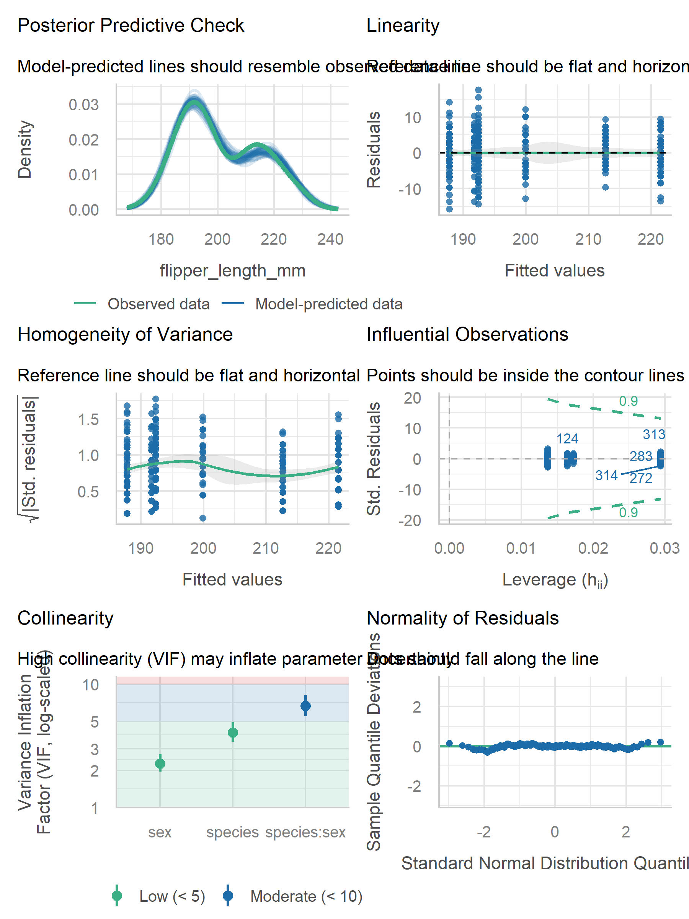
create formulas programmatically
[1] “flipper_len~speciesbody_mass_gsex” [1] “flipper_len~species+body_mass_g+sex”

