**Practical Exercise 7**

**submitted by Sven Niedorf, Isabelle Maye and Lena Wolos**

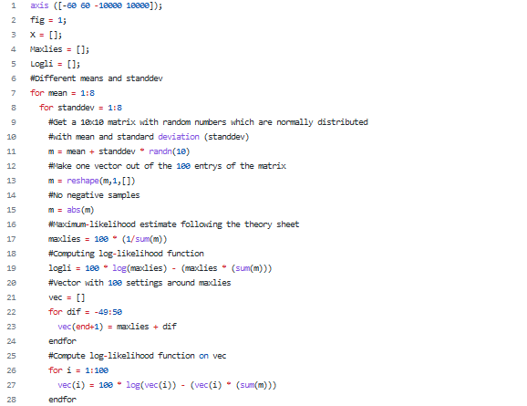**Code**

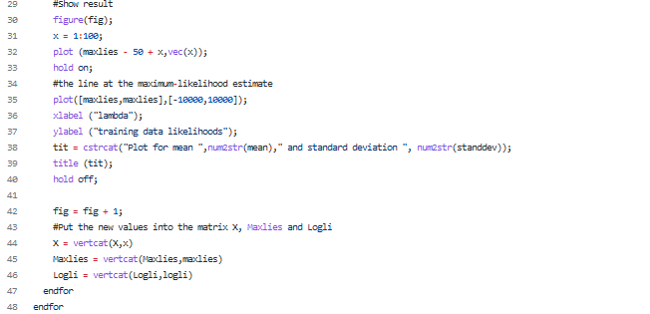

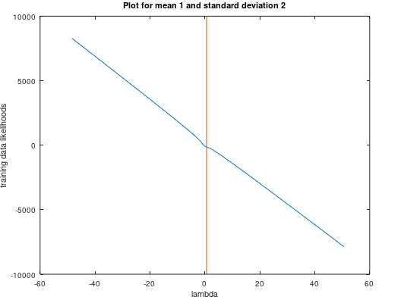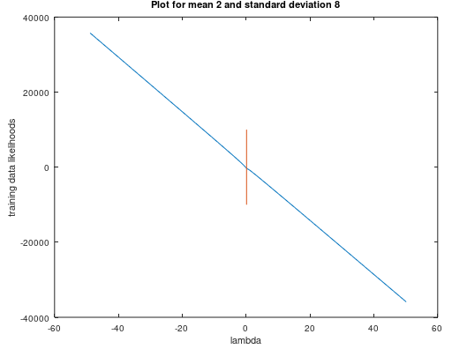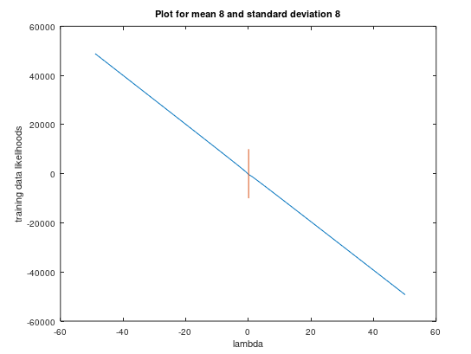

**Comment on the results**

In the graphs above we clearly see the intersection of the estimated lambda (the vertical red line marks it) and the likelihoods of the training data (blue line) for given lamda. Intersection is the value of the estimated likelihood.

Furthemore we notice that the function of likelihoods is almost a linear function for all data sets. That was to be expected because the likelihood-function is a linear function in relation to lambda (see theory sheet 5).