CS 567 · 3D User Interfaces and Human-Centered Spatial AI · Fall 2026 · Project Proposal
Physics You Can Feel: A Pseudo-Haptic VR Sandbox for Experiencing Mechanics and Material Properties
CS567_SVEN · Sven Skoglund, sven.skoglund@colostate.edu
Department of Computer Science, Colorado State University, Fort Collins, CO, USA
ABSTRACT
Physical intuition about mass, volume, density, and friction, and about simple machines such as levers and pulleys, is hard to build from equations and 2D diagrams, and the demonstrations that would make it concrete are often impractical or unsafe in a classroom. We propose an immersive virtual-reality sandbox in which learners create, hold, weigh, and manipulate objects and simple machines. Because commodity headsets cannot render true weight, we use pseudo-haptic cues so a denser object feels heavier and a loaded lever feels harder to move. The application is pure VR with no in-scene agent; agentic AI is instead the development workflow, an AI coding agent that helps implement the Unity project. As an online, demonstration-focused project it has no human-subjects study: success is an interactive Quest 2 demonstration whose pseudo-haptic cues track the underlying physics across several scenarios.
Keywords: 3D user interfaces; virtual reality; embodied learning; pseudo-haptics; physics education; agentic AI; AI-assisted development

1 INTRODUCTION AND MOTIVATION
Introductory physics rests on relationships that students can state long before they can predict with them. Density relates mass to volume, buoyancy determines whether an object floats, friction resists sliding in proportion to the normal load, and simple machines such as levers and pulleys trade force for distance. The usual failure is not arithmetic but intuition. Asked whether a kilogram of gold or a kilogram of ice is larger, which of two blocks slides farther down a ramp, or where a load balances on a lever, many learners fall back on misconceptions such as “heavier means bigger.” Textbooks and 2D simulations show the formula and the result, yet they do not let a student feel the difference.
Doing the demonstration in real life is harder than it sounds: the comparisons that isolate a single variable are exactly the ones that are awkward, expensive, or unsafe to stage, since matched-mass materials are not classroom stock and friction is hard to hold constant. Virtual reality can present these controlled manipulations on demand, but a handheld controller weighs the same whatever it represents, so the sensation many lessons depend on is missing. The open question is whether a spatial interface can make physical properties and mechanical behavior felt well enough to matter, given that the dominant channel for weight and force is the one current hardware cannot deliver.
2 RELATED WORK
Immersive VR for science learning. Slater and Sánchez-Vives argue that immersion's value lies in place and plausibility illusions that let users respond to virtual events as if real [1]. In physics, Tsivitanidou et al. report conceptual gains from inquiry-based immersive VR, though the effect interacts with learners' attitudinal profiles [2], and Georgiou et al. show that gains depend heavily on how interaction and scaffolding are structured, not on immersion alone [3]. Immersive physics learning is promising but design-sensitive.
Rendering weight and force without them. Because headsets cannot reproduce real heft, haptics work substitutes perception for physics. Wang et al. survey how far true force feedback remains from consumer hardware [4]. Pseudo-haptics sidesteps the hardware: Ujitoko and Ban survey how manipulating the visual consequences of a motion (gain, lag) induces felt weight and stiffness [5], and Kim et al. show that added auditory and visual cues shift perceived virtual weight [6]. These cues generalize to the effort of operating a machine.
Guidance and foundations. Makransky et al. find that guidance from a pedagogical agent aids immersive VR science learning when well matched to the learner [7]; we realize that scaffolding through scene and task design rather than an in-application agent. We ground interaction in Bowman et al.'s canonical treatment of 3D manipulation [8]. The gap: immersive physics studies rarely give learners genuine haptic contrast, and pseudo-haptic studies rarely span both material properties and simple machines in one environment.
3 APPROACH
We will build a VR “physics sandbox” in which the learner constructs and probes scenarios and the interface makes the governing property perceptible. Early scenarios target material properties: pick up two same-mass blocks of different materials, weigh them on a balance, drop them in water to see buoyancy, and drag them across a ramp to compare friction. The same interaction model extends to mechanical devices, such as placing weights on a lever to find its balance point or routing a rope through a pulley to feel the reduced effort. In each case a single variable is isolated so the outcome has a clear cause. Weight and resistance are conveyed through pseudo-haptics, modulating control-to-display gain and visual lag so a denser block feels heavier and a loaded lever feels harder to move [5], [6]. This is where the project complies with HCI research in Virtual Reality: the contribution is an interaction technique for making an unrenderable physical property perceptible through direct, embodied manipulation.
The second aspect is the agentic-AI development workflow, and we are deliberate about the distinction the assignment draws. The finished application has no in-scene chatbot for the learner to talk to. Instead, agentic AI is how the software is built: an AI coding agent works in the project with real tools, editing Unity C# scripts, running builds, reading compiler and test output, and iterating toward a working scene over many steps rather than emitting one block of code from a single prompt. It plans, uses tools, observes results, and self-corrects toward a goal. We report what it implemented, where it needed human correction, and how the workflow shaped the build. The professor has confirmed that a pure VR project built this way satisfies the assignment.
4 SYSTEM VISION AND TECHNOLOGY
When it works, the demo is a first-person VR scene with a ground plane, a work area, and a menu for spawning materials and mechanical devices (Figures 1 and 2). The learner grabs objects with hand-tracking or controllers and feels a denser one resist motion or a loaded lever push back; a side panel shows each object's properties and the measured outcome of an interaction. Early scenarios cover density, buoyancy, and friction, with levers, pulleys, and projectiles added on the same framework as the project grows.
We will build in Unity 6 with the XR Interaction Toolkit and OpenXR, in C#, targeting the Meta Quest 2 (hand-tracking and controllers). Physics uses Unity's rigid-body engine with per-material density and friction parameters and standard joints for levers and pulleys. Development uses an agentic-AI coding workflow, an AI agent that edits scripts, runs builds, and reads compiler output while iterating toward each scene. We already have a Quest 2 and a Unity development machine.
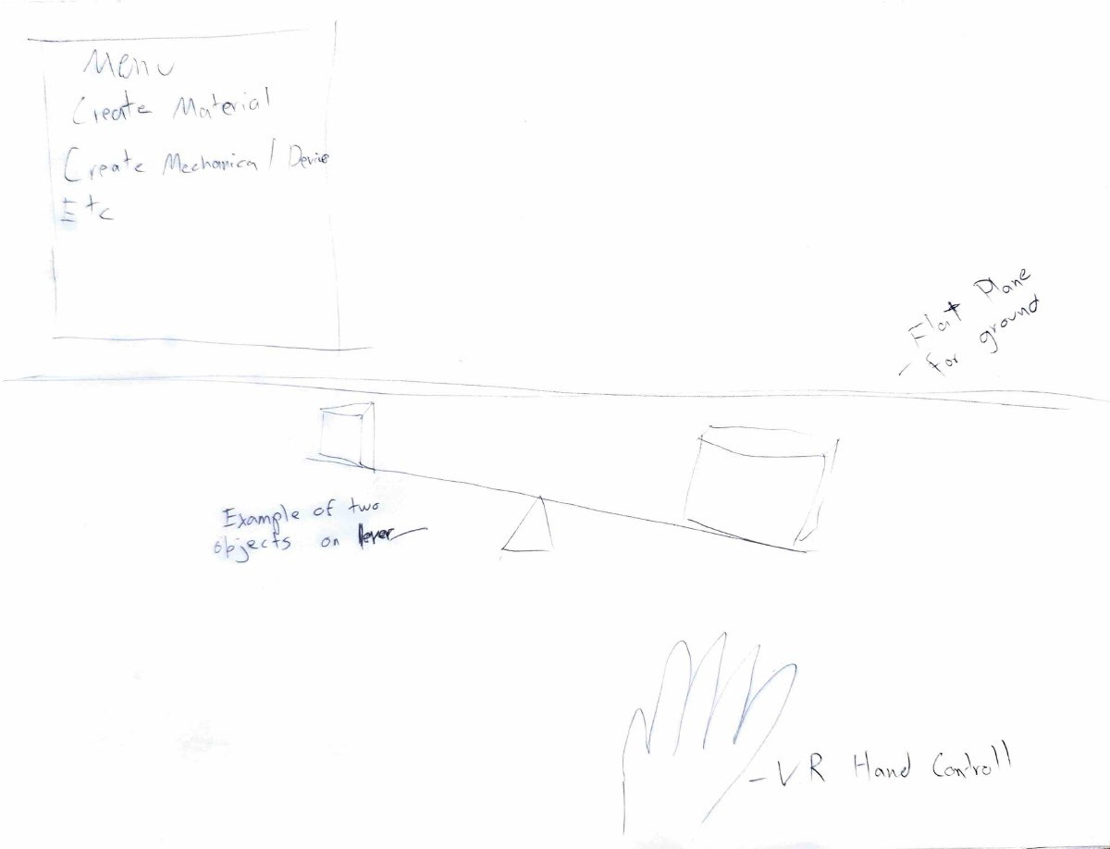
Figure 1: Hand-drawn concept sketch: menu panel, two objects on a lever over a fulcrum, and a tracked VR hand for direct grab-and-place interaction.
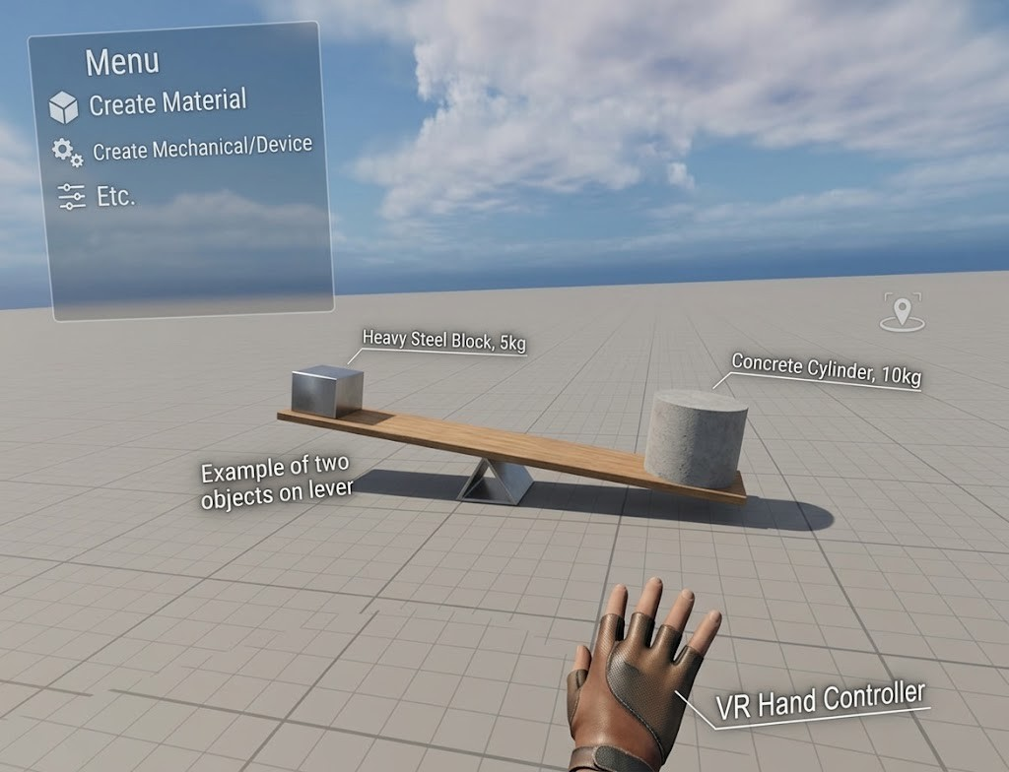
Figure 2: AI-enhanced render of the same scene (Google Gemini, from Figure 1). A labeled steel block and concrete cylinder on a lever, with the floating menu for spawning materials and mechanisms.
5 EVALUATION PLAN
This is an online, demonstration-focused project, so it has no human participants and requires no IRB submission. We evaluate the system itself, with success defined at the system level rather than by learning gains on students.
Physics fidelity: automated checks compare each scenario against its closed-form prediction within tolerance, for example that equal-mass blocks show the correct relative volumes, objects float or sink by density, ramp sliding follows the friction coefficient, and a lever balances at the computed load position.
Pseudo-haptic behavior: the cues must be monotonic, a denser object always feeling heavier and a more heavily loaded lever always harder to move, with gain and lag mapping to density and load in the intended direction.
Development workflow: because agentic AI is our build method, we report which parts of the implementation the coding agent produced through tool use and iteration and where human correction was needed.
Success: an interactive Quest 2 demonstration in which the fidelity checks pass, the pseudo-haptic cues behave monotonically across scenarios, and the scene runs stably on-device. An informal peer walkthrough may inform design, but no formal user data is collected.
6 DELIVERABLES
By mid-November: a Unity 6 scene on Quest 2 with grab-and-place interaction for at least four materials, a working balance, a water tank, and a ramp, plus one mechanical device (a lever), all with pseudo-haptic weight and force modulation; automated physics-fidelity checks against closed-form predictions for density, buoyancy, friction, and the lever; and in-scene logging of interactions and outcomes.
Toward the early-December presentation: an expanded sandbox adding at least one more concept (for example a pulley or projectile launcher) on the same framework; a recorded on-device demonstration video; and the paper extending this proposal, documenting the design, the system-level evaluation, and a report on the agentic-AI development workflow.
Roles: solo project (group CS567_SVEN); Sven Skoglund is responsible for all work, including the Unity interaction and pseudo-haptics, the fidelity checks, the demonstration, and directing the agentic-AI development workflow.
7 CONCLUSION
We are building a VR physics sandbox that turns abstract relationships, from density and friction to the mechanics of levers and pulleys, into things a learner can feel and test through direct, embodied manipulation. The application is pure VR with no in-scene agent; agentic AI is the workflow used to build it. The class should expect a working Quest 2 demonstration, automated checks that the simulation matches the underlying physics, and a report on how the agentic-AI development process shaped the result.
USE OF AI
Generative AI (a large language model) was used to help locate candidate peer-reviewed references and to critique the argument and grammar of drafts. Google Gemini generated the enhanced mockup in Figure 2 from the author's hand-drawn sketch (Figure 1). The implementation is planned as an agentic-AI development effort in which an AI coding agent assists in writing and iterating on the Unity project under the author's direction, and this will be documented in the final paper. All prose in this proposal was written and revised by the author, and every cited work was read and verified by the author.
REFERENCES
[1] Mel Slater and Maria V. Sánchez-Vives. 2016. Enhancing Our Lives with Immersive Virtual Reality. Frontiers in Robotics and AI 3 (2016), 74. https://doi.org/10.3389/frobt.2016.00074
[2] Olia E. Tsivitanidou, Yiannis Georgiou, and Andri Ioannou. 2021. A Learning Experience in Inquiry-Based Physics with Immersive Virtual Reality. Journal of Science Education and Technology 30, 6 (2021), 841–861. https://doi.org/10.1007/s10956-021-09924-1
[3] Yiannis Georgiou, Olia Tsivitanidou, and Andri Ioannou. 2021. Learning Experience Design with Immersive Virtual Reality in Physics Education. Educational Technology Research and Development 69, 6 (2021), 3051–3080. https://doi.org/10.1007/s11423-021-10055-y
[4] Dangxiao Wang, Yuan Guo, Shiyi Liu, Yuru Zhang, Wei Xu, and Jing Xiao. 2019. Haptic Display for Virtual Reality: Progress and Challenges. Virtual Reality & Intelligent Hardware 1, 2 (2019), 136–162. https://doi.org/10.3724/SP.J.2096-5796.2019.0008
[5] Yusuke Ujitoko and Yuki Ban. 2021. Survey of Pseudo-Haptics: Haptic Feedback Design and Application Proposals. IEEE Transactions on Haptics 14, 4 (2021), 699–711. https://doi.org/10.1109/TOH.2021.3077619
[6] Jinwook Kim, Seonghyeon Kim, and Jeongmi Lee. 2022. The Effect of Multisensory Pseudo-Haptic Feedback on Perception of Virtual Weight. IEEE Access 10 (2022), 5129–5140. https://doi.org/10.1109/ACCESS.2022.3140438
[7] Guido Makransky, Philip Wismer, and Richard E. Mayer. 2019. A Gender Matching Effect in Learning with Pedagogical Agents in an Immersive Virtual Reality Science Simulation. Journal of Computer Assisted Learning 35, 3 (2019), 349–358. https://doi.org/10.1111/jcal.12335
[8] Doug A. Bowman, Ernst Kruijff, Joseph J. LaViola Jr., and Ivan Poupyrev. 2004. 3D User Interfaces: Theory and Practice. Addison-Wesley, Boston, MA, USA.

