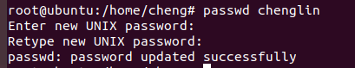

Useradd username添加用户username

Passwd username为username 添加密码