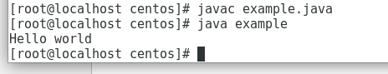

public class example

{

public static void main(String[] args)

{

System.out.println("Hello world");

}

}