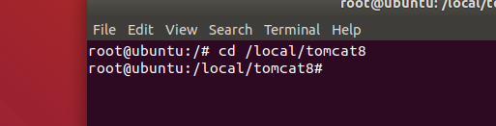

Cd 路径

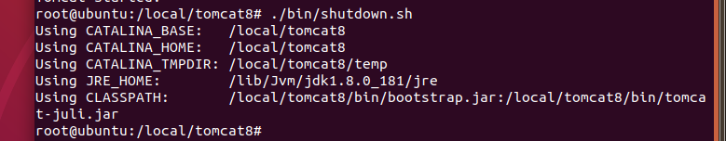

./bin/shutdown.sh



Ps –ef|grep tomcat

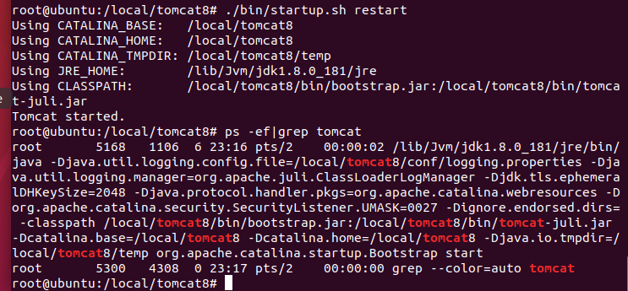

Startup.sh restart