**Experient-7**

**Design and Configuration of Hybrid Topologies using Packet Tracer. Step1:** 7 switches and 8 PCs

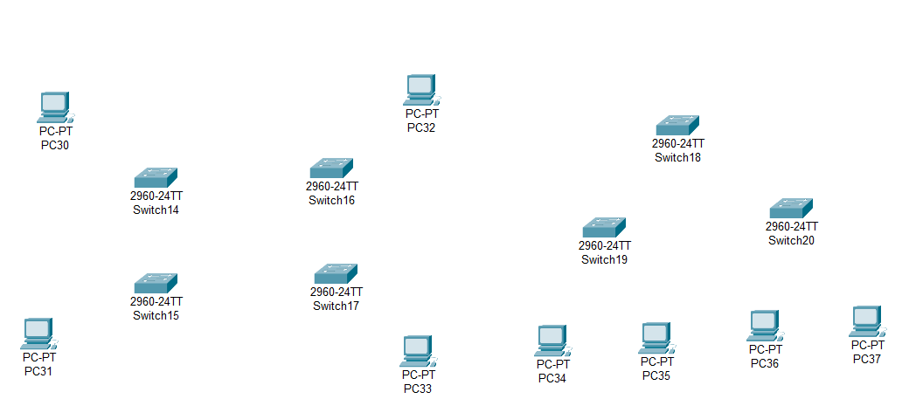

**Step2:** connect fast ethernets from switch to switch and switch to PCs

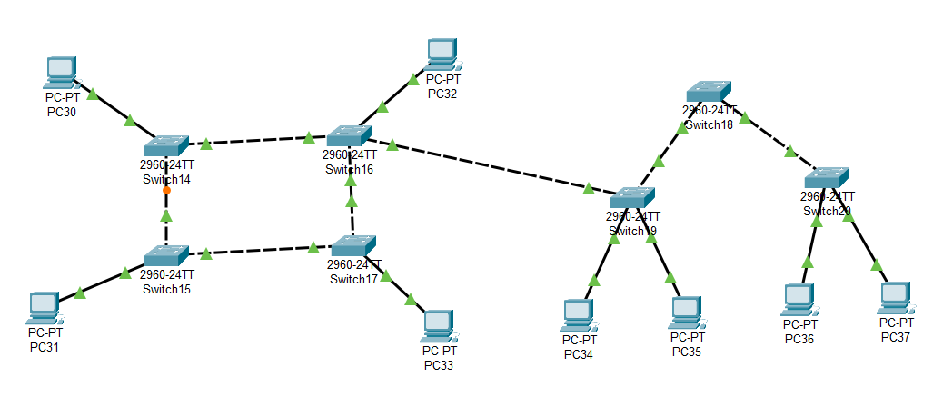

**Step3:** Assign IP address for each PCs

IP address for PC30:192.168.1.7

IP address for PC31: 192.168.1.8

IP address for PC32: 192.168.1.9

IP address for PC33: 192.168.1.10

IP address for PC34: 192.168.1.11

IP address for PC35: 192.168.1.12

IP address for PC36: 192.168.1.13

IP address for PC37: 192.168.1.14

**Step4:** allocate the message



**Result:** message sent successfully from PC30-PC37