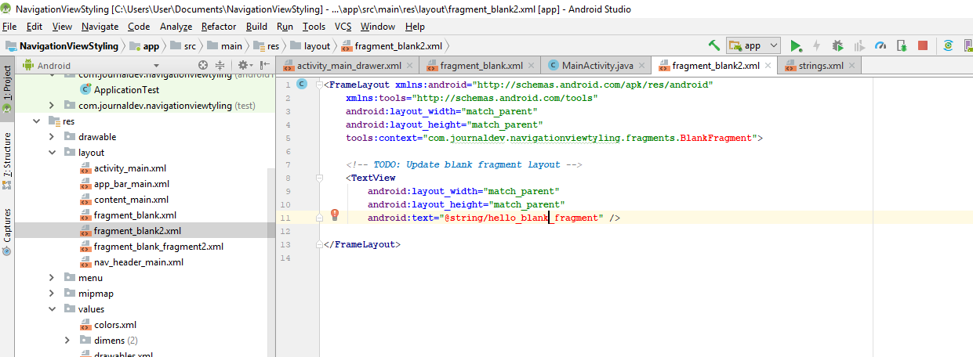

**if** (id == R.id.***nav_camera***) {  
 *// Handle the camera action  
 // Toast.makeText(getApplicationContext(), "Foto is clicked", Toast.LENGTH_SHORT).show();//*} **else if** (id == R.id.***nav_Settings***) {  
 Toast.*makeText*(getApplicationContext(), **"Settings is clicked"**, Toast.***LENGTH_SHORT***).show();  
 ftrans.replace(R.id.***container***, **settingsFragment**);  
} **else if** (id == R.id.***Music***) {  
 Toast.*makeText*(getApplicationContext(), **"Music is clicked"**, Toast.***LENGTH_SHORT***).show();  
  
} **else if** (id == R.id.***nav_video***) {  
 Toast.*makeText*(getApplicationContext(), **"Video is clicked"**, Toast.***LENGTH_SHORT***).show();  
  
} **else if** (id == R.id.***nav_share***) {  
 Toast.*makeText*(getApplicationContext(), **"Share is clicked"**, Toast.***LENGTH_SHORT***).show();  
  
} **else if** (id == R.id.***nav_message***) {  
 Toast.*makeText*(getApplicationContext(), **"message is clicked"**, Toast.***LENGTH_SHORT***).show();  
  
}  
ftrans.commit();