# Where we are

We have a framework with tests in code. Let’s switch that to BDT.

Please watch the Test Automation Approaches video for some context.

# Task

1. Install SpecFlow (check InstallingSpecFlow file).
2. You now have a single (or more) methods with SpecFlow attributes that get called when you launch your auto-generated test:

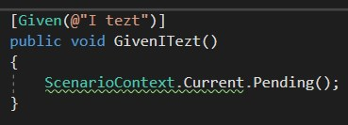

1. Let’s add arguments to our text file:

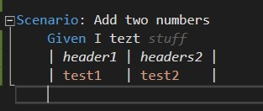

1. Now, let’s add a Regexp group to capture the inline argument (in this case, “stuff”). You need to read up on what regular expressions are and the basics of their use. After that, use a site like <https://regex101.com/> to determine what the groups will be in your case. Then, we need to add this argument as a string argument to our method. Since we supplied a table as well, we need to add that as Table argument:

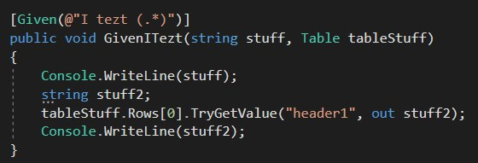

Now, if we launch the “Given I tezt stuff” feature file, we get this output:

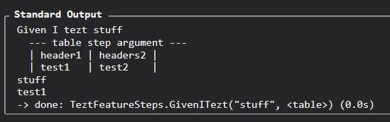

1. Using the information above, you need to turn your test cases to BDT format. Remember to keep them short, work to remove any duplicate sequences, and stick to logical actions rather than implementation details (such as clicking buttons).