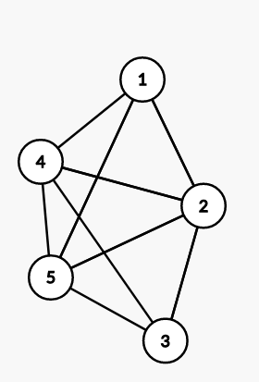

2. Vertex 1: [1, 4]
Vertex 2: [5]
Vertex 3: [5, 6]
Vertex 4: [2]
Vertex 5: [4]
Vertex 6: []

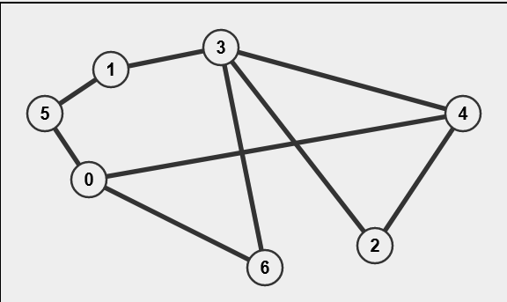
3.

