# Lab: Spring Boot and Spring Data

# MobiLeLeLe web application

MobiLeLeLe is an application in which you register cars, with several properties.

You will have to create a simple application which has several pages and some object entities.

## Data

This is the data layer of the application. There are some data object for you to implement.

### Brand

Create a Brand class, which holds the following properties:

* id – a **uuid or number**.
* name – a **name of brand**.
* **created** – a **date and time**.
* modified – a **date and time**.

### Model

Create a Model class, which holds the following properties:

* id – **uuid or number**.
* name – a **model name**.
* category – an enumeration (Car, Buss, Truck, Motorcycle)
* imageUrl – the **url of image** with size between 8 and 512 characters.
* startYear – a **number**.
* endYear – a **number**.
* **created** – a **date and time**.
* modified – a **date and time**.
* brand – a **model** **brand**.

### Offer

Create a Model class, which holds the following properties:

* id – **uuid or number**.
* description – some **text**.
* engine – **enumerated** value (GASOLINE, DIESEL, ELECTRIC, HYBRID).
* imageUrl – the **url of image**.
* mileage – a **number**.
* price – the **price of the offer**.
* transmission – **enumerated** value (MANUAL, AUTOMATIC).
* year – the **year** of offered car.
* **created** – a **date and time**.
* modified – a **date and time**.
* model – the **model of a car**.
* seller – a **user that sells the car.**

### User

Create a User class, which holds the following properties:

* id – **uuid or number**.
* **username** – username of the **user**.
* **password** – password of the **user**.
* **firstName** – first name of the **user**.
* **lastName** – last name of the **user**.
* isActive – **true OR false**.
* role – **user's role (User or Admin)**.
* imageUrl – a url of user's picture.
* **created** – a **date and time**.
* modified – a **date and time**.

### UserRole

Create a UserRole class, which holds the following properties:

* id – **uuid or number**.
* **role** – **enumerated** value.

This is an example of ER Diagram

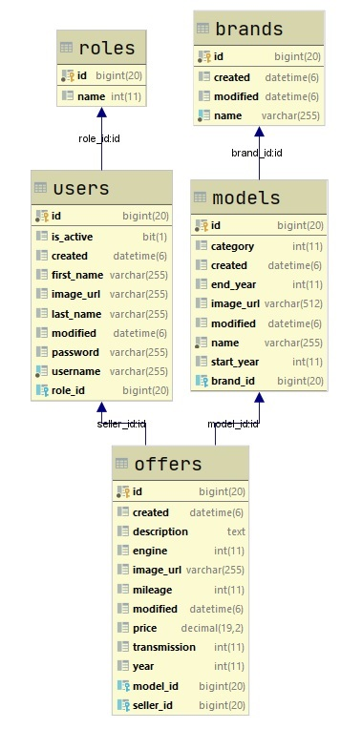

## Populate DB

* Create Data Initializer class, that populate the DB with information about cars when application starts for the first time.

Hint:

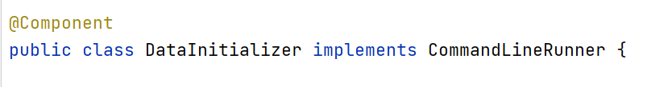

## Prepare All needed layers

* Repositories
  + If you want, you can implement some common methods
* Services and their implementations
  + If you want, you can implement some common methods in implementations
* ServiceModels, that contains the same fields as the entity

In the next Lab, we continue working on this application