Lab: Data Types and Table Basics

Part I - Simple Database Operations Using PostgreSQL pgAdmin

Create a New Database
First, let us create an empty database called "gamebar". Right-click on the databases field; choose "Create" -> "Database":
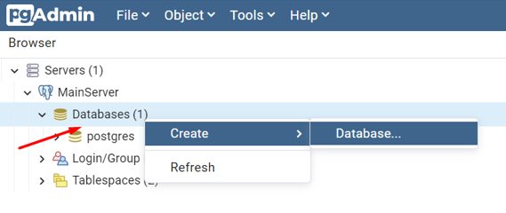
A new "Create Database" window will appear. In the "Database" field type our new database's name - "gamebar".
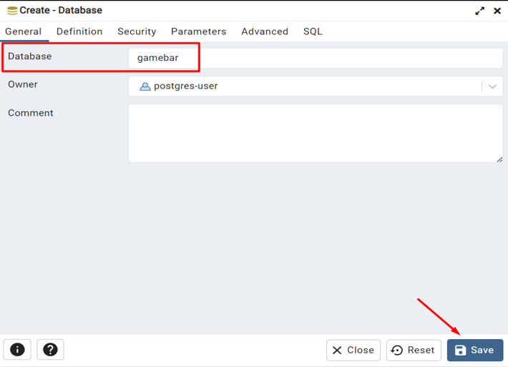

Create New Table
Open the newly created "gamebar" database, then open "Schemas" -> "public". Right-click the "Tables" and select "Create" -> "Table".
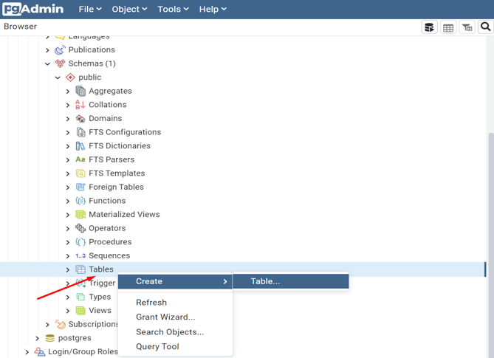
The table creation tab will appear. In the "Table Name" field type the name of your new table – "employees". From the "Columns" tab you can start creating your table fields.
First, create an "id" field. Set the data type to serial, Primary key(PK), and Not NULL. Create one more field – "name" with data type character varying.
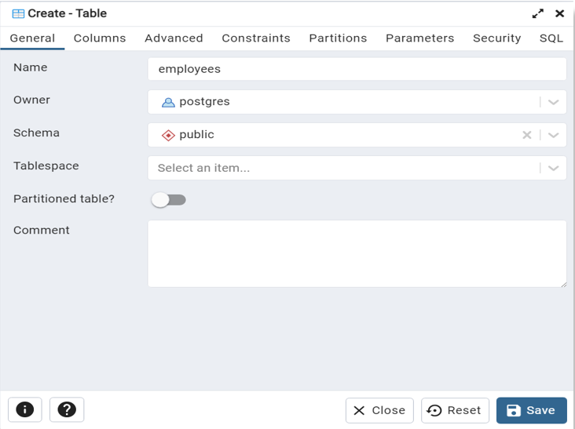
Click the Save button to finish the table creation.
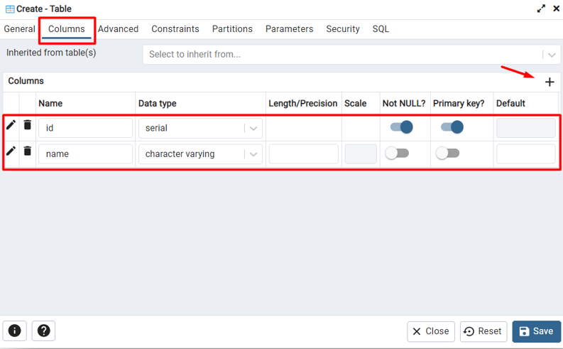

View and Edit Tables
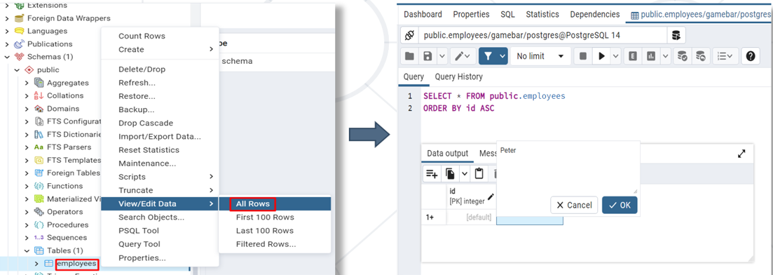
Now you can modify your table and add 2 more columns to it (adding columns to tables was already described above):
- salary – numeric, specified to the second decimal place, and has 10 digits in total
- devices_number – integer
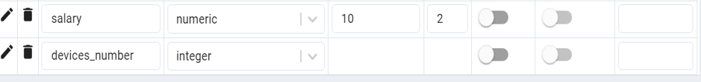

Create Tables "departments" and "issues"
Similar to "employees" create 2 more tables.
Table "departments":
- id – serial, primary key, Not NULL;
- name – character varying, max length 50;
- code – character, fixed length 3;
- description – text;
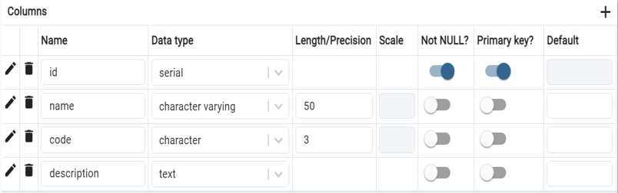
Table "issues":
- id – serial, primary key, unique;
- description – character varying, max length 150;
- date – date;
- start – timestamp without time zone
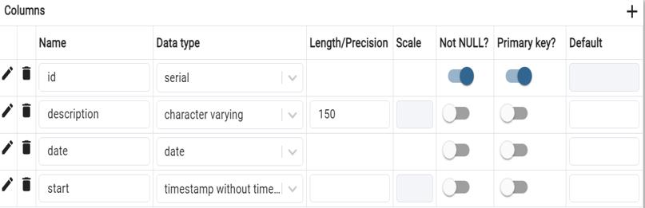

Insert Data in Tables
Now we can start adding some records to our newly created tables. First, select the "employees" table to see all rows:
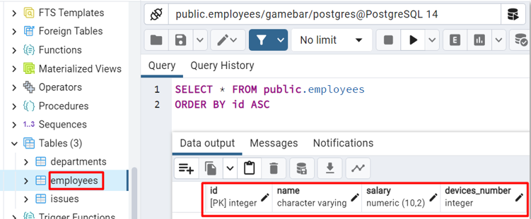
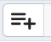
Select the button to add a new record.
Fill in the fields with values by double-clicking inside the desired field. Create 3 records in each table. Save data by clicking on the database icon.
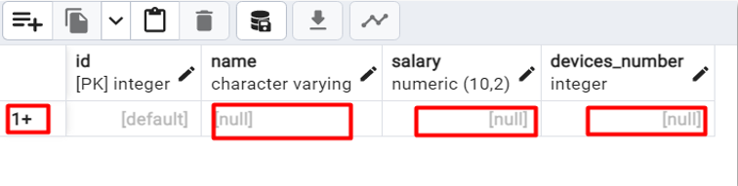

Editing Data
Data in tables can easily be edited with the GUI. Now that we've populated our tables with values, we can edit them by double-clicking on the value field. Save data by clicking on the database icon.
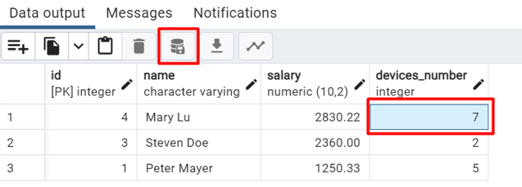

Deleting Data
Data deletion is easy too. We can just select the row we are about to delete and click on the bin icon. Do not forget to save your changes.
Delete all rows from table employees.
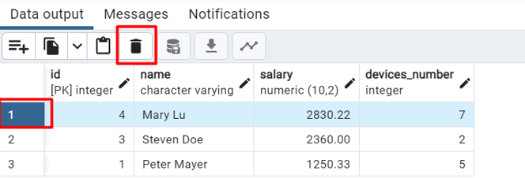

Modifying Columns and Adding Constraints
Select the table "employees". You can modify the column named "name", so you change it to first_name, then add a new column last_name. Add a new column hiring_date as well.
Set all constraints as follows:
- first_name – character varying, max length 30, Not NULL;
- last_name – character varying, max length 50, Not NULL;
- hiring_date – date, default '2023-01-01';

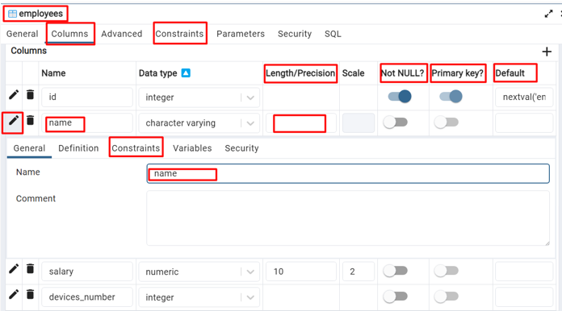
Your modified table employees should look like the following now:
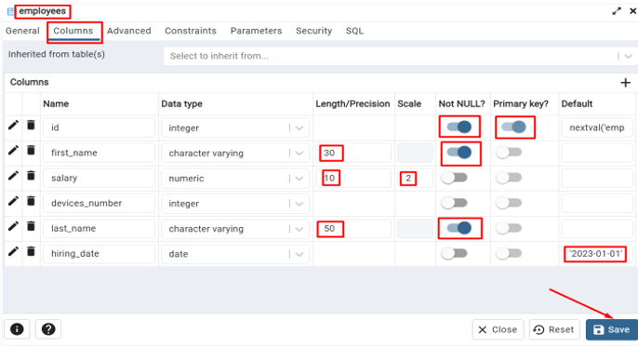
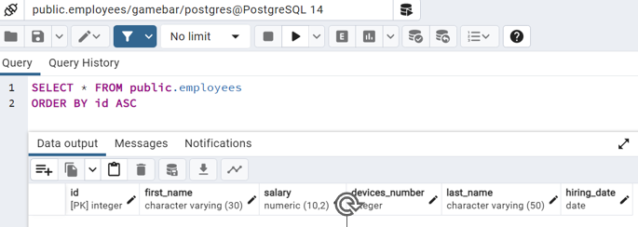

Dropping Tables
We can delete the whole table, by selecting the one we want to delete, right-clicking, and selecting "Delete/Drop". You cannot undo this action.
Now drop your 3 tables from your database.
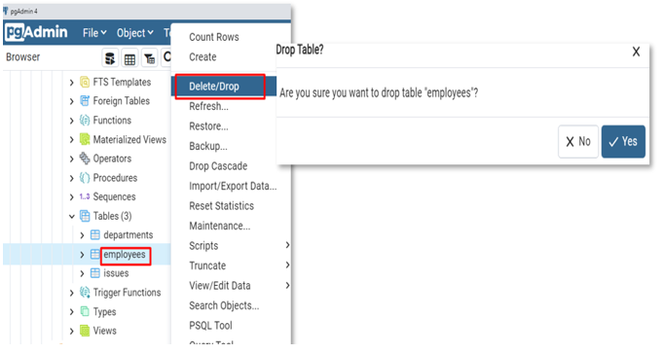

Dropping the Database
Similar to table dropping, you also have the option to delete the entire database. It's important to note that this action is irreversible.
To proceed, right-click on the database you like to remove and choose the "Delete/Drop" option.
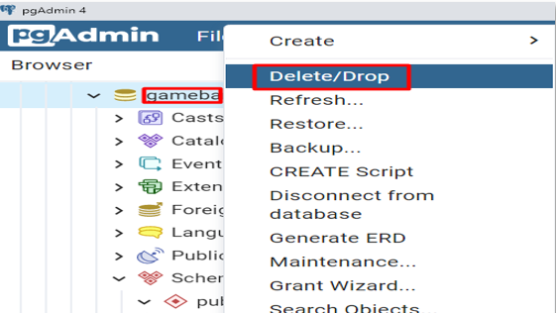

Part II - Simple Database Operations Using Queries
Now, we will follow the same steps from Part I, using simple SQL queries.
Exercises from this section should be submitted to the Judge Contest (tasks 1, 3 to 7).
Queries are written in the "Query" tab.

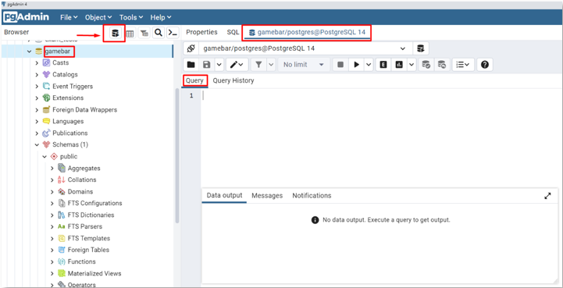

Descriptions for Exercises in Judge System

Create New Database
Write a query that will create the "gamebar" database. Open its Query Tool

Create Tables
Table "employees":
- id – serial, primary key, Not NULL;
- first_name – character varying, max length 30;
- last_name – character varying, max length 50;
- hiring_date – date, default '2023-01-01';
- salary – numeric, specified to the second decimal place, and has 10 digits in total;
- devices_number – integer;
Create the "departments" and "issues" tables analogically:
Table "departments":
- id – serial, primary key, Not NULL;
- name – character varying, max length 50;
- code – character, fixed length 3;
- description – text;
Table "issues":
- id – serial, primary key, unique;
- description – character varying, max length 150;
- date – date;
- start – timestamp without time zone;

Insert Data in Tables
*This task is not included in the Judge Contest.
Populate the "employees" table with 3 test values using pgAdmin UI.

Alter Tables
Altering the tables is done via the "ALTER TABLE" clause. Add a new column – "middle_name", "VARCHAR(50)" to the "employees" table.

Add Constraints
In the table "employees", set the salary column as Not NULL with a default value of 0. Set the hiring date column as Not NULL too.

Modify Columns
Change the property "VARCHAR(50)" to "VARCHAR(100)" for the middle_name column in "employees" table.

Truncate Tables
Truncate table "issues".

Drop Tables
Drop table "departments".

