Lab: Basic CRUD

Initial Steps:
Download the file hotel_db.sql from your Resources section.
Create a database "hotel" and open its Query Tool. You can use either the Query icon or Query Tool from the drop-down menu. Make sure you have selected your database hotel.
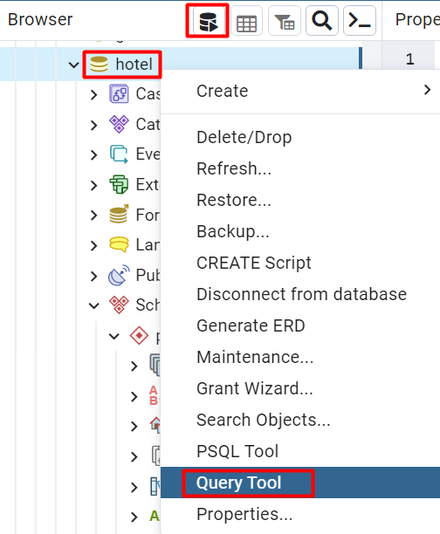
Import the file by clicking on the Folder icon.
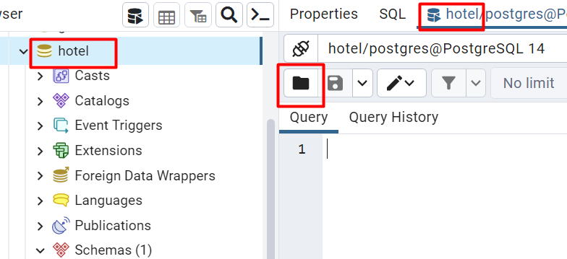
Navigate to file hotel_db.sql and select it. Queries will be loaded. Press the Play icon to execute them. This way you will create all tables and populate them with bulk data.
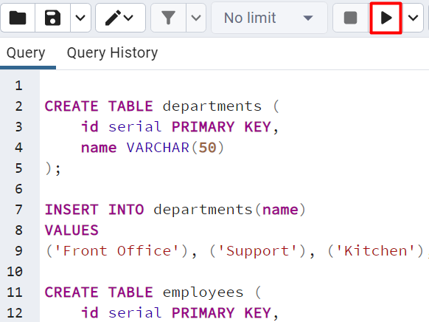
Get familiar with the hotel database and its tables. You will use them in the following exercises to make queries and retrieve data.

Exercises from the following section should be submitted to the Judge Contest (tasks 1 to 7).

Select and Display Employee Information by Concatenating Columns
Write a query to select all employees and retrieve information about their id, first_name, last_name (as Full Name), and job_title (as Job Title).

Example
id | Full Name | Job Title
1 | John Smith | Manager
2 | John Johnson | Customer Service
3 | Smith Johnson | Porter
… | … | …

Select Employees by Filtering and Ordering
Write a query to select all employees (id, first_name, and last_name (as full_name), job_title, salary) whose salaries are higher than 1000.00, ordered by id. Concatenate fields first_name and last_name into 'full_name'.

Example
id | full_name | job_title | salary
3 | Smith Johnson | Porter | 1100
4 | Peter Petrov | Front Desk Clerk | 1100
5 | Peter Ivanov | Sales | 1500.23
… | … | … | …

Select Employees by Multiple Filters
Write a query to retrieve information about employees, who are in department 4 and have a salary higher or equal to 1000. Order the information by id.

Example
id | first_name | last_name | job_title | department_id | salary
3 | Smith | Johnson | Porter | 4 | 1100
9 | Nikolay | Ivanov | Housekeeping | 4 | 1600

Insert Data into Employees Table
Insert new records into table employees by writing a query. Select all employees’ info to check the new entries.
New values:
Samantha Young, Housekeeping, 4, 900
Roger Palmer, Waiter, 3, 928.33
Submit both INSERT and SELECT queries.

Example
id | first_name | last_name | job_title | department_id | salary
… | … | … | … | … | …
10 | Samantha | Young | Housekeeping | 4 | 900
11 | Roger | Palmer | Waiter | 3 | 928.33

Update Employees Salary
Update all employees' salaries whose job_title is "Manager" by adding 100.
Retrieve information from table employees for all managers.
Submit both UPDATE and SELECT queries.

Example
id | first_name | last_name | job_title | department_id | salary
1 | John | Smith | Manager | 1 | 1000

Delete from Table
Write a query to delete all employees from the employees table who are in department 2 or 1. Then select all from table employees and order the information by id.
Submit both DELETE and SELECT queries.

Example
id | first_name | last_name | job_title | department_id | salary
3 | Smith | Johnson | Porter | 4 | 1100
6 | Ivan | Petrov | Waiter | 3 | 990
7 | Jack | Jackson | Executive Chef | 3 | 1800
9 | Nikolay | Ivanov | Housekeeping | 4 | 1600

Create a View for Top Paid Employee
Write a query to create a view that selects all information about the top-paid employee from the employees table in the hotel database. Call your view to check the results.
Submit both CREATE VIEW and SELECT queries.

Example
id | first_name | last_name | job_title | department_id | salary
8 | Pedro | Petrov | Front Desk Supervisor | 1 | 2100

