# Lab: Text Processing and Regular Expressions

Problems for exercises and homework for the ["Technology Fundamentals with C#" course @ SoftUni](https://softuni.bg/modules/57/tech-module-4-0).

You can check your solutions in [Judge](https://judge.softuni.bg/Contests/1216).

## Reverse Strings

You will be given series of strings until you receive an **"end"** command. Write a program that reverses strings and prints each pair on a separate line in the format **"{word} = {reversed word}"**.

### Examples

|  |  |
| --- | --- |
| **Input** | **Output** |
| helLo  Softuni  bottle  end | helLo = oLleh  Softuni = inutfoS  bottle = elttob |
| Dog  caT  chAir  end | Dog = goD  caT = Tac  chAir = riAhc |

### Solution

Use a while loop and read strings until you receive "end".

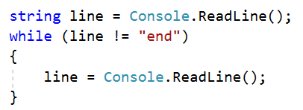

Reverse the string with a for loop. Start from the last index and append each symbol to the new string.

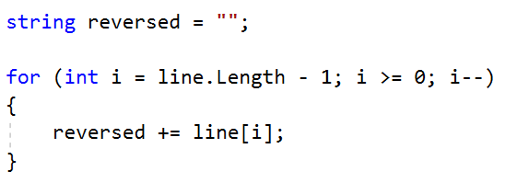

Print the reversed string in the specified format.



## Repeat Strings

### Write a program that reads an array of strings. Each string is repeated N times, where N is the length of the string. Print the concatenated string.

### Examples

|  |  |
| --- | --- |
| **Input** | **Output** |
| hi abc add | hihiabcabcabcaddaddadd |
| work | workworkworkwork |
| ball | ballballballball |

### Solution

* Read a string array.



* Initialize **StringBuilder**.



* Iterate through elements in the array.

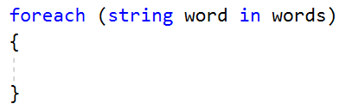

* Find the length of the current word and append it.

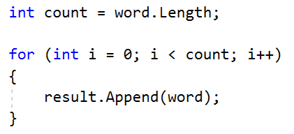

* Print the **StringBuilder**.

## Substring

On the **first line** you will receive a **string**. On the **second line** you will receive a second **string**. Write a program that **removes** **all** of the **occurrences** of the **first** string **in** the **second,** **until** there is **no match**. At the end **print** the **remaining string**.

### Examples

|  |  |  |
| --- | --- | --- |
| **Input** | **Output** | **Comment** |
| Ice  kicegiciceeb | kgb | We remove ice once and we get "kgiciceeb"  We match "ice" one more time and we get "kgiceb"  There is one more match. The finam result is "kgb" |

### Hints

* Read the input.
* Find the first index where the key appears.
  + Use the built-in method **IndexOf**()
* Remove the match.
  + Use the built-in method **Remove**(index, length)
* Repeat it until the text doesn't contain the key anymore.

## Text Filter

Write a program that takes a **text** and a **string of banned words**. All words included in the ban list should be replaced with **asterisks** "**\***", equal to the word's length. The entries in the ban list will be separated by a **comma** and **space** "**,** ".

The ban list should be entered on the first input line and the text on the second input line.

### Examples

|  |  |
| --- | --- |
| **Input** | **Output** |
| Linux, Windows  It is not **Linux**, it is GNU/**Linux**. **Linux** is merely the kernel, while GNU adds the functionality. Therefore we owe it to them by calling the OS GNU/**Linux**! Sincerely, a **Windows** client | It is not *****, it is GNU/*****. ***** is merely the kernel, while GNU adds the functionality. Therefore we owe it to them by calling the OS GNU/*****! Sincerely, a ******* client |

### Hints

* Read the input.
* Replace all ban words in the text with asterisk (*).
  + Use the built-in method **Replace**(banWord, replacement).
  + Use **new string(**char ch, int repeatCount**)** to create the replacement

## Digits, Letters and Other

Write a program that receives a **single** **string** and on the **first** **line,** prints **all the digits**. On the **second** – **all the letters**, and on the **third** – **all the other characters**. **There will always be at least one digit, one letter and one other character.**

### Examples

|  |  |
| --- | --- |
| **Input** | **Output** |
| Agd#53Dfg^&4F53 | 53453  AgdDfgF  #^& |

### Hints

* Read the input.
* Use loop to iterate through all characters in the text. If the char is digit print it, otherwise ignore it.
  + Use char.**IsDigit**(char symbol)
* Do the same for the letters and other chars
  + Find something like IsDigit method for the letters.

Problems for exercises and homework for the ["Technology Fundamentals" course @ SoftUni](https://softuni.bg/courses/technology-fundamentals).  
Please submit your solutions (source code) of all below described problems in the [Judge System.](https://judge.softuni.bg/Contests/1344/Regular-Expressions-Lab)

## Match Full Name

Write a program that **matches full names** from a list of names and **prints** them on the console.

### Writing the Regular Expression

First, write a regular expression to match a valid full name, according to these conditions:

* A valid full name has the following characteristics:
  + It consists of **two words**.
  + Each word **starts** with a **capital letter**.
  + After the first letter, it **only contains lowercase letters afterwards**.
  + **Each** of the **two words** should be **at least two letters long**.
  + The **two words** are **separated** by a **single space**.

To help you out, we've outlined several steps:

* Use an online regex tester like <https://regex101.com/>
* Check how to use **character sets** (denoted with square brackets - "[]")
* Specify that you want **two words** with a space between them (the **space character '** **'**, and **not** any whitespace symbol)
* For each word, specify that it should begin with an uppercase letter using a **character set**. The desired characters are in a range – **from** ‘**A**’ **to** ‘**Z**’.
* For each word, specify that what follows the first letter are only **lowercase letters**, one or more – use another character set and the correct **quantifier**.
* To prevent the capturing of letters across new lines, put "\b" at the beginning and at the end of your regex. This will ensure that what precedes and what follows the match is a word boundary (like a new line).

In order to check your RegEx, use these values for reference (paste all of them in the **Test String** field):

|  |  |
| --- | --- |
| **Match ALL of these** | **Match NONE of these** |
| Ivan Ivanov | ivan ivanov, Ivan ivanov, ivan Ivanov, IVan Ivanov, Ivan IvAnov, Ivan Ivanov |

By the end, the matches should look something like this:

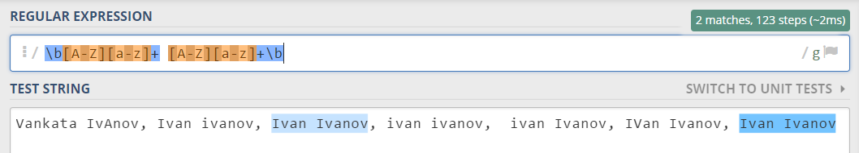

After you’ve constructed your regular expression, it’s time to write the solution in C#.

### Examples

|  |
| --- |
| **Input** |
| Ivan Ivanov, Ivan ivanov, ivan Ivanov, IVan Ivanov, Test Testov, Ivan Ivanov |
| **Output** |
| Ivan Ivanov Test Testov |

## Match Dates

Write a program, that matches a date in the format “dd{separator}MMM{separator}yyyy”. Use **named** **capturing groups** in your regular expression.

### Compose the Regular Expression

Every valid date has the following characteristics:

* Always starts with **two digits**, followed by a **separator**
* After that, it has **one uppercase** and **two lowercase** letters (e.g. Jan, Mar).
* After that, it has a **separator** and **exactly 4 digits** (for the year).
* The separator could be either of the three: a period (“.”), a hyphen (“-“) or a forward slash (“/”)
* The separator needs to be **the same** for the whole date (e.g. 13.03.2016 is valid, 13.03/2016 is **NOT**). Use a **group backreference** to check for this.

You can follow the table below to help with composing your RegEx:

|  |  |
| --- | --- |
| **Match ALL of these** | **Match NONE of these** |
| 13/Jul/1928, 10-Nov-1934, 25.Dec.1937 | 01/Jan-1951, 23/sept/1973, 1/Feb/2016 |

Use **named capturing groups** for the **day**, the **month** and the **year**.

Since this problem requires a more complex RegEx, which includes **named capturing groups**, we’ll take a look at how to construct it:

* First off, we don’t want anything at the **start** of our date, so we’re going to use a **word boundary** “\b”:  
  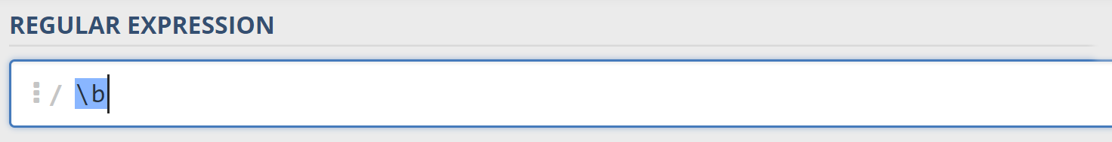
* Next, we’re going to match the **day**, by telling our RegEx to match **exactly two digits**,and since we want to **extract** the day from the match later, we’re going to put it in a **capturing group**:  
  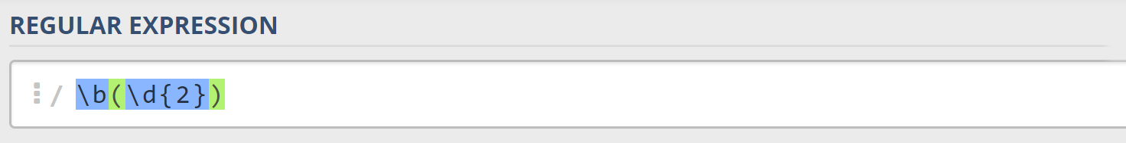  
  We’re also going to give our group a **name**, since it’s easier to navigate by **group name** than by **group index**:  
  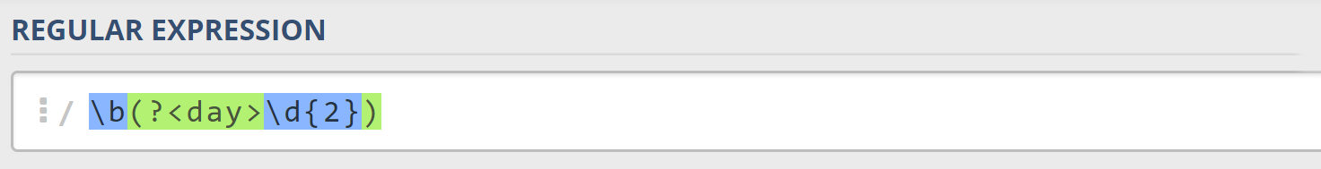
* Next comes the separator – either a **hyphen**, **period** or **forward slash**. We can use a **character class** for this:  
  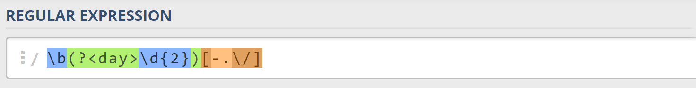  
  Since we want to use the separator we have matched here to match the **same separator** further into the date, we’re going to put it in a **capturing group**:  
  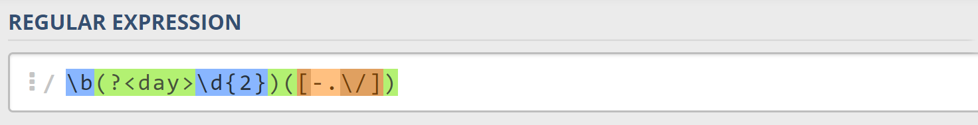
* Next comes the **month**, which consists of a **capital Latin letter** and **exactly two lowercase Latin letters**: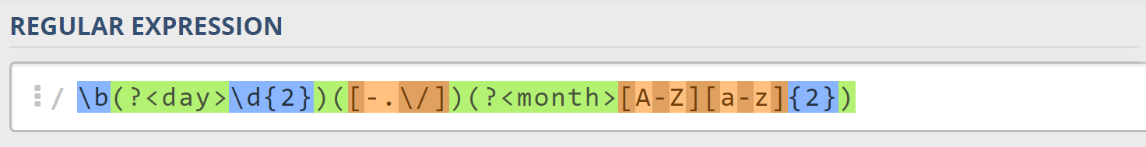
* Next, we’re going to match the **same separator** **we have matched earlier**. We can use a **backreference** for that:  
  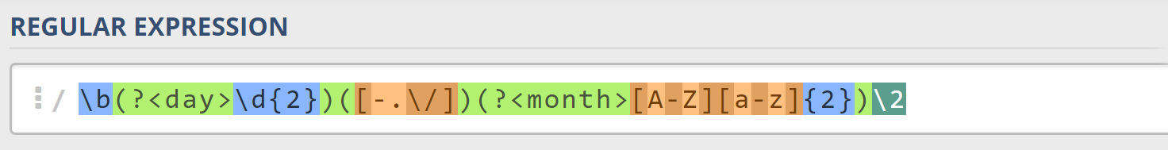
* Next up, we’re going to match the year, which consists of **exactly 4 digits**:  
  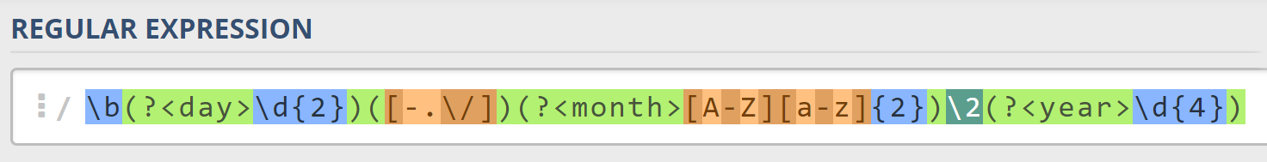
* Finally, since we don’t want to match the date if there’s anything else **glued to it**, we’re going to use   
  another **word boundary** for the end:  
  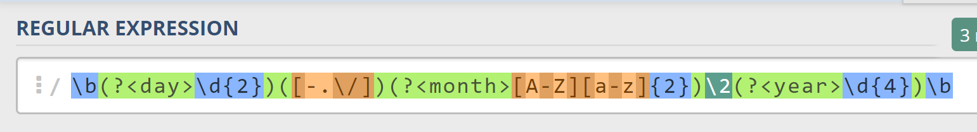

Now it’s time to find all the **valid dates** in the input and **print each date** in the following format: “Day: {day}, Month: {month}, Year: {year}”, each on a **new line**.

### Examples

|  |
| --- |
| **Input** |
| 13/Jul/1928, 10-Nov-1934, , 01/Jan-1951,f 25.Dec.1937 23/09/1973, 1/Feb/2016 |
| **Output** |
| Day: 13, Month: Jul, Year: 1928  Day: 10, Month: Nov, Year: 1934  Day: 25, Month: Dec, Year: 1937 |

## Match a Phone Number

Write a regular expression to match a **valid phone number** from **Sofia**. After you find all of the **valid phones**, **print** them on the console, separated by a **comma and a space** “, ”.

### Compose the Regular Expression

A valid number has the following characteristics:

* It starts with "**+359**"
* Then, it is followed by the area code (always **2**)
* After that, it’s followed by the **number** itself:
  + The number consists of **7 digits** (separated in **two** **groups** of **3** and **4** **digits** respectively).
* The different **parts** are **separated** by **either a space or a hyphen** ('**-**').

You can use the following RegEx properties to **help** with the matching:

* Use **quantifiers** to match a **specific number** of **digits**
* Use a **capturing group** to make sure the delimiter is **only one of the allowed characters** **(space or hyphen)** and **not** a **combination** of both (e.g. +359 2-111 111 has **mixed delimiters**, it is **invalid**). Use a **group backreference** to achieve this.
* Add a **word boundary** at the **end** of the match to avoid **partial matches** (the last example on the right-hand side).
* Ensure that before the **'+'** sign there is either a **space** or the **beginning of the string**.

You can use the following table of values to test your RegEx against:

|  |  |
| --- | --- |
| **Match ALL of these** | **Match NONE of these** |
| +359 2 222 2222  +359-2-222-2222 | 359-2-222-2222, +359/2/222/2222, +359-2 222 2222  +359 2-222-2222, +359-2-222-222, +359-2-222-22222 |

### Examples

|  |
| --- |
| **Input** |
| +359 2 222 2222,359-2-222-2222, +359/2/222/2222, +359-2 222 2222 +359 2-222-2222, +359-2-222-222, +359-2-222-22222 +359-2-222-2222 |
| **Output** |
| +359 2 222 2222, +359-2-222-2222 |