Report

Table 1. Sales by Month
Date | Sales
01.01.23 | 129960,26
01.02.23 | 132215,41
01.03.23 | 145321,2
01.04.23 | 138160,99
01.05.23 | 150774,98
01.06.23 | 152605,75
01.07.23 | 162111,12
01.08.23 | 148020,45
01.09.23 | 153094,7
01.10.23 | 151272,28
01.11.23 | 146795,61
01.12.23 | 159978,81

Diagram 1. Sales by Month
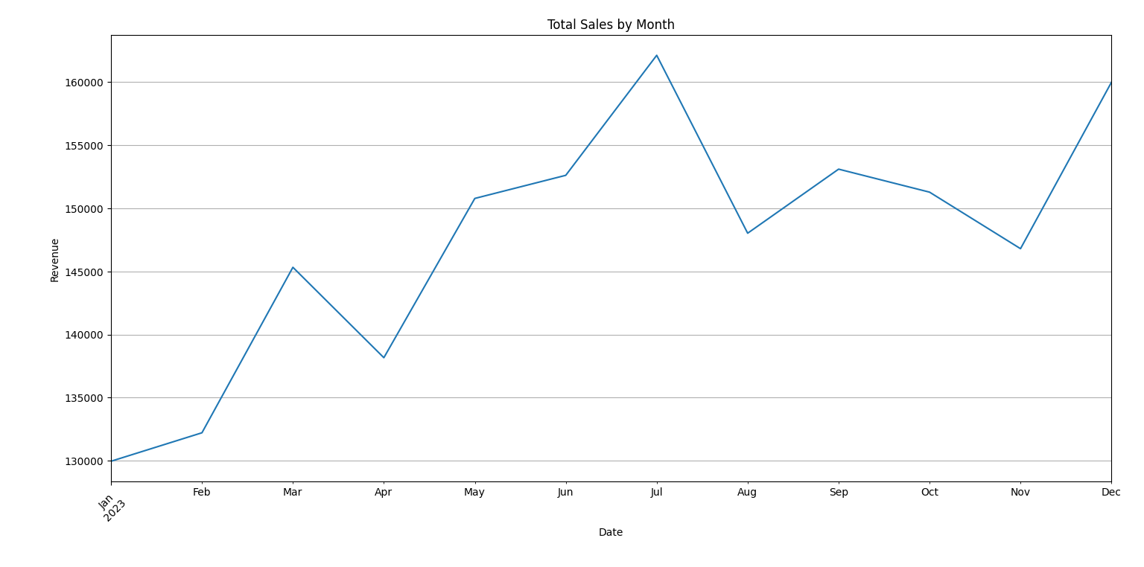

Table 2. Sales and Profit by Category
Category | Sales | Profit
Books | 370971,87 | 90909,62
Clothing | 350981,82 | 87583,39
Electronics | 362373,7 | 87207,47
Home Goods | 344634,29 | 84570,42
Sports | 341349,88 | 86764,25

Diagram 2. Sales and Profit by Category
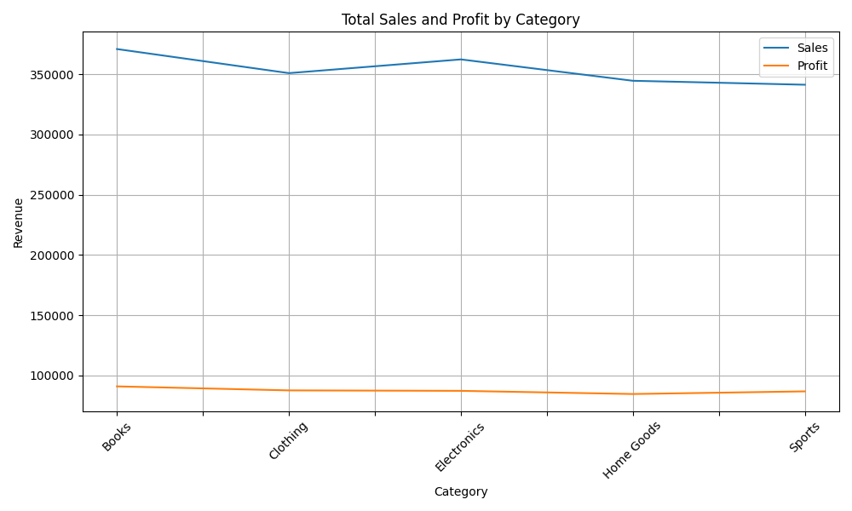

Table 3. Mean Sales by Category in Region
Reg. \ Cat. | Books | Clothing | Electronics | Home Goods | Sports
East | 1054,43 | 968,92 | 1038,89 | 1009,08 | 957,66
North | 1002,44 | 975,52 | 1040,47 | 955,23 | 971,23
South | 1013,4 | 985,95 | 1023,84 | 992,62 | 983,96
West | 1083,07 | 1000,81 | 1050,33 | 949,17 | 1006,15

Diagram 3. Mean Sales by Category in Region
