Task 1.1 (HelloWorld.java)

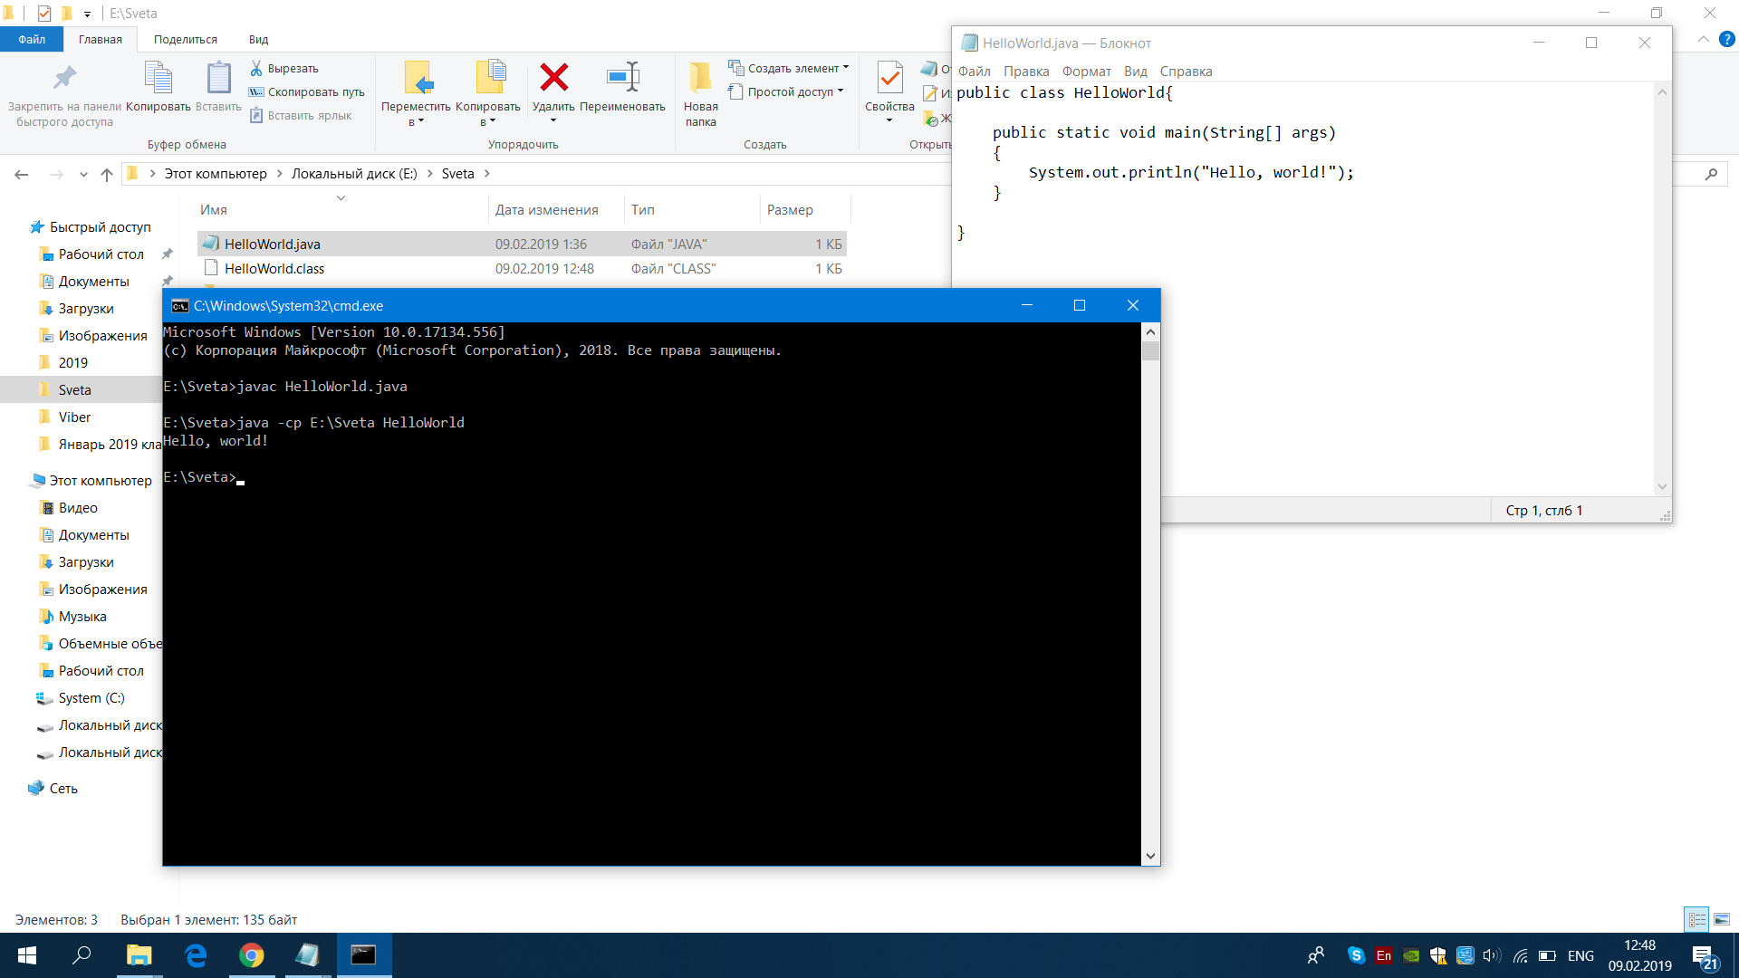

Pic. 1.1

Task 1.2 (CommandLineParams.java)

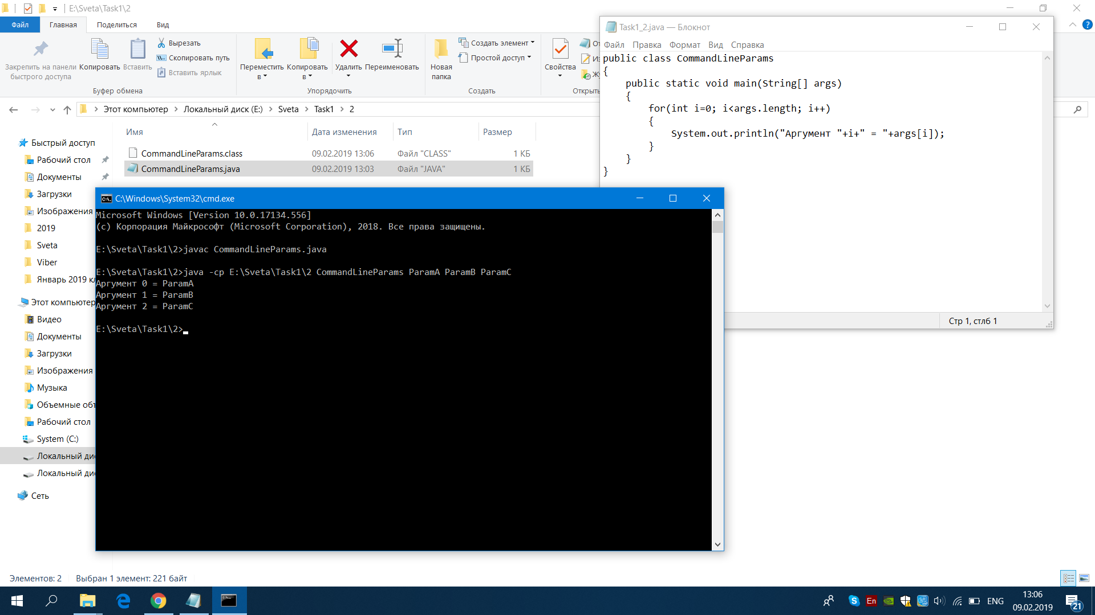

Pic. 1.2

Task 1.3 (InvertedCommandLineParams.java)

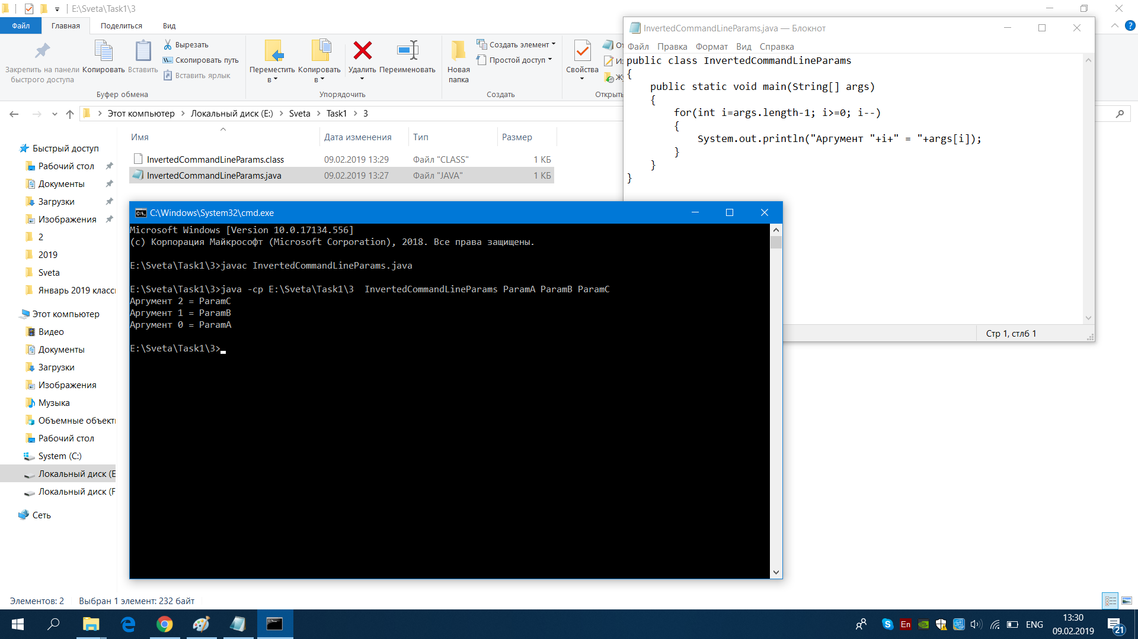

Pic. 1.3

Task 1.4 (NameForOutput.java)

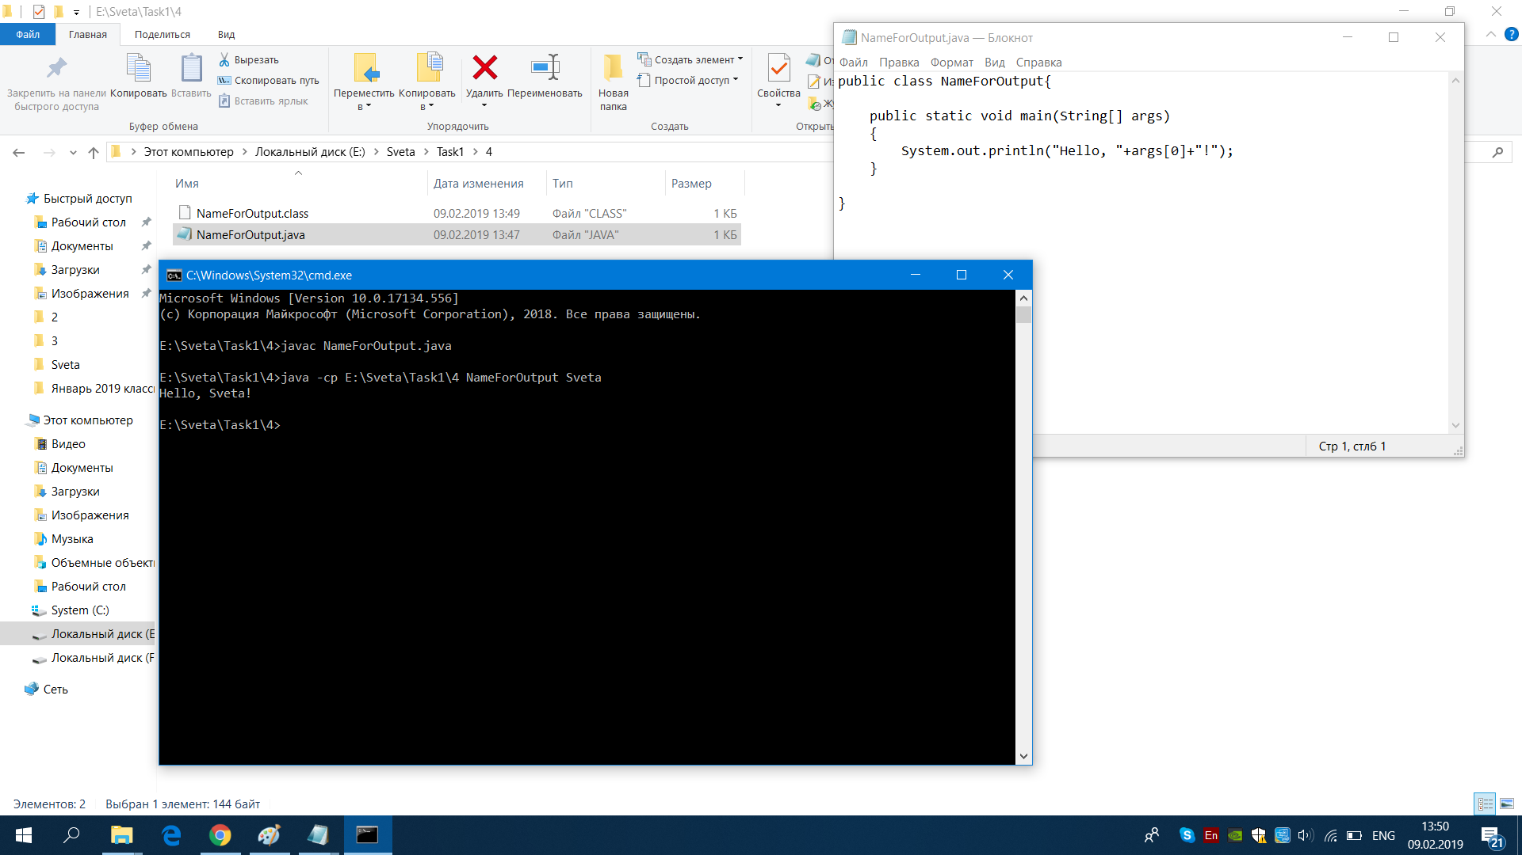

Pic. 1.4

Task 1.5 (Calculator.java)

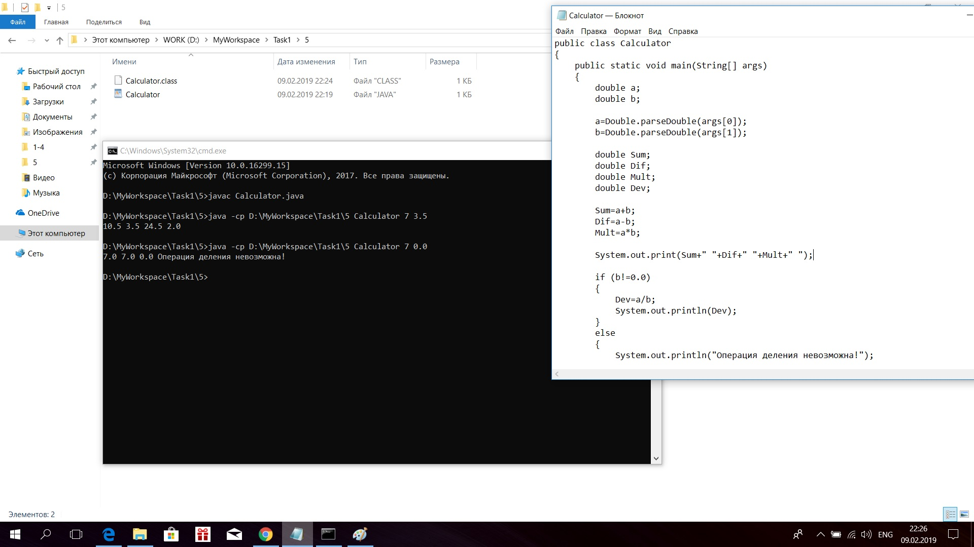

Pic. 1.5

Task 1.6 (PrintRandomNumber.java)

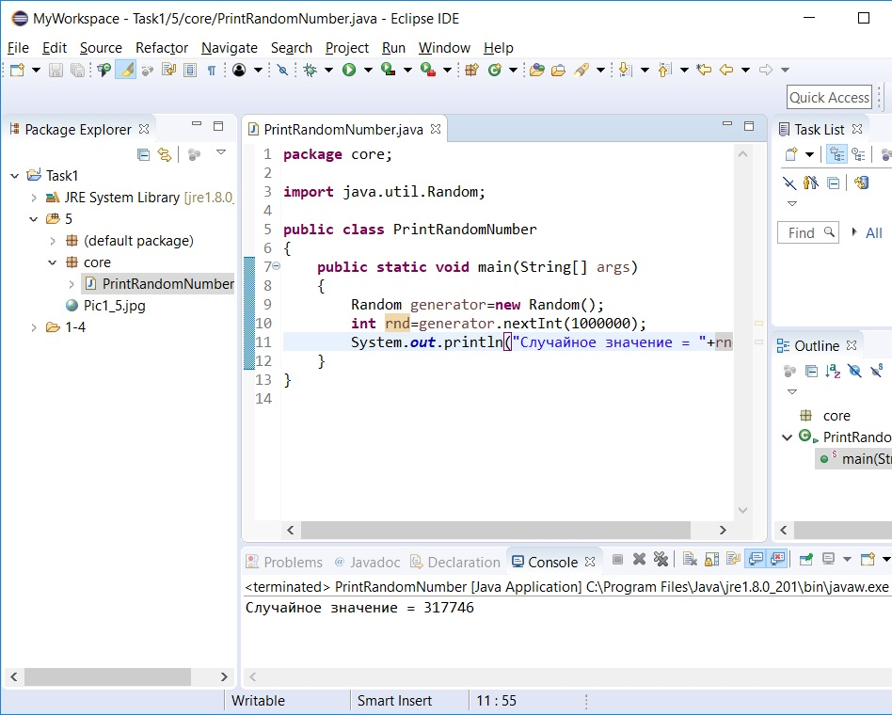

Pic. 1.6

Task 1.7 (BasicTypes.java)

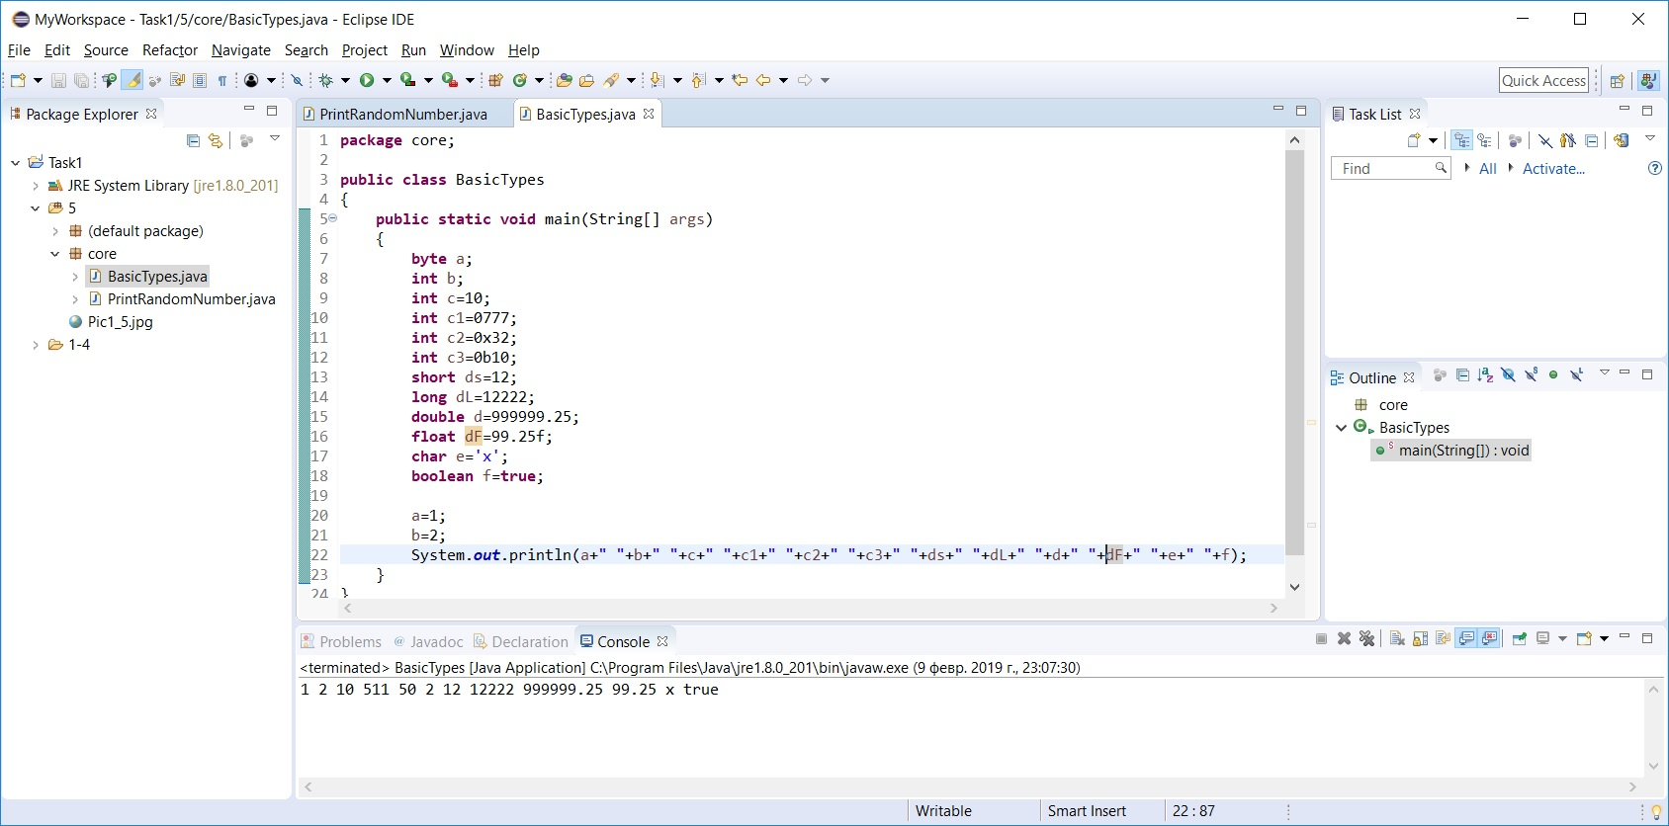

Pic. 1.7

Task 1.8 (Numbers.java)

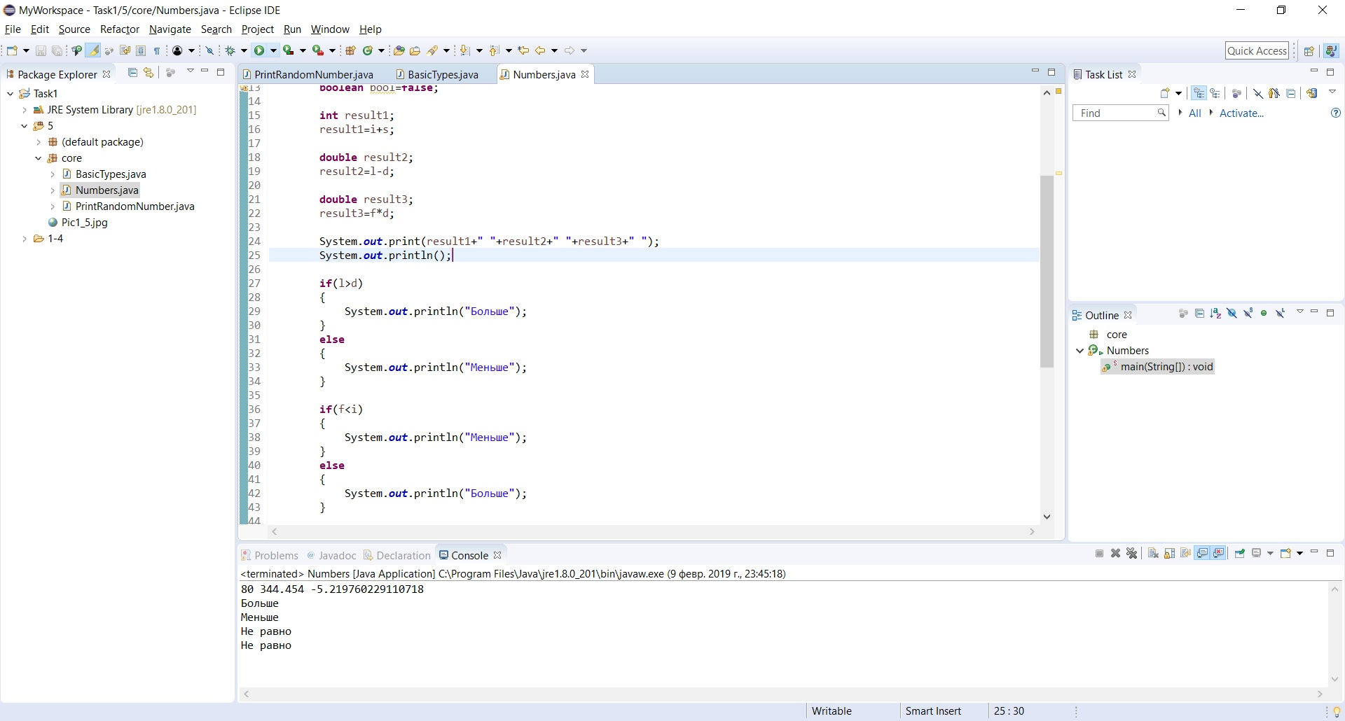

Pic. 1.8